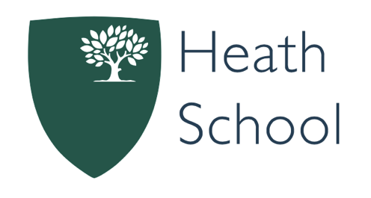

Required for September 2025

SENDCo
Heath School (H3 Federation)

MPS/UPS + TLR 2B + SEN allowance
Permanent

Full-time members of staff benefit from one fully remote flexible working Friday every three weeks
The Governors of H3 Federation are looking to appoint a dynamic and highly skilled SENDCo to join the outstanding staff team at Heath School.
We are looking for someone with significant experience in working with children with SEND. You should have a sound knowledge of the SEND Code of Practice and be confident in its application.
You will be passionate about supporting students with SEND, demonstrating an ability to work with sensitivity and positivity to ensure every student can thrive. Strong skills in school improvement planning, monitoring, and reviewing progress are essential, along with the ability to analyse SEND data and communicate your findings to both educational and non-educational staff.
This is an excellent career opportunity for someone looking to play a pivotal role in determining the strategic development of SEND policy and provision across the school, building on the effective structures already in place. You will have day-to-day responsibility for coordinating SEND support, ensuring each student’s needs are understood and met.
Heath School is a Pupil Referral Unit for children aged 11-16 in Camden who join us for a period of enhanced support and intervention in preparation for their return to mainstream school. In June 2024, Ofsted rated the school as ‘Good’ overall, with ‘Outstanding’ grades for behaviour and attitudes, leadership and management and personal development. Staff who work here receive “Excellent regular training” and join colleagues who “enjoy their development and training and report leaders are considerate of their well-being”. All staff at Heath enjoy the opportunity to work flexibly from home once every three weeks.
Students are taught in small classes by qualified teachers. HLTAs support in class, and may take responsibility for leading learning in a range of in class and extended curriculum settings.
Students at Heath are supported in their behaviour development by an excellent team of teachers, leaders and specialist support staff. We have high expectations. Our clear behaviour policy and strong, student-centred approach to individual needs means that children often make exceptional progress.
H3 Federation is a group of three Camden Schools which work together to ensure that ‘Every Student Can Learn and Grow’. The successful candidate will benefit from the opportunity to develop their careers within a Federation committed to professional development and progression opportunities.
If you share our passion for ensuring high standards for all, and have the ambition to help transform the lives of the young people in our school, we would very much like to hear from you.
For more information, please visit our website http://heath.h3federation.org.uk/ and the job pack. You are also welcome to contact the school on 020 7974 8906 to speak to the Head of School, Alex Wilson, or another senior leader.
Closing date for applications: Wednesday 2nd April 2025.
Interviews: Thursday 24th April 2025.
Please apply through the TES website https://www.tes.com/jobs/vacancy/sendco-camden-2189151



Heath School is proud to be part of the H3 Federation: where every child can learn and grow.
Heath School is committed to safeguarding children and promoting the welfare of young people and the successful candidates will be subject to an Enhanced DBS check and online vetting checks by the school.

