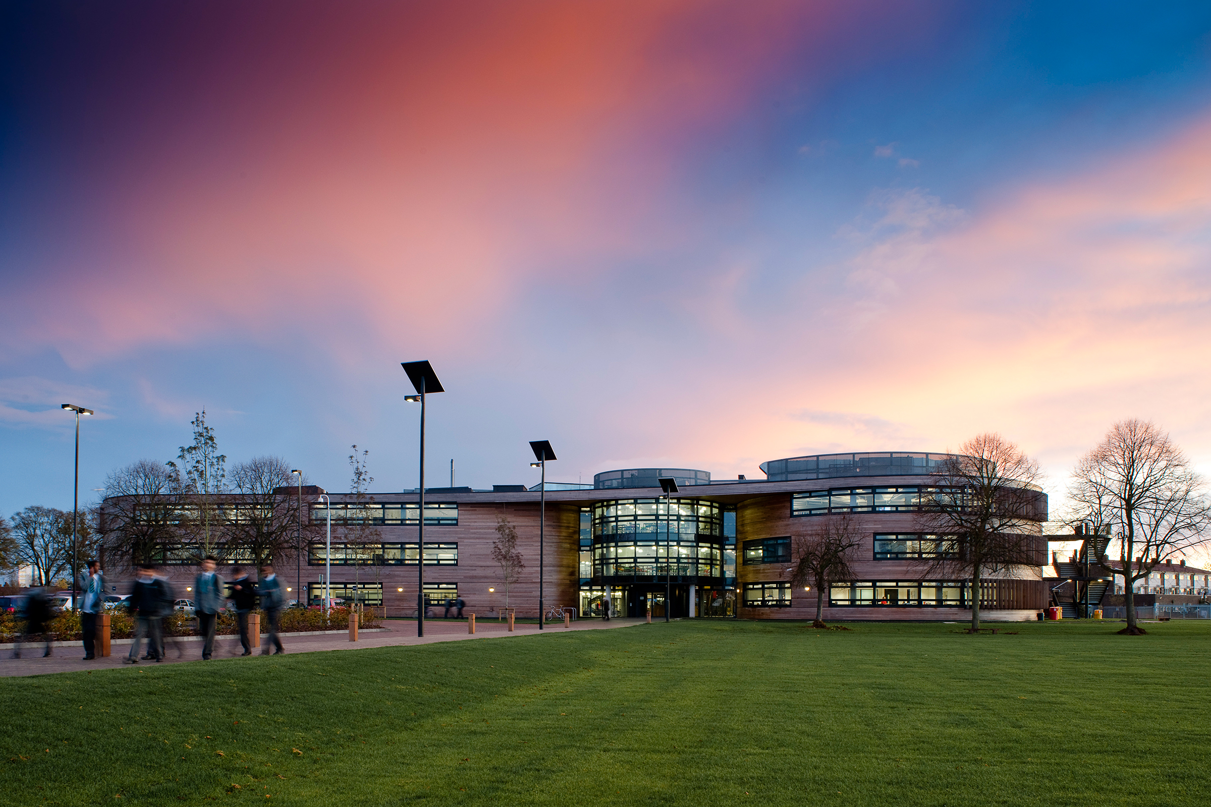

**The Langley Academy Secondary**

**Slough, Berkshire**

COVER MANAGER, OFFICE MANAGER

& PA TO DEPUTY HEADTEACHER



Thank you for your interest in the Cover Manager, Office Manager & PA to Deputy Headteacher post at The Langley Academy Secondary

**This pack contains:**

* Letter to candidates
* Details about the Sponsor and The Annabel Nicoll Foundation
* Information about The Langley Academy Secondary
* Information about The Langley Academy Primary and Parlaunt Park Primary Academy
* The job description and person specification

We hope that you find the pack informative and useful. If you do have any further questions, then please contact The Langley Academy Trust via the details below:

**Tara Mackay**

tara.mackay[@langleyacademy.org](mailto:sarah.friend@langleyacademy.org)

01753 214468

Deadline for applications: 9am 22 Feb 2019

Interview dates: w/k commencing 28 Feb 2019

If you wish to visit the academy prior to application then please contact Tara Mackay [tara.mackay@langleyacademy.org](mailto:tara.mackay@langleyacademy.org)

You can also visit our Trust website at [www.langleyacademytrust.org](http://www.langleyacademytrust.org)

Please take the time to review our Child Protection Policy:

<http://www.langleyacademytrust.org/documents/policies/trust/ChildProtectionPolicy(TLAT)(February2017).pdf>

Contents

Dear Applicant

Thank you for your interest in The Langley Academy and the position of Cover Manager, Office Manager & PA to Deputy Headteacher. This is an exciting opportunity to join our very vibrant school community and work in a beautiful setting.

We are looking for someone who is highly committed, motivated, and resilient with a clear vision for the role. We need an individual who will contribute to the Academy’s vision for the future, playing a pivotal role in going the extra mile to ensure that all students and staff achieve their very best.

At the Academy, we believe that students come to school to learn and achieve in order to live full and enriching lives. We want to empower them to contribute positively to their family, the community and the wider world. The staff, governors and trustees work hard together, along with parents and carers, to ensure that each of our students leave with a set of results of which they can be proud.

We place a strong emphasis on developing students’ confidence through opportunities in and beyond the classroom so that they can develop their personal and academic interests. Teachers and support staff seek to meet the needs of all within a rich and balanced curriculum, underpinned by our strapline of Curiosity, Exploration and Discovery. In return, we expect all students to be fully prepared and active participants in their learning. An agreed and established set of ground rules based on respect allows everyone to get the best from lessons, activities and unstructured time.

We also believe in lifelong learning and dedicate time and resources to ensure high quality professional development is available to all. The staff are very enthusiastic and would warmly welcome all teachers with a passion for learning. Please come and visit the academy to truly understand what we are aiming to achieve and whether you would like to be a part of our journey.

Yours sincerely



Alison Lusuardi

Headteacher of The Langley Academy

Dear Applicant

I am delighted that you are showing an interest in the Cover Manager, Office Manager & PA to Deputy Headteacher position here at The Langley Academy Secondary. I want to set out the reasons why we think it is so exciting. The Multi-Academy Trust (MAT) encompasses The Langley Academy Secondary, The Langley Academy Primary and Parlaunt Park Primary Academy. Our vision is to ensure we provide an outstanding education for every child in the Trust through high aspirations and quality learning through curiosity, exploration and discovery. By 2021, when The Langley Academy Primary has a full complement of year groups, we will have approximately 2,500 students and 350 staff working in the Trust.

We are looking for someone who is looking to be part of this vision. The Trust is in its fourth year and therefore very much still in its infancy and the continued development of an appropriate infrastructure is vital if we are to meet our strategic objectives. Both Primaries will be the main feeder schools with right of entry as part of the admissions policy. This means that the curriculum, assessment and pedagogy will be developed as a Trust to ensure our young people make rapid progress throughout.

A significant advantage of our approach is the capacity to provide outstanding in-house CPD as we will have excellence in each academy that can support professional development for those starting their careers or for those wishing to gain further responsibility. This capacity is further enhanced by understanding the significant resource the student body provides. Students in the secondary develop programmes of study for their careers whilst providing an invaluable service at each Primary. This might take place through the Duke of Edinburgh programme, our community service programme or the Child Development NVQ. In essence an academy improvement programme ‘on tap’ for each academy in the Trust. This will also give us the ability for each academy to respond to problems quickly. For example, staff across the Trust are able to lead on INSET days allowing us to access best practice.

One of the greatest qualities of the Trust is the Sponsors. Having worked with them since my appointment as Principal of The Langley Academy in April 2012, I cannot praise them highly enough. Annabel Nicoll is the Sponsor of the Trust. She has boundless energy and enthusiasm all directed at giving youngsters a better life. As a result of her work, students here have quite simply been afforded opportunities that many young people elsewhere in the country just would not get. The successful applicant will be able to draw on this support and networking opportunity to develop their own career and importantly offer a better education for the young people.

We are aspirational and want to be the best MAT in the country with each school rated outstanding as soon as possible. We believe the economies of scale, the cross-phase opportunities for students and staff development, the ability to respond to each other’s needs quickly and the ‘can do’ approach to everything we do, will make the working environment simply extremely exciting.

Yours sincerely



Rhodri Bryant

Executive Principal of The Langley Academy Trust

About the Sponsor and the Trust

**The Annabel Arbib Foundation (formerly The Arbib Foundation)** is a registered charity (number 296358) which supports the philanthropy of Annabel Nicoll, with a clear focus on education and providing opportunities for young people.

The Foundation was originally established in 1987 by Sir Martyn Arbib who set up the Henley-on-Thames based Perpetual Investment business in 1974. The Foundation provided charitable donations and financial support to organisations and causes around the UK, with a focus on the Thames Valley. Sir Martyn Arbib, and the Foundation, took a leading role in funding and establishing the River & Rowing Museum in Henley-on-Thames that opened in 1998 and attracts over 100,000 visitors per year. Sir Martyn and his daughter, Annabel Nicoll, have both actively supported the museum and its award-winning education work of The River and Rowing Museum since its inception.

In 2015 Sir Martyn Arbib retired as Chairman of The Arbib Foundation. His daughter Annabel Nicoll took over the Chair and has continued to use the Foundation, which has been renamed The Annabel Arbib Foundation, to support her own philanthropy and to continue her work with The Langley Academy Trust. Sir Martyn, Annabel and the rest of their family all maintain a keen interest in the work being done at the academies in the Trust.

The Langley Academy Trust is the principal beneficiary of the Annabel Arbib Foundation.

**The Langley Academy Trust** is a unique Trust that serves the young people of Langley, Slough and further afield. Our Trustees are a Board of interesting and experienced professionals who bring energy, enthusiasm and wisdom to their role. They share the ambitions of the Trust senior leaders to achieve the best possible outcomes for all children and students within the Trust.

**The Langley Academy** **Primary** is a three-form entry Free-School, sponsored by The Langley Academy Trust. It opened in September 2015 with 90 very excited Reception children and parents; the intake will grow year on year until it reaches capacity of 630 children in September 2021. In September 2016, we opened the new build which now serves 2 year groups with 180 children in total and an ever increasing nursery.

The Trust’s strong vision, high aspirations and determination to succeed in providing an outstanding education for children in the community are clearly evident throughout The Langley Academy Primary’s positive learning environment. Our supportive ethos, child-centred approach, rich curriculum based on first-hand experiences have ensured children are confident, independent learners, displaying Curiosity, Exploration and Discovery.

Although still in our early days, we have received very positive feedback from our latest DfE monitoring visit in March 2017 and the Local Authority Early Years Team. The visits confirmed the Trust’s review of the school and highlighted that the likely judgment in any future Ofsted inspection would be outstanding.

Throughout their growth period, under the guidance of The Trust and by working closely with Parlaunt Park Primary Academy, The Langley Academy Primary looks forward to shaping a new 21st Century Educational Experience.

**Parlaunt Park Primary Academy** is a popular school with recently modernised buildings that converted to a sponsored Academy within The Langley Academy Trust in September 2014.

Parlaunt Park Primary Academy caters for children between the ages of 3 and 11 years. The school was originally built in 1952 as a separate Infant and Junior School. The two schools were amalgamated in 1987 under one Headteacher. Major works were undertaken to enlarge its buildings following an expansion to a three- form entry school in 2009. The school has 635 children on roll plus a part time 39 fte Nursery provision.

The pupils come from diverse ethnic backgrounds which is typical for Slough, with the major groups being White British, Indian and Pakistani. There are smaller proportions of pupils from a wide range of other minority ethnic groups including Eastern European as well as a small group of Traveller children. The proportion of pupils with learning difficulties and/or disabilities is average. Just over a third of pupils speak English as an additional language. The proportion of pupils known to be eligible for free school meals is average. There is a breakfast and an after-school club.

Every child who attends Parlaunt Park Primary Academy is viewed as unique and treated as such. Children are encouraged to become independent thinkers with a love for life and learning. Their enthusiasm is stimulated by dedicated staff members who share the ambitions of The Langley Academy Trust to motivate the pupils to be inquisitive and thoughtful learners who will go on to success at Secondary School and beyond.

Parlaunt Park Primary Academy has developed holistically since it joined the Trust in September 2014. The curriculum has been honed to reflect the learning needs of the children and the strengths of the staff. RWI and T4W [Read Write Inc/Talk for Writing] are two key components of our literacy pathway. The wider curriculum is under review with both The Langley Academy Primary and Parlaunt Park Primary Academy embarking on an exciting journey over the next six years to map a new Primary curriculum and educational direction for the children encompassing first hand experiences, based on a thematic approach to learning and linked to visits and journeys and encompassing Museum Learning.

About The Langley Academy Secondary

The Langley Academy is housed in an iconic building, and bases its curriculum model on curiosity, exploration and discovery. We specialise in Science and strive to be at the forefront of Science education. We pioneer the use of museum learning and have developed links with national and regional museums to add an external dimension to learning. We aim to become a centre of excellence for sports, notably rowing and cricket. We have won our first rowing competition on the water and we have several National and European indoor champions. We are the only state school that runs an MCC Foundation Hub to spot cricket talent in Slough. At the heart of our vision, we aim for the highest achievement for all and to provide a welcoming, imaginative and creative environment which enriches the lives of all involved. You will see this in our building. We aspire to instil traditional values and promote respect for other beliefs. We are proud of what we and our students have achieved and we are confident that we will continue to achieve high standards for all our students and our local community.

In our most recent Ofsted inspection, in November 2017, we were rated as good and improving. Highlights from the report include:

*“Governors and leaders actively promote the vision through fostering a shared love of learning together with high aspirations for all pupils.”*

*As one parent commented: ’My son and daughter have both made spectacular progress under the guidance of passionate teachers …The leadership team, along with the staff, are an absolute asset to the school community and in helping shape the next generation of learners.’*

*‘Morale is high and staff recognise that the school is improving. Pupils and sixth formers confidently welcome visitors and are proud to share their work and enjoy working with their teachers. There is a sense of pride, both in The Langley Academy and in the outcomes pupils achieve, that is shared between staff, governors, trustees and pupils.’*

Our results are strong. At Key stage 4 we achieved 63% good passes (4+) in English and Maths with a Progress 8 score of +.23. KS5 results dipped last year but we anticipate a return to previous high standards this summer. A growing number of our leavers move on to university and we were very proud to have our first student take a place at Oxford this academic year. You will be able to find out more about our results and trends if you are invited to interview.

Benefits of working in the Trust

* We have a Wellbeing Group who meet on a regular basis. The group consists of teaching and non-teaching staff. Staff Wellbeing is very important to us.
* We have a generous Staff Absence Policy that reflects strong staff attendance and a can-do attitude
* Access to a weekly CPD programme that includes various Leadership programmes eg NQT and Middle Leader Programme across the Trust, NPQH, NPQSL, NPQML
* A subsidised Christmas Party is offered to all staff across the Trust.
* Flu vaccinations are offered every September to all staff across the Trust.
* PPA periods are on timetables and cannot be used for cover purposes.
* We have 4 Cover Supervisors reducing the amount of cover required by teachers.
* A very strong Behaviour for Learning Policy in place supports staff. Poor behaviour is not tolerated.
* A generous contribution is made towards pensions.
* Enhanced sick pay arrangements.
* Free car parking.
* Lunch provided for staff on INSET days.
* Working in a very modern environment.

The Langley Academy

Job Description

**COVER MANAGER, OFFICE MANAGER & PA TO DEPUTY HEADTEACHER**

**Salary/Grade**

Level 5b

**Purpose of the job**

To lead and manage Administration services and ensure that they operate efficiently and effectively to support learning and teaching and raising of student achievement

To manage the allocation of cover staff for absent teachers/staff.

To line manage nominated staff

**Reporting to**

Deputy Headteacher

**Liaising with**

Headteacher, Leadership Team, HR, teachers and support staff, external agencies and parents.

**KEY FUNCTIONS**

* To organise and manage the allocation of cover for absent teachers (and other staff required)
* Effective deployment of resources and budget management
* To line manage key support staff
* To provide admin support to the Deputy Headteacher

**SPECIFIC RESPONSIBILITIES**

**The main responsibilities of the post of Office Manager are to:**

* To be responsible for the design and effective operation of the Academy’s administrative procedures
* Secretarial and support services required by the school community
* Act as first point of contact for the Deputy Headteacher, including telephone enquiries, receiving visitors and arranging hospitality and booking rooms
* Upkeep of student records and school roll
* To ensure the smooth running of the reprographics systems within the Academy
* To produce and respond to complex correspondence, assisting with general administration tasks when necessary
* To cover reception when required and manage rota across admin team to support reception post
* Other administrative tasks or duties as required by the Headteacher

**The main responsibilities of the post of Cover Manager are to:**

* Organise cover for absent teachers on a daily basis using a computer based system, using supply staff and cover supervisors within the guidelines
* Publish cover details for staff, ensuring that all staff are kept fully informed of cover requirements
* Co-ordinate room changes for one-off activities
* Support Parent Voice
* Keep accurate and up to date records of staff absence and cover undertaken
* Book supply staff as required within the resources of the supply budget for absences of up to four weeks
* Line manage the cover Supervisors and supply teaching staff
* Liaising with external agencies as appropriate
* Attend and participate in regular meetings and participate in training and other learning activities, as required
* Participate in and support the performance management policy, including the appraisal & development of others
* Be familiar with and to adhere to relevant parts of the Academy's Health & Safety policy
* Promote and safeguard the welfare of children and young people you are responsible for or come into contact with
* Be aware of and comply with policies and procedures relating to safeguarding, health, safety and security, confidentiality and data protection, reporting all concerns to an appropriate person
* Be aware of, support and ensure equal opportunities for all
* Contribute to the overall ethos/work/aims of the Academy
* Undertake other tasks as reasonably required by the Executive Principal

Person Specification

|  |  |  |
| --- | --- | --- |
| **Qualifications and experience** | **Essential** | **Desirable** |
| GCSE to level C in English and mathematics or equivalent | ✓ |  |
| SIMS training as appropriate (on the job) |  | ✓ |
| Evidence of Continuing Professional Development |  | ✓ |
| Evidence of word processing/ICT competency |  | ✓ |

|  |  |  |
| --- | --- | --- |
| **Professional Knowledge & Understanding**  The successful applicant will need to demonstrate knowledge and understanding of: | **Essential** | **Desirable** |
| Ability to communicate with all levels of staff in confident, calm and professional manner | ✓ |  |
| Excellent numeracy and literacy | ✓ |  |
| High organisational skills | ✓ |  |
| Good ICT skills including Word, Excel and other Microsoft programmes | ✓ |  |
| Ability to manage workload and priorities | ✓ |  |
| Experience of dealing with highly confidential information |  | ✓ |
| Knowledge of office support processes | ✓ |  |
| Good records maintenance skills, including information retrieval |  | ✓ |
| Ability to handle sensitive & confidential information | ✓ |  |
| Flexible and adaptable, and able to work using own initiative |  | ✓ |
| Accurate and quick data input skills |  | ✓ |
| Good customer service / care skills |  | ✓ |
| Management of people |  | ✓ |

|  |  |  |
| --- | --- | --- |
| **Personal Qualities and Skills**  Ideally, we are looking for someone who: | **Essential** | **Desirable** |
| Ability to maintain confidentiality | ✓ |  |
| Ability to remain impartial | ✓ |  |
| Is sympathetic to the needs of the school community | ✓ |  |
| Have an openness to learning and change | ✓ |  |
| Have a positive attitude to personal development and training | ✓ |  |
| Have good interpersonal skills | ✓ |  |
| Is energetic, creative and enthusiastic | ✓ |  |
| Is co-operative, flexible and responsible | ✓ |  |
| Is reliable, well organised and committed to high standards | ✓ |  |
| Is able to prioritise | ✓ |  |
| Can lead, motivate, enthuse and inspire staff | ✓ |  |
| Can plan, organise and delegate | ✓ |  |
| Is punctual, with a smart appearance | ✓ |  |
| Has a good telephone manner | ✓ |  |