

Applicant Pack

Counsellor

Salary: £11,302.89 (£34,391.00 per annum FTE) – Point 20 of the Support Staff Pay Scale

Working hours: 14 hours per week, 8:30 am – 4:00 pm (30-minute unpaid break), Monday to Friday, term-time only plus enrolment week, (39 weeks per year).

FTE: 0.32865

Pension: West Yorkshire Pension Fund – Employer contribution rate of 21.5%, plus Death in Service Grant of 3 x your annual salary

Contract type: Permanent

Other benefits:
- Access to Kirklees Employee Healthcare (e.g. private counselling, physio, etc)
- Eye test vouchers
- Flu vaccination vouchers
- Free onsite car parking
- Cycle to work scheme
- Health and wellbeing events throughout the year, including dedicated staff wellbeing day
- Enhanced maternity and paternity pay
- Personal and professional development opportunities

Reports to: Lead Counsellor

Closing date: 12 April 2024 at noon

Start date: 27 August 2024

Welcome Letter

On behalf of Greenhead College, thank you for your interest in the post of Counsellor. We are pleased that you are considering Greenhead College as the next stage in your career, and we hope, subject to matching our criteria, you will apply.

Greenhead College is located on an attractive campus close to Huddersfield town centre, adjacent to the picturesque Greenhead Park. We are a short drive from the M62 and within walking distance of the train and bus station. Therefore, the College is an easy commute from much of the Northwest and Yorkshire.

The College provides outstanding education to approximately 2750 students, who study predominantly A Level courses. The philosophy of the College is based on the principle that each student and staff member is an individual and to be valued. According to the Government performance tables, Greenhead is currently the top performing Sixth Form College in the Yorkshire and the Humber for A Level results and third best nationally.

In March 2022, the College was once again graded ‘Outstanding’ by Ofsted, with no areas of weakness identified. This is testament to the resilience, ambition and success of our students, and the hard work of staff. Therefore, Greenhead is both a successful and significant Sixth Form College, with an outstanding local and national reputation.

The College is a great place to work, with a warm, inclusive atmosphere existing between students and staff. Our staff are recognised for their hard work and are encouraged to inspire each another, and to develop and grow. We are proud to have a strong and able Senior Leadership Team, experienced Governors, and a team of highly skilled teaching and support staff who work collaboratively to deliver the College’s key purpose and principles, and strategic objectives.

This is an exciting time to be joining Greenhead College. Recently, we were one of only 50 schools and colleges nationally to be granted multi-million-pound funding to build a new four-storey block, which is currently under construction and will open during the next academic year.

If you have any queries about this role, please contact our Human Resources Team via email jobs@greenhead.ac.uk. They will be happy to answer your queries and provide further information about the College and this role.

We look forward to receiving your application.

Best wishes,

Simon Lett
Principal
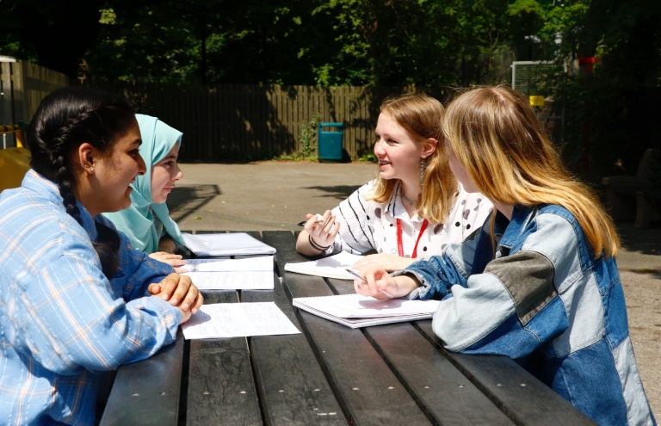

Job Description
Counsellor

Duties & Responsibilities:

The College looks to appoint a warm and confident Counsellor. The successful applicant will join a very friendly, hardworking and dedicated team supporting each other at all times. Applicants should be comfortable within such a team, but equally at ease using their own initiative to solve problems that come their way.

Role-specific responsibilities:

- To provide confidential counselling service to students
- To work under the supervision of the lead counsellor to establish and develop initiatives to support students.
- To adhere to the College system of recording and note-keeping.
- To provide data and regular updates to the Lead Counsellor outlining themes and issues of counselling.
- To liaise with the Lead Counsellor, personal tutors and other staff.
- To help develop College resources.
- To help promote the counselling service in a positive manner.
- To look at ways to develop the service and make it accessible for all students.
- To meet with the Lead Counsellor on a regular basis.
- To update skills through CPD.
- Any other duties as may be reasonably requested by the line manager to allow for the efficient running of the College without changing the general character or level of responsibility.

Safeguarding:

- All staff and senior postholders have a duty for safeguarding and promoting the welfare of children and young persons. Staff must be aware of the College’s procedures for raising concerns about children's welfare and must report any concerns to the Designated Person without delay. Staff must also ensure they attend the appropriate level of safeguarding children training identified by the College as relevant to their role.

General duties - the post holder will also:

- Promote, act as a role model and implement the College’s policies, practices and procedures including those relating to diversity and inclusion.
- Take reasonable care of the health and safety of self, other persons and resources whilst at work. This entails supporting the college’s responsibilities under the Health and Safety at Work Act.
- Demonstrate day to day commitment to the College’s core values of community and mission statement.
- Carry out such reasonable additional duties as may from time to time be determined by or on behalf of the Corporation.

Diversity and inclusion Statement:

The College will seek to ensure that all existing and potential employees and students are given equal opportunities for employment and education. It is committed to the elimination of unlawful or unfair discrimination on the grounds of sex, age, marital status, colour, race, nationality or other ethnic or national origin, disability, sexual orientation, trade union membership or activity and religious background.

The College will seek to ensure that no applicant for employment or education is disadvantaged by conditions or requirements which cannot be justified. The College provides an open, welcoming and safe environment for all its students, employees and visitors.

Safeguarding Statement:

The College is committed to safeguarding and promoting the welfare of children, young people and vulnerable adults, and expects all staff to share this commitment.

Prevent Statement:

The successful applicant will be required to uphold the values of democracy, rule of law, individual liberty and tolerance and have mutual respect for those with different faiths and beliefs.

Simon Lett
Principal

Counsellor

Closing Date:

The closing date for applications is 12 April 2024 at noon and interviews will take place shortly after.

Applicants for this post are asked to:

- Complete the College’s application form or TES application form and Equality and Diversity form.
- Write a supporting letter of application, with CV if you consider it useful.
- Write an explanation of your theoretical approach and how this works in practice (500 words max, font size 12, single space).

Please send the completed documents to:

Jen Rothery, HR and Recruitment Manager, as an email attachment to jobs@greenhead.ac.uk

Safer Recruitment:

Greenhead College is committed to safeguarding the welfare of all of its students and staff. The successful candidate will have to meet the requirements of the person specification in order to be offered the post and will be subject to safer recruitment checks. This position is working in regulated activity and therefore exempt from the Rehabilitation of Offenders Act 1974. Applicants will be required to self-disclose particular criminal convictions should they be shortlisted for interview. Further details can be found within the DBS filtering guide at https://www.gov.uk/government/publications/dbs-filtering-guidance

All offers of employment are subject to the following pre-employment checks:

- Two satisfactory references
- Enhanced DBS check with barred check list
- Overseas check if you have lived or worked abroad within the last five years
- Evidence of the right to work in the UK
- Prohibition check order
- Qualifications
- Fitness for Work

If you apply and are unsuccessful in being called to interview, can we thank you in advance for your time and trouble in making this application. Due to time constraints it would be impossible to respond to everyone individually - we hope that you will understand.

In line with KCSIE 2023 guidance, all shortlisted candidates will be subject to an online search.

The college is committed to Diversity and Inclusion and welcomes applications from all sections of the community.


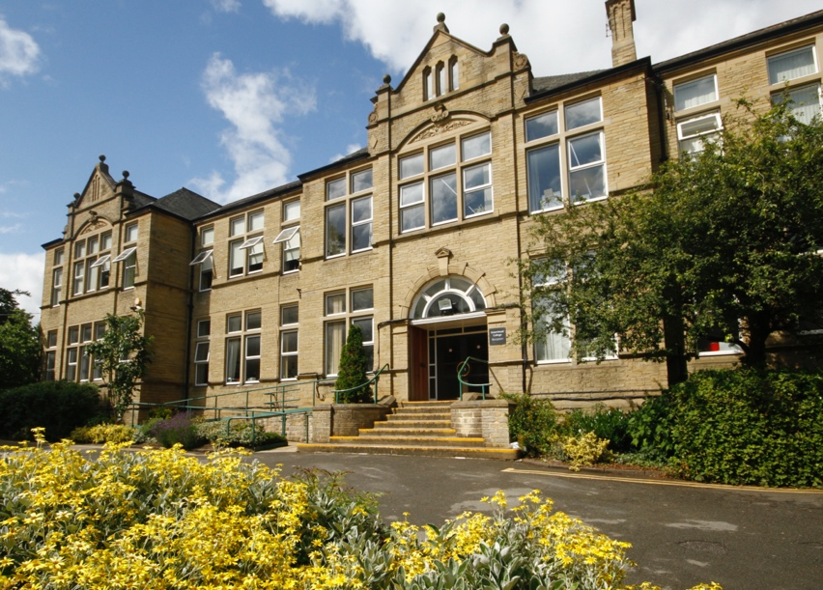


Person Specification – Counsellor

 | Essential | Desirable
QUALIFICATIONS:
Good standard of Education with a Diploma in Counselling | x
Member of BACP or equivalent | x
Accreditation with BACP |  | x

 | Essential | Desirable
KNOWLEDGE / UNDERSTANDING:
Knowledge of current Safeguarding and Child Protection legislation and procedures | x
Ann understanding of neurodivergent affirmative practice | x
Working with diversity | x

 | Essential | Desirable
EXPERIENCE:
Practical experience of counselling young people | x
Experience of both short and longer term counselling | x
Experience of counselling in an educational environment | x
Demonstratable post qualification experience | x
Practical experience of managing confidentiality, boundaries and risk. | x
Evidence of managing a case load of 5 clients per day | x
Experience of working with a range of presentations. E.g. Risk, mental health issues, neurodiversity, quiet clients etc. (Please note, this list is not exhaustive) | x
Experience of liaising with other College staff whose role it is to support those students |  | x

 | Essential | Desirable
SKILLS / ABILITIES:
Ability to work as part of a team | x
To be responsive to the needs of the students, underpinned by a solid theoretical approach | x
Positive, warm and empathetic with an understanding of the needs of the age | x
Excellent organisational skills | x
To have a good awareness of developmental and life stage issues, e.g. transgender issues, trauma, neurodiversity, bereavement, break ups etc. This list is not exhaustive | x
Excellent time management skills | x
Ability to engage with this age group and build a therapeutic alliance | x

Essential | Desirable

ATTRIBUTES
Courteous, positive, and can-do approach | ×
A commitment to quality | ×
A willingness to be flexible | x
A proven commitment to safeguarding and promoting the welfare of young people | x
A proven commitment to diversity and inclusion and an understanding of the College’s policies | x
Positive and professional approach with a high level of commitment to the College | x

The above criteria will be assessed by the: Letter of Application, Interview & Assessments.

