

Useful Information for Candidates

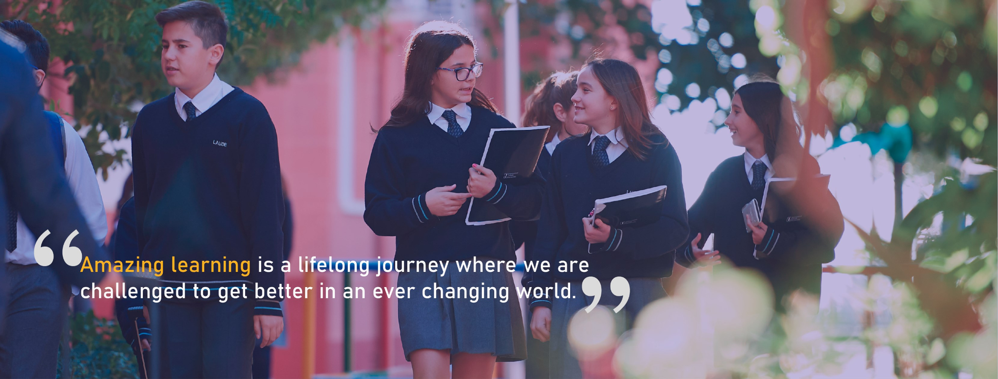

Teacher: LSA Primary

Welcome to our school…

At Newton College, amazing learning is a life-long journey where we are challenged to get better in an ever-changing world.

Since its foundation, Newton College has been a mixed, innovative, international school offering bilingual education (English – Spanish). It offers the British curriculum in Early Years and Primary education (authorised member of the National Association of British Schools in Spain and International Primary Curriculum centre). The school is also a member of the prestigious International Baccalaureate Organization (I.B.O), and besides the requirements of the Spanish Educational System, we teach their Middle Years Programme in Secondary education and the Baccalaureate Diploma Programme.
Newton College has its own, very special work environment. Besides the excellent English and Spanish language programme, it teaches Valencian from Year 2, and German or French from Year 7. Our students will acquire a multilingual education that will enable them to express themselves in any international, multi-cultural environment.

Newton College is not just another school. All the work carried out by the community (students, teaching staff and families) in these years has made it possible to consolidate our position as a pace-setting educational centre. This benchmark covers academic standards, where the quality of our work is firmly established, but also other aspects that contribute to the comprehensive education of our students.

- We offer our students a comprehensive education.
- We inspire each and every one of our students to develop a passion for learning.
- We provide quality education with personalised attention, based on our founding principles of respect and hard work.
- We contribute to the preparation of global citizens, with a sense of responsibility and integrity. We are thinkers, good communicators and very internationally minded.
- We inspire excellence, stimulate learning and creativity, and teach our students to discover the infinite paths to their educational and professional future, in an increasingly demanding world.
Furthermore:

- We value individuality, encouraging the personal growth of each of our students.
- We work to ensure that each child realises their full potential.
- Our students have access to a broad range of university courses as preparation for a successful professional career, whether in Spain or abroad.
- The education we provide is complemented by solid grounding in values in every subject and at every stage.
- Our open and friendly approach reflects the way we engage with others. We are proud of the strong personal links created across our educational community.

A great place to work and learn…

Newton College is a big school, with a big heart.

At Newton College we believe that our teaching team is our most valuable resource.

We are focused upon attracting, selecting and developing the best from across the world. This is why we offer a competitive salary that goes beyond the national scale (el convenio) and which is reviewed regularly.

We offer permanent contracts (after a standard probationary period) which run over the full 12 month year, unlike many local schools. Our commitment to your personal development and the preparation of great lessons means that a standard teaching timetable is far less than in other schools in Spain (see below for details). We also provide supplementary non/contact time for those with additional responsibilities.

Beyond this, we offer all teachers up to two free school places for your children (excluding some additional costs, such as school lunches, school uniform and some resources) and work with you to ensure that your move into the area goes smoothly. We offer the dedicated support of our Human Resources team to advise and support you through the administrative and personal arrangements that you and your family will need to undertake. We also offer free lunches and refreshments during the day. The school also provides other additional benefits, which we are happy to detail during the selection process.

We pride ourselves in offering new staff an induction and settlement support, which stands out in the region and nationally.

The School Day...

Secondary and Sixth Form

The Newton College Secondary school operates a 8 x 50 minute daily timetable with lessons starting at 9.00 a.m and finishing at 5.00p.m. (9.00 a.m. to 3.00 p.m. in September and June). There is a mid-morning break of 20 minutes (12:00 a.m. - 12:20 p.m.) and Lunch from 14.20 p.m. to 15.20 p.m.

Primary

The Newton College Primary School operates 7 x 50 minute lessons, from October to May- the day begins at 9.00 a.m. and finishes at 5.00 p.m. In September and June the school operates 6 x 50 minute lessons therefore, the daily timetable is 9.00 p.m. - 3.00 p.m.

The final session from October to June is extracurricular activities, however the class teacher must be present for the end of the day routines.

There is a morning break of 25 minutes from 10.40 a.m. - 11.05 a.m. and two lunch breaks each of 50 minutes - KS1 12.45 - 13.35 and KS2 13.35 - 14.25.

In Primary, we have specialist teachers for P.E, Music, Drama and Computing as well as
support teachers for languages, mathematics and additional learning needs. We have
specialist language teachers for Lengua, Ciencias Sociales and Valencian.
During these lessons, class teachers have their planning and preparation time.

KS1 has full time learning support assistants in each class.

We also have a variety of specialist rooms including a radio station, music room , computing room and primary kitchen.

Early Years

In Early Years the school day also begins at 9:00 a.m. and finishes at 17:00 p.m. from October to May and 9:00 a.m. - 15:00 p.m. in September and June.

Similarly to Primary, the final session in Reception from October to June is extracurricular activities, however the class teacher must be present for the end of the day routines.

There is a morning break of 25 minutes from 10.40 a.m. - 11.05 a.m. and a 1 hour lunch break.

In Early Years, we have specialist teachers for P.E, Music and Spanish as well as full time learning support assistants in each class. During these lessons, class teachers have their planning and preparation time. Teaching staff are given an additional time where they can meet as a team to organise planning, which is shared equally between the team.

The Early Years building ‘Wonderland’ was completed in August 2018. It provides an exciting and stimulating learning environment for our pupils. The building includes a range of carefully designed learning spaces, including large flexible learning spaces, a rooftop learning space, a slide from one floor to the next and its own dining area, as well as a large multi-purpose room for P.E., assemblies and performances.

All of our school stages have access to our school's NuCLEus area.
NuCLEuS Stands for…. Newton Centre for Learning and Educational Support.
The NuCLEuS is the heart of the school, serving and uniting the whole school community in our joint venture of Amazing Learning.



The Position…

Teacher in Primary

Do you want to develop your teaching career in one of the best schools in Spain?

In our ever growing school, we are currently looking to recruit teachers assistants for Primary. The successful candidate must have recent experience of the English National Curriculum. We follow the English National curriculum and International Early Years and Primary Curriculum from Nursery 1 up to Year 6.

For more information about our school please visit our website on www.laudenewtoncollege.com

If you have the experience and are confident that you can lead great learning in this role at Newton College, please you can apply through this link: https://careers.internationalschoolspartnership.com/jobs/13541353-lsa-primary-permanent-contract and if you have some questions, you can contact
Mrs. Sofia Sierra (HR Manager) at s.sierra@laudenewtoncollege.com who will be willing to help you.

CLOSING DATE: 31/11/2023

Newton College is committed to safeguarding and promoting the welfare of children and young people and expects all staff to share this commitment. Successful applicants will be expected to have undertaken an Enhanced Disclosure via the DBS process and/or local police checks.


Person Specification..
When considering applications for the above post, we will use the criteria below to inform decisions about short listing candidates for interview. Applicants should show how they meet the person specification in their application/supporting statement.

Essential | Source
Qualified Teacher Status (or pending QTS outcome) or qualification relevant to the stage | Application/Certificate
Degree appropriate to post | Application/Certificate
EYFS/Primary/Secondary-trained | Application
Knowledge of UK National Curriculum or MYP/IB | Application/Interview
Evidence of good/broad subject knowledge | Application /Interview/ Reference
Ability to teach across the full age and ability range | Application /Interview/ Reference
Confident about using data to improve levels of achievement | Application /Interview/ Reference
Recent experience in a EYFS/Primary/Secondary school/ Sixth Form | Application /Interview/ Reference
Commitment towards the learning culture at LNC | Application /Interview
Enthusiasm for teaching, learning and the achievement of every student | Application /Interview
Highly effective classroom teacher who has a good rapport with students of all abilities | Interview/ Reference
High professional standards | Reference/Interview
Good personal and interpersonal skills | Reference/Interview
Good oral and written communication | Application/Interview
Good time-management and personal organisation | Application/Reference
Commitment to continued personal and professional development | Application/Interview
Evidence from current practice of commitment to excellent attendance and punctuality | Post-Appointment Reference

Desirable | Source
Evidence of using a solution focused approach to adapt positively to change | Application/Interview/Reference
Ability to speak some Spanish | Application/Interview/Reference
Google educator trained | Application
A willingness to participate in the extracurricular life of the school | Application /Interview/ Reference
Experience of teaching International Programmes | Application/Interview/Reference

For more details about us
(or to talk through any initial questions)…
Please see our school website (www.laudenewtoncollege.com ) or Facebook page (Search: Laude Newton College)

You can also speak directly to…

Sarah Moran (EYFS posts) s.moran@laudenewtoncollege.com Francine Turner (Primary posts) f.turner@laudenewtoncollege.com Abbie Nuttall (Secondary posts) a.nuttall@laudenewtoncollege.com
Francisco Beltrán (Sixth Form post) f.beltran@laudenewtoncollege.com
Sofia Sierra (HR lead) s.sierra@laudenewtoncollege.com

School telephone number (+34 966 61 02 38)
