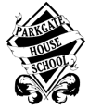
PARKGATE HOUSE SCHOOL
INFORMATION FOR APPLICANTS FOR POSITION OF
PRE-PREP TEACHER

Parkgate House School is a well-established independent co-educational preparatory school with specialist teachers, a rich curriculum and a reputation for equipping children for success at many of the country’s leading senior schools. With only 200 pupils across the Nursery, Pre-Prep and Preparatory years, we take pride in getting to know every child just that little bit better.

Parkgate House School
80 Clapham Common Northside
London
SW4 9SD
Admissions: +44 (0)20 7350 2461
School Office: +44 (0)20 7350 2452
Email: admissions@parkgate-school.co.uk
Email: office@parkgate-school.co.uk

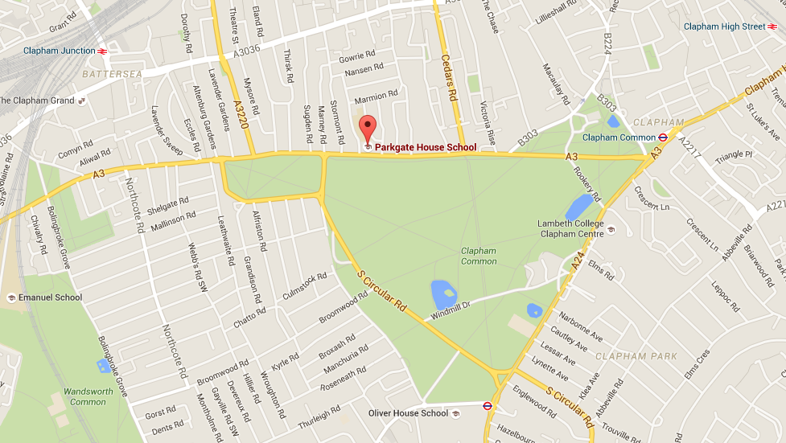

HISTORY AND ETHOS

Established in 1987, we have built our name on combining a warm, welcoming and caring atmosphere with small class sizes for children aged 2½ to 11 years.

Our strong, educational ethos is based upon providing teaching that caters to each child individually and empowers and encourages all children to think for themselves and achieve outstanding results.

We provide specialist teaching in all subjects, a wide range of clubs and activities, and have even created our own programme to ensure that homework is a positive experience.
With a rich curriculum, a fabulous outreach programme, a range of sporting activities, as well as opportunities for music, dance, ballet – and even horse riding, we aim to provide everything that a parent could want from their child’s education.

MISSION STATEMENT
In order to learn, children must be happy and feel secure in their environment. Parkgate House School is full of happy children. We are committed to providing a warm, welcoming and nurturing atmosphere with a strong educational ethos. Each pupil's self-esteem is fostered by positive relationships with pupils and staff. We are proud of our academic reputation as well as the opportunities we provide for each child to achieve across the whole curriculum.
We are passionate about helping to develop children's confidence and resilience and to raise their self-esteem. Nothing does this more than success across the full range of school activities; this is why sport, art, music, karate, ballet and drama are all as important as the pursuit of academic excellence. We provide opportunities for children to achieve success in all areas of the curriculum and we always celebrate their achievements.
We recognise that all children have talents, and every child is encouraged to realise their true potential, whatever that may be,in whatever area of school life. We demand and set high standards, and our children respond by always giving their best. At Parkgate House School we take pride in creating confident highly able young citizens who are eager to make their mark on the world.
Put simply, our mission is to: Develop Confidence - Provide opportunity - Realise Potential - in every single child.

MONTESSORI NURSERY

Montessori Nursery, 2½ - 4 years “Secure and happy, our Nursery puts in place the foundations for future success.”

Our Montessori Nursery isn’t simply a happy, safe environment, where children learn through activity; they are allowed to develop at their own pace and are made to feel confident and able to achieve.

Through the use of specialist teachers, subjects such as French, music, art, ballet and drama are gently and carefully brought to life.

Following the Early Years’ national curriculum for the foundation years, each day includes a wide range of activities to help develop each child’s physical, cognitive and social skills.

The building blocks necessary for future successes in reading, writing and number work are established and simple, fun activities develop coordination and fine motor skills.

Class projects, plays, nature walks, educational visits and workshops by artists and musicians are used to enrich the learning process. We also begin each child’s discovery into the world of science, art, craft, music and play, and early computer skills are introduced. There is also the opportunity to join after-school clubs in sport, French and drama.

PRE-PREPARATORY SCHOOL, 4 - 7 YEARS

“Every subject is brought to life to give children the best possible understanding.”
Our specialist teachers and broad curriculum play an increasingly important role as children progress through the Pre-Prep years.
Nurturing children for who they are, learning takes place in extremely happy, enthusiastic and energetic small class sizes, where each child is helped to achieve his or her full potential.
Pre-Prep school life begins by introducing children to the basic skills required for successful learning and focuses on creating enquiring minds.
With an emphasis on English, mathematics and science, the Pre-Prep curriculum also includes: French, humanities, ICT, ballet, drama, karate, swimming, music and sport.
Violin is taught to all children during the Reception year. Individual music lessons are available for piano, guitar, violin and singing.
Clapham Common provides a perfect venue for outdoor sports and a full sports programme takes place at Latchmere Leisure Centre.
PREPARATORY SCHOOL, 7 - 11 YEARS

“James’s academic scholarship to Dulwich College is not only due to the preparation for the examinations, but also a reflection of your belief and commitment to him.”
It is a testimony to our approach and commitment to involve parents at each stage of their child’s education that Parkgate House pupils typically go on to succeed at some of the country’s premier independent schools.
Creating well-rounded, highly capable individuals, our Preparatory environment encourages all pupils to flourish, enjoy school and have lots of fun along the way.
Promoting self-confidence and independence in a happy, stimulating environment, our curriculum includes mathematics, English, science, humanities, French, Latin, various sporting activities, ballet, karate, horse riding and swimming.
To keep learning fresh and engaging, a different curriculum focus is embarked upon every year.
To help each child secure a place at the senior school most suited to his or her skills, we provide a full programme of support activities in preparation for entrance examinations.

PASTORAL CARE

Carefully planned ‘Personal, Social and Health Education’ (PSHE) lessons are an
important part of helping children grow up to become responsible, respectful and morally-aware young adults.
At Parkgate House, our PSHE classes have the following main objectives:

- To teach the facts relating to health issues elemental to development and growth
- To help children understand the concepts of tolerance, respect and liberty
- To enable children to acquire skills relating to personal safety, discussion and decision-making
- To encourage children to develop informed opinions and attitudes about a range of personal, social and moral issues
- To nurture values based on our ‘Virtues Programme’, which instils principles key to the school community

CONDITIONS OF SERVICE / STAFF BENEFITS

This is a full time post commencing 1st September 2021. Lunch is provided free of charge. Parkgate offers a generous salary scale; salary will be commensurate with the importance of this appointment and will reflect qualifications and experience. The school also runs a staff pension scheme; the school shall contribute an amount equal to 4% of your salary in to your pension, and you shall contribute a minimum amount of 5% of your salary, to the pension scheme.

We offer lots of opportunities for teachers to move their practice forward, working in a collaborative and supportive environment. We use Joint Practice Development (JPD) in many ways at Parkgate House and teachers are regularly involved in peer observations, lesson study and learning walks at the school and can choose to be part of our Teacher Learning Community, where we look at many of the latest developments in education. We want to prepare our staff for moving forward in their career and as such teachers are provided with the opportunity to train for future roles through our Leadership Training Programme. The emphasis for our teaching staff is on continuously developing and improving, both individually and collectively.

APPOINTMENTS

The school is committed to safeguarding and promoting the welfare of children and questions will be asked at interview to assess the suitability of candidates to work with our children. All appointments are subject to a satisfactory enhanced Disclosure and Barring Service (DBS) check (including a check against the Children’s Barred List), and other pre-employment screening including a check on the Secretary of State list of prohibited staff. This includes receipt of at least two references satisfactory to the school, medical fitness, qualifications check where relevant for the post, right to work in the UK and an identity check. Our policy on the employment of ex-offenders is available on request.

All appointments are made in accordance with our Equality policy and applicants should let us know of any special needs they may have.

RECRUITMENT PROCESS
A completed application outlining the extent to which you can demonstrate your ability to meet our requirements as set out in the person specification, and including details of two referees, one of which should be your most recent employer, should be sent to Parkgate House School, 80 Clapham Common Northside, London, SW4 9SD. Candidates should also complete the Criminal Declaration section of the application form. Electronic applications are accepted and should be emailed to office@parkgate-school.co.uk.

Applications will be considered on receipt and should arrive no later than 3.00pm on Friday 5th March.

Short Listed candidates will be contacted and invited to interview. The selection process will consist of an observed 30minute lesson an interview and a tour of the school.

Candidates who have not heard from the school by 15th March should presume they have not been successful in their application.

Candidates must provide original documents to confirm their identity at interview and bring proof of qualifications where relevant for the post.

