Chief Executive Officer
Information Pack
August/September 2019

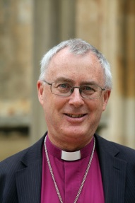

Dear Applicant,

Thank you for expressing interest in applying for this significant role. Since Sentamu Academy Learning Trust (SALT) was founded in 2015, the educational landscape has continued to evolve, providing both opportunity and challenge for our vision of schools which serve communities, nurture excellence and are authentically Christian.

Our Trust comprises five academies:

- Archbishop Sentamu Academy - an 11-19 Church of England “sponsored” academy
- St. James’ C of E primary academy
- Newland St. John’s C of E primary academy
- ASPIRE AP academy – a 150-strong provision which we opened under the Free School programme in 2014; and
- Compass AP academy, a 60 place 11-14 provision

The Church of England’s vision for Education, and our local expression of this across the breadth of the Diocese of York is both exciting and demanding. As a trust, we have a particular vision for, and commitment to, serving those young people most at risk of long-term multiple deprivation and social exclusion. Our ethos reflects this commitment, and we invest significantly to ensure that all young people in our care have the best possible chance to flourish and experience “life in all its fullness”. We are a “mixed MAT”, able to welcome academies without a formal church designation, and our plans for growth include AP academies and community schools, as well as C of E academies.

The Right Reverend Paul Ferguson

Bishop of Whitby & Chair of the Board of Education, Diocese of York

Dear Applicant,
Thank you for your interest in the post of CEO of SALT.

Following the retirement of our CEO, we are pleased to offer this post on a part-time (0.8 of FTE) basis commencing 1 January 2020. The successful candidate will be joining us at an exciting time of development.

You will see from our website that we currently have five academies in our trust, including primary, secondary and AP. Whilst three of these have been judged strongly “good” by OfSTED, two require improvement in two or more areas. A key goal for our new CEO will be to continue the drive to ensure that all our academies are judged at least “good”, and moving towards “outstanding”. Our Board of Trustees, which currently comprises six people from a variety of educational, financial and legal backgrounds, will fully support you in this. We are well aware that it is a challenging task!

Having led ASA, founded Aspire in 2014 and established the Trust in 2015, our current CEO is retiring after a long and distinguished career in education spanning 30 years. In addition to the work for SALT, he has also been part of a core group of local MAT CEOs who have successfully established Hull’s Learning Partnership, which brings together around 100 Headteachers across all phases. We are now looking for a CEO who can build on these successes, to lead SALT through its next phase of development.

We need someone who has an excellent track record of “achieving against the odds”, who has strong business acumen, and who excels in seeing and developing the potential in their teams. That person must be passionate about seeing all young people achieve, and have the resilience to cope with the additional rigours of working within a challenging urban environment.

Above all, we are looking to appoint someone committed to demonstrating their Christian faith in every aspect of the work they undertake in achieving these goals.

We realise that this post has a very high level of challenge, but we believe that the successful candidate will find it a highly rewarding experience. We look forward to receiving your application.

With every good wish,

Peter Duffield
Chair of the Board of Trustees

Vision, Values and Ethos
Our ambition as a Trust is that all our learners should experience “Life in all its fullness”. Of course this includes the aspiration that they will achieve outstanding educational outcomes – whether in primary or secondary school, or in alternative provision. However, our vision is broader and deeper than this. As a Trust, we want to see signs of the Kingdom of God growing in our young people, their families and their community, through:
- Freedom:
All our young people are to experience “Life in all its fullness” (John 10:10) – flourishing through the achievement of outstanding outcomes, including excellent exam results as well as successes in the areas of sports and the arts.
- Aspiration:
All our young people are to be given the tools and encouragement to move obstacles that appear insurmountable, to be the best they can be (Matthew 17:20). They will be resilient, use their talents and gifts to set ambitious goals for themselves, and develop strategies for achieving these.
- Inclusivity:
All are welcome, particularly those young people who are most marginalised and most at risk of exclusion (Isaiah 61 / Luke 4: 18-19). Our young people will be seen as welcoming, kind and accepting of others, recognising that we all have equal value, and that we have a duty to uphold and value each other.
- Transformation:
All our young people are to be SALT and LIGHT, becoming “the change they want to see” (Matthew 5: 3-16). Our young people will be characterised by their desire and willingness to serve others, finding practical ways of loving and forgiving each other, as we love and forgive ourselves.
- Hope:
All our young people are to know that they are loved and valued by God (1 John 4:10 & 19, Romans 8: 38-39, Luke 15: 11-32). They will have the assurance that this love is unconditional and available to all who wish to receive it.
We aim to achieve this vision as a trust by providing a supportive and accountable framework within which underperforming schools can convert as sponsored academies, and within which stronger schools becoming academies can lead the drive for all academies within the MAT to become outstanding. The focus will be on working in partnership, with a rigorous but collegiate approach to support and challenge that raises the bar for school leaders, staff and governors. The MAT will be fully inclusive and will include both community schools and Church of England schools.

Chief Executive Officer – Job Profile
Reporting to: Board of Trustees
Fixed Salary: FTE £110,000 to £120,000 depending on experience (actual salary between £88,000 to £96,000 for 0.8)
Part-time: to work four days per week
Holiday entitlement: 34.4 days leave (FTE 43, including bank and public holidays) to coincide with periods of academy closure and public holidays.

Job Purpose
To lead the Christian education vision for the Sentamu Academy Learning Trust and ensure the effectiveness of its delivery, enabling it to be the MAT of choice for all its stakeholders through the delivery of outstanding leadership, teaching excellence and sustained growth.

Job Description
Main responsibilities:
- To support the Board in the development and implementation of its vision, and the delivery of its strategic plan;
- To promote the distinctive Christian ethos of the Trust, in both its Church of England academies, and those without a formal Church of England designation;
- Through inspirational leadership, create a culture of constant improvement through knowledge sharing, collaboration, partnership and teamwork with the aim that all academies move to “outstanding” over time in all areas of their operation, including learner outcomes;
- To take responsibility for the delivery of the annual business plan, and the self-evaluation and improvement plans of all SALT’s academies;
- To ensure that the Board and its committees receive the required information to take informed and timely decisions within the regulatory framework;
- To ensure robust and appropriate risk mitigation and management with the Trust Board;
- Develop and maintain effective relationships with the Diocesan Board of Education, Regional Schools Commissioner (RSC), Department for Education (DfE), Education and Skills Finding Agency (ESFA), and local authorities within the area covered by SALT;
- To represent SALT on Hull’s recently-formed Learning Partnership
- Work with local communities to foster constructive relationships to create further opportunities for growth and local support for each academy;
- To be the Accounting Officer with direct responsibility to the Secretary of State for proper use of public monies.

Leadership and Management:
- To provide motivational and inspirational leadership at all levels of the organisation;
- To ensure that the Trust’s organisational structure is fit for purpose in a rapidly changing environment;
- Provide support and advice to the Chair of the Trust Board in his/her role of leading and supporting the committee Chairs;
- Provide professional leadership to the Chairs of Local Governing Committees;
- As a professional advisor to the MAT Chairs’ group, ensure that best practice is shared and communication is effective;
- To hold the Principals to account for the effective leadership of their academies, and their outcomes including line managing the Principal and leading the MAT Heads’ groups;
- To act as a mentor to the Principals across all academies, supporting and challenging them in their roles through the provision of advice and guidance and the development of their leadership skills;
- To ensure that Principals have appropriate support for the development of Christian distinctiveness in SALT academies;
- To ensure that there are quality assurance systems embedded across the Trust that drive consistency and improve performance;
- To take responsibility for effective data management, ensuring that systems are in place to capture, analyse and act upon the information;
- To create and develop Trust-wide policies and systems that encourage standardisation and effective shared practice;
- To develop a communication and marketing strategy to guide the Trust and its staff in their communications, both internally and externally, liaising with stakeholders, local and national media and social media.
Teaching and Learning:
- Provide dynamic and strategic direction and leadership for high quality teaching, learning and standards across all academies;
- To be accountable for all aspects of teaching, learning and standards across the Trust, setting high professional standards and ensuring that the education vision is understood and fully embraced;
- To be responsible for developing and leading the process for improvement across the Trust, providing quality assurance and accountability; using a rigorous and robust system of target setting as the basis for progress reports to the Trust Board and to ensure the best possible outcomes for learners;
Resources
- As the Accounting officer for the Trust, to act in accordance with the guidance published in the ESFA Academes Financial Handbook;
- To be the Line Manager for the Chief Finance Officer;
- To be the Line-Manager the Director of Human Resources, ensuring that the Trust has a high quality personnel which advises effectively on recruitment and retention, pay and conditions or service, staff performance, staff welfare and training and development;
- Guarantee financial sustainability by ensuring that financial management systems are in place and effectively monitored, and that issues are identified and acted upon at the appropriate level;
- Ensure there is a soundly based budget for each academy submitted in a timely way to the Audit Committee for recommendation to the Board;
- Establish systems to achieve value for money with service providers and economies of scale in accordance with the ESFA Academies Financial Handbook and statutory procurement regulations;
- Develop a strong and productive relationship with the DfE, ESFA and relevant funding bodies to ensure funding streams are secured and funding opportunities realised;
- Develop and implement strategies for additional revenue income and resources for the Trust;
- Hold each academy to account ensuring that the learning environment, resources and facilities are best used;
- Put in place and resource an ICT strategy and programme for the Trust.
Compliance:
- Ensure the Trust operates within the legislative and regulatory framework, meeting its statutory responsibilities including safeguarding, health and safety and the requirements of Companies’ house, the Charity Commission, GDPR regulations and the ESFA.
Accountable for:
- The outcomes of all academies within the MAT;
- The performance of Principals across all academies within the MAT;
- The performance of the Chief Financial Officer;
- The performance of the Director of Human Resources.

Person Specification

ESSENTIAL | DESIRABLE
Qualifications
Degree or equivalent | Recognised professional / Masters/ NPQEL qualification relevant to this role
Professional Development
A record of recent and relevant continuing  professional development | Experience of leading professional development
Experience
Successful headship or a significant leadership role  within a MAT, LA or other educational environment | Successful CEO or Board experience in a MAT  environment
Relevant portfolio of highly effective educational  improvement within a challenging urban context. | Relevant portfolio of driving high standards of pupil  achievement / attainment.  Senior leadership experience at Secondary, Primary and/or Alternative provision schools.
Practical evidence of developing and maintaining highly effective relationships with a wide range of stakeholders | A successful track record of human and financial resources management  Experience of working with other educational agencies (e.g. RSC, DfE, EFA)
Practical evidence of the effective development,  leadership and management of staff | Evidence of developing and supporting people into Headship
Practical evidence of strategic planning and review of progress against plans in terms of standards, performance and  finances, taking decisive action when necessary | Managing growth in pupil numbers  Leading a school out of an OfSTED category of concern  Managing a whole institution’s budget
Knowledge
Comprehensive knowledge and understanding of the schools’ OfSTED and SIAMS inspection criteria and processes | OfSTED Inspector trained  SIAMS Inspector trained  Knowledge and experience of working with RAISE online, ASP, IDSR, FFT and other national data sets
Awareness of current educational developments and their implications | Awareness of Company and Charity Law as it relates to academies
A thorough knowledge of safeguarding and other
critical health and safety issues
Knowledge of relevant policies, legislation and codes of practice across education
Evidence of having worked with corporate governance structures | Evidence of ability to apply principles contained in the Academies Financial Handbook
Skills
Ability to lead, motivate and manage change
Excellent and adaptable communication and interpersonal skills and an approachable style of leadership | Evidence of ability to work successfully with a range of external stakeholders including consultations with employee representatives
Ability to articulate a clear vision across SALT and to a variety of audiences
Other
A practising Christian* with a commitment to Church schools | Communicant member of a Church
Demonstrable commitment to equality and diversity in both service provision and employment practices
Flexible, approachable and resilient under pressure
Ability and commitment to work collaboratively as part of a team of highly skilled educational professionals

SALT Governance Structure
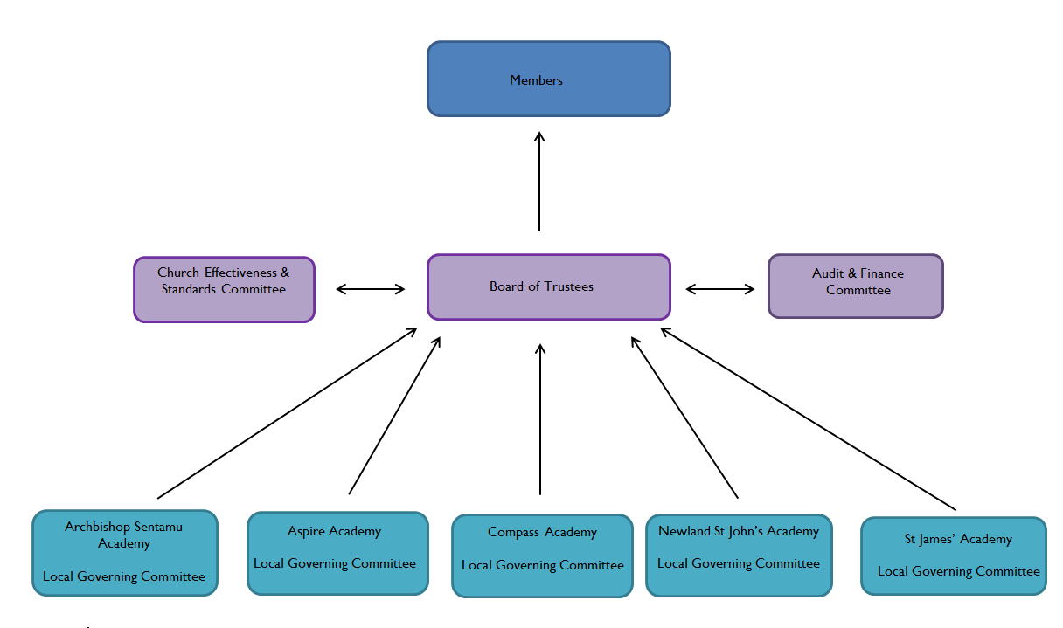
Members agree the Articles of Association, and have power to appoint and remove the auditors and the majority of Directors.
The Board of Trustees drive the vision, ethos and strategic direction. Committees of the Board have delegated responsibilities.

Recognising the historic foundation of the Trust, the Church Effectiveness and Standards Committee has a three-fold focus:

To scrutinise the academic standards and outcomes of all academies within the Trust, irrespective of whether they have a Church designation or not, reporting on their findings to the main Trust Board;

To ensure that the Church schools in SALT will continue to preserve and develop their Christian character and distinctiveness, in accordance with the principles of the Church of England and in partnership with the Church at parish and diocesan level. This will ensure schools meet and exceed the expectations of the Church of England National Board for Education and the Methodist Church and meet their statutory duty under Section 48 of the Education Act 2005. These terms will ensure that this aspect of school performance is closely monitored over time; and
- To ensure that the ethos of academies in the MAT without a religious designation supports the overall Christian ethos of the MAT.

The Audit Committee has a collective responsibility to:
- Ensure compliance with the accounting requirements of the DFE, ESFA and HM Treasury;
- Discuss, review and approve with the external auditors the nature, scope and audit plan for the annual audit, including co-ordination of audit effort with internal audit and to ensure that the external auditors have the fullest co-operation of staff;
- Review, discuss and approve the external auditors’ Management Letter and Audit Findings documents;
- Discuss, review and approve with the internal auditor the nature, scope and audit plan for the annual programme of work, including co-ordination of audit effort with external audit where appropriate and to ensure that the internal auditor has the fullest co-operation of staff;
- Review the effectiveness of SALT’s internal control and risk management systems to ensure they meet best practice standards as identified by the external/internal auditors, and the ESFA;
- Review the proposed consolidated budget for the Trust, to analyse, challenge and if necessary, request additional information or revisions before recommending the budget to the Board for approval.

Local Governing Committees have delegated authority to ensure educational progression and compliance with SALT policies and procedures. Local Governing Committees are specifically focused on the:
- Standard and quality of education in the academy;
- Welfare of the students at the academy;
- Relationship between the academy and the local community.
Performance Management of the CEO is conducted by members of the Trust Board, including the Chair.

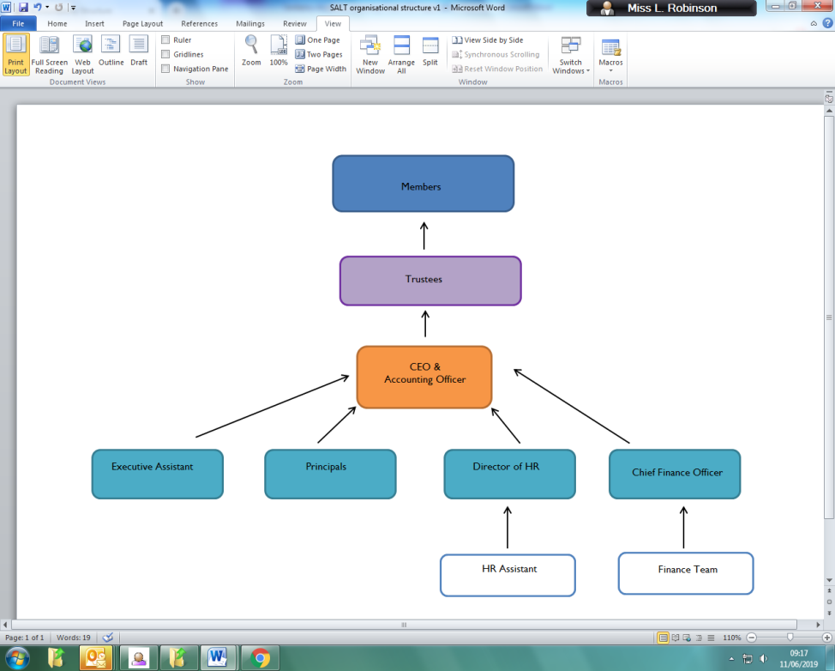
Organisational chart

Background
The Sentamu Academy Learning Trust was created in February 2015 and comprises:
- Archbishop Sentamu Academy – Secondary Mainstream Church of England Academy (joined 1 February 2015);
- Aspire Academy – 10-16 Alternative Provision Academy (joined 1 February 2015);
- Newland St John’s Church of England Academy - Primary Mainstream Academy (joined 1 February 2015);
- St James’ Church of England Academy – Primary Mainstream Academy (joined 1 February 2015);
- The Compass Academy – Key Stage 3 Pupil Referral Unit (joined 1 March 2019).
We are a mixed Multi Academy Trust comprising academies that were previously foundation, community and voluntary controlled Church schools. SALT’s prime aim is to ensure that all pupils in its academies receive an outstanding education, that they might experience life in all its fullness. It will have a particular focus for serving those pupils who are most at risk of long-term social exclusion.
The Trust receives £16M of grant funding and is responsible for 1632 secondary aged students and 489 primary pupils. We employ 327 (FTE) teaching and support staff.

Additional Information
The role is to work four days per week with seven weeks annual leave. A competitive salary between the range of £88,000 - £96,000 (FTE £110,000 – 120,000) plus appropriate contributory pension scheme, will be offered to the successful candidate according to their experience. Relocation costs may also be considered.

How to apply
Candidates are requested to submit a completed application form, along with their CV and a letter of application no more than two sides of A4 (minimum 10 point font) outlining how they would lead the Trust through the next phase of its development, and why they are the right person to do this.
All applications will be acknowledged within 48 hours, should you fail to receive a confirmation please call 01482 781912 and ask for Laura Fillingham.
Application Closing date: 12noon on Thursday 19 September 2019
If you have any queries about this application process please email: salt@sentamuacademy.org
Confidential discussion regarding the role
For a confidential discussion about this role please contact the Chair of the Board, Peter Duffield on 07785 254215or email: peterduffield@smailesgoldie.co.uk
Shortlisting/interviews
Shortlisting is scheduled to take place on Friday 20 September 2019. Interviews will take place on Thursday 26 and Friday 27 September 2019 at Archbishop Sentamu Academy, 1 Bilton Grove, Hull HU9 5YB.
Safeguarding and equal opportunities
The Trust is committed to safeguarding and promoting the welfare of children. We expect all staff to share this commitment and to act with integrity and honesty at all times. The successful candidate will be required to have an enhanced Disclosure and Barring Service (BDS) check and all relevant employment checks.
We are committed to equal opportunities in employment and education. The policies and practices of the Trust aim to promote an environment that is free from all forms of unlawful or unfair discrimination and values the diversity of all people. At the heart of our policy, we seek to treat people fairly and with dignity and respect.
*It is a genuine occupational requirement, in accordance with the Equality Act 2010, that the post holder is a practicing Christian and we would expect our CEO to adhere to our Christian values.
Thank you for your consideration

