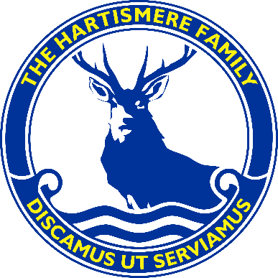
Hartismere Family of Schools

Person Specification: Expected Personal Qualities

- a consistent track record of getting along well with work colleagues of all types, parents from all backgrounds and children of all ability levels

- a flexible, hard-working attitude

- a cheerful and positive disposition

- a tendency not to be overly critical of others

- someone who dresses in smart business-like clothes and avoids ‘dressing down’

- someone who takes their work seriously without being overly sensitive or taking themselves too seriously

- being easy to approach if help is required or if correction or support is needed

- being willing and interested in further training and education

- being willing to do more humble tasks as well as those with a higher status

- having a genuine commitment to supporting extra-curricular and curriculum enrichment activities for children

- believing in the absolute value of education

- having a commitment to developing personal expertise rather than ‘knowing’ how others should do their job

- being committed to children in disadvantaged groups and particularly to those least well off financially

- holding the view that accomplishing valuable work as part of a team with less personal recognition is better than accomplishing on a purely individual level

- treating all nationalities, religious groups, those from wide ranging political persuasions, differing genders and sexualities and racial groups with respect, fairness and dignity

