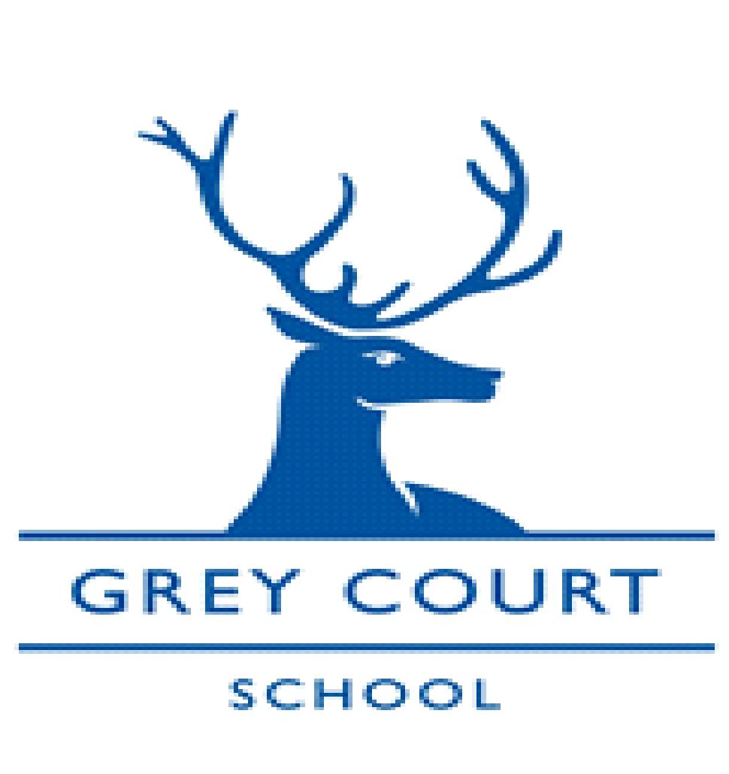

Science Lab Technician
January 2022 start

- Part-time 36 hours per week - 39 weeks (term time, some out of hours working may be required)
- NJC Scale 4 pt range 7- 10 (£22,992 – £24,256 pro rata)
- No holiday may be taken during term time

Grey Court is a successful and oversubscribed academy serving a diverse community in an outstanding environment, situated in the London Borough of Richmond and in very close proximity to the beautiful River Thames.

Graded Outstanding by OFSTED (for the second time) in January 2018, the school opened its sixth form in September 2014, with our cohorts of Year 13 students achieving continuously exceptional results in the first 3 years. In 2016 we became part of the Every Child, Every Day Multi Academy Trust and consequently, have further developed extremely strong working relationships with our partner schools. We are very excited about the future and the opportunities the MAT has brought to staff and students alike.

We are looking to appoint a full time lab technician to help with the smooth running of a very successful science department. You will be working alongside three other very supportive technicians.

Being an experienced technician is desirable, but not essential. It is more important that applicants have excellent interpersonal skills and enjoy working as part of a team. The successful candidate will be confident in preparing materials for science lessons and ensure a foundation of excellence for the science faculty. Candidates should have an enthusiastic attitude and a natural ability to use their initiative whilst being committed to the Every Child, Every Day academy trust.

If you want to join our vibrant team and have a willingness to contribute to the success of our young people, we look forward to hearing from you. Please go to our website to find the application form.

Closing Date: Friday 10th December 2021

Interview Date: w/b 13th December 2021

The Governing and Trust Bodies are committed to safeguarding and promoting the welfare of all our children and expect all staff to share this commitment. Any offer of employment will be subject to receipt of a satisfactory Disclosure and Barring Service check.

The schools within the Trust are committed to all aspects of personal development, are inclusive and seek to ensure every student achieves to the best of their ability.

For more information about Grey Court School, Job Descriptions and Application Forms please go to the school website or call 020 8948 1173. For an informal discussion please contact Ms Amy Moran, Head of Science on 020 8948 1173 ext 407 or email amoran@greycourt.org.uk

