

**APPLICATION PACK**



**FOR**

**TEACHER**



**TEACHER**

We are seeking to appoint a committed and enthusiastic teacher for our Specialist Resource Centre (the Ocean) and PPA cover. Candidates must have the vision, skills, abilities and focus to further raise standards, achievement and aspirations for our pupils at Furzefield Primary School. This is an exciting opportunity for an outstanding teacher who wishes to be part of a dedicated, friendly and supportive team.

Our Specialist Resource Centre offers places to children from Reception to Year Six who have a moderate learning difficulty and would benefit from the opportunity to access the resource centre in addition to some integrated mainstream provision.

The successful applicant will;

* Be an effective class teacher who is committed to teamwork and striving for high levels of achievement;
* Have good communication skills and the ability to inspire and motivate pupils and colleagues;
* Have the enthusiasm and commitment to make a positive impact on pupils' progression, personal development and learning ;
* Have experience of working with pupils with special educational needs

Furzefield is a vibrant community school in Merstham, Surrey, providing education for pupils aged 3-11 years and in November 2012 we achieved a Good Ofsted grading. We offer a creative curriculum, including Forest School, pupils who are eager to learn and staff who are friendly, supportive and committed to continuing development.

Furzefield Primary School is committed to safeguarding and promoting the welfare of children and young people and expects all staff and volunteers to share this commitment. As such this post is subject to a satisfactory Enhanced DBS check and references.

This is a fixed term appointment, from 1st January 2018 until 31st August 2018 initially. The appointment will be paid on the Main Pay Scale (£24,018 - £34,934), or Upper Pay Range (£37,017 - £39,725), with an SEN Allowance.

More information on the Ocean specialist centre can be found on the school website: [www.furzefield.surrey.sch.uk](http://www.furzefield.surrey.sch.uk). Please contact the school for a tour.

For further information and application pack, please contact the School Business Manager, Sharon Morgan on 01737 642842 or email: [sbm@furzefield.surrey.sch.uk](mailto:sbm@furzefield.surrey.sch.uk).

**Closing date: 20th November 2017 at 1pm**

**Shortlisting: 20th November 2017 (after 2pm)**

**Interviews: Friday 24th November 2017**

**ABOUT OUR SCHOOL**

Furzefield Primary School is a Community primary school that caters for children aged 3 to 11.

Our Specialist Centre for children with learning and Additional Needs (LAN) is called the Ocean Centre and can accommodate up to 14 pupils from Reception age to Year 6. In addition to their learning needs, children may also have speech or language needs, medical, physical or sensory needs, social or emotional needs, and some children may have a diagnosis of Autism or ADHD. Places at the centre are considered by the LAN admissions forum.

Each learner has access to the National Curriculum which is highly differentiated to take account of particular needs and modified to provide a personalised approach. Individual Support Plans (ISPs) have targets to support each child at their stage of learning. We promote a calm and positive environment where every child is valued and every step in learning celebrated. Our staff team know the children very well and adapt arrangements to maximize learning. We work closely with parents and carers.

Each child belongs to a mainstream class. They work in the centre in the mornings and integrate into mainstream in the afternoons, where appropriate, with support. The children in centre benefit from attending their classes and regular social interaction with their mainstream peers. Withdrawal to access additional specialist support may be required in order to successfully achieve their educational outcomes.

Through the additional support available in the Specialist Centre, children will gain strategies to develop increasing independence in line with their personal development.

We have good access to the building and facilities for disabled users, including two flat-bed lifts and several ramps to allow wheelchair access to the majority of the school. We utilise specialist equipment, including Occupational Therapy resources. We work closely with professional agencies such as Physical and Sensory Support Services, Occupational Therapy, Surrey County Council’s Moving and Handling Advisor, Physiotherapists and Speech and Language Therapists, monitoring and advising on provision for our learners.

In May 2009 The Red Oak Sure Start Children’s Centre opened on site and offers a range of advice, information and support to the local community along with a flexible day nursery, Shining Stars, for children aged 3-5.

Our school is well equipped with the latest technology, interactive whiteboards, large playing fields, wildlife garden, pond, outdoor classroom, library and music room.

Furzefield Primary School serves its community by providing an education of the highest quality within the context and understanding of shared values. We recognise and respect diversity, fostering positive attitudes and relationships, and a shared sense of cohesion and belonging.

The school had an Ofsted inspection in 2012 was judged Good.

“Teaching and learning are good across the school and some teaching in Key Stage 2 is outstanding.”

Ofsted 2012

“The Headteacher, senior leaders and governing body provide effective leadership and have ambitious plans to further improve the school.” Ofsted 2012



“The school provides a safe environment in which to learn. Pupils say they feel safe and well looked after.”

Ofsted 2012

“Pupils behave well in class and are respectful and caring towards each other around the school.” Ofsted 2012

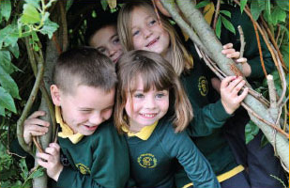

"Pupils are keen and enthusiastic to attend school and show positive attitudes both to each other and to their learning. They enjoy their lessons and behave well in and around school"  
Ofsted 2012

We expect the best from all our pupils and ourselves. By providing a broad, balanced and exciting curriculum for all our children, we are able to recognise and develop individual talents and interests, instilling a love of learning that our children will enjoy throughout their lives.   
  
Learning is fun and interactive and children are well supported to reach their personal targets. The key skills we teach encourage children to become lifelong learners and caring, sensitive citizens of the future.

We endeavour to provide a happy, safe and caring environment in which children feel secure and valued. Our school has achieved the Quality Mark, Learning Outside the Classroom Silver Award, numerous Sports Awards and Unicef’s RRS Bronze Award. We promote regular physical activity as part of the curriculum and through a range of after school clubs, as well as offering pupils the chance to join ‘Children’s University’. We promote healthy eating and offer delicious, nutritious meals cooked on site.

At Furzefield we run a Forest Schools program which encourages and inspires children to develop and learn through positive outdoor experiences.



“This school has come on an accelerated journey particularly since the arrival of the new Headteacher last September.”   
Quality Mark Assessor July 2011

**2017 KS2 Progress in Reading, Writing & Maths**

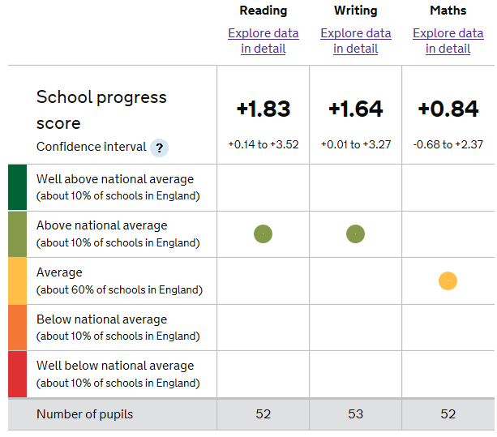

**OUR VISION­­­­­­ & OUR AIMS­­­­**

Here at Furzefield, our children develop their own self-worth in a climate of trust and happiness. Everyone is challenged to recognise and reach their full potential in order to become confident and valuable members of the local and global community.



• Make learning an enjoyable and valuable experience  
• Promote positive, active partnerships with all members of our school community   
• Provide equal opportunities for all children to develop their talents   
• Encourage social, cultural, moral and spiritual development preparing pupils to be sensitive and caring citizens   
• Celebrate diversity, acknowledging and learning from different cultures and heritage, both within and beyond the school community

“I like my school because I have nice friends. I like my teacher because she is very clever.”

Pupil

“The teachers are funny and talented. That's why my life at Furzefield has been brilliant.”

Pupil

“Furzefield is the best because of all the residentials and the teachers…

I love Furzefield School.”

Pupil

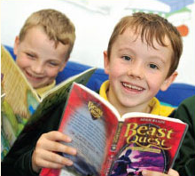

“My child is really enjoying her time in reception.”

Parent

“My daughter has enjoyed her journey through Furzefield.”

Parent

“I like Furzefield because there are lovely teachers and fun lessons.”

Pupil

“Furzefield is the best I've ever been to. My favourite lesson is PE and making stories. When we go on school trips it is brilliant.”   
Pupil

**JOB DESCRIPTION­­­­­­­­­­**

The Key Tasks are listed under each accountability heading. The same Key

Accountability headings have been used as they appear in the National Standards for Head teachers and Subject Leaders. The **Induction Standards** for NQTs have been used to create the key tasks.

A. Strategic Direction and Development

To contribute to the discussion of the school’s aims and policies and participate in the implementation of policies, plans, targets and practices.

Key Tasks

A1 take responsibility for implementing school policies and practices;

A2 plan and assess pupil’s learning using knowledge of school policies, schemes of work and National Curriculum requirements for the relevant curriculum areas.

1. Teaching and Learning

To secure and sustain effective teaching of the relevant subjects for individuals, groups and classes. Develop the quality of teaching, assess the standards of pupil’s achievements and set targets for improvement.

Key Tasks

B1 use school policy and National Curriculum requirements to set clear targets for improvement of pupils’ achievement and monitor pupil’s progress towards those targets.

B2 use appropriate teaching and learning strategies to communicate clear learning objectives and expectations including, where appropriate in relation to: literacy, numeracy and other school targets;

B3 recognise the level that a pupil is achieving and make accurate assessments, independently, against attainment targets, where applicable, and performance levels associated with other tests or qualifications relevant to the subject(s) or phase(s) taught;

B4 plan effectively to ensure that pupils have the opportunity to meet their potential, notwithstanding differences of race and gender, and taking account of the needs of pupils who are: underachieving, very able, not yet fluent in English; making use of relevant information and specialist help where available;

B5 plan effectively, where applicable, to meet the needs of pupils with Special Educational Needs and, in collaboration with the SENCO, make an appropriate contribution to the preparation, implementation, monitoring and review of Individual Education Plans;

B6 take appropriate account of ethnic and cultural diversity to enrich the curriculum and raise achievement

C. Managing and Working with People

To lead, manage and work collaboratively with pupils and, as appropriate, with other adults and colleagues.

Key Tasks

C1 secure a good standard of pupil behaviour in the classroom through establishing appropriate rules and high expectations of discipline which pupils respect, acting to pre-empt and deal with inappropriate behaviour in the context of the behaviour policy of the school;

C2 where applicable, deploy other adults effectively in the classroom, involving them, where appropriate, in the planning and management of pupils’ learning;

C3 work as a member of a team, planning co-operatively, sharing information, ideas and expertise;

C4 liaise effectively with pupils’ parents/carers through informative oral and written reports on pupils’ progress and achievements, discussing appropriate targets and encouraging them to support their children’s learning, behaviour and progress

C5 take responsibility for own professional development, setting objectives for improvements, and take action to keep up-to-date with research and developments in pedagogy and in the subject(s) taught.

D. Deployment of staff and resources

To develop, monitor and control resources within the teaching area.

Key Tasks

D1 organise and maintain a stimulating working environment appropriate for a range of activities;

D2 teach pupils to take responsibility for resources and the environment;

D3 ensure that resources are organised and readily available to promote a purposeful environment for teaching and learning to take place.

**CONTACT DETAILS**

**Headteacher:** Mrs Susan Chrysanthou

**School Business Manager:** Mrs Sharon Morgan

Furzefield Primary School

Delabole Road, Merstham, Redhill, Surrey RH1 3PA

Tel: 01737 642842 Fax: 01737 645201 Email: enquiries@furzefield.surrey.sch.uk

www.furzefield.surrey.sch.uk

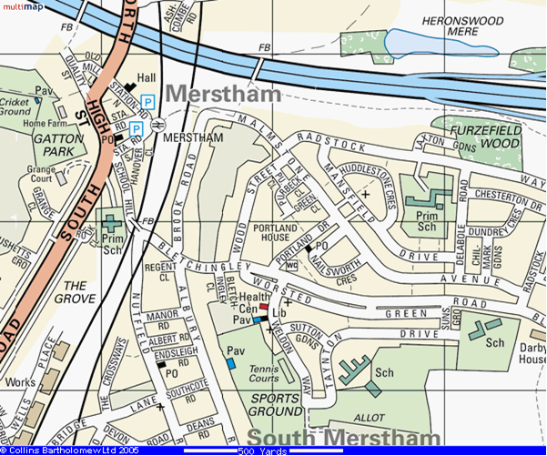

WE ARE HERE

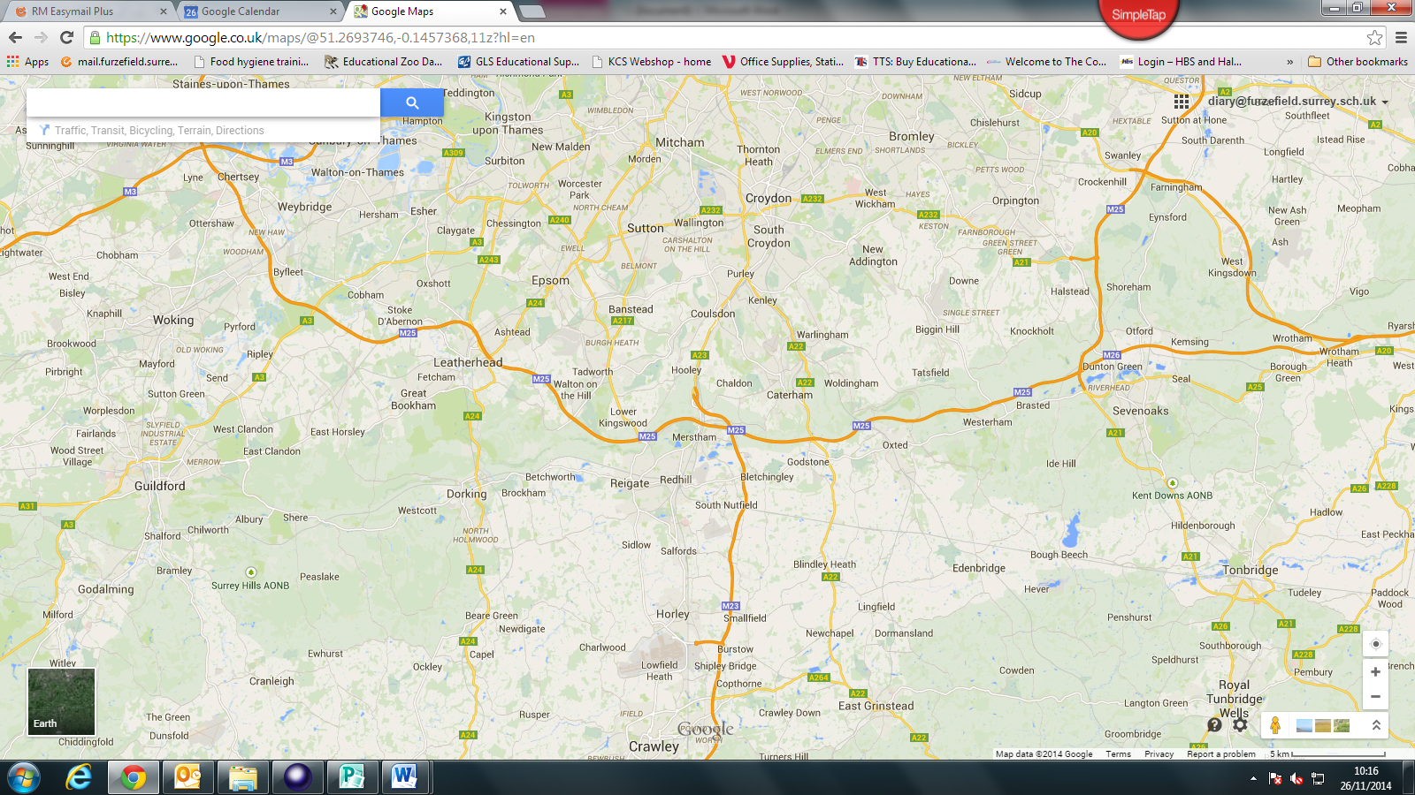

**WE LOOK**

**FORWARD TO**

**SEEING YOU**