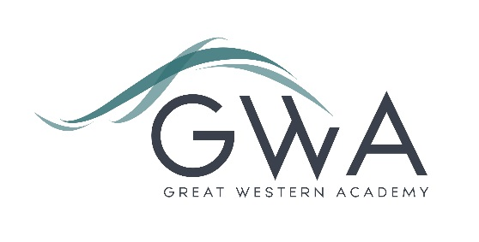

Information for Applicants

Academy Business Manager
An applicant’s briefing pack with full information about Great Western Academy and the role is available on the GWA website at www.gwacademy.co.uk/school-information/vacancies
Application process

Please complete the application form supplied and enclose a supporting letter, either in the space provided on the application form or as a separate document. The application form should be completed in full in black ink or type. A CV is not required and should not be submitted as part of the application.

Your supporting letter should be no more than 2 sides of A4 (with a font size no smaller than 11) and should enhance your application by providing further information, matched to the person specification, about your suitability for this role. This should include evidence of relevant successes in leadership in your current and previous roles, and how you believe you can help establish Great Western Academy as an outstanding school from day one.

If you have any questions about the application process or about the role please contact Rebecca Mathis on 01793 732809 or email gwa.recruitment@newcollege.ac.uk .

Applications can be returned by post to:

Graham Davis
Principal, Great Western Academy
c/o New College
New College Drive
Swindon
SN3 1AH

Electronic applications will also be accepted via email to gwa.recruitment@newcollege.ac.uk
All applications will be acknowledged within 3 working days of receipt.

Closing Date: 4pm on Monday 29th January 2018
Interviews: Monday 5th February 2018

The interview process will include observation of a variety of short tasks and a panel interview.
Great Western Academy is committed to safeguarding and promoting the welfare of children, young people and vulnerable adults and we expect all staff to share this commitment and undergo appropriate checks. All posts within the Trust are therefore subject to an Enhanced DBS and barred list check.

References: References will be taken up prior to interview.

