“A place for everyone…to work and succeed!”

Welcome from the Principal Team
We live in exciting times – our great city of Liverpool is currently undergoing an amazing renaissance, with new jobs, investment and opportunities. We are proud to tell you that North Liverpool Academy is also undergoing its own renaissance. Our most recent Ofsted inspection has graded us as a ‘good’ school in all areas. Our exceptional academic results and reputation continue to confirm us as one or the fastest improving schools in Liverpool.
NLA lies at the heart of the local community. It is our task to prepare our young people for the exciting challenges and opportunities ahead. Our curriculum inspires a lifelong passion for learning and equips our students with the confidence and skills to take advantage of the tremendous opportunities on our doorstep and further afield.
Our ethos and core values are built around a culture of enjoyment and achievement. We believe that when joining our team as a student, parent, member of staff or a member of the local community, by embracing our values of high aspiration, transformational experience, community engagement and excellent achievement we will deliver outstanding educational outcomes for all.
We believe it is our job to ensure that our students take pride in all they do and graduate from North Liverpool Academy with the confidence to take on the competitive and ever-changing world around us. This is a truly exciting time for the North Liverpool Academy as we establish a world class academy with excellence for personal development, leadership, teaching and learning.
If you have any questions, would like a conversation or if you wish to come and see the outstanding work happening across our academy please feel free to contact us.
Emily Vernon Patrick Ottley-O’Connor
Interim Principal Executive Principal
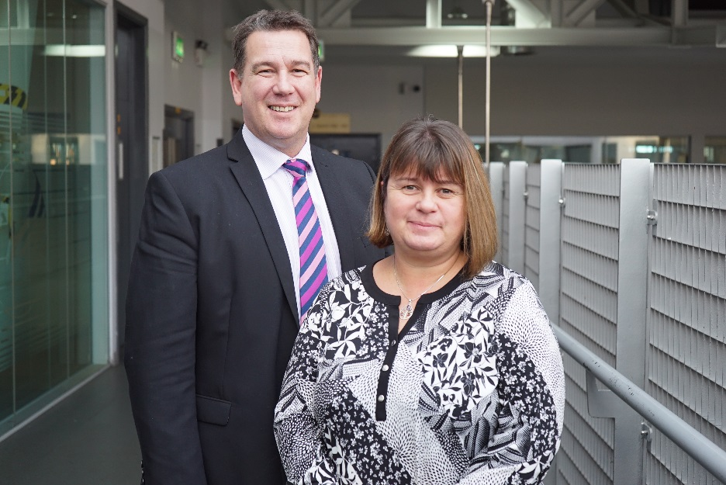
History of NLA

North Liverpool Academy opened in 2006 as one of the first Academies in the country and has benefitted from the various advantages that brings. The Academy is well resourced both in terms of facilities and staff. It is housed in a superbly equipped building, erected in 2009 and enjoys an excellent reputation within the local community.

The Trust

Northern School Trust is a not-for-profit education charity. It is a well-developed MAT (Multi-Academy Trust) held in high regard by the DFE. There are currently four schools in the Trust including an innovative Studio School and a Life Sciences UTC in the centre of Liverpool and a UTC based in Wigan.

The Trust is proud of its collaborative way of working and is developing into a nationally recognised and trusted academy sponsor with an excellent reputation. The Trust has a wide range of expertise and specialised experience to call upon, having access to the FE, University, private and voluntary sectors as well as partner schools and consultant expertise drawn from across the UK.

The Trust has a central team that provides best value and an efficient service delivery in areas of HR, Finance, Enterprise & Marketing, Governance, Strategic ICT Development, Data and Facilities Management to all NST schools.

Latest Ofsted

North Liverpool Academy’s recent Ofsted inspection rated the school officially as a Good School, along with the improving trend in academic results confirms the school as one of the most improved in Liverpool.

Ofsted recognised the significant improvements and achievements made as well as the aspirational ambition of the academy. The inspectors praised the “highly effective leadership, clear vision, high standards” and “strong ambition” and emphasised that “the schools is well placed to continue improving”.

Rated Good across the board, inspectors said that: “Pupils enjoy their learning and have positive relationships with one another and their teachers.”

“Pupils behave well in lessons and take pride in their work”

The report also praised the Sixth Form saying: “It is effectively led and consequently has improved since the last inspection. Outcomes are good because students are taught well. When they leave, an increasing number of students move on to University courses, further education, employment and training” showing a sustained picture of improvement.

Latest results
Key Stage 4
2018 Exam Results – Invalidated
Attainment
- Our Attainment 8 score is 41.4
- 59.5% of pupils achieved a 4 or above in one of the English GCSEs
- 51.8% of pupils achieved a 4 or above in GCSE Maths and in one of the English GCSEs
- 30.4% of pupils achieved a 5 or above in GCSE Maths and GCSE English
- 58.9% of pupils gained a grade 4 or above in GCSE Maths
Progress
- Our Progress 8 score is -0.16
- Our Maths Progress 8 score is -0.04
- Our English Progress 8 score is -0.63
Destinations
96% of students from this cohort have continued to be in education or training, or move on to employment at the end of 11 to 16 study
Key Stage 5
Value added by qualification category.
*Figures taken from SISRA Analytics and currently in-validated

*This is currently only available for A level and Applied General qualifications; this will be updated January 2018 when national data is released.
- The Progress Measure for A level results is -0.20
- The Progress Measure for Applied General qualifications is -0.56
Average grade by qualification category
*Figures taken from SISRA Analytics and currently in-validated
- The average grade that students achieve in A level qualifications is D+
- The average grade that students achieve in Vocational qualifications is Distinction-
- The average grade that students achieve in Applied General qualifications is Distinction-
- The average grade that students achieve in Technical level qualifications is D-
Progress in English and Maths (from Key Stage 4)
*Figures taken from SISRA Analytics and currently in-validated
- The Progress measure for English Level 2 qualification is 1.06
- The Progress measure for Maths Level 2 qualification is 0.06
Retention
- 86% of students in Year 12 2016/17 have progressed to Year 13 in 2017/18

Key stage 5 destinations
- 75.6% of students in Year 13 in 2017/18 now attend university or college
- 12.8% of students in Year 13 in 2017/18 are now in full-time employment
- 5.1% of students in Year 13 in 2017/18 are now in an Apprenticeship
- 93.5% of students continue in education or training, or move on to employment at the end of 16 to 19 study

Key stage 4 destinations
*This data is in-validated at present, and will be updated on publication of the September Guarantee
For the academic year 2017/18, 92.1% of students continue in education or training, or move on to employment at the end of 11 to 16 study

Charter Mark & Achievements
- Flagship Inclusion Mark
- Leadership Academy Award
- Sainsbury’s School Sports Mark Gold
- Career Connect Quality Awards
- Healthy Schools Award
Our Amazing Facilities:
North Liverpool Academy moved into a purpose built state of the art building in September 2009 and has the following outstanding facilities to name a few:
- 7 Technology classrooms
- 13 state of the art Science classrooms which are fully supported by 2 full-time Science Technicians
- Outstanding Drama Theatre which includes movable walls and bleacher seating to accommodate 220
- High quality dance studio with 2 designated teaching spaces
- Music practice and performance rooms
- Designated sixth form provision with LRC, classrooms and space for study or research
- Library
- ICT facilities including banks of I-Pads, Chromebooks and laptops
- Multi-purpose media suite
- Teaching & learning hub
- Sports hall and fully equipped Gym and Fitness Centre
- Full size Astro pitch
- On site Scoot 66 Scooter supplies shop
- Secure car parking with spaces for up to 140 cars
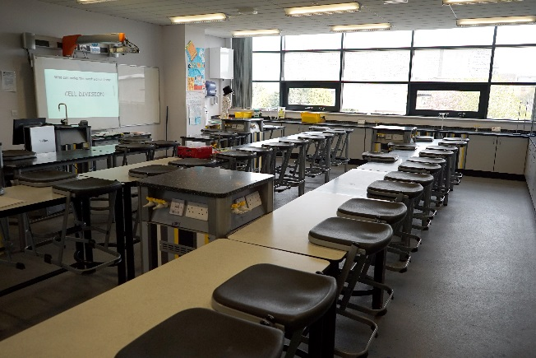

So why choose North Liverpool Academy?
All Staff
- Excellent opportunities for advancement & promotion
- Bespoke training as part of our talent management programme and online accredited CPD courses
- Well lead and managed teams
- Inclusive induction programme
- Designated reprographics support & ICT helpdesk
- Pay related benefits such as Childcare vouchers and Cycle to Work scheme
- Proactive approach to mental health and wellbeing including a supportive HR Department who can provide access to wellbeing services such as Counselling & Occupation Health
- Free on-site secure parking
- Free access to Fitness suite
- Complementary tea & coffee facilities
- Duke of Edinburgh
- Extended opening hours to promote a better quality of work/life balance
Teachers
- Fast track UPS/Leadership progression
- Main scale teachers have a minimum 15% timetabled PPA time
- Training and support for middle or emerging leaders and access to NPQML/SL programmes
- Comprehensive NQT/School Direct/Teach First programme
- Paid Development post opportunities
Support Staff
- 35 days paid annual leave
- Support for staff wishing to progress into teaching through School Direct
- Membership into the local Government pension scheme, where we as employers pay an additional 11% of contributions
- Time off in lieu when available
- Non contractual discretionary leave during school closure periods

The Science Department
The Department consists of 13 full time and 1 part time teachers with a range of experience and levels of responsibility both within the department and across the Academy. The department is fortunate to have a Resident Scientist, Professor Dave Hornby from Sheffield University who works closely with the science team to develop an innovative approach to the science curriculum, as well as delivering specialist teaching at Post-16 level as North Liverpool Academy strives to support its students to develop into the Scientists of the future.
“Science sits at the heart of everything we do. Every element of our lives is impacted by the rapid developments and real World application of science. The Science team at North Liverpool Academy are passionate about developing and delivering an innovative curriculum that will prepare our students to be successful, well informed citizens within an every changing World.
The city of Liverpool is fortunate to be the home of some of the leading lights in the world of science. At North Liverpool Academy, we have developed a wide range of industry partners that work closely with our team to ensure that our students get to experience the real life application of science beyond the classroom. We strive to raise the aspirations of our students by encouraging them to consider a career in science, technology, engineering or mathematics and to apply the skills of scientific enquiry to their everyday lives.
We are committed to recruiting teachers who share the enthusiasm of the team and are excited by the uncertainty that is created by the daily developments in the scientific world. As we continue to develop as one of the leading educational providers within Liverpool we are determined to add to our team of practitioners to ensure science education remains at the cutting edge of developments”
Kelly Howes Assistant Principal

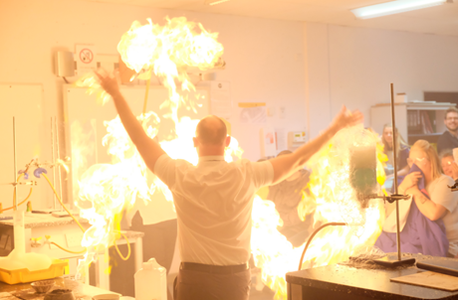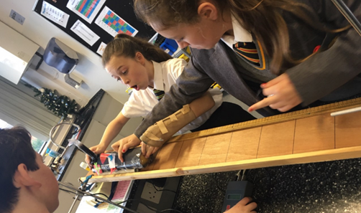

Curriculum
Our team of experienced, specialist science teachers have designed an inspiring programme of study to deliver the Key Stage 3 National Curriculum to allow students to master the fundamental knowledge, understanding and skills needed for GCSE-level success. This programme has been developed by incorporating the AQA schemes into a theme based approach to enthuse and challenge pupils to learn and achieve in their first two years.
At key stage 4 we teach AQA separate science and trilogy dual award science. We have a 3 year key stage and this allows time to continue with the thematic approach as an introduction to GCSE in year 9 and the remainder of the curriculum time is used to complete the specification, required practicals and have revision built in to embed the knowledge . Our students are taught content through practical science where possible and have timetabled skills lessons to embed the necessary skills to become competent scientists at key stage 5.
Our key stage 5 curriculum consists of A-levels with AQA in Biology, Chemistry and Physics running alongside the Edexcel BTEC Applied Science course. Working within key stage is Professor David Hornby who is developing a scheme of extracurricular opportunities with both universities and industry to ensure our sixth form science scholars develop skills and experiences outside of the classroom environment.
Our team
Assistant Principal – Kelly Howes
College Leader – Steven McGhee
Subject Leader – Nicki O’Meara
KS5 Co-ordinator – Mark Blackham
KS4 Co-ordinator – Dee Cameron
KS3 Co-ordinator – Anne-Marie Binks
STEM co-ordinator – Graeme Erickson
Resident Scientist – Professor Dave Hornby
Science teachers
Laura King
Dave Wright
Abi Ognjanovic
Neil Hughes
Lena Wakil
Charlotte Bisset- Walsh
Science technicians
Rachel Bristow
Richard Molyneux

Staff profiles
Nicki O’Meara, Subject Leader of Science
“I joined the academy in 2008 as long term supply and have never left. I was permanently employed quickly after starting and successfully completed my NQT year with lots of support. During my NQT year I swiftly recognised the need to show students the importance of science in our everyday lives and the need to make science relevant and contextual was paramount. The enjoyment and progress made by students during practical lessons using the fantastic facilities and equipment available has made teaching science here a joy.
After completing my NQT year I was asked to be part of a teaching and learning development team that provided CPD for all staff to improve their teaching practice, this involved providing them with strategies to improve student engagement and attainment. After this recognition from SLT to join the team I applied for KS4 co-ordinator and was successful in this application.
While undertaking the role of KS4 co-ordinator I received extensive support and guidance that has both improved my teaching and my leadership skills. This led to a successful promotion to KS4 leader in Science and more recently following a successful application to a middle leaders training programme I have achieved a promoted post as head of department.
I have grown up at NLA and it has shaped me to be very successful in my career so far. I see a long future for our team by driving a successful department forward to become the leading science provider in the city. Every day is different at NLA and it is the challenges and triumphs that we as a group face that make us a family of science teachers striving to improve our professional development.”

Abi Ogjanovic, Teacher of Science UQT
“I only joined the Academy in 2018 and was originally employed as a Graduate Learning Support Assistant straight from University. My main role was to enable our students to not just learn science in the traditional ways but to be and think like scientists themselves. Our students are participating in experiments using equipment that I didn’t see until I went to University!
After a couple of months, my role evolved from a GLSA to an unqualified teacher working mainly with the Sixth Form biologists and chemists. Seeing the students’ progress and their genuine enjoyment of science and practical science in particular is immensely rewarding. With the support of the science leadership team and the science department as a whole, I have made massive progress in my own personal and professional development.
I am excited to do my teacher training here at the Academy next year with a timetable tailored to my strengths and professional development. The Academy has provided me with some amazing opportunities and I am looking forward to what the future holds.”
Mark Blackham, Lead Teacher of Physics
“I moved to NLA to work in a forward thinking vibrant environment. The school works to create a balance of academic and pastoral needs for each pupil through a system of regular assessment cycles coupled with thorough data analysis. The pastoral staff are always on hand to help our pupils with their emotional needs, making our learners some of the happiest I’ve taught in any of the four schools in which I have worked.
The science department is developing into a strong team and is led with drive, understanding and total commitment by our newly appointment head of department. Our team work tirelessly to ensure that no one in the department is left behind. All big tasks are shared and everyone is willing to give a helping hand if the need arises.
One of my favourite aspects to working within the NLA science department is the drive to ensure that our children are active and enquiring learners. Our schemes of work are devised to bring out passion and enthusiasm for Science via a range of real world links and frequent practical work. We aim to make sure the pupils are asking big questions about the topics they are studying.
I started at NLA in September 2018 and am the happiest I have ever been in terms of job satisfaction. NLA is a school which is willing to allow ideas to be tried.”

Job Description
Post Title: | TEACHER
Purpose: | - To contribute effectively to the work of the Academy and to the achievement of its mission.  - To facilitate and encourage a learning experience which provides students with the opportunity to achieve their individual potential.  - To contribute to the provision of an appropriately broad, balanced, relevant and differentiated curriculum for students.  - To actively safe guard and promote the welfare of students in the Academy
Reporting to: | Curriculum Leader.
Responsible for: | The provision of a full learning experience and support for students.
Liaising with: | Support staff other teachers other professionals
Salary/ Grade: | The appropriate point on the STPC scale for teachers.
MAIN (Core) DUTIES
Operational / Strategic Planning | - To contribute to the whole Academy's planning activities.  - To assist in the development of appropriate syllabuses, resources, schemes of work, marking policies and teaching strategies in the Curriculum Area.  - To plan and prepare courses and lessons.
Curriculum Provision | - To assist the Curriculum Leader to ensure that the curriculum area provides a range of courses which will complement the Academy’s strategic objectives.
Curriculum Development | - To assist in the process of curriculum development and change so as to ensure the continued relevance to the needs of students, examining and awarding bodies and the Academy's Mission and Strategic Objectives.
Staffing  Staff Development  Recruitment / Deployment of Staff | - To take part in the Academy's staff development programme by participating in arrangements for further training and professional development.  - To continue personal development in the relevant areas including subject knowledge and teaching methods.  - To participate in the Performance Management process.  - To work as a member of a designated team and to contribute positively to effective working relations within the Academy.
Quality Assurance | - To help to implement Academy quality procedures and to adhere to those.  - To contribute to the process of monitoring and evaluation of the curriculum area/department in line with agreed Academy procedures, including evaluation against quality standards and performance criteria. To seek/implement modification and improvement where required.  - To review from time to time methods of teaching and programmes of work.  - To take part, as may be required, in the review, development and management of activities relating to the curriculum, organisation and academic mentoring functions of the Academy.
Management Information and Administration | - To maintain appropriate records and to provide relevant accurate and up-to-date information for MIS.  - To complete the relevant documentation to assist in the tracking of students.
Communication | - To communicate and consult with the parents of students.  - Where appropriate, to communicate and co-operate with internal/external individuals and bodies as appropriate.  - To follow agreed policies for communications in the Academy.  - To show an active and personal commitment to safeguarding students by communication any issues that may arise
Marketing and Liaison | - To take part in marketing and liaison activities such as Open Evenings and liaison events with primary schools.  - To help with the interviewing of prospective students.  - To contribute to the development of effective subject links with external agencies.
Management of Resources | - To contribute to the process of the ordering and allocation of equipment and materials.  - To assist the Curriculum Leaders to identify resource needs and to contribute to the efficient/effective use of physical resources.  - To co-operate with other staff to ensure a sharing and effective usage of resources to the benefit of the Academy, department and the students.
Academic Mentoring System | - To promote a safe environment for all students as part of the safeguarding agenda  - To promote the general progress and well-being of individual students.  - To register students, accompany them to assemblies, encourage their full attendance at all lessons and their participation in other aspects of Academy life.  - To undertake regular personal review interviews with students to assist in evaluating their progress and development and in identifying and monitoring personal action plans.  - To evaluate and monitor the progress of students and keep up-to-date the individual student progress file and other records as may be required.  - To contribute to the preparation of Records of Achievement/ profiles and other reports, including the drafting of references.  - To alert the appropriate Curriculum Leader to problems experienced by students and to make recommendations as to how these may be resolved.  - Monitor course work and targets and report any falling off of performance  - Monitor merits rewards and sanctions and undertake appropriate actions  - To support the activities of the House and take part in events.  - To deliver the Academic mentoring programme.  - To contact the parents, via the Head of House curriculum leader or House manager to keep them informed of any difficulties and problems experienced.
Teaching | - To teach, according to their educational needs, including the setting and marking of work to be carried out by the student in the Academy and elsewhere.  - To assess, record and report on the attendance, progress, development and attainment of students and to keep such records as are required to provide, or contribute to, oral and written assessments, reports and references relating to individual students and groups of students.  - To undertake a designated programme of teaching.  - To ensure a high quality learning experience for students which meets internal and external quality standards.  - To prepare and update subject materials.  - To use a variety of delivery methods which will stimulate learning appropriate to student needs and demands of the syllabus.  - To make extensive use of the ICT facilities that are available to enhance teaching and learning.  - To contribute to the development of the materials on the VLE  - To maintain discipline in accordance with the Academy's procedures, and to encourage good practice with regard to punctuality, behaviour, standards of work and homework.  - To undertake assessment of students as requested by external examination bodies, departmental and Academy procedures.  - To mark, grade and give written/verbal feedback as required.  - To ensure that all cross curricular aspects such as Citizenship are delivered according to the academy’s plan and that these are assessed and recorded.
UPS 1,2,3 It is the role of post threshold teachers to support others younger in the profession to gain the necessary skills to pass through the threshold or to move higher in expertise. It is therefore expected that each member of staff will contribute towards the development of the practice of colleagues and be supportive of them so that that the base of knowledge is shared and our expertise as an academy grows. UPS 1,2 and 3 are deemed to be good and very good practitioners and the quality of their work should be always commensurate with that expectation

Enhanced DBS for all roles

OTHER SPECIFIC DUTIES
This job description is current at the date shown but, in consultation with you, may be changed by the Principal.

This Academy is committed to safeguarding and promoting the welfare of children and young people and expects all staff and volunteers to share this commitment.

Person Specification

TEACHER
QUALIFICATIONS
Essential
- Relevant professional qualifications - Degree level or equivalent
- Has up to date knowledge of relevant legislation and guidance in relation to working with, and the protection and safeguarding of children and young people
- Displays commitment to the protection and safeguarding of children and young people
- Teaching Certificate

SKILLS / KNOWLEDGE / QUALITIES

Teaching

To be a good very good or excellent teacher

Management of Learning
Essential
- Commitment to and ability to support the distinctive ethos of the Academy
- very good communication skills
- Planning and organisational skills
- Ability to relate well to staff, students and parents
- Values and respects the views and needs of children and young people
- Has good ICT skills which can be used in teaching for learning and good presentational skills
- Is resilient and demonstrates ability to work well under pressure. Manages time effectively
- Ability to be a fully integrated team member and be adaptable and flexible in approach to meet the needs and aspiration of the students.
- Is committed to personal and professional development. Is reflective and learns form past experiences.
- Is willing to work within the organisational procedures and processes to meet the required standards for the role
- Has problem solving analytical and negotiating skills

Curriculum
Essential
- Good understanding of the relevant curriculum area
- Willingness to keep up-to-date on issues concerning curriculum development
- Willingness to participate in the evaluation and monitoring of the relevant curriculum area(s) and quality assurance procedures
- Willingness to identify and implement action points for improvement
- Ability to maintain confidentiality where appropriate

Staff
Essential
- Willingness to participate in Personal Development Review and Staff Development procedures.
- Commitment to equality of opportunity and fair treatment for all staff and students.
- Appreciates the significance of safeguarding and interprets this accurately for all individual children and young people whatever their life circumstances
- Willingness to undertake training to complete individual training needs.
- Willingness to contribute to the design and delivery of staff development programmes.

The Academy is committed to the safeguarding of its students and the promotion of the welfare of children and young people and expects all staff and volunteers to share this commitment.

Liverpool and Mersey region
Whether you are a native to Merseyside or looking at relocating, it’s clear that Liverpool and Merseyside as a whole has a lot to offer. Being European Capital of Culture in 2008 it’s evident why.
Here in Liverpool, there is something for everyone to enjoy, whether it’s visiting one of the many museums for a spot of history and culture, to experiencing a taste of the orient – Liverpool has the biggest Chinese arch outside of mainland China!
Here are some other reasons to enjoy our City
- 2 amazing Cathedrals
- Amazing parks and gardens
- 2 top premier league football clubs – both of which are located within walking distance of the Academy
- House prices in the North West are far cheaper than anywhere else in the UK
- Excellent transport links
- Top tourist attractions
- Fantastic range of shopping, restaurants and nightlife

Why not visit www.visitliverpool.com to see why Liverpool is great!

