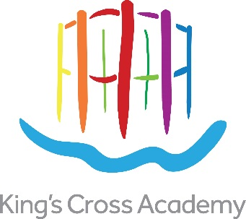
Recruitment Pack
Dear Applicant

Thank you for taking an interest in King’s Cross Academy. The Academy opened in September 2015, as part of an innovative education campus, collocated with Frank Barnes School for Deaf Children and in the heart of King’s Cross.

King’s Cross is an exceptional place: one that represents the best of Central London. New homes, offices and workplaces; shops, cafés and restaurants; higher educational institutions; leisure, social and community facilities are set around successful new streets and outstanding public spaces, framed by historic buildings and structures.

The Academy is located just to the west of Granary Square and along the historic Regent’s Cana in the new ‘Plimsoll Building’.

Every aspect of the Academy should be the best it can possibly be. We want to give our pupils the best possible education and the best learning opportunities to face the challenges of the 21st Century, so they leave us as highly successful learners with the aspiration to achieve even more in their future lives.

We intend to make use of Academy freedoms but also see ourselves as an active member of the Camden family of schools. In particular, we will draw upon the exceptional facilities we are creating at King’s Cross and our unique relationship with incoming occupiers such as Google UK to develop a first-class educational offer and enrichment programme.

We are enormously excited about the Academy and we have high expectations of everyone who works with us.

This is a unique, “once in a lifetime” opportunity for us all. We are looking for exceptional classroom teachers to share this excitement, work with us and help develop the Academy, to transform the lives of children and families in King’s Cross.

Kind Regards

Emyr Fairburn
Founding Headteacher

Introduction
King’s Cross Academy Trust is seeking outstanding teachers who share our ethos and passion for the role of education in transforming lives. We want to appoint individuals who care passionately about the children and the Academy; who work continually to do the best for them, who can get the best from colleagues and who are vehemently focussed on learning. We want exceptional teachers to transform the lives of those children who come to the Academy.

About the New King’s Cross Academy


The ongoing transformation of King’s Cross is one of the largest, most significant and successful urban development projects in the UK. This is a new, thriving and growing community, which includes 2,000 new homes, commercial and retail properties, higher educational and other education institutions, leisure and social amenities including 26 acres of open space. At the heart of this project, within the ‘Plimsoll
Building’, a unique education campus has been purpose designed. We see King’s Cross Academy as fundamental to the wider regeneration of King’s Cross, becoming a focal point for and delivering benefits to the whole community.

King’s Cross Academy is collocated with Frank Barnes School for Deaf Children, situated to the north of King’s Cross and St Pancras station, close to the Regent’s Canal and Camley Street Natural Park. The schools and an associated community meeting facility occupies the ground and first floors of a 15 storey building, with new homes (apartments) above, accessed by a separate entrance off Handyside Street.

The Academy has its own secure playground on site. It also has access to a new urban park within the re-erected Gas Holder No. 8, the symbol of the school, and to a multi-use games area in the adjacent building.

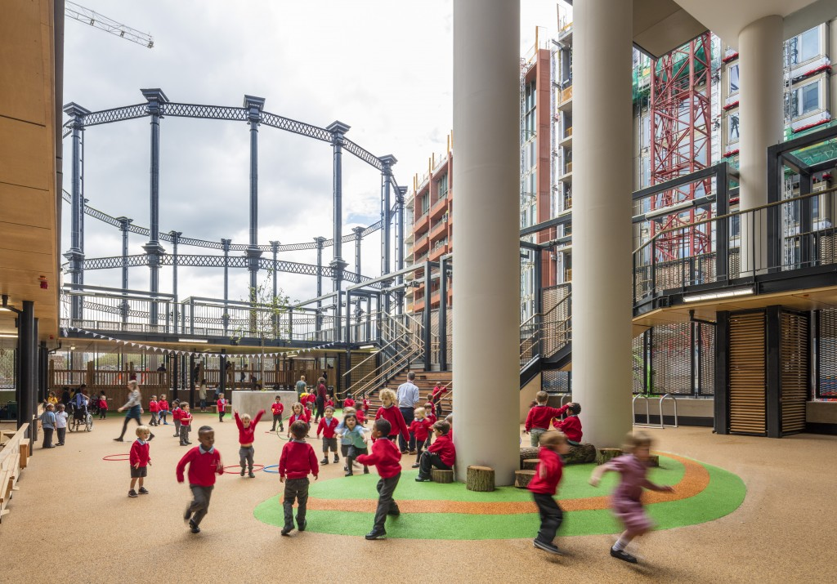
King’s Cross Academy opened in September 2015 as a 2 form entry (426 place) primary school with a 26 place nursery for 3-4 year olds. In 2015 the intake was restricted to the nursery and two Reception classes. The Academy has expanded each year and reached capacity this year with the opening of our first year 6 classes. The premises have been designed with shared spaces for staff training and collaborative development and for children from both schools to play together. The new schools’ community will celebrate bilingualism: English, British Sign Language (BSL) and other community languages. We will have a wonderful and cultural mix with all children feeling a deep sense of belonging in the schools.

King’s Cross Academy Trust

King’s Cross Academy is being sponsored by the King’s Cross Academy Trust. The King’s Cross Academy Trust is a new single Academy Trust formed by the King’s Cross Limited Partnership (KCCLP) and Michael and Clara Freeman. KCCLP is the developer responsible for the King’s Cross redevelopment, including The Plimsoll Building and the new school premises. KCCLP is chaired by Sir David Clementi, former Deputy Governor of the Bank of England and now a Member of the Academy Trust.

Our Chair of Governors, Robert Evans, is a Partner at Argent and is the CEO of the King’s Cross Development. He is also a Member of the Academy Trust. Robert has been playing a lead role in the King’s Cross project since 2001 and was responsible for drawing up the outline planning application. He was also responsible for commissioning the first design studies of co-locating the new Academy with Frank Barnes School for Deaf Children and has worked closely with their Headteacher and other local schools. He is a member of Camden Partnership for Educational Excellence (CPEE) Board.
Michael Freeman co-founded Argent. Clara Freeman, his wife, a former Executive Director of Marks and Spencer are both Members of the King’s Cross Academy Trust.

The overriding vision for King’s Cross is to create an exceptional area of London, one that presents a world-class offer to people who will choose to live, work, study or spend time here. It is an eclectic place: professional without being corporate, with many different kinds of activity successfully co-existing side by side: well integrated with the areas around it and designed to be sustainable for many decades. King’s Cross Academy lies at the heart of this new area.

Our Vision

The Trust’s vision is that King’s Cross Academy should be the best it can possibly be. Every pupil, every teacher, every helper, everyone involved with the Academy must have the best possible opportunities, the best possible experience while they are there and the best possible future prospects.

Our vision for King’s Cross Academy is for a school which keeps pace with our rapidly changing world, makes the most of this dynamic location within London as a World City and prepares children for both the opportunities and challenges that will face them in the 21st Century and beyond. We aim to create a school with an inclusive and respectful ethos that celebrates the richness and diversity of its location and population, while promoting high aspirations and high educational attainment, excellent behaviour and concern for others’ needs and sensitivities.

The challenge for everyone involved with the Academy will be to realise this vision and to give local children the best chances from the start. The Sponsors, Governors and Headteacher are excited at this amazing opportunity of opening a school in this fantastic location, and we want teachers who will work with the Headteacher and current staff on ensuring the future success of the Academy.

King’s Cross Academy’s Neighbours
King’s Cross Academy is uniquely placed with opportunities for its pupils and staff to benefit both in mainstream delivery and enrichment support. UAL has identified the Academy as a key partner school within its plans for widening participation with exciting offers of practical art and design support from their staff and Student Ambassadors for our pupils, staff and parents. The businesses and organisations on the site or nearby who want to work in partnership with us include Google UK, who will occupy one of the most innovative office buildings ever designed in the UK, and Waitrose, a supermarket and cookery school who want to work with local schools. Other neighbours include BNP Paribas Real Estate, Camden Council, the Aga Khan Foundation, Argent, Louis Vuitton, Global Generation and, within the immediate area, the Guardian, Macmillan and Network Rail. We have a strong relationship with Camden Council and want to play an active part in achieving Camden’s vision for the area.
The Academy works closely with other schools and maintains the outstanding primary education results for the area. There are real opportunities of promoting collaborative arrangements between businesses and other local agencies. The Academy has already become a critical hub for King’s cross, delivering benefits for young people and the whole community. We make use of academy freedoms by extending the school day and drawing upon the exceptional facilities being created at King’s Cross and our unique relationships with other King’s Cross occupiers to develop an enrichment programme, including breakfast and after-school activities.

Teachers
The Teachers work with the team at ensuring we take advantage of these opportunities to promote high aspirations and educational attainment for all our pupils.
We need individuals who are ready to become a part of a team that is able to take on the exciting challenge of creating a new learning community within the heart of a new and growing wider community.
Our teachers will:
- be outstanding practitioners
- have a passion for learning and sees the power of research in informing and improving practice
- have experience of analysing pupil data and designing interventions to support pupils’ learning
- have a track record of delivering improvement in children’s learning and teachers’ practice
- be flexible and understand the many exciting opportunities and challenges that lie ahead.

All our teachers will be outstanding practitioners who are able to ensure that our children and our whole school community share the aspiration to ‘be the best they can possibly be’.

Curriculum
Our curriculum provides an integrated framework for learning. It will provide breadth and balance as well as securing the fundamentals of literacy, numeracy, science and ICT capability. There is a strong emphasis on children’s personal development including the development of learning and thinking skills and personal, social and emotional skills. All children have high quality opportunities to take part in music, arts and sport and find out what they enjoy; and what they are best at. The aim of our curriculum is to enable all the children at the Academy to be highly successful life-long learners, confident individuals and responsible citizens.
The curriculum is constructed to make the best use of the Academy’s unique location, both in terms of the opportunities offered by the collocation with Frank Barnes School for Deaf Children and the school’s position within the King’s Cross development, Camden and London. For example:
- our curriculum includes the teaching of British Sign Language to all children, as well as other modern foreign languages;
- we maximise the opportunities for arts education that come from being linked to UAL;
- we introduce our children to the joys of nature, to the fun of growing things, to healthy eating and a love of exercise and sport; and
- we plan our curriculum to highlight the scientific, historical and geographical first hand learning opportunities offered by the ongoing planning, construction and management of the surrounding development, which includes the refurbishment and reuse of some 20 historic buildings and structures and the delivery of new urban squares, parks and gardens.

General Note

Canvassing the Head teacher or members of staff or members of the Governing Body, directly or indirectly, is prohibited and will be considered a disqualification.
You may request policies associated with our recruitment and selection procedures by email.
If you would like to speak with the Headteacher, Emyr Fairburn, to find out more about the Academy and this post please contact the administration team at admin@kingscrossacademy.org.uk
To find out more about the Academy please visit our website at kingscrossacademy.org.uk

To find out more about the King’s Cross development visit kingscross.co.uk

