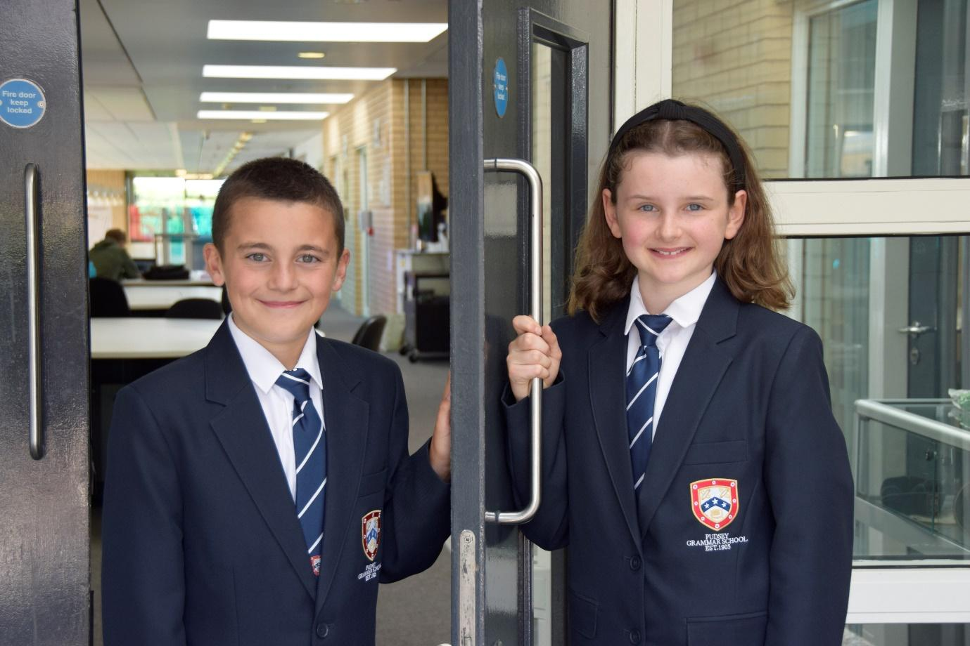

**TEACHER OF**

**ENGLISH**

**APPLICATION PACK**

**Permanent Subject Leader**

**of Design Technology**

**MPS/UPS £30,000 - £46,525**

**(+ TLR 2b £5,385 pa)**

**Either a full-time or part-time working pattern will be considered for the right applicant**

**To start September 2024**

**Contents**

Introduction from the Headteacher

General school details

Information on the post

Job description

Person specification

Enhanced disclosure

**Introduction from the Headteacher**

Thank you for the interest you have shown in the post of Subject leader of Design Technology This is an excellent opportunity to join our dynamic staff team.

Pudsey Grammar School is a heavily oversubscribed mixed comprehensive secondary school located in the heart of the market town of Pudsey. Situated between Leeds and Bradford, the town has always valued its independence from its two larger neighbours. The school has a long and proud history stretching back to 1905. The school has 1350 students with a thriving and expanding Sixth Form of over 250 students, all taught in a state of the art building. The innovative and unique style of the building creates a calm atmosphere very different to many secondary schools.

I was appointed in 2014 and since then we have received a letter from Amanda Spielman (HMCI Ofsted) which stated we ‘have transformed all aspects of the school.’ This assertion was further underlined in 2018 when the increase in our exam results resulted in the school being the most improved school in Leeds and one of the most improved in the country (we were delighted to follow these achievements up with our best ever GCSE exam results in 2019 which were above the national average). The pattern of improvement continued in 2020 with our Year 11 students achieving grades which were outstanding. The school had a highly successful Ofsted inspection in April 2019 and was judged as good in all areas, including our Sixth Form.

In 2022, the school was selected to be a national Behaviour Hub school. This is a Department for Education programme led by the Governments’ School Behaviour Advisor, Tom Bennett, which identifies schools who have ‘an exemplary behaviour culture’. We are one of only 20 secondary schools out of 4000 who have achieved this prestigious accolade and we are working with other schools across the north of England to improve their behaviour cultures.

In 2023, the school was awarded £4million by the Department for Education to build a new Sixth Form to support the growth in student numbers across Leeds. This exciting new development is scheduled to open in early 2025.

We have a comprehensive House system which runs across all year groups with over 30 diverse competitions across the year for students and one each half term for staff too. House assemblies take place once every three weeks lead by our eight House Leaders. At the end of each academic year, the winning House is awarded our 80-year-old Victor Ludorum Cup.

We are aiming to be a centre of excellence and every indicator we have, we are on track to achieve this goal. Continuing to recruit high calibre staff is a key priority of our strategy.

The following passages are taken from the 2019 Ofsted report:

‘The Principal leads the school with passion and determination.’

‘Behaviour, both in lessons, and about the school, is good. Pupils treat each other and adults with respect.’

‘There is a calm and purposeful atmosphere.’

‘Strong leadership, at all levels, is at the heart of this school’s success. The Principal is very ably supported by an effective team of senior leaders. The Principal describes the middle leaders as the ‘engine room of the school’ and they are indeed a real strength.’

‘Staff morale is high. Staff, at all levels, have embraced the changes and are proud to be part of a successful school.’

The school has a long tradition in the town, being established as Pudsey Grammar School in 1905. Although the school is taught in a state of the art building, our core values of respect, resilience, integrity, compassion and ambition are highly traditional and are based on the goal of ensuring that every student reaches their true potential.

Our school is not just about the students gaining knowledge and qualifications, although these are extremely important. We believe in teaching young people core values of decency, social skills and how to be a good citizen in an ever changing world. We want their character to develop and grow, and for them to leave us with an inquiring and independent mind. We want our students to gain the best qualifications they are capable of whilst experiencing a range of opportunities which are second to none. As a result, the school is extremely popular with our community and is significantly over-subscribed every year.

Our Sixth Form, which is rated as good by Ofsted, has grown rapidly in recent years following significant investment and we now have over 250 Post-16 students studying at Pudsey Grammar. We have a strong tradition of ensuring students access the best universities, including Oxford and Cambridge.

Our staff show exceptional dedication and commitment to our students. Relationships in the school are extremely strong and this underpins the ethos of the school. We pride ourselves in the care and support that we give our staff and, as a result, there is a real team spirit in the school where people enjoy being part of our school community. Teaching and learning is the key focus of the organisation and everything that we do is designed to ensure that the classroom experience for

the students is excellent. We are currently redesigning our curriculum to ensure that the education we offer is second to none.

We offer fantastic support and professional development to staff, which ensures that they are equipped with all the necessary skills to deliver excellent lessons to the students on a daily basis.

The school is a Foundation Trust school and our partners include global companies such as M&S and HSBC bank, alongside leading local business and training provider, Appris. These high quality links allow our school to offer excellent careers

opportunities to students across the ability range. As a result, the school has 0% NEETs at Year 11.

We are currently part of the Red Kite Teaching Alliance, which is providing outstanding opportunities and CPD for all of our staff. Subject Leaders attend their Collaborative Learning Groups, which allows them to network and share best practice. This is further disseminated through the school via regular Department meetings and weekly Teaching & Learning briefings.

This clearly is an exciting time to join our school.

If you have a desire to be part of one of the most exciting and rewarding schools to work in, which will also provide you with excellent development opportunities, please complete the application form. Any further details can be obtained directly from the school’s HR Team: [recruitment@pudseygrammar.co.uk](mailto:recruitment@pudseygrammar.co.uk)) or our website [www.pudseygrammar.co.uk](http://www.pudseygrangefield.co.uk)

**Mark McKelvie**

**Headteacher**

**Pudsey Grammar School**

**Departmental Information**

Our Design Technology department currently consists of four specialist teachers, plus two full-time technicians each specialising in Food/Woodwork and Textiles. The department is committed to developing new ways of teaching and learning, which focus on students' needs. We have fantastic classrooms, spaces and resources for delivering our DT curriculum, consisting of two large Food workrooms, two very large and well-equipped workshops with an offer to deliver wood / metalwork plus two specialist workrooms housing our Graphic Design and Textiles equipment. We have recently invested in over thirty new iMac computers to enhance the existing fifteen PC computers containing Adobe and CAD software, allowing students an excellent learning experience across this subject range. We work closely with the Art / Photography department as well as cross-curricular opportunities with Science & Business.

The department is structured into carousels in KS3, which are split into the specialisms of Food Technology, Textile Design and Product Design. We currently offer KS4 in Graphic Communication and Product Design at GCSE Level, we also have scope to deliver subject offers like 3D Design, Construction, Resistant Materials, Engineering as we have the necessary facilities and are looking for an enthusiastic subject leader who will be passionate about developing the curriculum offer.

**KS3** - Students study Design Technology for four lessons across a two-week timetable in Year 7, 8 and 9. Students follow an engaging curriculum, within Food / Textiles / Product Design lessons. This develops the knowledge and skills needed to support them in success at GCSE level and aims to capture their interest and thirst for choosing DT as a subject option.

**KS4** – DT is a very popular option at GCSE and students start their Graphic Communication and/or Product Design coursework in Year 10 and sit their examinations at the end of Year 11. Students can study either of the Design Technology specialisms currently on offer for five lessons over a two-week timetable. Graphic Design are currently studying the OCR - Art & Design GCSE syllabus and the Product Design GCSE is currently taught through WJEC. The emphasis for both is for expression through practical application, allowing for students at PGS to develop and hone their skillset for life.

**Post 16** – We are looking to expand on the current Post 16 offer and this post offers an excellent opportunity to directly shape and drive the curriculum in subjects such as A Level Food / Hospitality & Catering, Product Design, Engineering etc.

The department offers 'DT Clinics', as an after school club designed to allow for students from KS3 and KS4 to work on personal projects or continue using facilities to complete any outstanding coursework. We also offer a KS3 'Sewing Bee' club to year 9 to help promote textiles for GCSE choices for KS4, and have a Post 16 club 'Cooking on a Budget'. We pride ourselves on the department’s extra-curricular offer and we are keen to continue to build on this.

**Details of advert**

**Job Role**: Subject Leader of Design Technology

**Grade**: MPS/UPS £30,000-£46,525 + TLR 2b £5,385.00 pa

**Start date**: September 2024

**Working Pattern**: We welcome applications from candidates seeking both full-time and part-time working patterns

We are seeking to appoint an outstanding professional to lead our Design Technology department. We are looking for an inspirational, dedicated and motivated colleague who is passionate about their subject specialism and the development and delivery of an excellent and inspiring curriculum. You will be part of a dynamic subject team which is committed to achieving excellent outcomes for all our students, collaboratively working to improve teaching and learning across key stages 3, 4 and 5.

Applicants should be highly respected teaching practitioners who have already begun to demonstrate effective leadership characteristic. Your application will need to demonstrate:

* A drive and ability to lead your specialism effectively to ensure all staff within the department are focussed and high achieving
* A commitment to delivering to high standards and the ability to share good practice with others
* An ability to actively contribute to the strategic development of the department by implementing new initiatives, monitoring and reporting on key outcomes and ensuring the department is meeting, and where possible exceeding, academic targets
* An ability to be held accountable for student attainment and achievement through effective tracking of progress and supporting learning needs, being confident and proficient in the use of data to support departmental strategies.

Applicants should be committed to their own professional development, and have aspirations for wider responsibility and school leadership.

**Why work at Pudsey Grammar School?**

* Be part of a rapidly improving school
* Work for an organisation which has staff wellbeing as its core
* Embrace the opportunity to play a key part in the continuing transformation of the school
* Be part of a dynamic and enthusiastic team of staff who are ensuring our students are successful in every way
* Work alongside hub-schools in the Yorkshire and Humber region and University College London, with access to high quality Teaching and Learning training, networking events, CPD
* Belong to a supportive organisation which prides itself on high standards for staff and students
* Work in an award-winning state of art building

**This school is committed to safeguarding and promoting the welfare of children and expects all staff and volunteers to share this commitment. Appointments will be subject to an enhanced DBS disclosure. If shortlisted, you will be required to disclose relevant information regarding criminal history and an on-line search will be conducted.  This includes only information publicly available on-line.**

**We promote diversity and want a workforce that reflects the population of Leeds.**

**Employment is conditional on confirmation of the right to work in the UK – either as a UK or Irish citizen, under the EU Settlement scheme or having secured any other relevant work visa. If you do not have the right to work in the UK and the role**

**does not meet eligibility for sponsorship, please consider carefully whether you meet the eligibility to apply for this position.**

**Application Process**

Should you wish to apply for this position, please send the following to [recruitment@pudseygrammar.co.uk](mailto:recruitment@pudseygrammar.co.uk).

* A completed application form. Applications should be made electronically in Word or PDF format
* **Please be aware that we do not accept Curriculum Vitaes**
* In support of your application you may include a covering letter. This should be in addition to the completed application form.

**Closing date for application 4th March 2024 at 12.00 noon**

**Successful candidates will be contacted direct with details of the interview.**

**Interview date: 14th March 2024**

**Job Description**

|  |  |
| --- | --- |
|  |  |
| Post Title: | **Subject Leader of Design Technology** |
|  |  |
| Post Purpose: | * To lead the subject/department team to deliver quality outcomes. * To facilitate and encourage learning which enables students to make progress and achieve high standards. * To implement the school’s policies and procedures. |
|  |  |
| Reporting to: | SLT Link |
|  |  |
| Working time: | Full-time/Part-time FTE as agreed for the successful candidate |
|  |  |
| Salary/Grade: | MPS/UPS £30,000-£46,525 + TLR 2b £5,385.00 pa |
|  |  |
| Main (Core) Duties: | |
|  |  |
| Teaching  and Learning | * Lead in the day-to-day management of the specialist subject area/department, including curriculum development, resource allocation, and timetabling. * Assist in the recruitment, induction, and professional development of department staff, fostering a positive and collaborative team culture. * Lead in the development of curriculum and resources across all key stages. * Contribute to the planning and delivery of high-quality lessons, ensuring differentiation and inclusion for students of varying abilities. * Monitor and evaluate the progress of students within the department, providing timely feedback and interventions to ensure their academic success. * Foster a positive and supportive learning environment, promoting high expectations, discipline, and positive behaviour management strategies. * Act as a role model and mentor for department staff, offering guidance and support in instructional strategies, classroom management, and assessment practices. * Keep up-to-date with the latest educational research and pedagogical practices, incorporating innovative teaching methods and technologies into classroom practice. * Attend and lead department meetings, parent-teacher meetings, and other school events as required * Model best practice in the classroom to other colleagues in the Department * Lead items at Department meetings and take responsibility for developing the skills and knowledge of other teachers |
|  |  |
| Quality assurance | * Take regular work/book samples to ensure that marking policies are adhered to, presentation is good and student work demonstrates progress is being made. * Undertake learning walks and lesson observation to ensure behaviour and teaching and learning is good and classroom routines are being followed. * Undertake quality assurance activities to ensure that PP and SEN students are accessing the curriculum and being appropriately challenged. * Conduct student voice, gathering information about teaching and learning routines, homework and classroom behaviour. * Feedback to staff and SLT * Conduct follow up QA events to ensure standards are upheld across the Department. |
|  |  |
| Planning and Assessment | * Lead the development of schemes of work across the key stages ensuring differentiation and inclusion for students of varying abilities. * Design key assessments across the key stages and ensure these are implemented effectively. * Oversee moderation process, analyse results, identify key trends and design interventions. |
|  |  |
| Enrichment and the wider curriculum | * Identify opportunities for students to access a range of experiences which enhance the standard curriculum: competitions, guest speakers, wider reading etc. * Organise educational visits across the key stages, giving students the opportunity to deepen their knowledge and understanding of the subject. * Forge cross-curricular links with other subjects that enhance the learning experience. * Contribute to raising the profile of the subject across the school. |
|  |  |
| Manage Own Performance and Development | * Take responsibility for their own professional development and to keep up to date with research and developments in pedagogy and in the subjects they teach. * Share corporate responsibility for the implementation of school policies and practices. * Provide a role model to all students they encounter, in their presentation and their personal conduct. * Evaluate their own teaching critically and use this to improve their effectiveness. |
|  |  |
| Managing and Developing Staff and Other Adults | * To establish effective working relationships with professional colleagues including, where applicable, associate staff. |
|  |  |
| Safeguarding | * To work in line with statutory safeguarding guidance (e.g. Keeping Children Safe in Education, prevent and our safeguarding and child protection policies) * To work with the designated safeguarding lead (DSL) to promote the best interests of students, including sharing concerns where necessary * To promote the safeguarding of all students in the school. |
| Managing Resources | * Select and make good use of ICT and other learning resources which enable learning objectives to be met. |
| Physical Conditions | * The post is based at Pudsey Grammar School. * The school is accessible by stairs and lift and is available by disabled persons to the ground floor by a portable ramp on request. * This post is subject to an enhanced Disclose and Barring Service check. * The school operates a non-smoking policy. |
| Prospects | * Whilst there is no automatic progression to any more senior posts, opportunities do exist for advancement and promotion, dependent upon normal staff movements and on the capabilities of the individual post holder. |
| Training | * The school encourages training both “in-house” and external to meet the needs of the individual and of the Service |
|  |  |
| Any Special Conditions of Service:  No smoking policy | |
| **The school is fully committed to safeguarding children and promoting their welfare and expects all staff to share in this commitment.  All posts are subject to an Enhanced DBS with Barred List check.**  This job description is to assist staff joining Pudsey Grammar School to understand and appreciate the work content of their post and the role they are to play in the organisation.  Whilst every endeavour has been made to outline the main duties and responsibilities of the post, a document such as this does not permit every item to be specified in detail. This job description is not a definitive list of responsibilities but identifies the key components of the role. The post holder will, therefore, be required to undertake other reasonable duties commensurate with the purpose and salary level of this post.  Employees should not refuse to undertake work, which is not specified on this form, but they should record any additional duties they are required to perform, and these will be taken into account when the post is reviewed.  Please note the successful applicant will be required to undertake a six-month probationary period in line with the current school policy for recruiting support staff.  Pudsey Grammar School is an equal opportunities employer and requires its employees to comply with all current equality policies both in terms of equal opportunity for employment and access to the school’s services. | |
|  | |
| Statement:  Pudsey Grammar School will endeavour to make any necessary reasonable adjustments to the job and the working environment to enable access to employment opportunities for disabled job applicants or continued employment for any employee who develops a disabling condition.  This job description is current at the date below but will be reviewed on an annual basis and, following consultation with you, may be changed to reflect or anticipate changes in the job requirements which are commensurate with the job title and grade in line with the school’s changing needs.  Dated: 30/11/2023  (Headteacher) | |

**Person Specification**

|  |  |  |
| --- | --- | --- |
| **ATTRIBUTES** | **REQUIREMENTS** | **HOW IDENTIFIED** |
| Qualifications, Training & Knowledge | * Degree in specialist or relevant/related subject or equivalent; * Qualified Teacher Status; * Good knowledge of current educational developments, especially in specialist area or related area; * Good knowledge of the requirements of the National Curriculum;   Know strategies for raising attainment; | * Application Form * Interview |
| Experience | * Teaching experience of secondary school in specialist subject area or related area; | * Application Form * Interview * References |
| Skills | * A good team member; * Flexible and able to use own initiative; * Ability to inspire and motivate students; * Good ICT skills; including editing software * Good written and spoken communication skills. | * Application Form * Interview * References |
| Personal Qualities | * Evidence of effective organisational and communication skills; * Evidence of being a successful teacher; * Capable of inspiring students; * Able to form good working relationships with colleagues; * A willingness to become fully involved in the wider life of Pudsey Grammar School. | * Application Form * Interview * references |

The Job Description should be read alongside the range of professional duties of Teachers as set out in Part X11 of the Teachers’ Pay and Conditions Document, sections 48 to 50. The postholder will be expected to undertake duties in line with the new Professional Standards for Teachers (2008) and uphold the professional code of the General Teaching Council for England.

### **School Location and Travel Information**

Pudsey Grammar School

Mount Pleasant Road

Pudsey

Leeds

LS28 7ND

Tel: 0113 2558277

Twitter - @PudseyGS

[www.pudseygrammar.co.uk](http://www.pudseygrammar.co.uk)

