11 February 2019

Dear Applicant

I hope you find the information pack of interest and I look forward to receiving your application.

St Hugh’s School is a special school for students between the ages of 11 and 19 years who have a range of learning difficulties, including moderate and severe learning difficulties, autism spectrum disorders, profound and complex needs. The school is rated “Outstanding” by Ofsted and is a National Teaching School, leading an alliance of over one hundred partner and associate school and educational providers.

We have a large staff group, over 100. The team of staff are loyal, and committed, working towards the best possible outcomes for our students. It is a privilege to be Head Teacher at St. Hugh’s. Our students are an asset and true ambassadors of our school.

If you would like to arrange to visit our school, please feel free to contact me at the school for an informal discussion and to arrange a visit. For more information about the school please look at our website at www.st-hughs.n-lincs.sch.uk.

The School is committed to safeguarding and promoting the welfare of young people and expects all staff and volunteers to share this commitment. This post is subject to an Enhanced Disclosure and Barring check.

I wish you every success with your application and look forward to meeting you.

Kind Regards
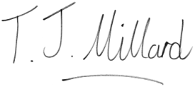

Tracy Millard
Head Teacher

