
Brief for the appointment of
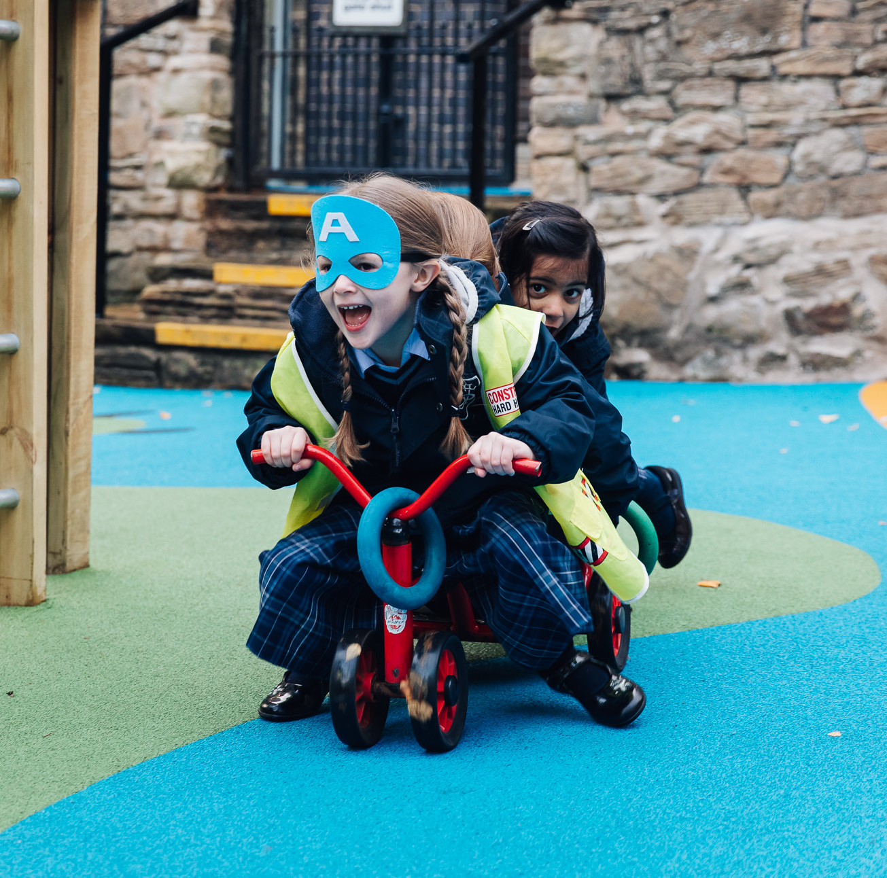

Brief for the appointment of
Head of Junior School

The Role
Sheffield Girls’ has an exciting opportunity for an inspirational and confident leader to take on the Headship of our outstanding Junior School from September 2024.

The Infant and Junior School at Sheffield Girls’ is a vibrant and dynamic community where girls enjoy learning and develop skills for the future. Our Fusion Curriculum is knowledge-rich but also provides students with broad educational experiences mapped against six key competencies: Creativity, Independence, Moral & Ethical, Confidence, Appreciation and Curious Cognition. We place great emphasis on critical thinking, Growth Mindset and mastery, and making learning relevant. The impact we see is that the children have a genuine love of learning. Our Girls of Steel character education programme develops and celebrates the skills and values that will be required of the leaders of tomorrow, and a range of co-curricular clubs, competitions and adventures enrich the student experience.

Our girls are supported by a talented, loyal and dedicated staff who show care and compassion in all that they do.
Outstanding pastoral care supports every child and helps them navigate everything from friendship issues to managing their emotional wellbeing and growing up. We are an accredited Silver Award Unicef Rights Respecting School, showing our commitment to creating an equal and inclusive learning environment where we celebrate diversity and girls are empowered to challenge inequality.

The standout provision in our Infant and Junior School has seen us receive various awards including being named Prep School of the Year at the Independent School Awards 2023. The next Head of Junior School will join us at an exciting time and will build on a platform of success, following the retirement of Chris Hald after eight years of outstanding leadership.

The Junior School is self-contained in its own buildings but situated on the same campus as the Senior School and Sixth Form. There are approximately 150 pupils between Reception and Year 6. Although independent in the day-to-day running of the school, there are very close links between the Juniors and other sections of the school. The Head of Junior School works closely with the Head and is an important member of the Senior Leadership Team. As a member of the GDST, the Head of Junior School has access to a network of supportive colleagues in other Trust schools.

We are looking for a Head of Junior School who is:
- An inspirational leader with significant experience in Junior / Primary School leadership.
- An outstanding educator who recognises the features of exceptional learning, both inside and outside the classroom.
- A champion of girls-only education.

The GDST has its own salary scale with remuneration for Heads of Junior School starting from £72,369. We also offer a package of wider benefits including a generous pension scheme, life assurance benefit, employee assistance programme, financial guidance and support, and a discount of up to 50% on fees for children at GDST schools.

The closing date for applications is 12 noon, Thursday 11th January 2024. Longlist interviews will be held during the week commencing 15th January 2024 and final stage interviews will take place on Thursday 25th January 2024.

Sheffield High School for Girls and the GDST are committed to safeguarding and promoting the welfare of children. Applicants for all jobs will undergo appropriate child protection screening including checks with past employers, online checks and the Disclosure and Barring Service (DBS). For further details of our Safeguarding Policies and Procedures, please follow this link: https://www.sheffieldhighschool.org.uk/school-policies/safeguarding-policy/

The GDST is committed to diversity, inclusion and real change: a family where every individual is valued, respected and included.

Our School

Our aims
At Sheffield Girls' we aim to nurture a love of learning and curiosity in our girls that encourages them to explore, question and challenge.
We want our girls to be confident, to flourish and be ready to take their place, and make a difference, in an ever-changing world.
We want our girls to be proud! Proud of themselves, proud of each other, proud to be forged at Sheffield Girls'.

“Teaching her everything so she can be anything”

Our values
We have three school values: Positivity, Kindness and Courage.
We want our girls to be positive. Positive in the way they approach their learning, positive in the outlook on life, positive in their aspiration for the future.
We want our girls to be kind. Kind to others, kind to themselves, kind to the world they live in.
We want our girls to have courage. Courage to stand out from the crowd, courage to speak up for what is right, courage to push herself that little bit further.

Girls only by design
Schools like ours can offer a learning environment dedicated to girls' learning needs and preferences, an environment where girls can establish their own identities attitudes and self-worth free from gender stereotypes during those crucial formative years.
We firmly believe that girls' education has never been more important, because it has a purpose and a unique position in a world that can only benefit from the contribution these girls will make to a better future for us all.

An exceptional education from 4-18
Founded in 1878, Sheffield Girls’ is situated in Broomhill, a very pleasant area of the city between the University and the Botanical Gardens.

The school serves a wide geographical area attracting girls from the neighbouring towns of Barnsley, Doncaster and Rotherham as well as Derbyshire and North Nottinghamshire.

The school is spread across several buildings within close proximity of each other, and we have specialist facilities to support learning across all ages.

At Sheffield Girls’, our pupils are immersed in a purposeful environment, free from disruptive behaviour, where it is cool to work hard and do your best, which means the girls are enthusiastic and motivated in their learning.
The learning is rigorous, but it is fun. Lessons are fast-paced with students engaged as active learners and they are delivered by inspirational teachers who bring a wealth of experience and are innovative in their approach. Learning takes place in a supportive environment where mistakes are encouraged. We aim to develop the girls’ resilience and confidence and instil a ‘can-do’ attitude.

There are currently 750 girls on roll which includes approximately 150 girls in the Junior School and a Sixth Form of around 150 students.

We have a commitment to innovation, sustainability, skills development, and equality, diversity, and inclusion (EDI). Our strategic actions over the last three years have seen us achieve Unicef Rights Respecting Schools Silver Award status; become the national hub for World Education Robotics (WER); introduce and embed a competency based curriculum across our all phases; appear in 18th position in the School Sports Magazine’s ‘Top 200 sporting schools’; achieve the highest judgements in our ISI Educational Quality Inspection in September 2021; be named the Sunday Times Top Independent Secondary School in the North of England 2023 and, most recently, achieve the title of Prep School of the Year at the Independent School of the Year Awards 2023.

Part of the GDST
Sheffield High School for Girls is one of 25 schools administered by the Girls’ Day School Trust (GDST).

The GDST is the leading network of independent girls’ schools in the UK, with nearly 20,000 pupils and over 3,700 staff in its 23 fee-paying schools and two academies. The GDST is also the UK’s largest educational charity with an annual turnover of more than £200m. The GDST is fully committed to its current and future students, parents and staff and any surplus is reinvested in its schools, for the benefit of its pupils.

For further information on the school or the GDST, please visit www.sheffieldhighschool.org.uk or www.gdst.net

Job Description
Role | Head of Junior School
Job Purpose | To lead and manage the Infant and Junior School on behalf of the Head, so that all pupils have the best possible care, have access to a broad and balanced curriculum and achieve the highest standards, in line with the ethos of the school.  As part of the Senior Leadership Team, contribute to whole school management.
Accountable to: | The Head
Accountabilities | 1. Policy / Strategic Direction and Development  - Create and communicate a shared vision within the Junior School, which expresses the core values of the whole school, is responsive to local factors, and which motivates and inspires others.  - Translate the whole school vision into agreed objectives within the Junior School (to include the formulation and implementation of the Junior School Development Plan).  - Contribute to whole school policy development as required by the Head.  - Take lead responsibility for policy development and implementation in relation to the junior phase. Keep policies under review, making recommendations for change to ensure the school’s developing needs are met.
2. Teaching and Learning

- Promote excellence and innovation in teaching and learning in the Junior School, ensuring a continuous and consistent phase focus on pupils’ achievement and development (moral, spiritual, physical, and social, as well as academic).
- Establish and keep updated a curriculum which is innovative, creative, appropriate to the age and stage of the pupils, and informed by current knowledge and best practice, in order to develop the potential of all pupils and equip them with the necessary skills required in the 21st century (including the use of ICT).
- Be the lead practitioner in the Junior School in establishing creative and effective approaches to learning and teaching, with high expectations of self and others.
- Monitor, evaluate and review classroom practice throughout the Junior School; celebrate and promote excellence, challenge under-performance, and ensure appropriate action (in consultation with the Head).
- Ensure that individual pupil progress is regularly assessed, recorded, reported to parents and utilised effectively to inform teaching and learning.
- Ensure strategies are in place to identify and provide appropriately for particular needs, e.g. the more able, SEN, EAL.
- Ensure pupils have fun, enjoy their learning, and have opportunities to share their knowledge and understanding with their peer, teachers and parents.
- Ensure pupils have access to a rich and varied extra-curricular programme.
- Create a ‘seamless’ educational experience as pupils transfer across phases at key transition points and ensure the effective liaison between Junior and Senior school staff, in relation to Year 6 to 7 transfer and specialist subject teaching.
- Undertake an appropriate programme of teaching in accordance with the duties of a standard scale teacher as outlined in the general job description.

3. Pastoral Care
- Ensure effective systems are in place to support the physical, mental and moral safety well-being and welfare of all pupils (including before- and after-school provision).
- Consult with experts/agencies (internal and external) as appropriate and address any concerns with sensitivity and diplomacy, keeping the Head informed as appropriate.

4. Leadership and Management of self and others

- Lead the work of the Junior School Leadership Team and relevant stakeholders to help achieve the school’s vision.
- Lead and manage the Junior School, recruiting, inducting, developing, deploying, motivating, and appraising members of the Junior School to make the most effective use of their skills, expertise and experience, to ensure that they have clear expectations of their roles, and that high performance standards are achieved and maintained.
- Manage day to day operational requirements, delegating as appropriate, to ensure the efficiency of the Junior School.
- Ensure the school’s vision is understood by all Junior School staff (teaching and support), with clear targets for development and outcomes evaluated in fulfilling these aims.

5. Communications, Marketing and External Links

- Working in consultation with the school’s marketing manager, implement a range of robust and innovative marketing strategies in the Junior School, to ensure its attractiveness in the wider market and secure optimum pupil numbers; seek opportunities to promote the Junior School at every opportunity.
- Build successful relationships and partnerships with parents and other members of the community, to ensure an excellent local reputation of the Junior phase, and to promote the GDST.
- Manage the admissions and assessment processes for prospective pupils in the junior phase in accordance with agreed guidelines.
- Develop amongst Junior School staff an outward perspective and personal commitment to promotion of the school.
- Build wider links, with both across the GDST and beyond, to ensure that national and international perspectives feature in the school’s work.

6. Management of resources

- Organise a relevant and age-appropriate timetable for the junior school; analyse staffing requirements to ensure optimum benefit to pupils, within budgetary constraints.
- Monitor and control the Junior School’s allocated budget and purchasing arrangements, to ensure the efficient and effective use of all resources.
- Identify future resourcing needs and aspirations for the Junior School for consideration in the school budget planning process.
- Ensure that all resources are fit for purpose and used in accordance with health and safety guidelines in ORACLE.
- Ensure that there is appropriate risk management throughout the Junior School, including school visits, activities, clubs and competitions.

6. Training and Development of Self and Others
  - Develop and maintain a culture of high expectation for self and others within the Junior School.
  - As a lead professional, regularly review own practice, set personal targets and take responsibility for own continuous professional development.
  - Ensure that training needs within the Junior School are identified, appropriately met (with due regard to whole school initiatives), and that all members of the Junior School are active in their own personal and continuous professional development.
  - Ensure that induction arrangements for new staff (including those for NQT’s and students) make them feel welcomed and appropriately briefed to undertake their responsibilities.
7. Monitoring and Evaluation
- Ensure rigorous and effective systems of monitoring and evaluating the work of the Junior School are in place and used to inform future teaching, including the effective use of end of Key Stage/phase and internal data.

8. Supporting the work of the GDST
- Develop strong, positive relationships with GDST colleagues, contribute to collaborative work cross GDST Schools and support other staff in participating in GDST work in order to share best practice.

General requirements | All school staff are expected to:  - Work towards and support the school vision and the current school objectives outlined in the School Development Plan.  - Contribute to the school’s programme of extra-curricular activities.  - Support and contribute to the school’s responsibility for safeguarding students.  - Work within the school’s health and safety policy to ensure a safe working environment for staff, students and visitors.  - Work within the GDST’s Diversity Policy to promote equality of opportunity for all students and staff, both current and prospective.  - Maintain high professional standards of attendance, punctuality, appearance, conduct and positive, courteous relations with students, parents and colleagues.  - Engage actively in the performance review process.  - Adhere to policies as set out in the GDST Council Regulations, ORACLE and GDST circulars.  - Undertake other reasonable duties related to the job purpose required from time to time.
Review and Amendment | This job description should be seen as enabling rather than restrictive and will be subject to regular review.

Person Specification

Skills Required
Enthusiastic, inspirational and confident leader, possessing drive, energy and commitment;  Has a presence which engenders confidence and respect from pupils, staff and parents; Leads by example | Essential
Proven ability to inspire pupils | Essential
Outstanding interpersonal and communication skills, (verbal and written);  Ability to handle sensitive situations with tact and diplomacy | Essential
Ability to prioritise own workload, manage a varied workload and delegate appropriately | Essential
Strategic thinker;  Ability to articulate and share school vision and identify steps which need to be taken to fulfil identified aims | Essential
Excellent digital literacy and understanding of the role of ICT across the curriculum | Essential
Ability to make firm decisions when required | Essential
Commitment to the highest standards of education and pastoral care for all pupils | Essential
Strong analytical and problem-solving abilities | Essential

Knowledge Base
Outstanding primary practitioner, with strong knowledge and understanding of child development, the primary curriculum, EYFS and principles of good practice;  Child-centred philosophy and approach | Essential
Knowledge of current educational thinking, initiatives, issues and matters of pedagogy | Essential
Commitment to the protection and safeguarding of children, showing an awareness of current issues, legislation and working with other agencies where appropriate | Essential
Ability to make secure judgements about the quality of teaching and learning | Essential

Qualifications/Attainment
Undergraduate degree | Essential
Appropriate teaching qualification | Essential
Evidence of further educational or management qualification, e.g. MA, NPQH | Desirable

Experience
Relevant leadership and management experience in an educational setting | Essential
Experience in more than one school and location | Desirable
Experience in managing change | Desirable
Experience of carrying out staff review and target setting | Desirable

Attitude/approach
Honesty and integrity | Essential
Able to demonstrate adaptability and flexibility | Essential
Approachable | Essential
High expectations of oneself, as well as of others | Essential
Ability to remain calm in sensitive or potentially volatile situations | Essential
Ability to listen and make reasoned and informed judgements | Essential
Holds a strong vision, and has the necessary skills and attributes in order to fulfil that vision | Essential

