13th January 2020

Dear Applicant,

Re: School Meals Supervisory Assistant Post

Thank you for your interest in the above position, you will find the relevant information required to apply is enclosed.

Castlebar is an exciting and unique school to work in. We are proud of all that we achieve for our children and particularly of the positive atmosphere that exists in our school.

Please use the Person Specification enclosed as a plan for your application. All supporting statements must be typed. Please note that all appointments are made to the school and may involve working with very challenging children.

The closing date for applications is: Friday 24th January 2020

Interviews will be held: Monday 3rd February2020

We hope that after reading the information you will wish to apply for this post and if there is anything you require, please do not hesitate to contact us.

Yours faithfully

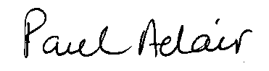

Paul Adair

Headteacher

