Mr C A Wakefield B Ed (Hons) NPQH
PRINCIPAL
Fambridge Road
Maldon
Essex
CM9 6AB

Tel: 01621 854681
Email: personnel@plume.essex.sch.uk
Website: www.plume.essex.sch.uk

November 2018

Dear Applicant

Teacher of Art

Thank you for your response to our advertisement for the post of Teacher of Art. This is a part time post for two terms – to 31 August 2019. From our website you will be able to glean lots of information which we hope will be of interest and help you with your application, but if you have any queries or would like further information, please let us know.

All staff at the academy are committed to looking after the individual. Sometimes this is not easy in a large split-site 11-18 comprehensive academy but we pride ourselves in continually striving to attain the best for each individual, whether a student or member of staff.

In order to help us with this task we have, over the years, invested very heavily in staff, staff development, teaching resources, technology and the environment. I believe we now have the majority of the resources we need in order to enable us to do an excellent job for our students and ensure that they make good progress. In January 2018 Ofsted confirmed that Plume is a ‘Good Academy’ across all areas including the 6th Form.

The one thing we will always need is professionally skilled, concerned and energetic staff who are committed to continually improving standards of teaching and learning. We are at the centre of our community and aim to develop the skills, confidence and attainment of all the students in the Maldon area.

We look forward to hearing from you.

Closing date for applications is 9am on Monday 12 November 2018.

Yours faithfully
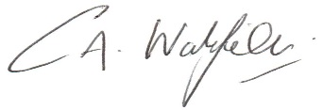
Mr C A Wakefield
Principal

