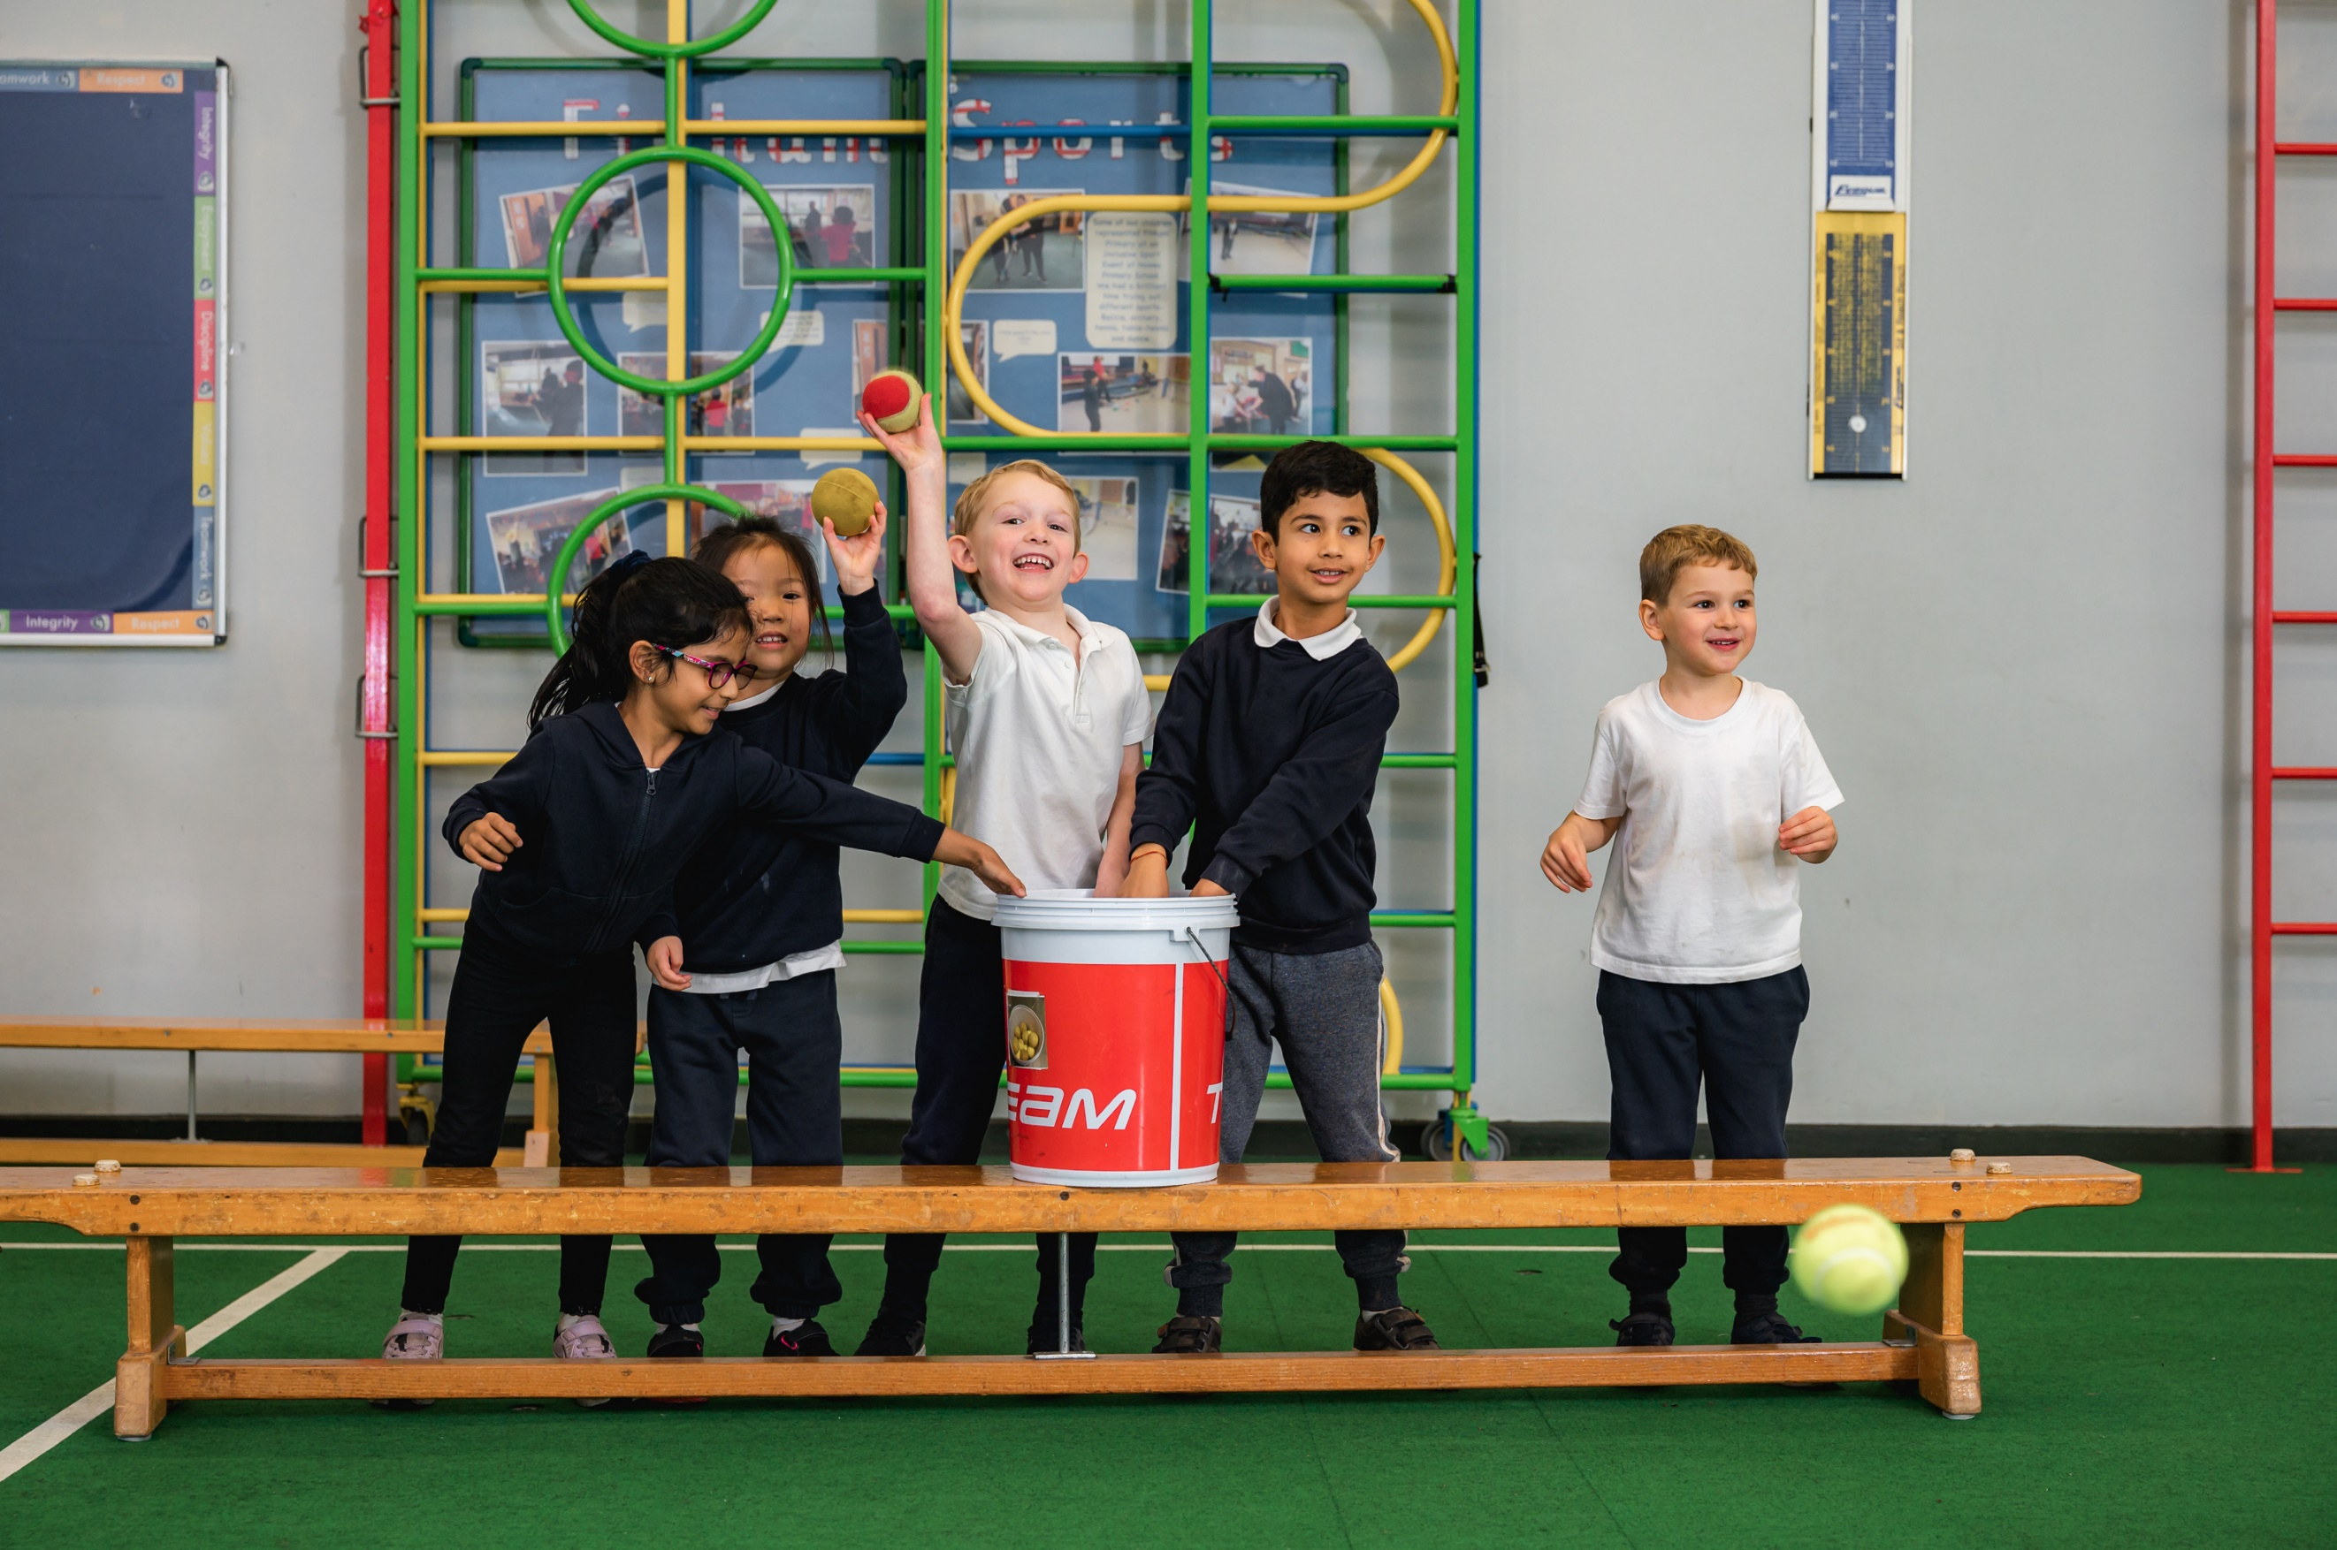
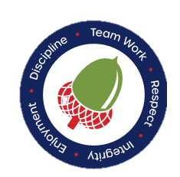
Finham Primary School


INFORMATION FOR CANDIDATES 2023-2024
Discipline Team Work Respect
Integrity Enjoyment

Welcome to Finham Primary School,
It is my pleasure to introduce you to Finham Primary School exceptional learning community of 460 pupils, where we put children at the heart of everything we do.
Through our dedicated approach children thrive and develop holistically, nurturing their unique skills and attributes. Our enthusiastic staff and high-quality inspiring values-based curriculum enables children to learn, flourish, and become lifelong learners.
The staff at Finham Primary are our greatest asset and we believe it’s a priority to invest in people. As a school, we aim to nurture and develop you no matter your career stage. We have a unique environment, where staff and children flourish alike! Finham is a supportive, welcoming and purposeful place to work. Our staff retention is a testament to this. Writing it is one thing, but we would be proud for prospective candidates to come and witness this for themselves.
Being part of Finham Primary School and the Finham Park MAT, means all employees, at every level, are able to access tailored CPD and exciting opportunities to enhance their development.
We are a committed team where we celebrate distinctiveness and individuality. Every member of staff brings their own unique set of talents and experiences to motivate and support children along their educational journey. Through coaching mentoring and high-quality action research, we are developing and modelling a research partnership that allows staff to continue their learning. This ensures that children reach the high expectations that we set for all.
Busy having an impact on learning
Here at Finham, we enhance the curriculum using our beautiful safe and secure environment, which allows children to explore, develop and learn inside and outdoors. Using supportive adults, the environment stimulates children’s curiosity and continues to fuel the leaning process. The school environment supports our high-quality teaching and learning, using the most up to date, relevant technology.
We encourage families and groups from the wider community to get involved in all aspects of school life and be a part of something special, using the rich and diverse community we have in Finham, as a resource to enhance the learning experience.
We have an active PTA that encourages all parents to get involved in school life. They raise funds to provide facilities and equipment for the pupils in our school and build relationships, organize fun events and enhance experiences for the community. Alongside this, they also use their professional expertise to promote the entrepreneurial skills of the pupils involved.
We work closely with the local pre-schools and secondary schools to ensure a smooth and effective transition for our children.

Thank you for your interest, we can’t wait to meet you.

Sarah Bracken - Headteacher
Our School
‘’I would be happy to have my child in any class at any time at Finham Primary School’’
At Finham, children receive a holistic education, that nurtures their unique skills and talents. Although children will develop at different rates, they all deserve a bespoke, values led, inclusive education and an excellent start in life. We strive for the highest standards. This is achieved by challenging, whilst supporting and nurturing each and every child. We cultivate creativity and critical thinking to develop intrinsically motivated learners with high aspirations for their futures.
Our staff are part of a committed team where we celebrate distinctiveness and individuality. Every member of staff brings their own unique set of talents and experiences to motivate and support children along their educational journey. Through coaching, mentoring and high-quality action research, we are developing and modelling a research partnership that allows staff to continue their learning. This ensures that children reach the high expectations that we set for all.
‘’My child has thoroughly enjoyed himself at Finham Primary School and it has been great to see him thrive’’
Children at Finham learn through a broad and balanced, relevant curriculum that challenges and inspires them to learn, by putting cognitive approaches at the centre of the objectives and activities. Our holistic curriculum encompasses: physical, intellectual, emotional, social, cultural, moral and spiritual development. It also builds self–esteem and confidence. Accordingly, pupils are able to apply and transfer their knowledge and understanding to reasoning and problem solving thereby giving them a greater depth of comprehension.

‘’We are pleased that our child is demonstrating positive personal qualities as well as achieving academically’’

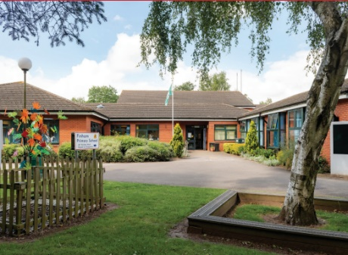

Here at Finham, we enhance the curriculum using our safe and secure environment, which allows children to explore, develop and learn inside and outdoors. Using supportive adults, the environment stimulates children’s curiosity and continues to fuel the learning process. The school environment supports our high-quality teaching and learning, using the most up to date, relevant technology.
Strategic Framework
1 EDUCATIONAL OUTCOMES  Our School will…  Provide a “World Class” learning experience for all through the development of outstanding & inspirational teaching:  Ensure that all students enjoy a “World Class” curriculum that is personalised and encourages outstanding contributions toward a cohesive community:  Ensure every learner achieves academic success and strives toward personal excellence. | 2 SUPPORT FOR ALL  Our School will…  Develop “World Class” support & guidance for our whole community where academic performance is underpinned by outstanding care, guidance and support for every student.  Collaborate at all levels to co-construct a “World Class” education for all our learners and support each other to overcome any challenges we may face. | 3 THE EMPLOYER OF CHOICE  Our School will…  Offer “World Class” CPD and career development opportunities so that our students benefit from the best teaching, support and guidance and that staff are happy; secure; feel valued by everyone and achieve work-life balance. | 4 ENABLING SUCCESSFUL SCHOOLS  Our School will…  Recruit, develop and maintain effective leadership & governance at all levels while succession planning for the future.  Benefit from high quality central services that will allow Governors and School Leaders to focus on education and provide excellent value for money. | 5 EARLY YEARS  Our School will…  Ensure every learner across early years achieves academic as well as wider success and strives towards personal excellence.
1a  Allow children to flourish by embedding our bespoke values-based curriculum that enables children to know more and learn more. | 2a  Work in partnership with pupils and families to ensure that behaviour, attendance and rewards policies promote positive learning behaviours. | 3a  To develop a programme of high quality CPD both internally, across the Trust and external, including the enrolment of staff on NPQs. | 4a  Develop effective governance and accountability through challenge and support, in partnership with the MAT Board and the MAT School Improvement Delivery. | 5a  To effectively assess children across EYFS to ensure that all children are making maximum progress.
1b  Continue to develop high quality research-based, responsive teaching, using tailored coaching to support professional development. | 2b  To ensure effective working relationships with multiple outside agencies, including SEN and safeguarding, through consistent communication and being part of working parties/panels. | 3b  To work closely with the Lion Alliance, apprenticeship bodies and local universities to create outstanding teachers of the future within our schools. | 4b  Ensure finance procedures and planning allow us to demonstrate excellent ‘value for money’, with a continued focus on sustainability.  Reviewing impact against outcomes and experiences for pupils. | 5b  Provide opportunities to enhance the curriculum which raise aspirations, develop life-long learners and enable children to experience the awe and wonder of the world in which they live.
1c  Use consistent assessment strategies that enable staff to engage with data effectively to raise attainment and ensure children reach their full potential. | 2c  Deliver the highest standards of education and support for those pupils with SEND and those who are vulnerable in our schools. | 3c  Develop a culture of strategic leadership and reflection through a model of distributed leadership, CPD and leadership succession. | 4c  To embed new HR systems and policies to ensure consistency across school in line with Trust. | 5c  To identify pupils with SEND needs early in order to gain maximum support through external professionals. Then use the small steps tracker to record milestones in their development.
1d  Provide opportunities to enhance the curriculum which raise aspirations and develop life-long learners. This will be built on the school’s core values. | 2d  Develop a systematic approach to closing gaps between groups of pupils, particularly disadvantaged pupils. | 3d  Integrate employee wellbeing at the heart of our work, providing opportunities that lead to increased enjoyment, improved resilience, reduced sickness absence and better outcomes for pupils. | 4d  Use IT effectively to maximise school systems and support parents in their child’s learning journey. | 5d  To develop a bespoke programme of CPD to ensure all EYFS staff exhibit best practise.
1e  Ensure high quality assurance systems are in place, which aim to drive school improvement and improve the experience and outcomes for all pupils. | 2e  Ensure an effective safeguarding culture exists, where children, parents and staff feel empowered to report concerns, feel safe and are confident to seek help if they need to. | 3e  To work with the Trust to ensure all appraisal processes and pay policies are consistently excellent and contribution to the recruitment and retention of the highest quality staff. | 4e  Ensure that Finham Primary’s environment, wider site and resources are high quality and suitable to deliver a ‘World Class’ experience for all stakeholders. | 5e  Allow children to flourish by embedding our bespoke values-based curriculum that enables children to know more and learn more.

Opportunities
We fully believe in creating a ‘culture of learning’ which encourages all to enquire, develop and share collaboratively across the education sector. We have dedicated co-planning and co-construction time built into our directed time budget so that teaching staff can work collaboratively within the school and across the MAT on teaching, learning and assessment. We also offer a range of in-house and nationally accredited courses through the Lion Alliance and some of these include:
Chartered Teaching Programme | TeachMeets | Lion Leadership Courses | ECT (Early Career Teacher) Programme
We are a registered learning partner for the Chartered College of Teaching and offer the CTP to colleagues within the alliance. | We host regular TeachMeet events that draw on our expert colleagues’ knowledge. This means we can be flexible and adapt to the changing needs of staff in schools. | We have 4 strands of leadership development courses. This includes Associate, Aspiring Middle, Middle and Senior Leaders courses. | The Head of the Lion Alliance is one of the regions ECT training facilitators; able to support newly qualified teachers as they begin their career.

We also have key speakers work with a huge range of world-renowned authors and teaching professionals; inviting them to speak at our school about the latest developments in their specialist area. Guests have included:

Tom Sherrington | Tom Bennett | Oliver Caviglioli | Mark Roberts
Adam Boxer | Matt Pinkett | Nina Jackson | And many more...

We also recruit and mentor PGCE students through a school-led PGCE programme (in partnership with the University of Warwick), meaning we can offer further opportunities in:
PGCE Mentoring | Working with us as an alliance | Working with our partner universities
There are opportunities to mentor PGCE students in your subject. This involves mentor training being provided by our University partners, and is a great way to nurture the next generation of teachers. | We have regular opportunities to get involved and share your expertise with colleagues in our alliance schools. | We work with the University of Warwick, Coventry University and Birmingham City University, where there are opportunities to help support and contribute to the wider higher education community.

Find out more by visiting www.thelionalliance.co.uk

https://thelionalliance.co.uk/continuing-professional-development-cpd/

The area

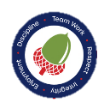
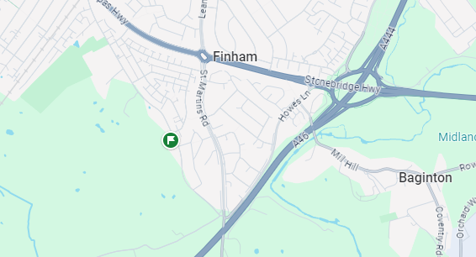Coventry, a historically significant city with ancient Saxon and Roman origins and a vibrant heritage in industries like weaving, watchmaking and the automotive engineering, emerged from the ashes of World War II as a symbol of hope and resilience. The city's international partnerships, including twinning with 27 other towns, fostered its transformation into a centre for peace and reconciliation, while offering diverse activities, cultural attractions and excellent transportation links in a scenic Warwickshire setting. Finham Park is located in an area close to the border between Coventry and Warwick.


024 76415425

Finham Primary School,
Green Lane,
Coventry,
CV3 6EJ

www.finhamprimary.co.uk

admin@finhamprimary.co.uk
hr@finhamparkmat.co.uk



,



