

Receptionist
(Administrative Assistant)
Wren Academy Enfield

Closing Date: 9.00am, Monday 15 July 2024



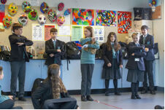

Contents
Principal’s Letter

Advertisement

Job Description

Person Specification

Selection Process Details


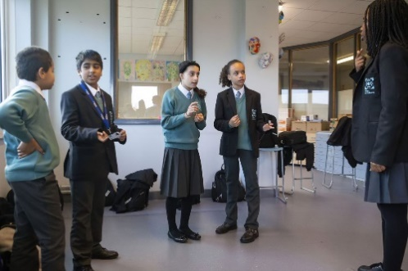


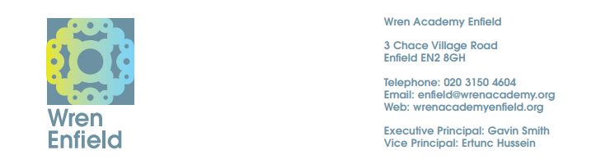

June 2024

Dear Colleague

Wren Academy Enfield – Receptionist (Administrative Assistant)

Thank you for your interest in this post at Wren Academy.

The information given in the documentation here and more general information elsewhere on our website should give you a clear understanding of the Academy. However, if you wish to find out more, please contact Penny Culmer on 020 3150 4604.

If you decide to apply, please follow this guidance carefully. Your completed application form, must be received by the Academy by 9.00am, Monday 15 July 2024, however applications will be considered as they are received. A hard copy of your application can be posted to the address above or sent by e-mail to recruitment@wrenacademiestrust.org.

Finally, thank you for taking on the demanding and time consuming task of preparing your application for this role. I look forward to meeting you if you are selected for interview.

Yours sincerely



Ertunc Hussein
Principal

The Wren Academies Trust is committed to the highest standards of safeguarding and promoting the welfare of children and young people and expects all staff and volunteers to share this commitment. A Disclosure and Barring Service Certificate will be required for all posts which will be subject to enhanced checks.

The Trust embraces diversity and promotes equality of opportunity. We wish to further develop a diverse community and encourage applications from all sections of society.

Receptionist (Administrative Assistant)

Full time position: Paid for working 40 weeks of the year, 36 hours a week.
Salary £24,459 - £25,583 per annum. NJC Scale Point 6 – 9.

Start date: As soon as possible

An exciting opportunity has arisen to work as part of a welcoming, talented and highly motivated team. The successful candidate will provide assistance in the smooth running of the Academy’s Reception and general administration.

Wren Academy Enfield is the second school of the Wren Academies Trust. Having successfully opened in September 2021 with a first cohort of Year 7 students.

Wren Academy Enfield is jointly sponsored by the London Diocesan Board for Schools and Berkhamsted School. This new school has been closely modelled on the successful Wren Academy Finchley which has a strong sporting tradition with high standards of involvement and conduct.

Wren Academy Finchley quickly developed a strong reputation for outstanding teaching and learning, as well as enabling students to make excellent progress as demonstrated by our Progress 8 figure, which places us in the top 100 schools nationally. All the factors that have led to the notable success so far are being put in place to ensure similar outcomes at Wren Academy Enfield.

The successful candidate will demonstrate excellent communication skills, a keen desire to learn and the ability to be part of a team. Training will be given where appropriate but experience of working in a fast-paced administrative environment will be desirable

The ability to work professionally and to deal with confidential and sensitive information is required. Relevant experience, together with the ability to interact appropriately across a number of levels, is also important. The successful candidate will demonstrate an ability to use their own initiative and to have a common sense approach.

Closing date: 9.00am Monday 15 July 2024

For an application pack, please see our website: Recruitment - Welcome to Wren Enfield (wrenacademyenfield.org)

Please note that we require the Wren Academy Application Form to be completed before we are able to consider your application. We do not accept CV’s.

The Wren Academies Trust is committed to the highest standards of safeguarding and promoting the welfare of children and young people and expects all staff and volunteers to share this commitment. A Disclosure and Barring Service Certificate will be required for all posts which will be subject to enhanced checks. The Trust embraces diversity and promotes equality of opportunity. We wish to further develop a diverse community and encourage applications from all sections of society.

WREN ACADEMIES TRUST

Wren Academy Enfield

Job Description – Administrative Assistant (Receptionist)

Purpose

The purpose of the job is to be a key part of the reception and administrative teams of the
Academy.

The colleague in this role needs to be able to deal effectively and professionally with visitors, carry out general administrative tasks and have a flexible and positive attitude.

Working Time

36 hours per week, for 40 weeks of the year (term time plus the last week of the summer
holidays)

Contract Type

Permanent

Reporting to

Senior Administrator

Duties

- To be responsible for the effective and professional operation of the Student Services Desk, this will include issuing vouchers, tablets and resources.
- To be responsible for the production and maintenance of Community Service Rota, including distribution to Senior Leaders.
- To create the Tutor Bulletin in a timely manner.
- To manage the distribution of the Academies Tablet Scheme.
- To cover for Reprographics when required
- To be responsible for the collation of Positive Contributions.
- To organise and order Stationery for the Student Services department.
- To assist with student enrolment, through the use of Admissions+
- To carry out typing and spreadsheet work, including updating student contact details in-line with GDPR.
- To undertake other general administrative tasks as directed by line managers, or the Executive Principal.
- To assist the Attendance Officer with attendance as and when required.
- To act as receptionist, greeting, assisting and directing visitors to the Academy, ensuring that entry is welcoming, safe and secure.
- To deal with the gate entry-systems, answer the telephone, and liaise with Site Services as necessary.
- To monitor the Academy camera system to support the safeguarding of the Academy students and staff.
- To help oversee the work of the Academy’s student receptionists.
- To be responsible for all external communication to parents and carers, including letters and text.
- To ensure that the Reception area is kept in an appealing and appropriate condition.
- To help organise tours of the Academy, as necessary.
- To liaise with Academy staff to organise effective procedures for hosting visitors.
- To deal with Academy post.
- To ensure that all staff badges are created and ready for Academy events.
- To be a First Aider.
- To take part in the Academy’s staff duty rota as appropriate.
- To be available for occasional work at Academy events, such as Open Evening.

Professional Behaviour

- To maintain high standards of professional behaviour towards colleagues and students.
- To lead by example and to follow the Academy’s dress code and code of conduct.
- To carry out duties in a friendly, helpful and professional manner.
- To have a flexible approach and to be prepared for the unusual.
- To uphold and actively support the Academy’s policies and procedures on the safeguarding of young people.

Assessment

- To continue personal development as agreed in performance management.
- To engage actively in the performance review process.
- To address the performance management targets set by the line manager.

Other Specific Duties
- To play a full part in the life of the Academy community, to support its distinctive aim, ethos and policies, and to encourage staff and students to follow this example.
- To support the Academy in meeting its legal requirements as a Church School.
- To have a record of excellent health, attendance and punctuality.

This Job Description is current at the date shown but, in consultation with you, may be changed by the Executive Principal, to reflect or anticipate changes in the job commensurate with the salary and job title.
July 2024

WREN ACADEMIES TRUST

Wren Academy Enfield

Person Specification – Receptionist (Administrative Assistant)

Professional Skills and Experience

- Experience in a similar role in either a school or other large organisation.
- A professional manner, good telephone and communication skills are essential
- An adaptable approach to work.
- Good information technology skills. High level typing skills are essential.
- Be able to demonstrate an understanding of secondary school systems.
- A friendly, calm personality and excellent interpersonal skills.

People, Relationships and Communications

- Be committed to maintaining a distinctive and inclusive Christian ethos in the Academy.
- Be able to relate to all students and staff in a positive and constructive way.
- Be part of a whole Academy team which seeks and develops a variety opportunities to support and work with students.
- Have qualities which earn the trust and respect of students, staff, parents and governors.
- Possess integrity, optimism, credibility, resilience, calmness and a sense of proportion.
- Possess good written and verbal communication skills.
- Be able to build constructive working relationships with local schools and colleges, employers and the local authority.
- Appreciate the balance between academic and social development of young people, needed to create an outstanding school.

Selection Process Details

Application deadline

Completed application forms must be received by 9.00am, Monday 15 July 2024.

Completing your application

Candidates are asked to read the details in this pack carefully, especially the Job Description and Person Specification. Please ensure your application fulfils all the criteria set out in the Person Specification and you present evidence of this. Please complete all the standard information required on the application form. Failure to provide information requested may lead to your application being rejected.

Your completed application should be emailed to recruitment@wrenacademiestrust.org. CVs will not be accepted.

Selection process

The selection process will consist of a combination of tasks, activities, lesson observations, presentations and interview. Further details will be provided to the candidates shortlisted for interview.

References

Candidates are advised that references will be taken up immediately after shortlisting. Please ensure that your referees are warned of the need to respond within the timescale set. The post will be offered subject to satisfactory completion of pre-employment checks.

Safeguarding children

Prior to appointment, formal checks will be made in accordance with the current statutory requirements relating to child protection.

July 2024

