DEHONG EDUCATION
JOB DESCRIPTION: Class Teacher – English Medium Learning

Working with us
A commitment to lifelong learning, for ourselves and our students so we can all make a positive difference
Dehong Education recognises that exceptional and inspirational teachers are our most valuable resource in providing our students with an excellent international education. Dehong teachers are ambitious for their students’ learning and put students first in everything they do. They have the highest aspirations for their students’ achievement and development, both in the classroom and through the many co-and extra-curricular activities on offer. Our teachers actively promote the School’s mission and vision through their enthusiastic and full participation in school life and their supportive engagement with students, colleagues and parents.
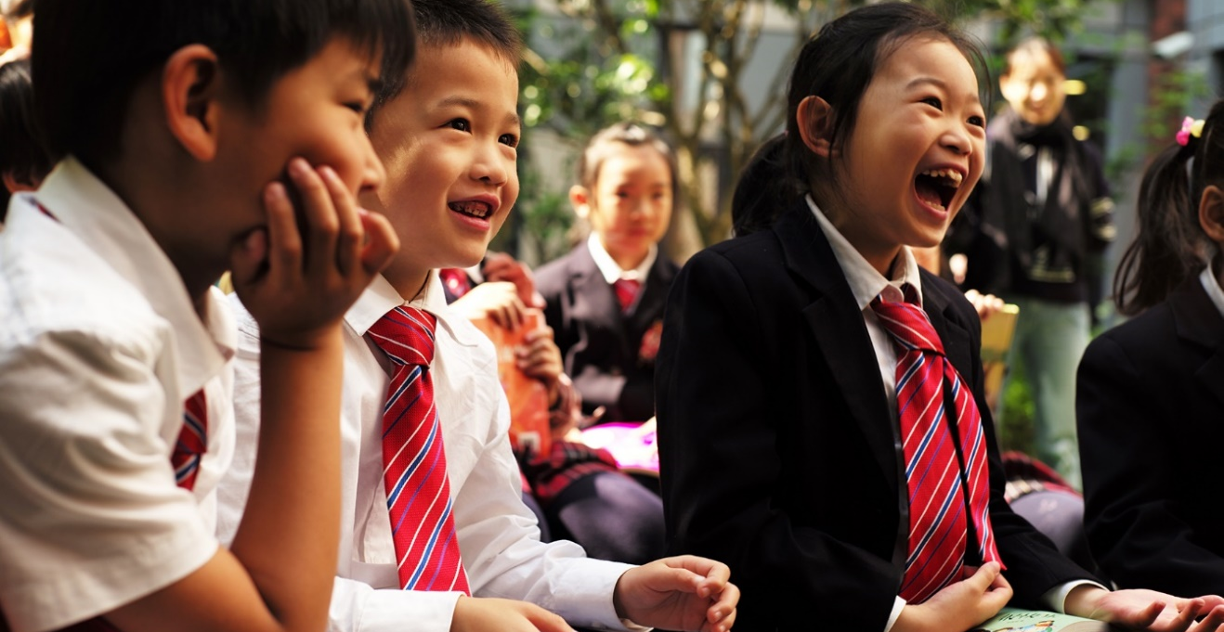

Role: | Class Teacher – English Medium Learning
Reports to: | Head of Elementary School
Purpose of Role:
The Dehong elementary school teacher creates a warm, flexible, language rich environment to promote high quality learning, student agency, and independence. He/she develops positive and caring relationships with students, parents and all school staff. The teacher motivates students to love learning and knows how to build knowledge and skills, leading to deeper conceptual understanding. The teacher understands how to support student wellbeing and the development of strong and positive character attributes essential to leading a successful and purposeful life. He/she works in close collaboration with others across the grade level and school to develop the Dehong curriculum and to plan and deliver exciting, academically challenging, inquiry- based units, which are carefully designed to ensure the development of each student’s language competencies. The teacher believes strongly in action research and uses best practice to inform his/her planning, classroom practice and assessment strategies. A clear understanding of Dehong’s vision, mission and learning principles is essential.

Learning and Teaching Standards
1. Know students and How they Learn | Dehong teachers have insightful and detailed knowledge of the developmental characteristics and learning needs of the children they teach. They have expertise and the desire to meet the wide range of individual learning and wellbeing needs of children who come from Chinese cultural, linguistic and educational backgrounds.
2. Plan for and implement effective learning and teaching | Dehong teachers have current knowledge of the curriculum in the age range they teach. They set high expectations and challenging developmental and learning goals for their students and use a variety of effective learning and teaching strategies, resources and digital technology to support their students in achieving these goals. They encourage their students to be innovative, imaginative, creative and critical thinkers who are able to work well with others.
3. Assess, provide feedback and report on student learning and progress | Dehong teachers are knowledgeable and effective users of assessment to support learning. They use a range of data measures and assessment strategies to inform their evaluation of students’ progress which enables them to plan for learning, to report accurately and effectively on student progress and to design appropriate intervention and support strategies
4.Develop supportive and safe learning environments | Dehong teachers are committed to safeguarding and to promoting the welfare of children and young people. They ensure secure, stimulating and well managed learning environments that promote a sense of safety, support and wellbeing.
5. Demonstrate International-mindedness and Global Citizenship | Dehong teachers have an appreciation of their own culture, as well as an openness to the perspectives, beliefs and educational philosophy of China. They respect other cultures, religions and languages. They recognise the importance of developing our students to be ethical Chinese and global citizens.
6. Engage Professionally in Learning and with the Community | Dehong teachers participate actively in professional learning and work collaboratively with colleagues to improve their practice. They hold themselves accountable to the highest professional standards in their interactions with colleagues, students and parents.

Additional Expectations
- Contribute to continuous innovation and to the enhancement of the Dehong curriculum (English medium learning components)
- Lead and/or support a minimum of one (1) co-curricular activity
- Attend and participate constructively in staff meetings
- Participate (including preparing students/activities) in assemblies, celebrations and extra-curricular events
- Collaborate with colleagues across Dehong schools and our Dulwich College International sister schools to share best practices across the network and participate in group-wide events as appropriate
- Support service learning and sustainability practices, events and programmes
- Other teaching and learning related tasks as determined by the Principal

Person Specifications
 | Required | Desired
Qualifications: | (Essential for China Work Permit)  - Bachelor’s degree in relevant/specialist subject area  - Post Graduate Certificate in Education (PGCE) or equivalent | - Masters degree  - CLIL or EAL qualification or experience  - Qualified Teacher Status in Australia, Canada, New Zealand, South Africa, UK, USA
Skills/experience: | - Mother tongue or near-native fluency in English  - Minimum 2 years’ experience in teaching inquiry-based learning (or PYP curriculum) within Elementary school  - Demonstrated success in working with students in the age range you are teaching  - For Specialist Teachers, demonstrated experience in your discipline  - A strong understanding of progressive pedagogy  - Effective planning and time management  - Creative and effective use of resources, including education technology  - Ability to maintain student focus and active engagement on learning  - Positive management of behaviour  - Strong, clear communication and listening skills  - Adaptable to varying contexts and an enthusiasm for working with Chinese colleagues and parents  - Experience in teaching EAL/ELL students  - Enthusiasm for curriculum study and development  - Demonstrated experience in using a variety of assessment and feedback techniques  - Demonstrated experience in raising achievement and setting aspirational targets | - Previous experience in an international school  - Some proficiency in oral Chinese Mandarin would be an advantage but is not a requirement  - Excellent subject knowledge, especially in literacy and elementary school Science (for non-Specialist Teachers)

Safeguarding Statement
We are committed to developing supportive and safe learning environments
Dehong Education is committed to safeguarding and promoting the welfare of all the students in our care and expects all applicants to share this commitment. We follow safe recruitment practices which are aligned to the recommendations of the International Task Force on Child Protection. We hold ourselves to a high standard of effective recruiting practices with specific attention to child protection. All appointments are subject to an interview, identity checks, criminal record checks, and successful references.

