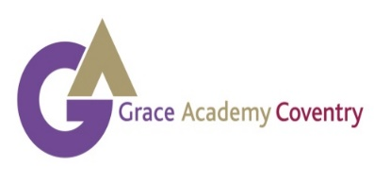

About Grace Academy Coventry
Welcome to Grace Academy Coventry where our vision is to develop well educated, considerate and caring citizens with a strong sense of values, who will succeed in, and contribute to, modern society. With Grace Academies situated in Coventry, Solihull and Darlaston, the Grace family is built on a Christian Ethos embodied in our core values of: Grace, Integrity, Excellence, Respect and Potential.
In April 2019, the three Grace Academies joined Tove Learning Trust, a multi academy trust committed to ensuring that all students achieve as highly as possible by offering stimulating environments that enable very learner to progress and flourish. There is a small central team and a committed Board of Trustees that are focused on delivering outstanding outcomes.
With a new principal appointed in September 2019 and fantastic Exam results, we are on a rapid journey to improvement towards outstanding. We believe that excellent teaching and support, fantastic facilities and outstanding enrichment activities combine to give our students the best possible preparation for their adult life.
We offer in house, bespoke CPD sessions to staff and also benefit from additional support, training and resources from the Trust. We work closely with our primary partners to develop relationships with our prospective students before they join us, including holding transition days and events to enable them to become familiar with the environment before they attend the Academy. With pupil intake numbers increasing year on year we are making the right progress to achieve our goals.
Our careers and enterprise programme includes inspirational workshops, bespoke advice and guidance, visits to universities and work placements with local employers. Students interact with our many local and national business partners.
As well as a strong emphasis on academic and examination achievement, an extensive choice of extra-curricular lessons, enrichment activities and clubs give students the chance to explore their creativity or acquire a qualification that will impress future employers. These range from girls’ and boys’ football and rugby, trampolining, basketball and dance workshops to our Duke of Edinburgh challenges.
We also work hard to retain students into our Post 16 and attract external students from the wider community. We encourage business dress at all times and offer dedicated study areas, computer suite and social spaces with an opportunity to study exciting A Level courses, specialised vocational courses or a combination of the two. Our aim is to provide students with the tools they need to progress successfully to university, further training or high quality employment.

