
Teacher of Classics (Maternity Cover)

Welcome
Worksop College and Ranby House; one community set across two schools - educating children from age two to eighteen. We're proud of being a broad-ability school - with a focus firmly on progress, recognising that every child has their own set of skills and abilities, whether it be academic, sporting, musical or otherwise. We believe that education is about more than the flight towards academic success, but about human flourishing.
We want our students to be the very best version of themselves. If they are destined to attend an established University, here is where they will flourish, or if they are an outstanding sportsperson, here is where they will hone their skills. Perhaps they are a talented artist or musician, here is where they’d perfect their craft, but if these talents are yet to be revealed, here is where they’ll be discovered.
We are a remarkable school, in a stunning setting, with exceptional facilities and a talented teaching staff. At our school, what matters is the individual, their aspirations and their future.

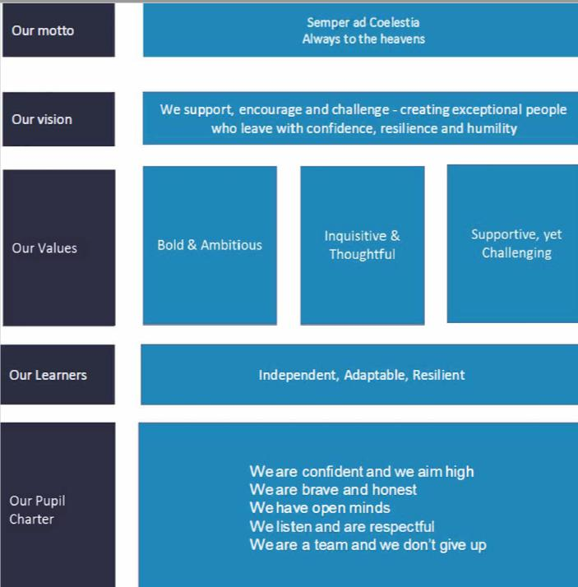
Our Value System
A golden thread that links from our school motto, right through to our pupil charter - our value system is a way of life. From the way we recruit, to the business decisions we make, teaching styles to personal development reviews, our value system is a blueprint for the way we behave and the vision we have for our pupils.

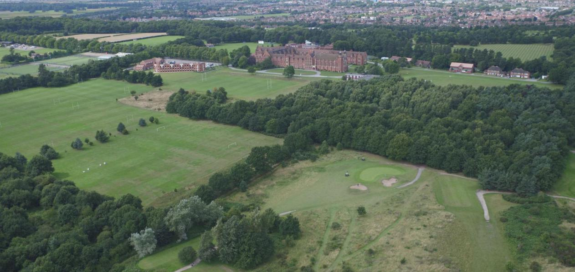

Where we are
Set in 400 acres of stunning North Nottinghamshire woodland, Worksop College and Ranby House has the benefit of a sprawling campus, with some of the best facilities in the county. The major cities of Sheffield, Doncaster and Nottingham are an easily commutable distance and give the school a secure and rural feel, whilst enjoying a comfortable proximity to city life. In addition, Worksop’s location on the edge of Clumber Park and with ease of access to the A1, M1 and East Coast mainline make it an ideal place to live and work. Major university cities Leeds and York are easily accessed by road or rail, as are Newcastle, Edinburgh or London, allowing for academic visits or personal enjoyment in the generous holidays. The Peaks, the Dales, even the Borders are also within easy reach.

The Role

We are looking for an outstanding teacher of Classics to join our experienced and passionate staff team to cover maternity leave. The successful candidate will be able to offer Classics and another Humanities subject to Key Stage 3 and GCSE – the ability to offer A-Level teaching would be advantageous but not essential, and applicants should detail their other specialisms in their application.
Our focus is firmly placed on academic excellence for all within a non-selective school. Worksop College is entering an exciting phase in its development, and we therefore wish to recruit dynamic and self-starting staff to work with us in fulfilling our aims and objectives.
The successful candidate will provide outstanding high-quality teaching and learning opportunities for our children, ensuring they achieve and make progress in relation to their potential and school expectations. The appointee will promote and support the mission, vision, values and ethos of the school and work as a supportive team member catering for a wide range of children’s needs and providing provision and organisation of a variety of learning experiences to support a broad, balanced educational experience.

Responsibilities

- Teach Classics and another Humanities subject.
- Contribute to the development of the super-curricular life and offer of the department.
- Promote resilience, adaptability, and independence through teaching.
- Teach engaging and motivating lessons informed by high expectations of students and designed to raise levels of attainment.
- Teach challenging, well-organised lessons and sequences of lessons across the age and ability range they teach.
- Have a secure knowledge and understanding of their specialism as an academic subject, including the contribution that their subjects can make to cross-curricular learning.
- Know how to use skills in literacy, numeracy and ICT to support their teaching and wider professional activities.
- Have high expectations of the pupils in your classes and motivate them to do well, providing extra support at clinics where necessary.
- Liaise with the Head of Department to maximise the progress of students.
- Offer support to the learning, pastoral and co-curricular needs of the individual students through the House system as a tutor, and the co-curricular programme. These duties should be carried out to a high standard to ensure the all-round quality of education for pupils at Worksop College.
- Adopt high standards of behaviour in their professional role.
- Maintain an up-to-date knowledge and understanding of the professional duties of teachers and the statutory framework within which they work.
- Communicate effectively with students, colleagues and parents, giving timely and relevant information about attainment, progress and well-being.
- Have a commitment to collaboration and co-operative working where appropriate.
- Design opportunities for learners to develop their literacy, numeracy, ICT, personal, learning, emotional and thinking skills.
- Contribute towards the planning and running of trips and organising speakers to come into school and the wider pursuit of scholarship.
- Plan, set and assess prep, other out-of-class assignments and coursework for examinations, where appropriate, to sustain learners' progress and to extend and consolidate their learning.
- Monitor the progress of students taking the subject in your class and set targets where appropriate; support key groups of pupils in their studies e.g. the most able pupils, and pupils with EAL or Learning Support needs.
- Have a good, up-to-date working knowledge and understanding of a range of teaching, learning and behaviour management strategies.
- Share resources and good practice, be involved in lesson observations and work scrutiny; be a part of collaborative teaching and continue your own professional development.
- Contribute to schemes of work at all levels.
- Participate fully in the school’s appraisal system and actively seek opportunities to further professional development.

The Department

The department comprises two members of staff and is housed in a dedicated classroom on the main cloister near the refurbished Library and the ICT suite. The department runs regular trips locally, nationally and internationally, most recently to the British Museum with GCSE and A-Level students. To give a flavour of the work of the department, in recent weeks the department delivered an interactive Classics Day to Year 8 with an external provider; and hosted an outreach day with our partner state schools in the shape of a day of workshops alongside both the Universities of Leicester and Lincoln. The department will be visiting Rome and Pompeii in October 2024 with 30 students and a trip to Greece is planned for the following academic year. It is expected that the successful candidate will seek active involvement in the work of the department beyond the classroom.

All Year 7 and 8 pupils study a bespoke Classics course covering religion, daily life and mythology and the Cambridge Latin Course book 1. In Year 9, Classical Civilisation and Latin are option subjects, and there are currently two classes of Classical Civilisation (where The Odyssey and Sparta vs Athens is studied) and one set of Latin, which continues with the Cambridge Latin Course.

Latin and Classical Civilisation are both offered at GCSE and at A Level and are becoming increasingly popular courses. Latin GCSE follows the WJEC/EDUQAS course, with departmental staff delivering their own subject specialisms and interests. The modules currently taught in the OCR GCSE Classical Civilisation course are ‘Myth and Religion’, and either ‘War and Warfare’ or ‘Roman City Life’.
At A Level both subjects follow the OCR course with Classical Civilisation including modules on 'The World of the Hero', ‘Greek Theatre’ and ‘Love and Relationships’. The set texts for Latin are currently Virgil and Tacitus.

The department also offers two courses of Greek as an extra-curricular activity (beginners and advanced), with the intention ultimately to offer students the option to take the subject as an additional GCSE.

Qualifications and Attributes

The ideal candidate will:
- possess a good degree in Classics, or a related subject (with a supporting PGCE or QTS).
- have experience of teaching Classics.
- have the ability to offer a further subject.
- be able to deliver inspiring and exciting lesson across the age range.
- have a proven track record of excellent results and an ability to encourage students to perform at the highest level.
- promote resilience, adaptability and independence through teaching.
- demonstrate a willingness to participate in the Christian traditions of the school.

Application

Please complete our application form which you will find as a downloadable file from our main profile on the TES website

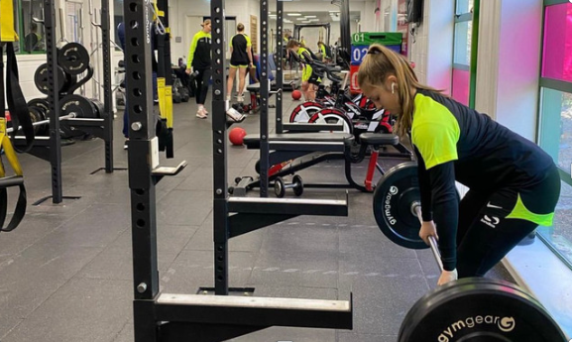

Benefits of working with us
Working at Worksop and Ranby House is as much about a lifestyle choice as it is about pursuing a satisfying career path. We have high expectations of our staff and reward with an attractive benefits package, which includes:
- Fee concessions for your children
- Workplace pension scheme
- Access to gym, sports hall and swimming pool
- Discounts across a number of retail and hospitality outlets
- Free lunch provided when on duty with tea and coffee available throughout the working day
- Free onsite parking


Statutory requirements & equal opportunities
Safeguarding & Child Protection
For this post applicants must be willing to undergo child protection screening, including, but not limited to, reference checks with previous employers, online searches, prohibition checks and a criminal record check via the Applicants Disclosure and Barring Service (including Barred List Check). All offers of employment are conditional upon the satisfactory outcome of child protection screening checks.
Disclosures
We will appoint, train, develop and promote on the basis of merit and ability alone. It is a stipulation of the Governors and a statutory requirement that members of staff appointed to Worksop College should be shown not to have any criminal record, which might prevent them accepting a post at the College. Accordingly, the College requires permission from all members of staff to make an appropriate investigation. Offers of employment are subject to a satisfactory outcome of this enquiry.
The post is exempt from the Rehabilitations of Offenders Act 1974 and the School is therefore permitted to ask job applicants to declare all convictions and cautions (including those which are “spent” unless they are “protected” under the DBS filtering rules) in order to assess their suitability to work with children.
Equal Opportunities
Worksop College is an equal opportunities employer and is committed to a policy of treating all our employees and job applicants equally. It is our policy to take all reasonable steps to employ and promote employees on the basis of their abilities and qualifications without regard to age, disability, sex, gender reassignment, pregnancy, maternity, marital or civil partnership status, race (which includes colour, nationality and ethnic or national origins), sexual orientation, trade union membership, religion or belief.


Getting to Worksop College
By road
Worksop College is easily accessible by all major roads and just 10 minutes from junction 23 of the M1. If driving, please use S80 3AP for your Sat Nav. The AA’s online route planner is a useful way of determining the route and distance ahead of your journey.
By Rail
Retford station is approximately 15 minutes away and the journey will take less than 1.5 hours from Central London.
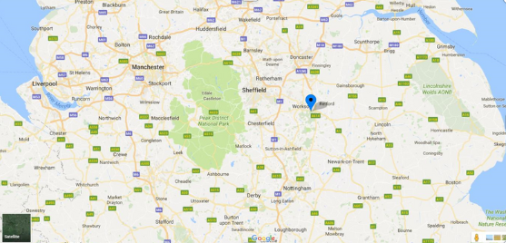


Contact us
01909 537100
HR@wsnl.co.uk

