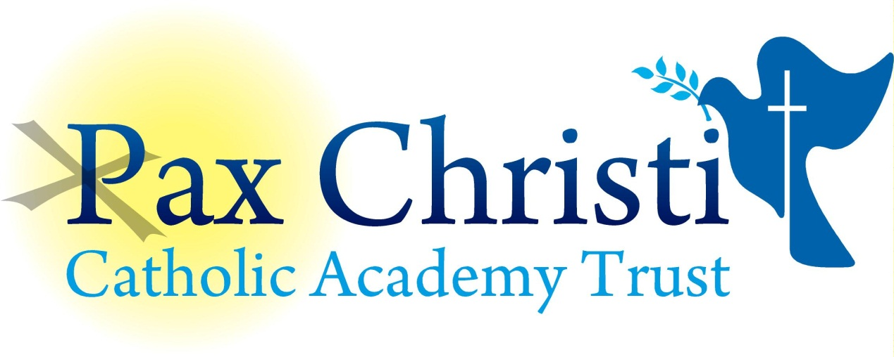

CHRIST THE KING CATHOLIC VOLUNTARY ACADEMY

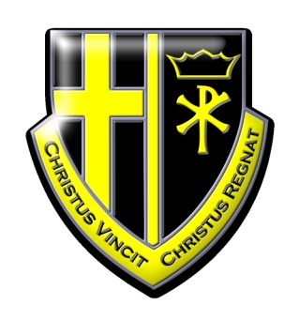

JOB DESCRIPTION

Technology Technician - Graphics/Resistant Materials

Current Post holder: | Vacant
Job Description Review Date:  Signed…………………………………………………………… | October 2017  Date………………………………………..

Job Purpose
This post holder will provide general technician support to the Technology Department (CAD CAM, Graphics Products, Resistant Materials and Product Design) which will include the preparation and maintenance of resources and support to staff and students.

Line Management
Responsible to: Principal, Support Services Manager,
Responsible for: No staff

Specific Responsibilities – Maintenance Duties
The post holder will:

- Prepare equipment and materials, including handouts, required for demonstration and for practical work and dismantling and storage after use.
- Assisting students and teaching staff with classroom practical and demonstrations.
- Inspect, repair and maintenance of machinery and hand tools and reporting equipment for repair if outside the capabilities of the technician.
- Construction and/or modification of simple teaching aids.
- Inspection, maintenance and correct use of safety equipment.
- Operating an efficient system for stocking, storing, transporting and distributing all items used in the Department.
- Operating departmental documentation systems cataloguing, filing, worksheets, etc.)
- Maintaining a good stock of necessary materials and operating and administering stock control including ordering procedures, preparation of requisitions, obtaining quotations, checking deliveries etc.
- Being responsible to the Head of Department for the maintenance and upkeep of the workshops and advising on any improvements which can be made in this respect.

Skills and Abilities
The post holder will be expected to demonstrate the following skills and abilities at all times during the discharge of their duties:

- Work on own initiative and to demonstrate the ability to solve unexpected or new problems in a methodical, efficient manner.
- Learn new skills and expand current skill set and to be able to pass on knowledge and techniques to others.
- Demonstrate good general interpersonal and communication skills.
- Deal with conflicting demands and work flexibly.

Whole Academy Responsibilities
- Be a positive influence on the climate and culture of the Academy and show a positive example at all times.
- Support the catholic ethos of the Academy.
- Be aware of and comply with policies and procedures relating to child protection, health, safety and security, confidentiality and data protection, copyright etc. reporting all concerns to line manager.
- Be aware of and support difference and ensure equal opportunities for all.
- Contribute to the overall aims of the Academy.
- Appreciate and support the role of other professionals.
- Attend and participate in relevant meetings as required.
- Participate in training and other learning activities and performance development as required.
- Recognise own strengths and areas of expertise and use these to advise and support others.
- Be flexible in hours/shift worked to meet the requirements of the school during term time and school holidays.

General

To work in collaboration with other Pax Christi Academies, sharing good practice and supporting during time of absence and/or heavy workload.
- This job description contains the main accountabilities relating to this post and does not describe in detail all the tasks required to carry them out. All staff are expected to be flexible to ensure the most effective organisation and delivery of services.
- The duties and responsibilities of the post will evolve with the natural development of the Academy and/or Trust. Such changes are, therefore, a normal part of the post and the post holder must be prepared to undertake any other duties commensurate with the general level of responsibility of the post which may be determined from time to time subject to the proviso that any permanent, substantial changes shall be incorporated into the job description and evaluated as such.

