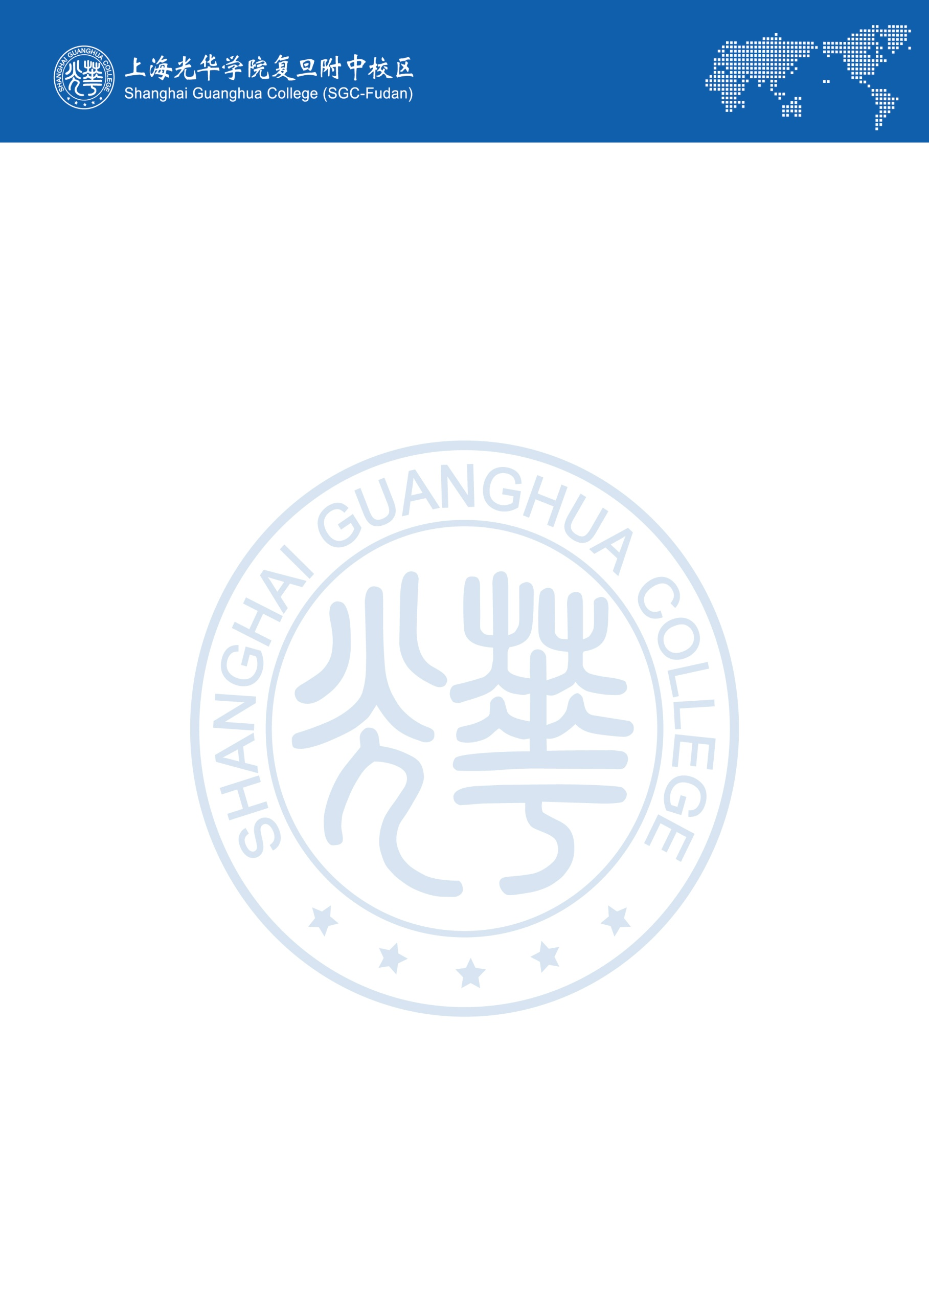
Guanghua Cambridge International School (GHCIS) is seeking
experienced and dedicated A level Teachers

Due to the differences between the education systems, Chinese students find the direct move from a Chinese high school system to a Western University exceedingly difficult. Language learning and cultural differences in educational systems make it challenging for a Chinese high school graduate to do well, if s/he has not been exposed to foreign language content instruction at home.
An appreciation of these problems by Chinese parents has led to a growing demand for offering an internationally recognized curriculum (A level) for Chinese high school students who intend on continuing their education overseas. Guanghua Cambridge International School has taken a key role in offering this academic alternative.
More than nine years have passed since our first opening in August 2011. We have thrived from a promisingly new school of 88 students to a moderately influential school of around 1000 students and more than 180 teaching and administrative staff. Our first graduating class of 17 students received nearly 80 offers including 3 from Oxford University (UK), 5 from Imperial College London (UK), 1 from Parsons School of Design (US), and 4 from top Canadian universities, marking an auspicious start. Further on, greater achievements have been proudly brought to us by our students this year (Sep. 2020), a total number of 1704 offers have been received by our graduating class of 2020, among which 13 were from Cambridge or Oxford University, 19 from London School of Economics, 54 from Imperial College London and 177 from University College London. We have also received 439 offers from US universities, as well as 110 offers from the top three Canadian universities (University of Toronto, University of British Columbia, and McGill University). As a result of this, GHCIS was ranked the no. 1 A-level school in Shanghai and the East China region in terms of university destinations.
In Aug. 2020, we opened our second campus, namely Guanghua Cambridge International School South Campus (GHCIS-SC). This serves as another landmark in GHCIS’s course of development. Both campuses have been fully equipped with teaching and learning facilities, which include 14 science labs (Chemistry, Physics and Biology), libraries, computer rooms, lecture rooms, an auditorium, music theatre, school canteen and sports field etc. The school also runs regular shuttle buses to the nearest metro station. On-campus accommodation is provided for the South campus staff; the school strives to provide a neat and comfortable working environment.

The school's culture and ethos define the school's identity; our school’s motto is 'Happy International School'. We strongly believe that happy teachers create a happy school. Based on our past experience in the international educational field, we realize how important good relationships are in a school and how a buzzing and friendly environment helps teachers and students in the process of productive teaching and learning. We welcome and respect cultural diversity. The school is committed to creating a relaxed yet disciplined working environment, to attract top talented professionals and maintain a high retention rate.
As we are an ever-growing school, there are many opportunities for professional development, making this an ideal job for dedicated professional educators who are seeking a warm and rewarding working environment.

School address: 2788 Chuanzhou Road, Pudong District, Shanghai. (Main campus)
1258 Dicui Road, Pudong District, Shanghai (South Campus)
Vacancies for August. 2021

We are looking for a drama teacher.

Personal specifications
GHCIS could be an attractive option for you if you,

- Hold a valid degree in relevant subjects and can demonstrate excellence and expertise in this subject
- Are a qualified teacher (PGCE preferred)
- Have at least one year of relevant teaching experience
Welcome cultural diversity; appreciate different thinking between Easterners and Westerners
Would like to have a unique teaching experience with well-behaved Chinese students
Are a committed educator and a passionate teacher
Care for students and take student centered teaching philosophy

Job Description
A teacher in Guanghua Cambridge International School always aims for the highest standards of professionalism both as a teacher and a team member of our staff.

Although this job description is not exhaustive, subject teachers will be responsible for the following:

- Having a general lesson plan for all lessons. The plan should be based on the published Scheme of Work and include lesson objectives, teaching methodology and homework details.
- Teaching strictly to the CAIE syllabus for each subject (please see more course details on https://www.cambridgeinternational.org/). Teachers should use the course book adopted by the school for each course and may supplement with any suitable resource material when necessary.
- Becoming familiar with the programs and courses of study used at the school to ensure the teaching quality.
- Assigning homework, periodic tests, and providing clear and actionable feedback in a timely manner.
- Preparing school reports twice each term: one at the mid-term and the other in the end of the term. School report preparation includes students’ individual test/exam scores or grades with teacher’s comments on student’s general performance, effort level, strengths, and areas of concern.
- Meeting with parents to discuss students’ progress according to the school’s arrangements. Those meetings are likely to be held after school hours or during the weekends.
- Promoting and adhering to school policies, such as uniform, classroom rules and other disciplinary policies.
- Recording attendance at lessons, and finding ways to investigate absence; report prolonged or regular absence to class supervisors.
- Participating in and/or help to organize extracurricular activities
- Being observed by the Academic Director, Subject Coordinator and/or designated personnel for evaluation purposes and to get support, encouragement and feedback for teaching.
- Following a set timetable for classes. Personal arrangements for replacements and switching classes are not allowed without management’s consent.
- Regularly evaluating his/her own performance and progress.
- Providing useful suggestions to students regarding their University entry requirements and write recommendation letters when required.

Remuneration Package:
For successful candidates, the school will provide a competitive remuneration package, which includes:
- Starting salary: all depends on the teacher’s academic qualifications and number of years of relatable teaching experience.
- For Newly Qualified Teachers: the entry point ranges from RMB 16,000 – RMB 18,000(taxable),
- For teachers who have three or more years’ experiences in the relevant subject areas, salary will be in the range of RMB 19,000 – RMB 23,000(taxable).
- Salary paid in 12 months, including winter and summer holidays.
- Completion bonus for a two year contract, which is equivalent to one month salary (excluding housing allowance).
- Paid Chinese Statutory Holidays.
- Housing allowance: RMB 7,000 for staff working on main campus. For staff working on South campus, there are two choices, teachers can take RMB 7,000 and find apartment by him/herself or take RMB 5,000 and live on campus. On campus accommodation is a fully furnished one-bedroom flat with en suite.
- Annual reimbursement for round trip airfare economy class up to a maximum of RMB 8,000 between your home country residence and Shanghai.
- Up to one -week free accommodation upon initial arrival into China.
- Paid mandatory health check (on arrival in China) and all visa extension fees.
- Medical insurance, high-end medical cover, can access to a wide range of quality hospitals.

Application Process

- Please send a CV to jobs@ghedu.com
- For any questions or informal inquiries, please contact Ms. Hannah Beasley: hbeasley@ghedu.com. Ms. Beasley is based in the UK and responsible for school expatriate staff recruitment.

- If you are being short-listed, our recruitment manager will get in touch with you, having an initial interview.
- If initial interview went well, you need to complete our application form, and provide all the required documents.
- Once we receive all the required documents, a demo lesson via skype will be arranged at a mutual convenient time.
- If the demo lesson is satisfactory, reference check will be conducted.
- If all the information we collected meet our expectation, proposed employment contract will be sent out.
- If you accept our offer, school HR will guide you for preparing documents for visa application.
- Airport pick up will be arranged once you let us know your flight details.
- Hotel will be provided in the 1st week after you arrive in Shanghai. During that time, our administration staff will help you to find an appropriate apartment.

FAQs (Frequent Asked Questions)

- How long is the Contract Length?
The normal contract length for teachers and staff is one to two years. A two-year contract is preferred, in order to maintain the continuity of the program and so a one-year contract won’t earn a gratuity bonus.
- Does the school help me to sort out visa issues?
Yes. You will be advised on how to apply for a visa to enter into China. Once you arrive in Shanghai, our administration staff will ensure you have the valid visa and help you to apply for the Foreigner’s Work Permit, so to change your visa type to ‘employment’. You just need to follow the instructions given by us and the school will handle the rest.
- Will there be anyone picking me up at the airport?
Once you give us your flight details and arrival date, we will send a local member of staff to meet you at the airport.
- Where do I stay after I arrive in Shanghai?
The school will provide up to one week’s free accommodation upon your arrival. The hotel will be pre-booked and paid, and one of our local staff will take you to the hotel.
- Do you provide on-campus accommodation?
We do provide on-campus accommodation on South Campus. Teacher receives a reduced housing allowance and can have a fully furnished one-bedroom flat with a brand new en suite. However, we don’t have on campus accommodation on Main Campus. Instead, we give a monthly housing allowance, and teachers have freedom to choose their own living space.
- Are you going to help me to find an apartment?
Yes - upon your arrival, our administration staff will contact the estate agencies and prepare a list of flats for you to view. Since our school is located at a very popular and easily reached area, once you find a flat you like, a quick decision needs to be made.
- How much does the accommodation cost in Shanghai?
The rent varies from location to location. Around our school area, a decent two-bedroom flat costs around RMB 5,500 – 6,500 and the rent for a one-bedroom flat will be around RMB 5,000.
- How much deposit do I have to pay initially?
Normally, three months’ rent and one-month deposit are required to be paid in advance (in addition, an agent fee would also need to be paid which is usually 1/3 of the monthly rental price). So, we advise staff to prepare some funds to cover the initial costs; the school can also offer a housing loan, if necessary.
- How is the salary paid and what’s the tax rate?
The monthly salary will be directly deposited to your account in Bank of China and is comparable to the standard pay scale for teachers. Personal tax increases gradually, taxes rate are approximately 20%. Salaries are paid on the first working day of the month (for the previous month), and are paid in RMB.
- Do I get medical coverage?
The school will provide medical coverage for you. Insured staff can go to the English-speaking departments of all state owned key hospitals in Shanghai. Detailed benefits will be given after the commencement date of your employment.
- What does your school calendar look like?
Our school has two semesters in an academic year. The autumn term normally starts from the middle of August and ends before the Chinese New year, while the spring term starts after the Chinese New year and finishes at the end of June. There are two and a half weeks for the winter holiday and six weeks for the summer holiday.
- What are the school holidays?
Please see the attached calendar for the academic year 2020-21 for an accurate representation of holidays. Although next year’s calendar is not yet available, it is likely to be very similar to this year.
Apart from the winter and summer holidays, the school also breaks for all Chinese statutory holidays, which include the following:
Summer Holiday | 7-8 weeks, Mid June - Mid August
Winter Holiday | 3 weeks in January/ February (exact dates depend on Lunar calendar)
Tomb Sweeping Festival | 1 day in April
May day Holiday | 1 day - 1st May
Mid Autumn Festival | 1 day in late September or beginning of October
National Day | 7 days: 1st – 7th October
Christmas Day | 1 week
New Year’s Day | 1 day: 1 January
- Does your school have a dress code?
Yes, we expect all staff members to dress wisely and appropriately to work at our school. Denim jackets and t-shirts are not acceptable.
- Does your school have an orientation program?
School provides induction program for all new staff in August, the program is divided into two parts; the first part is the understanding of the values, ethos and various policies of our school; the second part is about teaching and administration, such as the characteristic of Chinese students’ way of learning, what means a good lesson, what makes a good teacher, get familiar with school SOW and course syllabus etc. You can also ask any questions you may have during those sessions.

