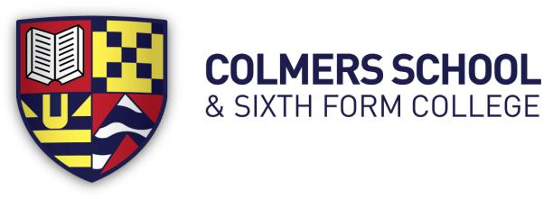
Bristol Road South, Rednal, Birmingham, B45 9NY
Headteacher: Ms E Leaman
Telephone: 0121 453 1778
11-19 Mixed Comprehensive School – 1150 on roll

TEACHER OF HISTORY

Full Time

Mainscale
Required for: September 2021

The Governors of this dynamic 11-19 school are seeking to appoint a well-qualified, enthusiastic and energetic Teacher of History. This post is suitable for an
experienced or newly qualified teacher. The successful candidate will join a collaborative team of highly committed teachers, on a mission to develop confident, curious and resilient learners.

We are looking for a colleague who understands the importance of History and is passionate about inspiring our students, equipping them with the powerful knowledge and understanding they need to succeed. This role will offer the successful candidate exciting challenges that will be both rewarding and fulfilling. You will be well supported to achieve your own personal career goals and aspirations.

Please submit applications to Mrs T Davis, HR Manager tdavis@colmers.school

Colmers School is committed to safeguarding and promoting the
welfare of children and young people and expects all staff to share this commitment.
We are committed to diversity, equity and inclusion.
An enhanced DBS check is required for all successful applicants.

Closing date for Applications: Monday 19th April at midday
Interviews Thursday 22 April or Friday 23rd April 2021

