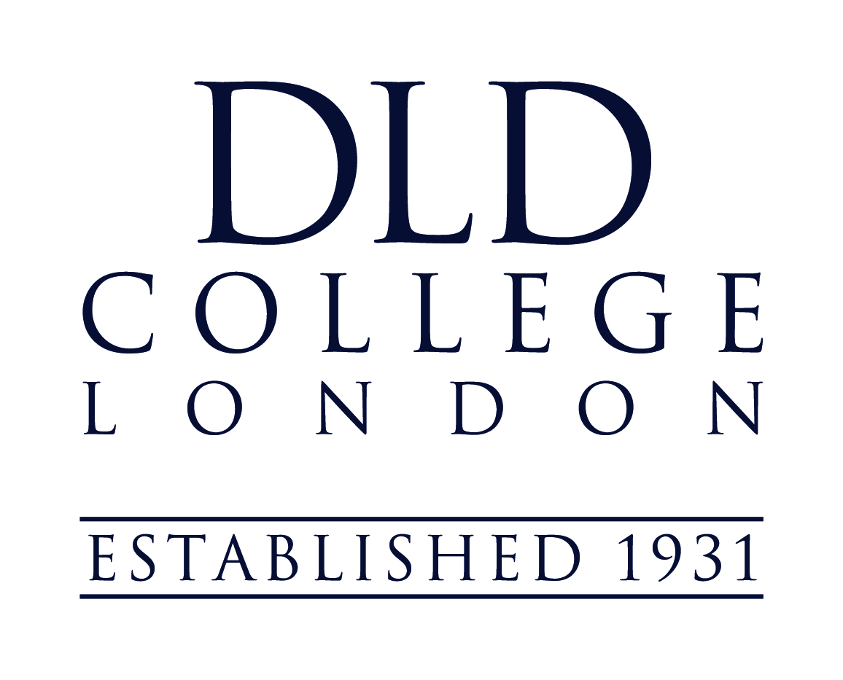
Job Description
Job title: Marketing & Communications Manager
Location: DLD College London
Reports to: Head of Admissions at DLD College London and Group Marketing Manager at Head Office
Responsible for: Chinese Liaison Officer
Job Purpose
The Marketing & Communications Manager is responsible for increasing applications for DLD College London in domestic and international markets. The Marketing and Communications Manager works with the Head of Admissions to develop the College’s marketing strategy and annual marketing plan, in collaboration with the College’s leadership team and the Group’s Marketing Manager at Head Office. The postholder oversees all marketing activities for the College and regularly generates content to stimulate demand and interest in the College. The Marketing and Communications Manager tracks and reports on essential marketing KPIs.
Key responsibilities
Marketing:

- Develop and implement a coherent marketing strategy for the whole College, in close consultation with the Principal and the Group’s Marketing Manager, aligned with College’s key aims, Development Plan, vision and values, so that student recruitment and retention is optimised at all times
- Raising of the College profile – nationally and internationally
- Development of an integrated marketing and communication strategy and regular analysis and reporting on all marketing tactics
- Responsible for the design and production of internal and external marketing material
- Effective management of external communications
- Creative design and production of College marketing collateral, liaising with external agencies when appropriate
- Responsibility for the production of the weekly newsletter (‘From the Principal’), invitations, programmes, business cards, College Christmas card and other marketing and communication collateral.
- Consistent implementation of the College’s brand guidelines, providing overall editorial and design control across all communications and advertising media
- Market research and competitor analysis (including mystery shopping)
- Development of strategic promotions that include systematic email and direct mail campaigns
- Acquire and share strategic customer insights that can be used to formulate action-plans that are based around an objective-first action framework
- Ensure photographs and video are captured and used in line with Group policy
- Generate original and engaging content – including video
- Daily engagement of differentiated content on social media channels including Twitter, Facebook, YouTube, Instagram, LinkedIn, VK, and WeChat
- Support planning of overseas recruitment trips and attend overseas recruitment trips to key markets, as agreed with the Principal. These will include working closely with overseas agents and/or attending international trade fairs
- Development and implementation of the College’s communications and PR strategy by raising awareness and differentiation across key markets – local, regional, national and feeder schools via effective tactical contact, advertising and communication plans
- Management of the College website, blog and electronic newsletter
- Ensuring listings and directories for the College are up-to-date
- Organising and attending College events – including those held in the evening, weekends and school holidays e.g. concerts and plays
- Writing and producing dynamic presentations and press releases
- Forecast, monitor and track key metrics such as return on investment, customer/student acquisition cost, and lifetime value
- Oversight and editorial control of the prospectus, College magazine (DLD Discover), and all other College promotional and advertising collateral, both print and digital, nationally and internationally, in close liaison with the Principal, Assistant Principal (Staff Development & Partnerships) and Head of Admissions.
- Strategic management of the College’s website, with responsibility for its continual evolution, update and ongoing accuracy. Development and implementation of an effective digital and social media strategy;
- Development and oversight of the College’s overall events strategy including Open Days, Feeder School events, Open evenings, taster events etc. – attending these whenever necessary;
- Visits to feeder schools, educational exhibitions and other UK recruitment events, as agreed by the Principal, as well as involvement in developing suitable links and relationships in the local community as a whole
- Development and responsibility for our alumni relations by keeping them updated with effective and appropriate communications and organising alumni events
- Oversight of marketing activity across all faculties and departments, providing guidance when necessary
- Networking and relationship building with all key stakeholders: feeder schools, DLD staff at all levels, the media, current and prospective parents and agencies both in the UK and overseas
- Any other tasks that the Principal may reasonably assign

Admissions support:

- Be an active, approachable and engaging presence for all stakeholders
- Provide advice to parents/guardians/agents about courses at the College
- Support projects and campaigns that have the potential to boost engagement, applications and student retention
- Assist in organising the testing of UK candidates working with academic staff at all entry points;
- Maintain a good working knowledge and experience of GDPR regulations
- Liaise with academic and pastoral staff for content generation
- Provide support and cover for other members of the Admissions department when necessary

Line management responsibilities:

The postholder will line manage:

Chinese Liaison Officer

Qualifications & Experience:
- A record of good academic achievement and educated to degree level or equivalent
- A demonstrable understanding of the principles of marketing, customer care and PR
- Proven organisational, communication, team and project management skills
- Established experience in managing a performance marketing channel (paid search or paid social)
- The ability to write and verbally communicate messages that are clear, concise and inspiring
- An understanding of understanding of digital marketing including social media, PPC, SEO and awareness of current digital trends
- The ability to generate high quality marketing collateral, including brochures, PPT presentations and infographics
- Certified at the enhanced DBS level (check undertaken prior to employment
Knowledge and Skills
- Excellent communication skills
- Excellent people management skills
- Energy, stamina and a sense of humour
- Strong management skills that can develop and coach colleagues
- Have a passion for education and excellence
- Strong typography, layout and graphic design skills
- Ability to multi task and deliver high quality work under tight deadlines
- Strong knowledge of Google Analytics, including reporting, audience and goal tracking
- Skills and awareness to differentiate between market segments (domestic and international families)
- A commitment to promoting and safeguarding the welfare of children

SAFEGUARDING

APG is committed to safeguarding and promoting the welfare of children and young people and as an employee of APG you are expected to share this commitment. The protection of our students’ welfare is the responsibility of all staff within APG Schools and individuals are expected to conduct themselves in a way that reflects the principles of our organisation.

September 2019

