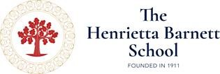

Design, Technology & Engineering Technician
(Start date: September 2023)

Information Pack

Appointment

The Henrietta Barnett School is seeking to appoint an enthusiastic Design, Technology and Engineering Technician to join an excellent department in this highly successful selective girls’ school. The department benefits from modern, purpose-built facilities, which include a fully equipped workshop and project room.

Training will be given, but knowledge of workshop tools, equipment, machinery and CAD/CAM technologies would be an advantage.

The successful candidate will be enthusiastic about progressive and forward thinking DTE curricula, and have a passion for STEM initiatives.

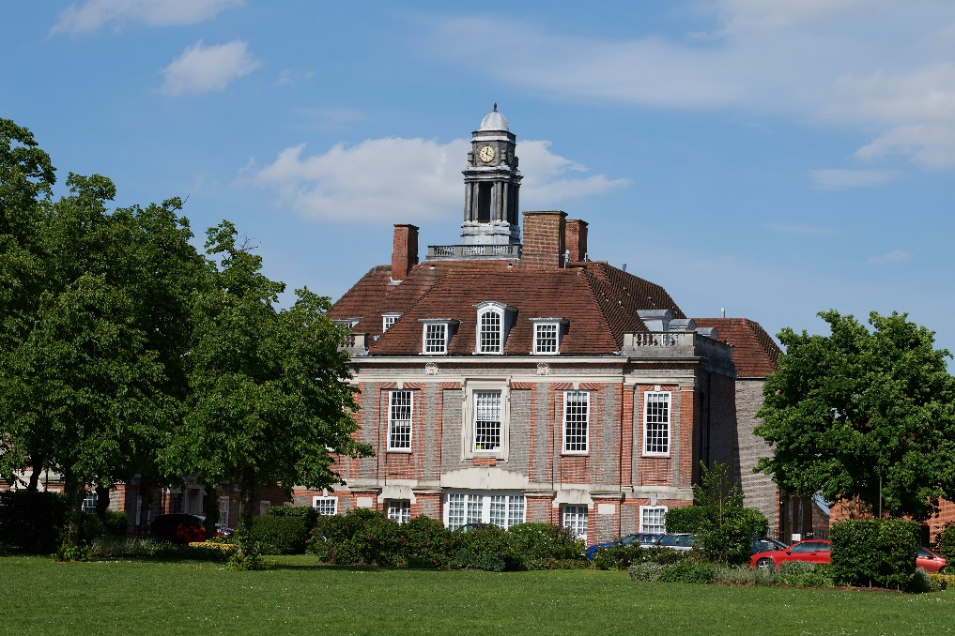

The School

The Henrietta Barnett School is a fully selective girls’ grammar school, situated in the beautiful surroundings of Hampstead Garden Suburb. Dame Henrietta Barnett, who was a social reformer, pioneer of education and champion of the poor and needy, founded the school in 1911. Dame Henrietta strongly believed in the power of education to shape people’s lives and founded the school to provide educational opportunities for the highest quality for its students.

The main school building, designed by Sir Edwin Lutyens, is Grade II listed. We were delighted to be awarded the title of State School of the Year 2023 for Academic Achievement by The Sunday Times Parent Power Guide for having the best GCSE and A Level results in the country. Over 25 students a year gain places at Oxbridge and the vast majority go onto study at the top universities in the country.

The aim of the school is to encourage and enable all students to make the most of their gifts and talents and to fulfil their academic and personal potential. We offer a challenging academic curriculum with enrichment opportunities throughout the school. We encourage students to enjoy their learning for its own sake and to value their independence of mind. We place great emphasis on high quality Teaching & Learning and provide regular high quality CPD opportunities for staff. Pastoral care and the well-being of our students and staff is our priority. The environment at HBS is unique; it is an extremely warm, friendly and vibrant school, with a very strong sense of community. We support all of our students and ensure that everyone is well known, valued and encouraged.

We provide a broad education that is ambitious, varied and stimulating. Academic excellence and a wide range of extra-curricular opportunities are offered in an open, caring and supportive environment, enabling each individual to thrive and achieve their potential. We are committed to developing the whole person, encouraging students to explore their interests in a wide variety of ways and promoting curiosity of mind, independence of spirit and a love of learning.

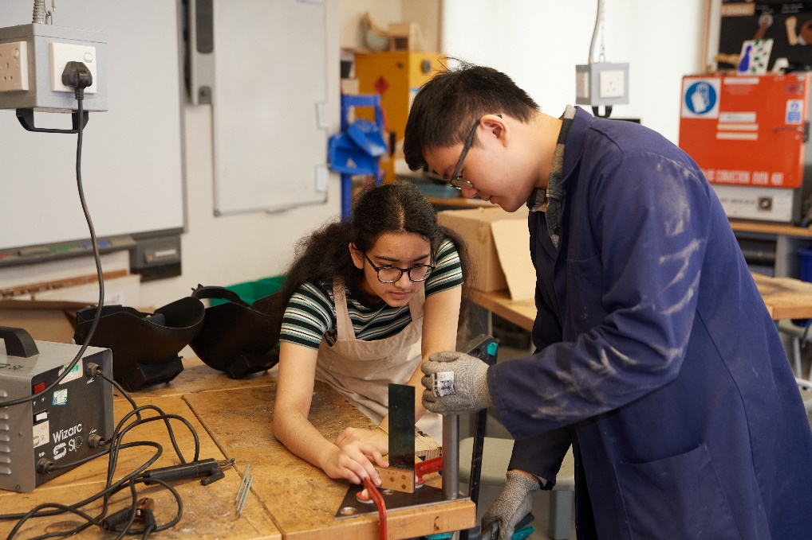

Design, Technology & Engineering Department

The Design, Technology & Engineering Department at The Henrietta Barnett School is a forward-thinking, progressive, dynamic and vibrant department, which is committed to providing an enjoyable and challenging experience of design and problem solving for all its students.

At Key Stage 3 classes enjoy one 70 minute lesson per week and complete three extended projects per year. Teaching focusses primarily on Resistant Materials but electronics, Systems & Control, Graphics and Textiles are also taught throughout the KS3 curriculum.

At Key Stage 4 we deliver the Eduqas Design and Technology specification. There are currently two classes in both Years 10 and 11, with two classes progressing to start KS4 next year.

At Key Stage 5 we deliver the Eduqas specification. We encourage the use of new and modern materials and manufacturing techniques pushing the boundaries of Product Design and providing the environment for exploration of new experiences. Practical lessons are design led and planning and preparation is tailored to meet the needs of individual students and their chosen design solutions.

Aims of the department

- prepare our students to cope in a rapidly changing technological world
- enable students to think and intervene creatively to improve that world
- develop skills required to participate responsibly in home, school and community life
- help our students to become discriminating consumers and users of products
- help our students to become autonomous, creative problem-solvers
- support our students working as individuals and with others
- equip our students with the knowledge, skills and understanding about materials, tools and processes (technical know-how)
- develop practical capability - being able to apply knowledge, skills and understanding when designing and making
- encourage the ability to consider critically the uses, effects and values dimension of design and technology (technological awareness or literacy).

Staff
- Head of department – full time.
- Teacher – part time.
- Technician.

Accommodation and resources
Bespoke designed suite of rooms, installed in 2010, comprising:
- Workshop equipped with workbenches, machines and hand tools for working with wood, plastic and metal. We have a computer controlled milling machine and laser cutter. Most of the tools and equipment are kept in the workshop accessible to students. There is an adjacent materials store with a panel saw.
- Design Studio with computers, individual workplaces and large tables. It is used for graphic design, model making, textiles and electronics. A small design library is available for students. A 3D printer is available for students to use.
- Project Room opening directly off the studio. This is used by students working individually and as an overflow space for both the other rooms. Students’ folders are kept here together with graphics and textiles resources. We also have a computer controlled cutter for card and thin plastic and an A4/3 colour laser printer.

Job Description

General responsibilities
- Work flexibly with the DTE teaching staff
- Be responsible to the Subject Leaders
- Participate in the development of the department’s practical activities
- Maintain the DTE working environments
- Attend appropriate Health and Safety courses and implement safety measures.

Support in teaching
- Prepare materials according to staff and student requirements
- Support teaching staff in practical lessons, helping and advising students in conjunction with the teacher
- Prepare and clear away equipment in practical lessons as requested by teachers
- Prepare and construct teaching aids to include sample projects if required
- Assist with general administrative tasks and on occasion provide lesson cover for absent teachers in other subject areas if required.

Stock control & order
- Monitor stock levels of all consumables and advise Subject Leaders when stock needs to be re-ordered
- Complete and record orders in accordance with departmental policy
- Organise stock so that it can be accessed quickly and safely
- Manage the safe and accessible storage of all hand tools and equipment
- Prepare materials in advance of project work.

Skills
(These are desirable but not essential to be appointed). If you do not yet possess these skills you must have a willingness and capacity to learn them within a short and mutually agreeable time period.
- Be familiar with and be able to use 2D and 3D CAD software in order to support staff and students in the production of practical work in DT
- Be familiar with CAM technologies such as laser cutting and 3D printing
- Assist with the development of a STEM focused practical activities across the school.

Health & Safety
- Complete and maintain risk assessments in consultation with the Subject Leaders
- Ensure the general safe working of all equipment, the safety, security and tidiness of Studios
- Carry out weekly H&S checks of all machines and the environment in line with requirements set by HSE
- Maintain workshop machines to ensure safe and accurate working of staff and students. This includes replacing wearable parts such as blades and bands
- Maintain hand tools and equipment as required
- Liaise with specialist tool maintenance company for any repairs that cannot/ should not be done on site.

Reprographics and Paperwork
- Carry out some photocopying and collation of teaching/exam materials
- Assist in organising filing of teaching material and students’ work, and record keeping.

Note: The job description is not necessarily a comprehensive definition of the post. It will be reviewed at least once a year and it may be subject to modification or amendment at any time after consultation with the holder of the post. The duties may be varied to meet the changing demands of the School at the reasonable discretion of the Head. This job description does not form part of the contract of employment. It describes the way the post holder is expected and required to perform and complete the particular duties set out.

Safeguarding: recruitment

We have a duty of care to ensure the well-being of our students. As a school, we maintain the highest possible standards during our recruitment and interview processes. Only by doing this can we maintain the quality of the staff we recruit. It is the duty of any post-holder appointed to promote and safeguard the welfare of pupils at the school.

The Henrietta Barnett School values the diversity of our staff and students and all of our staff are equally valued and respected.

