Hills Road Sixth Form College, Cambridge
Appointment of a Director of Maths

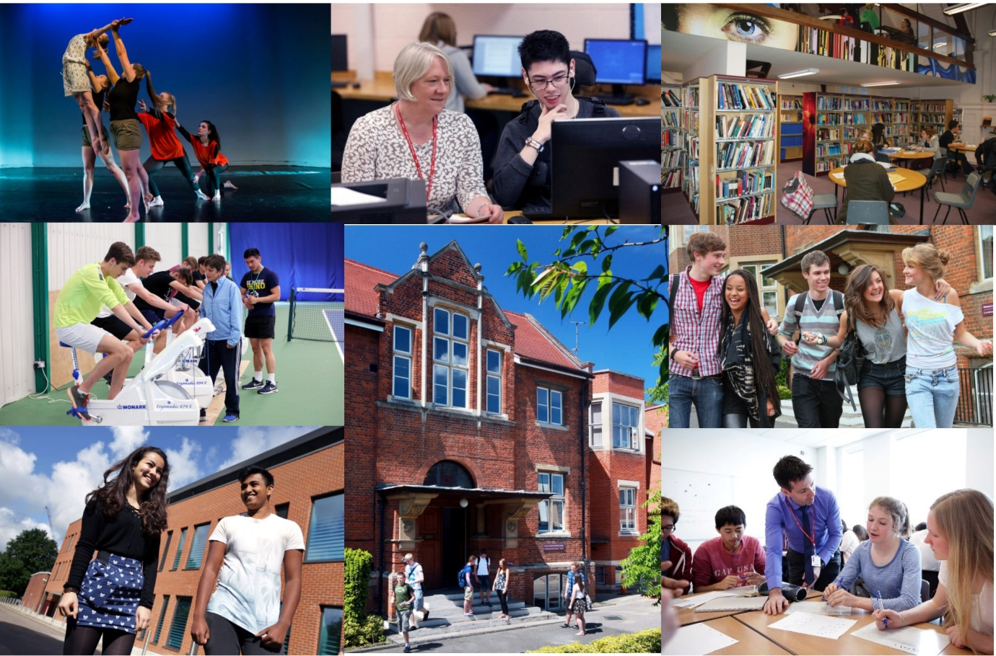

Opportunity ● Quality ● Achievement

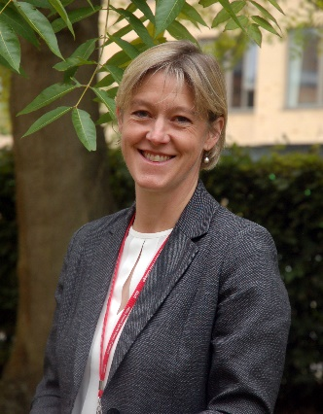
Welcome from the Principal

Thank you for your interest in Hills Road Sixth Form College and in this post of Director of Maths. We really hope that the information in this booklet will support you in making an application to our College and will provide all you need for deciding whether our College is right for your next career step. We hope it is!

Choosing an institution where you find a fit in terms of ethos and values is hugely important. Hills Road Sixth Form College enjoys a strong national reputation, having topped Sixth Form College performance league tables for outcomes since their inception over twenty years ago. But that doesn’t make us complacent. We still want to evaluate and improve the ways in which we work with young people to get the best for them and from them, whatever that might take.

We are therefore looking for a colleague to join us who shares that drive and wants to make a real difference by communicating a passion for their subject and sharing that enthusiasm and expertise with our students. As a specialist A level College, we have a fantastic cohort of students to work alongside and we will be seeking a colleague who is committed to making A level learning experiences as good as they can be. Through the application and interview process, we’ll be keen to understand your ideas and approaches to delivering the best learning experiences and outcomes for A level students.

As an education organisation, we’re keen on learning and will be keen to support you to keep developing in your time with us and to share that learning with others. At our biennial Learning Fairs, we share action research projects of ways in which we’ve been working with students to secure increasingly positive outcomes. As part of the Cambridge and Suffolk Schools Alliance, we have opportunities to learn from schools across both counties in the primary and secondary age ranges too which, in turn, informs our thinking about the best ways to meet the needs of A level learners.

As a busy, vibrant community of nearly 2,400 young people, there’s always a great deal going on and lots to be part of and take part in. Extra-curricular opportunities abound and we hope you will want to get involved with the extraordinary range of activities that is on offer. If you would like to talk through a prospective application or to explore the College’s ethos and values a little more, please don’t hesitate to make contact for an informal chat.

Finally, I do appreciate the time commitment involved in completing a job application and, if you do decide to apply, can I thank you for the investment of time you have chosen to make. Whatever the outcome, can I wish you all the very best with securing a positive difference for young people, wherever that may be.
With very best wishes
Jo Trump
Principal
Overview of the College

The College

The College operates on an attractive site just over a mile south of the centre of the historic city of Cambridge. The site has been occupied from 1903 when it was originally home to the Cambridge and County School for Boys. Since its inception in 1974, succeeding the former boys’ grammar school, the College has concentrated mainly on providing Advanced level courses to students in the Cambridge area. Having responded to strong and sustained demand for places over a number of years, we now have nearly 2,400 full-time 16-19 students for whom we provide a choice of 34 A level subjects plus the Extended Project Qualification, an extensive programme of enrichment and extra-curricular activities and responsive individual support and guidance. The breadth, depth and challenge of this curriculum are at the heart of our long-standing educational vision.

The College is a member of the Cambridge Area 14-19 Partnership: there are ten other centres for post-16 education: Cambridge Regional College, Long Road Sixth Form College, The College of West Anglia, The Cambridge Academy of Science and Technology, (formerly the UTC Cambridge), and six school sixth forms. The Cambridge Area 14-19 Partnership provides a common application procedure for post-16 courses and co-ordinates the information and guidance services for student transfer at 16+. The great majority of our full-time sixth form students are recruited from 18 maintained secondary comprehensive schools in the Cambridge area, 12 of which do not have their own sixth form.

We deliver an Adult Education programme, mainly during evenings and some weekends. The number of part-time adult student enrolments is around 4,000 a year. The range of courses reflects the needs of a much wider community in Cambridge and the surrounding area. The College is also a study centre for the Open University.

The Hills Road Sports and Tennis Centre is solely owned by the College and operates as Cantabrigian Ltd. While providing an outstanding facility for staff and students of the College, it also serves as a community sports centre working in partnership with Cambridge City Council and the Lawn Tennis Association. Local residents use the centre on a pay-as-you-play basis or via the membership scheme. Activities range from tennis and fitness room sessions to squash, cricket and Pilates.

College Performance

Hills Road Sixth Form College enjoys a national reputation for excellence and, in its last two Ofsted inspections, was rated outstanding in all graded areas.

A summary of the College’s performance
- In the Government’s examination performance table for ‘points per examination entry’, the College has consistently posted the highest score of any sixth form college in the country.
- In recent years the tables have included the percentage of students achieving at least AAB at A level in at least two of the Russell Group's 'facilitating subjects'. Year on year Hills Road has recorded the strongest sixth form college percentage.
- The College’s in-year learner level retention rate on study programmes, as used for funding purposes, has averaged 99.4% over the past six years. In last year’s first set of retention figures to feature in the Schools Performance tables (SPT), both our 97% retention rate from Year 12 to Year 13 and our 98.7% retention rate in Year 13 were the second highest for a sixth form college.
- A level pass rates have remained close to 99.5% for five years.
- Value added has tended to be positive overall indicating that, on average, Hills Road students achieve better results than might have been expected based on their prior GCSE outcomes.
- Often after a gap year, around 90% of our leavers progress to Higher Education; two thirds go to the most sought-after Russell Group universities.
- Hills Road students consistently thrive in higher education with 41% earning first class honours degrees in 2017 according to the latest Sixth Form College Association report which is based on HESA data.
- Hills Road has been shortlisted in 2017, 2018 and 2019 as a finalist in the TES ‘Sixth Form College of the Year’ award.

Exam Results 2018

The 2018 A Level results are very similar to the typical, strong level in recent years and are likely to translate into another good performance in the Government’s league tables:

 | 2018  HRSFC | 2018  National
A* | 13.4% | 8.0%
A* - B | 71.6% | 52.7%
A* - E | 99.5% | 97.6%

College Ethos

At Hills Road we are strongly committed to providing our students with a broad sixth form education characterised by academic excellence, high quality learning experiences and extensive enrichment opportunities. Students are encouraged to achieve the highest standards not only in the classroom but also in a range of extra-curricular activities which help them to develop new skills, think independently and exercise their responsibilities as global citizens. We seek to promote a caring and supportive atmosphere with a strong sense of community in which all students are valued equally as individuals and treated as young adults.

From teaching and tutorial departments to administrative and support functions, Hills Road staff are deployed within specialist teams where their expertise, knowledge and skills may be used to best effect: each student has a specialist tutor with whom s/he meets regularly; subject departments offer lunchtime workshops where students can receive one-to-one support with homework queries or extension work; help with all aspects of learning, from essay writing to time management, is available from the specialist team in the Study Skills Department; and the Careers Department advises students on the world outside and beyond Hills Road, from work experience to UCAS applications. The Student Services Team respond to all manner of student need and ensures a qualified staff member is available throughout the College day to respond to student concerns in respect of wellbeing and mental health.

Specialisation brings considerable benefits to staff as well as to students: not only does it have a significant impact on the quality of teaching, support and guidance, but it also helps to enrich working relationships and to promote a culture of learning and continuous improvement. Teams are encouraged to work in creative and collaborative ways and to reflect on their own and each other’s performance.

College Facilities

Throughout our history the buildings have been extended and refurbished to meet changing needs. All lessons take place in high quality, purpose-built accommodation. In addition to excellent classrooms which are fully equipped with digital media resources, the College enjoys first class facilities including: extensive open-access IT facilities, a Library and Resources Centre, The Robinson Theatre, a modern well-equipped Music Department with recital room and practice rooms, an Art and Design Centre and specialist laboratories for science and language learning. Indoor and outdoor sports facilities are excellent, with the Sports and Tennis Centre located on the main site and a well-maintained ten-acre sports ground, including a modern pavilion, situated within a short walk from the College. The most recent addition to our facilities is The Linda Sinclair Building, a fabulous three-storey building at the edge of our site which provides outstanding accommodation for the Maths, Performing Arts and Sport departments.

We recently opened a new Student Services area at the heart of the College site. This houses the Supported Independent Learning Service, the Careers department, a new library-style student study space and a reception area staffed by members of the Student Services Team.

College Finances

Since incorporation, the College has managed its finances effectively and has continually met the financial criteria under the different funding bodies. The College’s financial returns have been consistently assessed as ‘outstanding’ over many years with the years ending July 2016 and July 2017 scoring ‘good’ as a result of cash being invested in the most recent stage of the College’s Property Strategy which was completed in May 2016. Full management accounts are produced each month in order to monitor and manage the finances and to report to senior management and the Corporation in a timely manner. Sound financial management has allowed the College to maximise the potential for investment in human and physical resources and, in particular, to fulfil the phases of its long-term property strategy.
Advert
Director of Maths
Salary L4 £48,494 to L6 £51,161
Required from 23 August 2019

Are you looking for an opportunity to develop your leadership skills, both within a department and across an organisation? Do you have the skills to lead a large team in securing outstanding outcomes for all students?

We are looking for an excellent practitioner to lead our large and vibrant Maths department. Maths is the largest department within our sector-leading sixth form college, with approximately half of all students studying Maths A level. In addition, we have one of the largest cohorts of Further Mathematicians in the country. This new post has been created to reflect the strategic importance of the Maths department within the College and to give it a voice at a more senior level.

You will already be a Head of Department, or a second in department/teacher with leadership experience gained in a secondary school or College. You will have worked in an environment with substantial A level Maths provision at some point in your career. You will bring clarity of vision, be a creative and strategic thinker and be capable of inspiring trust in staff and students. For someone with drive, energy and enthusiasm the College will provide a stimulating, supportive and exciting environment to support your career development, including for those with senior leadership goals.

Please refer to the job description and person specification; if you would like to discuss any aspect of the role before making an application, please contact Nicki Dartnell (Deputy Principal) for an informal discussion ndartnell@hillsroad.ac.uk

Details and an application form for the above post may be obtained from our website www.hillsroad.ac.uk

If you would like any further general information please speak to the College’s Human Resources Manager, Michele Nightingale on 01223 278063 or email mnightingale@hillsroad.ac.uk

The closing date for applications is 9.00am on Monday 21st January. Interviews will take place on Monday 28th January and Tuesday 29th January.

The College is committed to safeguarding and promoting the welfare of its students and staff and expects all members of the College community, volunteers and visitors to share this commitment. The College actively promotes equality and diversity and welcomes applications from all sections of the community.

Information for applicants for the post of Director of Maths

The Post

As the biggest department in this highly successful Sixth Form College, this post represents a fantastic opportunity for a talented and committed mathematician. With over 1,200 Maths students on roll, the scope for professional development within this role is significant. The role we have is for a Director of Maths to begin with us on Friday 23rd August 2019. It represents an excellent opportunity for a well-qualified and experienced leader to lead this large and forward-looking department in the next phase of their development. Additionally, the Director of Maths will have a place on Curriculum Team and will be involved in developing teaching and learning at whole College level, representing this large department in a more senior capacity.

The Department

Presently, the department consists of 19 members of staff, a mix of full and part time, including a part-time administrative assistant. Between us we have a great deal of teaching experience and come from a range of backgrounds. We are always looking for ways to develop further and come together, not just in department meetings, but also at break and lunchtimes to share teaching ideas over tea and coffee (often with biscuits or home-made cake!).

Departmental Management

The department is currently led by a Head of Department, who receives a paid and timed allowance for the completion of duties, assisted by a Second in Department. From 2019 the Head of Department role will be superceded by the Director of Maths post.

There are twenty-five teaching periods in the College week. The new post holder will have teaching commitments of up to thirteen and a half periods a week, with six and a half periods of time remission for the post (a full time teacher having twenty periods a week contact time). Whilst the majority of this time remission will be to manage the Maths department, as a Director and member of Curriculum Team there will be some involvement in meetings and duties across College.

In addition, several members of the department are allocated time resource, which is used widely for the support of students. Some of this resource is also used to fund a gap year Maths student to support students through the day. Other resources are used to support students in their applications to university, to develop the use of IT within the department, to organize trips and visits, and to develop internal assessment tasks.

Students

There are approximately 1200 students in the department. The students are generally well motivated and able; the vast majority progress to higher education courses, many involving the study of Maths. The teaching is rewarded by the rapid development and achievements of our students, who readily acknowledge the high level of support they receive from both teachers and support staff.

Courses Offered

We offer courses in both Maths and Further Maths (both AQA board). Further Maths is taught alongside Maths in “Double Maths” classes. For the applied options in Further Maths all students will complete more Statistics and more Mechanics.

Most sets contain about twenty-three students and are generally taught by two teachers.

Course | Number of sets in Y12 | Number of sets in Y13
Single Maths | 23 | 20
Double Maths | 11* | 7
AS Further Maths |  | 1

* These students will make a decision as to whether to complete double Maths or change to single Maths at the end of year 12.

The department provides classes for students who face additional assessments when they apply to university; around fifteen per year apply to study Maths at Cambridge or Oxford and others to study Maths or mathematically-based subjects at universities with demanding entry requirements.

Examination Results

The A-level results for 2018 were:

 | % A*-B grades | % A*-C grades | % A*-E grades
Maths | 75 | 87 | 99
Further Maths | 70 | 86 | 99

Accommodation and Resources

The department occupies a new purpose-built suite of ten teaching rooms and a staff base room, also including a resources area incorporating a computer suite and a library area. All teaching rooms are equipped with computers and data projectors. In addition, there is ample access to computers in the base room. There is a substantial Maths section in the College Library.
Extra-curricular Activities

Over 180 students opted to take part in the Senior Mathematical Challenge last year, with nearly 20% of them obtaining gold certificates.

Parties of students attend lectures both locally and in London about Maths and its applications and there is the opportunity to attend lectures and events organised by Cambridge University.

I would like to take this opportunity to thank you very much for the interest that you have shown to this point in the College, the Maths Department and this post and hope very much that you will decide to apply. Can I thank you in advance for the time that it will inevitably take to do so: we do appreciate that.

Gary Wing
Head of Maths
gwing@Hillsroad.ac.uk
01223 247251 extn 1243

Job Description

Director of Maths

Purpose: To provide leadership and strategic direction for Maths across the college, bringing evidence based approaches to the delivery and experience of Maths at A level, supporting Maths staff and students to achieve their full potential.

Reports to: Deputy Principal

Main Accountabilities:

Curriculum planning, development and delivery
- To lead members of the department in developing a conscious curriculum that supports mastery of mathematical skills and to initiate action and change, where appropriate
- To identify any relevant development issues and to support the implementation of an appropriate action plan to ensure improvement
- To evaluate the impact of any improvement activities on the quality of teaching and learning and on outcomes for students and staff
- To deploy departmental staff appropriately and to plan departmental timetabling and room allocation effectively
- To ensure that departmental and staff annual objectives are aligned to the College’s vision and operate effectively in order that individual students and staff meet their personal goals

Leadership of Teaching, Learning and Assessment
- To lead and model excellence in Maths teaching and learning to enable all students to grow in independence and achieve their academic and personal potential
- To be an outstanding practitioner of Maths and to be able confidently to lead the department to:
- implement and monitor strategies to ensure teaching across the subject area is consistently good or better
- ensure all teachers in the subject are contributing to the development and review of schemes of work and lesson planning and provide exemplars of good and outstanding lessons
- ensure class work is supported by suitably differentiated and challenging independent learning that is regularly set and assessed
- raise attainment and value added
- contribute and co-ordinate continuous evidence based CPD for staff to ensure teaching and learning strategies take account of best practice and knowledge about how students learn
- To ensure that assessments provide sufficient challenge to stretch the most able, while identifying under-performance and that assessment provides timely opportunities for students to develop their problem solving skills through the revisiting of previous topics

Liaison and Progression
- To support the successful progression of full-time students from their previous school, creating effective partnerships with feeder schools through outreach visits and research projects
- To ensure the provision of opportunities to enhance and extend the mathematical understanding of the most able and those seeking the most competitive Higher Education routes
- To participate in both enrolment days in August, acting typically as part of the course change team for new students
- To develop links with the wider community, where appropriate, introducing a programme of talks, visits and opportunities to draw on the mathematical expertise of the Cambridge area
- With colleagues, to contribute to the curriculum advice and guidance provided to partner schools within the Cambridge Area Partnership, through attendance at advice evenings and through other communication channels, as appropriate
- To take an active part in the admissions process, in particular by interviewing applicants

Managing People and Communication
- To plan, and contribute to, the recruitment of staff in accordance with the Appointments Guidelines Section of the College Handbook
- To take responsibility for the induction of new members of staff in accordance with the section of the College Handbook on Support for Staff during their Six Month Probationary Period
- To ensure that all staff for whom the post holder is responsible receive adequate support and training for their role
- To communicate effectively College and departmental procedures and policies to all members of the department
- To promote and explain departmental issues to other audiences, for example parents, governors, staff and prospective students
- To plan and organise the work of technical and support staff, where appropriate
- To manage the placement of student teachers, where appropriate
- To promote collaborative and effective teamwork within the department

Managing other Resources
- To manage the finances of the department
- To advise on the provision of appropriate departmental facilities and accommodation and to lead on the provision of appropriate resources, including online provision of independent learning materials
- To advise Estates of the maintenance needs of the department

Quality Assurance
- To monitor student performance data and take appropriate action
- To monitor and evaluate assessment data across the Department to identify trends in student performance and progress, and issues for development
- To plan and maintain appropriate record-keeping procedures, including through Markbook and the provision of a subject Progress Review for each student
- To ensure the implementation of appropriate Quality Assurance procedures in collaboration with the Deputy Principal

Cross-College Management
- To be a member of Curriculum Team
- To take responsibility for one of the College’s key teaching and learning priorities through an annually agreed project role
- To work with the other Curriculum Directors to ensure that best practice supports consistency in high quality teaching and learning
- To work with the other Curriculum Directors to maximise opportunities for collaboration
- To play an active role in promoting expectations for student behaviour, including playing a part in the good order rota
- To act as one of the “on-call” members of staff for trips and visits throughout the year
- To contribute to the general management of the College
- To play a full part in the life of the College community and to encourage staff and students to follow this example
- To play an active part in the planning of events which have an impact across the College and beyond departments
- To celebrate diversity and actively promote non-discriminatory behaviour in accordance with the College’s Single Equality Scheme
- To comply with all College policies and procedures. This includes those where each member of staff has an individual duty to act and for which the College can be held vicariously responsible for the actions of its employees:
- equality and diversity
- safeguarding the welfare of children
- health and safety

Posts within the Curriculum Team are not associated indefinitely with particular responsibilities. In the best interests of the College and also of the professional development of the post holders, specific responsibilities are reviewed, in consultation with the post holders, from time to time.

Person Specification for the post of Director of Maths
 | Essential | Desirable | Evidence
Qualifications and training | - Educated to degree level or equivalent in Maths  - Qualified Teacher Status  - evidence of recent and relevant continuing professional development | - AST / SLE status or equivalent | Application form  Letter of application  References  Interview
Experience | - Outstanding record as a leader of Maths  - Experience of teaching A level Maths  - An excellent, evidence based practitioner that can model best practice  - Experience of data handling and analysis | - Experience of exam board Maths marking  - Experience of leading, developing and enhancing the teaching practice of other staff  - Relevant management experience  - Evidence of engagement with current research in to Maths pedagogy
In addition, the successful candidate will demonstrate, or have potential to develop, strengths in the following areas:
Skills and Ability | - Excellent classroom practitioner  - Effective behaviour/classroom management  - Strategic and innovative thinker able to identify opportunities for improving performance and assess the feasibility of new ideas  - Ability to respond flexibly and positively to new and changing contexts and to manage change successfully  - Ability to lead on operational detail while maintaining a clear strategic vision and direction  - Solution focused and able to exercise sound judgement  - Ability to analyse, interpret and make effective use of a wide range of data  - Strong literacy, numeracy and IT skills  - Strong project management and planning skills  - Ability to develop positive relationships and to lead, motivate, develop and inspire trust in colleagues  - Ability to communicate clearly and concisely, both verbally and in writing  - Ability to represent and promote the College, its values, performance and objectives to a wide range of audiences  - Ability to demand high standards  - Ability to lead a high performing team  - Ability to develop and support other staff to develop a variety of teaching strategies  - Ability to enthuse and direct students and staff towards raising expectations and levels of achievement  - Ability to meet deadlines | Letter of application/  References/  Interview
Knowledge | - Awareness of current issues in Maths education  - Understanding of use of data to assess and inform teaching and learning  - An understanding of current and potential issues in education in particular in the post 16 sector  - A sound working knowledge of financial and accounting matters with regards budgetary control
Organisation | - Effective planning and teaching  - Well organised, able to prioritise and delegate effectively and to develop contingencies to cope with the unforeseen
Disposition and approach | - An ability to respect sensitive and confidential work  - Honest and open with a positive and approachable manner  - Emotionally resilient with drive and determination  - Reflective, self-aware and emotionally intelligent  - Professional and personal integrity  - Commitment to collaborative working while also being able to act with decisiveness and give direction when needed  - Commitment to achieving the highest standards in all aspects of operational and educational experience at the College  - Empathy with post-16 students, their aspirations and the personal challenges facing them  - Commitment to equality and the celebration of diversity  - Commitment to safeguarding and promoting the welfare of young people
Focus on quality | - Commitment to high standards of work and accuracy, with strong attention to detail  - Commitment to the ethos and values of the College  - Commitment to achieve quality and value for money in all aspects of the College’s work  - Commitment to continuous improvement and willingness to attend appropriate training and development events

How to Apply for the Post of Director of Maths

Applicants are asked to do the following:

- complete the Hills Road Sixth Form College application form
- complete the equality and diversity monitoring form
- write a supporting letter of application
- supply a brief CV

The completed application form should be submitted via email to recruitment@hillsroad.ac.uk. All documents should be submitted by 9.00am on Monday 21st January 2019. Please note that applications received after the closing date may not be eligible for consideration.

Interviews will be held on Monday 28th and Tuesday 29th January 2019.

Hills Road Sixth Form College will base its decision as to whether to invite you for interview solely on the details provided on your application and how well they match the criteria for this post.

Hills Road Sixth Form College is committed to ensuring equal opportunities in all aspects of employment and selects staff on merit, irrespective of race, religion, sex, disability or age. You are not obliged to complete the equality and diversity monitoring form, but any information given will help us to monitor the effectiveness of our equality and diversity policy.

If you have a disability you are invited to request any special arrangements you may require for interview, or any adjustments you may anticipate would be needed in your working arrangements, by contacting the Human Resources Team on 01223 278063 (direct line). Further information about accessibility to the site can be found on our website under ‘Equality and Diversity/Site Plan’ and also from ‘AccessAble’: www.accessable.co.uk.

Thank you for your interest in this post and in the College. We do hope that you will decide to apply, and we should like to thank you in advance for taking the time and trouble to do so. For more information about working life at the College please go to our website http://www.hillsroad.ac.uk.

Human Resources

A Stimulating Environment

We hope this has helped to convey some of the qualities which make Hills Road Sixth Form College a stimulating and rewarding place in which to work and learn. If your application is successful, you will experience a College which enjoys a happy and purposeful atmosphere and a unique blend of opportunity, quality and achievement.

