Hills Road Sixth Form College, Cambridge
Appointment of a Teacher of Physics

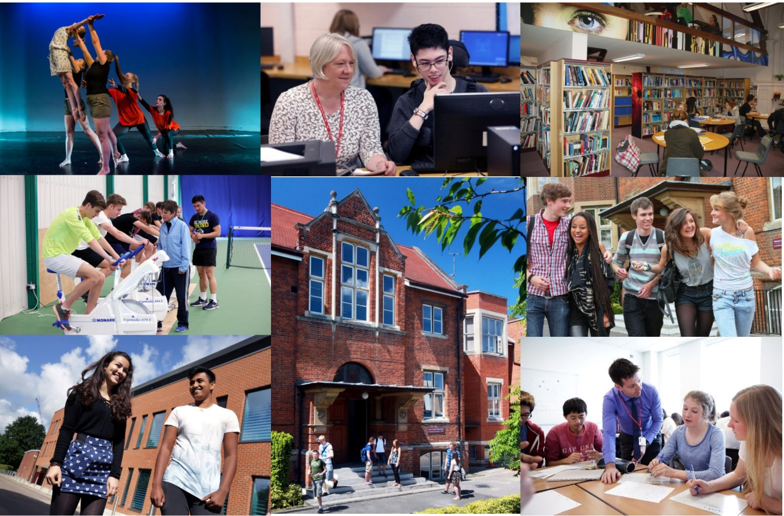

Opportunity ● Quality ● Achievement

Welcome from the Principal
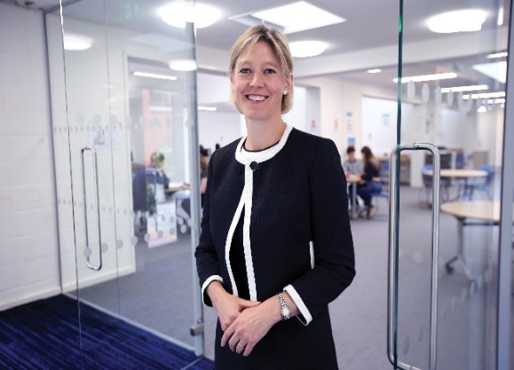
Thank you for your interest in Hills Road Sixth Form College and in this post. We really hope that the information in this booklet will support you in making an application to our College and will provide all you need for deciding whether our College is right for your next career step. We hope it is!

Choosing an institution where you find a fit in terms of ethos and values is hugely important. Hills Road Sixth Form College enjoys a strong national reputation, having topped Sixth Form College performance league tables for outcomes since their inception over twenty years ago. But that doesn’t make us complacent. We still want to evaluate and improve the ways in which we work with young people to get the best for them and from them, whatever that might take.

We are therefore looking for a colleague to join us who shares that drive and wants to ensure that the department they are joining continues to achieve excellent outcomes. Everything we achieve relies on the quality and commitment of our staff team whatever their role in the College and we are keen to recruit colleagues for whom excellence comes as standard. We also want you to continue to grow professionally while you are with us and will explore with you ways in which we can support that development. Through the application and interview process, we’ll be keen to understand your ideas and approaches to supporting delivery of the best educational outcomes at this specialist A level college.

As a busy, vibrant community of 2,500 young people, there’s always a great deal going on and lots to be part of and take part in. Extra-curricular opportunities abound and we hope you will want to get involved with the extraordinary range of activities that is on offer. We have an on-site sports centre, including a fully equipped gym, plus squash and tennis courts, to which all staff colleagues have free membership and our staff wellbeing programme includes access to on-site talking therapy, fitness and relaxation sessions. If you would like to talk through a prospective application or to explore the College’s ethos and values a little more, please don’t hesitate to make contact for an informal chat.

Finally, I do appreciate the time commitment involved in completing a job application and, if you do decide to apply, can I thank you for the investment of time you have chosen to make. Whatever the outcome, can I wish you all the very best with your future career, wherever that may be.

With very best wishes

Jo Trump
Principal

Overview of the College

The College

The College operates on an attractive site just over a mile south of the centre of the historic city of Cambridge. The site has been occupied from 1903 when it was originally home to the Cambridge and County School for Boys. Since its inception in 1974, succeeding the former boys’ grammar school, the College has concentrated mainly on providing Advanced level courses to students in the Cambridge area. Having responded to strong and sustained demand for places over a number of years, we now have 2,500 full-time 16-19 students for whom we provide a choice of 34 A level subjects plus the Extended Project Qualification, an extensive programme of enrichment and extra-curricular activities and responsive individual support and guidance. The breadth, depth and challenge of this curriculum are at the heart of our long-standing educational vision.

The College is a member of the Cambridge Area 14-19 Partnership: there are ten other centres for post-16 education: Cambridge Regional College, Long Road Sixth Form College, The College of West Anglia, The Cambridge Academy of Science and Technology, (formerly the UTC Cambridge), and six school sixth forms. The Cambridge Area 14-19 Partnership provides a common application procedure for post-16 courses and co-ordinates the information and guidance services for student transfer at 16+. The great majority of our full-time sixth form students are recruited from 21 maintained secondary comprehensive schools in the Cambridge area, 14 of which do not have their own sixth form.

We deliver an Adult Education programme, mainly during evenings and some weekends. The number of part-time adult student enrolments is around 4,000 a year. The range of courses reflects the needs of a much wider community in Cambridge and the surrounding area. The College is also a study centre for the Open University.

The Hills Road Sports and Tennis Centre is solely owned by the College and operates as Cantabrigian Ltd. While providing an outstanding facility for staff and students of the College, it also serves as a community sports centre working in partnership with Cambridge City Council and the Lawn Tennis Association. Local residents use the centre on a pay-as-you-play basis or via the membership scheme. Activities range from tennis and fitness room sessions to squash, cricket and Pilates.

College Performance

Hills Road Sixth Form College enjoys a national reputation for excellence and, in its last two Ofsted inspections, was rated outstanding in all graded areas.
A summary of the College’s performance
- In the Government’s examination performance table for ‘points per examination entry’, the College has consistently posted the highest score of any sixth form college in the country.
- In recent years the tables have included the percentage of students achieving at least AAB at A level in at least two of the Russell Group's 'facilitating subjects'. In every year, Hills Road has recorded the strongest sixth form college percentage.
- Retention and success rates also remain high (the second strongest amongst sixth form colleges), with about 96% of those enrolled on two-year courses going on to achieve the equivalent of at least two A level passes.
- Typically, over 90% of Hills Road students progress to higher education, with significant numbers going to the most sought after universities (for example, on average, our students earn 70 offers per year to Oxford and Cambridge universities).
- Hills Road students consistently thrive in higher education with 46% earning first class honours degrees in 2018 according to the Sixth Form College Association report which is based on HESA data.
- Hills Road was shortlisted in 2017, 2018 and 2019 as a finalist in the TES ‘Sixth Form College of the Year’ award.

Exam Results 2019

The 2019 A Level results are very similar to the typical, strong level in recent years and are likely to translate into another good performance in the Government’s league tables:

 | 2019  HRSFC | 2019  National
A* | 15.5% | 7.8%
A* - B | 73.6% | 51.6%
A* - E | 99.5% | 97.6%

College Ethos

At Hills Road we are strongly committed to providing our students with a broad sixth form education characterised by academic excellence, high quality learning experiences and extensive enrichment opportunities. Students are encouraged to achieve the highest standards not only in the classroom but also in a range of extra-curricular activities which help them to develop new skills, think independently and exercise their responsibilities as global citizens. We seek to promote a caring and supportive atmosphere with a strong sense of community in which all students are valued equally as individuals and treated as young adults.

From teaching and tutorial departments to administrative and support functions, Hills Road staff are deployed within specialist teams where their expertise, knowledge and skills may be used to best effect: each student has a specialist tutor with whom s/he meets regularly; subject departments offer lunchtime workshops where students can receive one-to-one support with homework queries or extension work; help with all aspects of learning, from essay writing to time management, is available from the specialist team in the Study Skills Department; and the Careers Department advises students on the world outside and beyond Hills Road, from work experience to UCAS applications. The Student Services Team respond to all manner of student need and ensures a qualified staff member is available throughout the College day to respond to student concerns in respect of wellbeing and mental health.
Specialisation brings considerable benefits to staff as well as to students: not only does it have a significant impact on the quality of teaching, support and guidance, but it also helps to enrich working relationships and to promote a culture of learning and continuous improvement. Teams are encouraged to work in creative and collaborative ways and to reflect on their own and each other’s performance.

College Facilities

Throughout our history the buildings have been extended and refurbished to meet changing needs. All lessons take place in high quality, purpose-built accommodation. In addition to excellent classrooms which are fully equipped with digital media resources, the College enjoys first class facilities including: extensive open-access IT facilities, a Library and Resources Centre, The Robinson Theatre, a modern well-equipped Music Department with recital room and practice rooms, an Art and Design Centre and specialist laboratories for science and language learning. Indoor and outdoor sports facilities are excellent, with the Sports and Tennis Centre located on the main site and a well-maintained ten-acre sports ground, including a modern pavilion, situated within a short walk from the College. The most recent addition to our facilities is The Linda Sinclair Building, a fabulous three-storey building at the edge of our site which provides outstanding accommodation for the Mathematics, Performing Arts and Sport departments.

We recently opened a new Student Services area at the heart of the College site. This houses the Supported Independent Learning Service, the Careers department, a new library-style student study space and a reception area staffed by members of the Student Services Team.

College Finances

Since incorporation the College has managed its finances effectively and has continually met the financial criteria under the different funding bodies. The College’s financial returns have been consistently assessed as ‘outstanding’ over many years with the years ending July 2016 and July 2017 scoring ‘good’ as a result of cash being invested in the most recent stage of the College’s Property Strategy which was completed in May 2016. Full management accounts are produced each month in order to monitor and manage the finances and to report to senior management and the Corporation in a timely manner. Sound financial management has allowed the College to maximise the potential for investment in human and physical resources and, in particular, to fulfil the phases of its long-term property strategy.

A Stimulating Environment

We hope this has helped to convey some of the qualities which make Hills Road Sixth Form College a stimulating and rewarding place in which to work and learn. If your application is successful, you will experience a College which enjoys a happy and purposeful atmosphere and a unique blend of opportunity, quality and achievement.

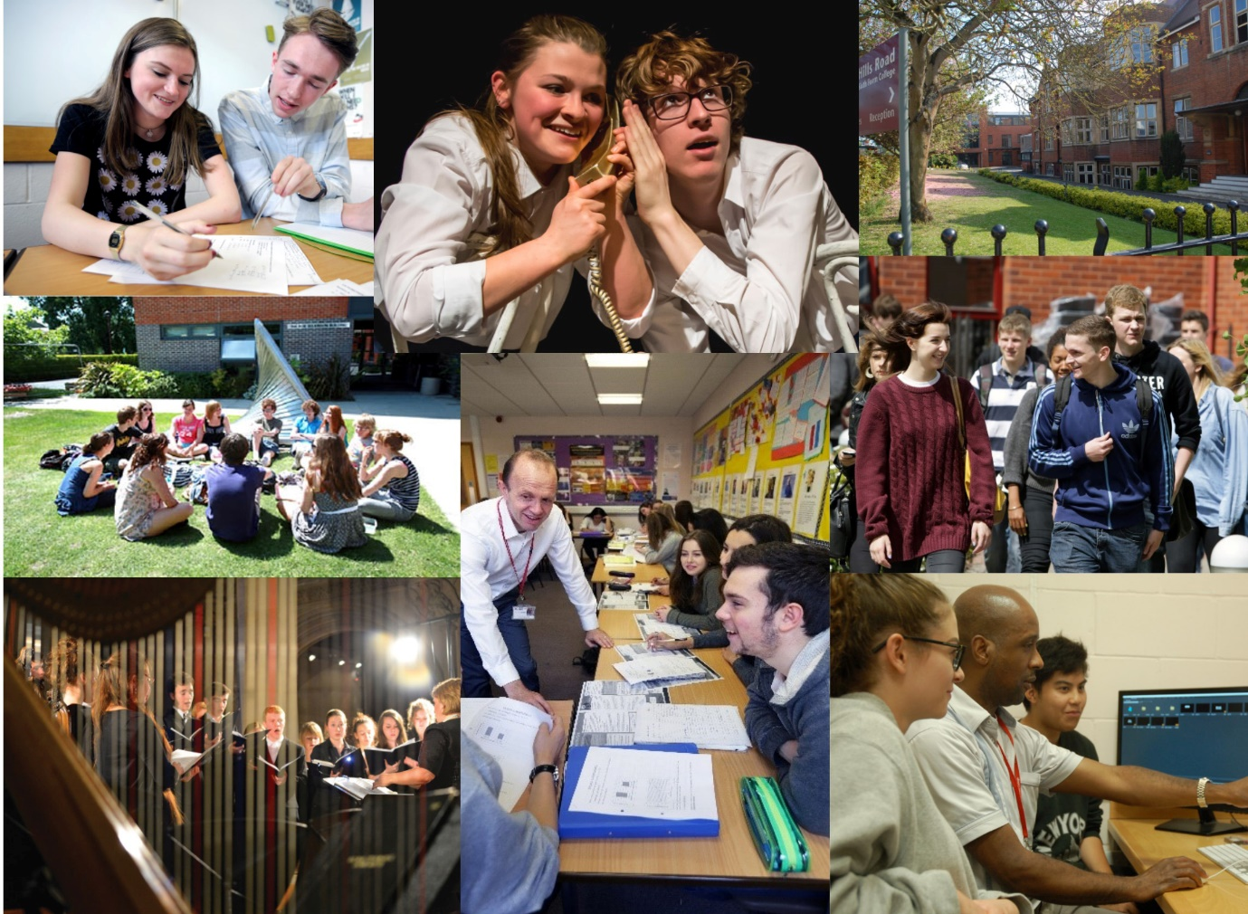

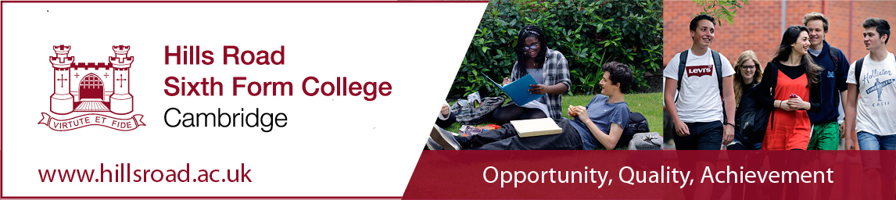

Teacher of Physics
Part-Time (approx. 0.6), Fixed Term until July 2020
£24,098 to £39,329 pro rata per annum depending on experience

Hills Road Sixth Form College is seeking to recruit a temporary A-level Physics who has enthusiasm, expertise and excellent subject knowledge to join the Physics and Computer Science department on 7th January 2020. This job may be combined with some teaching hours in Computer Science for the right person.
The ideal candidate(s) will:
- Be able to teach across the range of A-level Physics topics through the provision of high quality, engaging lessons;
- Enable students to improve their performance on an ongoing basis by providing positive, constructive feedback;
- Contribute to the department’s ongoing development of outstanding teaching resources;
- Be able to encourage, motivate and inspire all students in Physics, giving them clear focus and direction while on their course.
Hills Road Sixth Form College is one of the top-performing Sixth Form Colleges in the country. We offer a forward-thinking, collaborative and supportive working environment, with thoroughly engaged and enthusiastic students. Great support and resources await you at this highly regarded Sixth Form College and we hope you will consider joining us for your next career step.

Closing date: 16th October 2019
Interviews: 30th October 2019

Details and an application form may be obtained from our website www.hillsroad.ac.uk.

The College is committed to safeguarding and promoting the welfare of its students and staff and expects all members of the College community, volunteers and visitors to share this commitment. The College actively promotes equality and diversity and welcomes applications from all sections of the community.

Teacher of Physics
The Post
We are looking for a well-qualified teacher of physics to join a highly successful and established team.

The appointment will be from 7th January 2020 and run until the end of the Academic year in the first instance. We anticipate that the appointee will teach between 12 and 14 periods a week (likely to be four days). The ability to teach Computer Science would be desirable and there would be additional periods available to teach this for the right candidate.

We are looking for an enthusiastic and innovative teacher to be part of a department with a long record of high achievement and a wide diversity of activities. The successful candidate will relate well to our students who currently study the AQA Physics course. Students from the Department regularly participate in the British Physics Olympiad, student robotics contests and the Cypher Challenge for Computer Science students. Student visits to either CERN or Diamond have also become a very popular part of our annual programme.

The successful candidate will be a lively and committed team-player with
good IT skills positive approach and a willingness to contribute towards this thriving and diverse department.

Prospective applicants are welcome to contact the Acting Head of Physics and Computer Science, Dr Kathryn Bower (ext 204), to discuss the post.

The Department
The Physics and Computing Department form an energetic and supportive team in a very successful College.

The Department was awarded grade 1 in its last OFSTED inspection.

Accommodation and Resources
The Department is housed on the ground floor of the purpose-built science area opened in 2004. The Building is shared with Chemistry and Computing. The department comprises three teaching laboratories, one classroom, a lecture theatre and a dedicated project area with attached darkroom and workshop facilities. There is an adjacent resources and information technology area which contains a suite of modern, networked PCs, other resources and working space for use outside scheduled class time.

The Department is well equipped with books and apparatus, and has a wealth of supporting material to assist staff delivering their courses.
Courses Offered and Examination Results
The AQA Specification is taught to sets of about 23 students. Currently, there are thirteen physics sets in Year 12 and seven in year 13. AQA Computer Science is has four sets in both Year 12 and Year 13.

The results at A level are consistently good, with pass rates for the past 2 years at 100%, with about 70% of students achieving grades A*-B. Significant numbers gain places at Oxford or Cambridge each year and around 90% proceed to science-related careers.

Students
There are over 500 students currently in the Department who are generally both highly able and well-motivated. Whilst the expectations on staff and the College are high, the teaching is rewarding as the rapid development and fulfilment of potential among students becomes apparent. The level of personal and technical support given to students is often acknowledged.

Departmental Management
There are 25 teaching periods (each of 65 minutes) in the College week. For newly appointed members of staff there is a thorough induction programme.

Departmental meetings are held at regular intervals with training events in-house and away from College featuring at intervals. In addition to routine business, the Department has been actively involved in developing ways of increasing further the variety of Teaching and Learning approaches and the availability of scientific and technical experiences available to students.

Applications
The closing date for applications is 16/10/19. Shortlisted applicants will be advised accordingly and called for interview. Interviews will be held on 30/10/19.

Thank you for your interest thus far in this post and the College. I do hope that you will decide to apply, and I should like to thank you in advance for taking the time and trouble to do so.

If there is any further information that you would find useful, or if you would like to talk through any aspect of the College or role, please don’t hesitate to get in touch.

Best wishes

Kathryn Bower
Acting Head of Physics and Computing
October 2019

Job Description
Teacher at Hills Road Sixth Form College

Purpose: To teach students within the College and to carry out such other associated duties as are reasonably assigned by the Principal or Head of Department, and to make a positive contribution to the wider life and ethos of the College

Reports to: The Head of Department and, where appropriate, to the Head of Subject, in respect of departmental matters and curriculum development

Main Accountabilities:

Set high expectations which inspire, motivate and challenge students
- establish a safe and stimulating environment for students, rooted in mutual respect
- set goals that stretch and challenge students of all backgrounds, abilities and dispositions
- demonstrate the positive attitudes, values and behaviour which are expected of students.

Promote good progress and outcomes by students
- be accountable for students’ attainment, progress and outcomes
- be aware of students’ capabilities and their prior knowledge, and plan teaching to build on these
- guide students to reflect on the progress they have made and their emerging needs
- demonstrate knowledge and understanding of how students learn and how this impacts on teaching
- encourage students to take a responsible and conscientious attitude to their own work and study.

Demonstrate good subject and curriculum knowledge
- have a secure knowledge of the relevant subject(s) and curriculum areas, foster and maintain students’ interest in the subject, and address misunderstandings
- demonstrate a critical understanding of developments in the subject and curriculum areas, and promote the value of scholarship
- demonstrate an understanding of and take responsibility for promoting high standards of literacy, articulacy and the correct use of standard English, whatever the teacher’s specialist subject

Plan and teach well-structured lessons
- impart knowledge and develop understanding through effective use of lesson time
- promote a love of learning and encourage young people’s intellectual curiosity
- set homework and plan other out-of-class activities to consolidate and extend the knowledge and understanding students have acquired
- reflect systematically on the effectiveness of lessons and approaches to teaching
- contribute to the design and provision of an engaging curriculum and scheme of work within the relevant subject area(s).

Adapt teaching to respond to the strengths and needs of all students
- know when and how to differentiate appropriately, using approaches which enable students to be taught effectively
- have a secure understanding of how a range of factors can inhibit students’ ability to learn, and how best to overcome these
- demonstrate an awareness of the physical, social and intellectual development of young people, and know how to adapt teaching to support students’ education at different stages of development
- have a clear understanding of the needs of all students, including those with special educational needs; those of high ability; those with English as an additional language; those with disabilities; and be able to use and evaluate distinctive teaching approaches to engage and support them.

Make accurate and productive use of assessment
- know and understand how to assess the relevant subject and curriculum areas, including statutory assessment requirements
- make use of formative and summative assessment to secure students’ progress
- use relevant data to monitor progress, set targets, and plan subsequent lessons
- give students regular feedback, both orally and through accurate marking, and encourage students to respond to the feedback.

Manage behaviour effectively to ensure a good and safe learning environment
- have clear expectations and routines for behaviour in classrooms and take responsibility for promoting good and courteous behaviour both in classrooms and around the College in accordance with appropriate College policies
- manage classes effectively, using approaches which are appropriate to students’ needs in order to involve and motivate them
- maintain good relationships with students, exercise appropriate authority, and act decisively when necessary.

Accountabilities that relate to all staff at the College:
- demonstrate behaviour and values consistent with the person specification for this role
- promote equality of opportunity in accordance with the College’s Single Equality Scheme
- maintain high standards of attendance and punctuality
- have proper and professional regard for the ethos, policies and practices of the College
- this includes those where each member of staff has an individual duty to act and for which the College can be held vicariously responsible for the actions of its employees:
equality and diversity
safeguarding the welfare of young people
health and safety

Person Specification for the Post of Teacher of Physics

 | Essential | Desirable | Evidence
Qualifications and training | - Good honours degree in physics or engineering  - Relevant teaching qualification e.g. PGCE or willingness to complete a PGCE | - The ability to teach A level Computer Science | Application form/ Letter of application
Experience | - Experience of teaching physics at A level | - Experience of developing schemes of work at A level | Application form/ Letter of application

In addition, the successful candidate will demonstrate, or have potential to develop, strengths in the following areas.

Classroom teaching | - Lively, energetic and well planned classroom teaching  - Development and use of effective and varied resources for use in the classroom  - Clear focus on maximising student potential and encouraging high levels of attainment by all students  - Strong and positive commitment to individual students  - Creativity to contribute to the on-going development of schemes of work | Letter of application/ Interview day/ References
Professional standards | - Commitment to equality of opportunity  - Commitment to collaborative teamwork  - Good organisational skills and commitment to meeting deadlines  - Flexibility and ability to undertake new activities  - An on-going commitment to the study of physics  - A willingness to support the physics activities undertaken by the department  - Competent in the use of IT  - Willingness to undertake appropriate staff development | Application form/ Letter of application/ Interview day/ References
Focus on quality | - Commitment to continuous improvement  - Commitment to safeguarding the welfare of young people | Application form/ Letter of application/ Interview day

How to Apply for the Post of a Teacher of Physics

Applicants are asked to do the following:

- complete the Hills Road Sixth Form College application form
- complete the equality and diversity monitoring form
- write a supporting letter of application
- supply a brief CV

The completed application form should be submitted via email to recruitment@hillsroad.ac.uk. All documents should be submitted by 9.00am on Wednesday 16th October. Please note that applications received after the closing date may not be eligible for consideration.

Interviews will be held on Wednesday 30th October.

Hills Road Sixth Form College will base its decision as to whether to invite you for interview solely on the details provided on your application and how well they match the criteria for this post.

Hills Road Sixth Form College is committed to ensuring equal opportunities in all aspects of employment and selects staff on merit, irrespective of race, religion, sex, disability or age. You are not obliged to complete the equal opportunities monitoring form, but any information given will help us to monitor the effectiveness of our equality and diversity policy.

If you have a disability you are invited to request any special arrangements you may require for interview, or any adjustments you may anticipate would be needed in your working arrangements, by contacting the Human Resources Team on 01223 278063 (direct line). Further information about accessibility to the site can be found on our website under ‘Equality and Diversity/Site Plan’ and also from ‘AccessAble: www.accessable.co.uk.

Thank you for your interest in this post and in the College. We do hope that you will decide to apply, and we should like to thank you in advance for taking the time and trouble to do so. For more information about working life at the College please go to our website http://www.hillsroad.ac.uk

Human Resources

