Bishop Ramsey CE School

Teacher of Music

The Expressive Arts Faculty

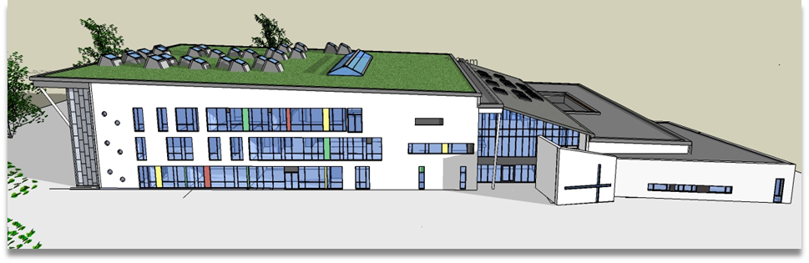

The Expressive Arts Faculty is multi-disciplinary comprising of 4 creative subjects - Art, Music, Photography and Physical Education.
Art
Art is taught to all students in Key Stage 3 and becomes an option choice for GCSE for those students in Year 9 who wish to pursue the subject further. Students specialise in either GCSE Art and Design (Edexcel) or GCSE 3D Art and Design (AQA). Both courses culminate in a 10 hour supervised examination time.

A-Level Art and Design is also offered in the Sixth Form. This includes two sections:
- A personal investigation (60%) including supporting studies, practical work and a written personal study;
- An externally assessed assignment (40%) including preparatory studies and a 15 hour period of sustained focus.
Music
Music is taught to all students in Key Stage 3. The topics studied develop students’ performance, listening and compositional skills through different instruments and students have access to notational and sequencing software.
Students may choose Music as an option at GCSE where we follow the Eduqas syllabus (WJEC). Students will compose two original pieces of music: one free composition and one according to the GCSE brief, using music software Sibelius. Both compositions are worth 30%. Students will play a solo piece on their instrument/voice and perform in a duet or ensemble on their instrument/voice. Both performances are worth 30%. Students will also sit the listening and appraising exam at the end of the three year course. This exam is based music from different areas of study and is worth 40%.
A level Music is offered in the Sixth Form, where we follow Eduqas syllabus (WJEC). Students will complete a live performance/recital to an examiner which is worth 35% and submit two original compositions which are worth 25%: one free and one according to the Eduqas brief. Students will also sit a listening and appraising exam at the end of the two year course based on three different areas of study. The exam is worth 40%.
There are a wealth of extra-curricular activities for students to be involved in throughout the year, including but not limited to Choirs, Orchestras, Peripatetic Music Lessons as well as two formal Music Concerts per year and a School Production.
Photography
Photography is an option for A level students in the Sixth Form, where we follow the OCR Photography specification. The course consists of 4 units, internally assessed coursework, a themed exam question set by the exam board, a personal investigation including written critical and historical research and finally a second themed exam question set by the board.
A Level Photography includes two sections:
- A personal investigation (60%) including supporting studies, practical work and a written related study;
- An externally assessed assignment (40%) including preparatory studies and a 15 hour period of sustained focus.

Physical Education
Physical Education is taught to all students in Years 7 – 11. Across each year students will follow and be assessed on a themed curriculum based on their year focus:
Year 7: Confidence and co-operation
Year 8: Health Competition and Resilience
Year 9: Learning to learn and learning to lead
Year 10: Mental Health and managing pressure
Year 11: Active lifestyles and career choices.
Students will continue with 2 hours of Physical Education up to Year 11.
Physical Education is an option choice for students in Year 9 who wish to follow the GCSE course. Students are assessed against the Edexcel specification over the 3 years, with 2 practical and 2 theory lessons per week.
The course comprises:
- 30% practical assessment from 3 different sports, internally assessed and externally moderated;
- 10% written and completed personal exercise plan, internally assessed and externally moderated;
- 60% written exam, split over 2 papers.

Students wishing to continue their studies in Physical Education can choose the very popular A-level option in the Sixth Form.
We follow the OCR specification for this course which includes four components:
- Physiological factors affecting performance – 30%;
- Psychological factors affecting performance – 20%;
- Socio-cultural and contemporary issues – 20%;
- Performance within physical education – 30%
  - Performance or coaching
  - Evaluation and Analysis of Performance for Improvement.

The Faculty
The Expressive Arts Faculty sits at the heart of Bishop Ramsey School. The inclusion of the creative arts is an essential part of the school’s balanced curriculum, by which all students can achieve their greatest potential. All staff are issued with laptops and all classrooms have audio and whiteboard facilities.
As a church school, we feel that a creative God should be at the centre of our thinking, remembering that we are made in his image and therefore we all have a level of creativity within us. It is with this in mind that we hope our students will be able to develop their full creative potential through our faculty.
Art, Music, and Physical Education all have their own department offices.
The Art Department currently consists of a variety of staff with specialist skills in Fine Art, Ceramics, Photography, and Printmaking. The new suite of five rooms has a purpose-built darkroom and kiln area and a special studio space for Sixth Form students.
The Music Department has well-equipped dedicated music rooms, with additional practice spaces and a music technology room, including a large mixing desk and computers.
The Physical Education Department has a large, recently extended, sports hall, including a small gym space, a multi-use games area, a large dance studio, further hard-standing courts and a large field.
The Faculty makes a large contribution to the wider life of the school. We run a vast number of extra-curricular opportunities feeding into larger showcases, including sports events, music concerts, art showcases, supporting drama productions, House events and many more.
We place a large focus on student leadership and have a vast number of opportunities for students to assist in the running and organising of projects within school across all the departments in the Faculty.
The Faculty works closely with trainee teachers in the Hillingdon SCITT, with all Department Leads also working as Subject Leads to the trainees. This often means there are new and exciting ideas coming from the trainees that we work with, who are often placed in our departments.
We hope this brief synopsis has given you something of the flavour of the Expressive Arts Faculty at Bishop Ramsey. We extend a warm welcome to new members of our diverse, friendly and supportive faculty.

