Meadowhead School
Academy Trust

a member of
The Meadowhead Community Learning Trust

Person Specification
Headteacher


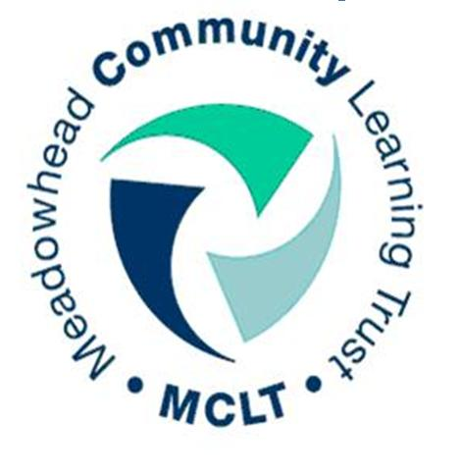



To carry out their responsibilities effectively, Headteachers need specific professional knowledge/ understanding and a range of leadership, management and personnel skills and attributes. These are detailed below and are grouped across the seven key areas of responsibility set out in the job description. Please note that your application will be shortlisted on how well you demonstrate having applied your skills, attributes and knowledge across these key areas.

Person Specification

Qualifications and experience
- Qualified Teacher Status
- Evidence of regular and appropriate professional development
- Evidence of recent management development

Headteachers should be able to demonstrate their experience, knowledge and understanding of the following areas
Shaping the future
- Local, national and global trends in education
- Ways to build, communicate and implement a shared vision
- Strategic planning processes – financial planning, budgetary management and principles of best value
- Communication strategies both within and beyond the school
- New technologies, their use and impact
- Leading change, creativity and innovation and its impact on organisations and individuals

Leading teaching and learning
- Demonstrable evidence of effective leadership and of raising attainment (such as Ofsted)
- Strategies to raise achievement, achieve excellence and develop a personalised learning culture
- Strategies to ensure inclusion, diversity and access to learning
- Strategies to develop effective staff
- Models of learning and teaching and principles of effective teaching and assessment for learning
- Data collection and analysis tools
- Performance monitoring and evaluation techniques
- Models of behaviour and attendance management
- Curriculum design and management
- Principles and models of self-evaluation

Developing self and others
- Strategies to promote self and team development
- Models of continuing professional development
- Building and sustaining a learning community

Managing the organisation
- Organisational models and principles of organisational development
- Principles and strategies of school improvement
- Project management and policy creation, through consultation and review
- Personnel, governance, security and access issues relating to the diverse use of school facilities
- Legal issues relating to managing a school (including equal opportunities, race relations, disability, human rights and employment legislation
- Experience of managing a budget and experience of securing external funding for projects

Securing accountability
- Principles and practice of quality assurance systems, including school review, self-evaluation and performance management
- Statutory educational frameworks, including governance
- Public service policy and accountability frameworks, including self-evaluation and multi-agency working
- Use of a range of tools (including performance data) to support, monitor, evaluate and improve aspects
of school life, including challenging poor performance

Strengthening community
- Current issues and future trends that impact on the school community
- Strategies to encourage parents and carers to support their children’s learning
- Models of school, home, community and business partnerships and opportunities for collaboration
- Wider curriculum beyond school and the opportunities it provides for pupils and the school community

Safeguarding and promoting the welfare of children
- Up-to-date knowledge and understanding of national and local safeguarding guidance
- Developing and ensuring a safe and supportive school culture
- Developing and introducing policies and practices that minimise opportunities for abuse or ensure its prompt reporting

