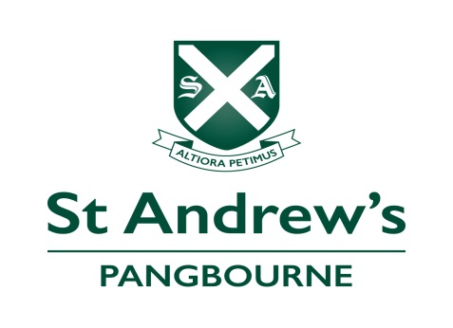

Teacher of Science
Accountable to the Head of Science

Job description

Overview

To teach in the Prep School and participate in the extra-curricular programme of a busy day/boarding school

Detail
The post holder is expected to:
- Teach a full academic timetable and play an active part in the extra-curricular life of the school.
- Plan and deliver stimulating lessons within a well balanced curriculum that conforms to the Science Department planning.
- Work co-operatively with other team members in the department on planning, organising the curriculum and departmental events.
- Refer to all the programmes of study and schemes of work that are in place and assist in their development as appropriate. Plan individual lessons appropriate to the needs, interests, experience and existing knowledge of the pupils in the classes taught.
- Teach another subject, if applicable
- Ensure ILPs and IPPs are used as appropriate in lessons (liaising with the Head of Learning Skills as appropriate).
- Mark and assess pupils’ work effectively and record accurately their development, progress and attainment.
- Plan and prepare activities to develop all aspects of each child's individual development in a stimulating atmosphere.
- Support and promote the teaching of science throughout the School.
- Actively take part in the pastoral care of the pupils.

- Ensure that pupils are offered equal opportunities with regard to their religious persuasion, racial origins, gender, disabilities, cultural or linguistic background.
- Care for and supervise the children with regard to their physical, emotional and intellectual needs.
- Ensure confidentiality is maintained.
- Adhere to the policies & procedures of St Andrew’s, ensuring compliance with the Safeguarding and Health and Safety legislation, all within the requirements and guidelines laid down by ISI.
- Supervise any teaching assistant, recognising training needs, monitoring training and developing teamwork.
- Complete developmental records and observations as directed.
- Adhere to the School’s policies on teaching and learning.
- Follow School guidelines on child protection and safeguarding.
- Assist in the assessment of pupils` progress socially and academically.
- Maintain good order and discipline in the classroom and around the school by promoting the School’s values and expectations, safeguarding health and safety and developing relationships with and between pupils.
- Build and maintain co-operative relationships with parents and, as necessary, communicate with them on pupils’ learning and progress. This includes parents’ meetings and writing reports.
- Maintain an attractive and stimulating classroom environment.
- As a form teacher, to supervise a form for registration, for quiet study, form periods and preparation as directed.
- Offer extra-curricular activities.
- To be part of a weekly duty team (as allocated by the Deputy Head).
- Assist with projects in other areas of the curriculum.
- Take part in the School’s professional development programme and undertake INSET as required.
- Liaise with other agencies e.g. Speech Therapists, Occupational Therapists, etc. as appropriate
- Undertake any other duties as may be required from time to time.

Special Responsibilities
The person appointed must respect the position of trust and responsibility and be aware of the sensitive and confidential nature of much of the information about individual children to which they have access. They should have read and agreed with the points covered in the staff handbook.
Science Teacher - Person Specification
 |  | Essential |  | Desired
Qualifications |  | Degree and Teaching Qualification |  | Science based degree
 |  | An inspirational specialist science teacher with the confidence to develop independent learning skills in the pupils |  | Evidence of further professional development and able to enthuse children to be passionate about learning
Experience |  | Experienced in teaching science to KS2/KS3. |  | Experienced in teaching science to Common Entrance and scholarship level to senior independent schools at 13+
Skills and Aptitudes |  | Knowledge of the 7 - 13 curriculum, including Common Entrance and scholarship |  | Experience/ability to teach a second subject
 |  | Ability to contribute to the sports coaching and/or the extra-curricular programme |  | Ability to coach one of the major sports (hockey, rugby, football, netball, swimming, cricket or lacrosse).
 |  | Ability to relate to, and communicate with, children, parents and staff |  | Dedicated to promoting the welfare of young people and engaged in pastoral care
 |  | Ability to work in a team |  | Collaborative by nature and mindful to the needs of others
 |  | Ability to incorporate technology into their teaching to enhance learning |  | Technology fully integrated in the teaching and learning
Personal Qualities |  | Enthusiastic and self-motivated, with good organisational skills
 |  | Empathy with the tradition, history and Christian ethos of St Andrew’s School
 |  | Willingness to take a full part in a busy school and always prepared to go the extra mile and have a sense of humour!
 |  | Energy and resilience to thrive in a long school day within a busy prep school

