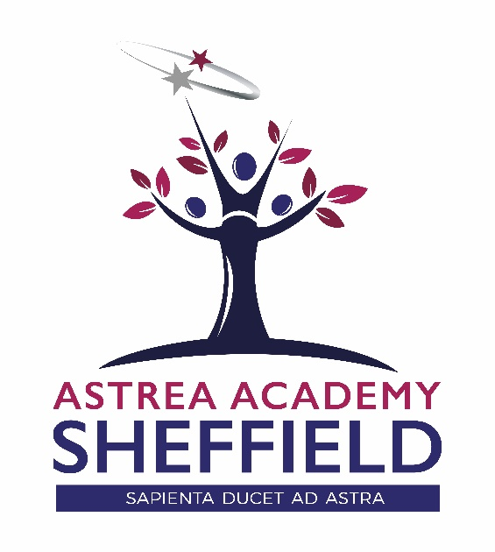
Applicant Information Pack

A BEACON OF EXCELLENCE FOR THE NORTH OF SHEFFIELD

Contents

ASTREA ACADEMY SHEFFIELD

- Welcome Letter – Libby Nicholas, CEO
- Welcome Letter – Kim Walton, Executive Principal
- Astrea Academy Sheffield – The Vision
- Astrea Academy Sheffield Floorplan
- Astrea Academy Trust
- Astrea Academy Trust Ethos
- Astrea Academy Trust Family
- Child Safeguarding Policy
- Explanatory Notes
- How do I apply?

"The staff are amazing, a true team with a shared vision who have the pupils best interests at heart.

The expectations of pupils are high, everyone is so supportive and we always work together to achieve the high standards expected at Astrea Academy Sheffield"

Sarah Naylor | Head of PE

Welcome Letter from Libby Nicholas

CEO – Astrea Academy Trust

Thank you for your interest in this role with Astrea Academy Sheffield. At Astrea, we are passionate about education that inspires beyond measure. The Astrea Academy Sheffield, Astreas first purpose built all-through academy, will be a beacon for the area – both literally and metaphorically: looking out over the city, it will provide an absolutely exceptional education for 2-18 year olds.

Astrea was established in 2015. Our schools – primary, secondary and all-through – do not subscribe to the typical notion of “schooling” where everything is driven by results. Our pupils achieve to the very highest levels, but we believe that education is about so much more than just attainment. To deliver this, we focus on encouraging and nurturing Resilience, Empathy, Aspiration, Contribution and Happiness in all of our children and young people. We also have the highest expectations of the staff in our family: responsibility and leadership; aspiration and development; honesty and integrity; enjoyment and innovation; and collaboration and inclusion. These values are used as a measure of progress with individuals, academies and overall as a trust. We have the highest expectations of pupil behaviour, so that our teachers are able to focus on teaching to the ‘Astrea Teacher Standards’.

This is a hugely exciting time for our family of academies. The Trust has been recognised by the Department for Education as being well placed to raise standards and achieve excellence for pupils in a growing number of academies. We are presented with a rare opportunity to make a real difference to the lives and life chances of so many primary and secondary school children – many of whom haven’t previously received the educational opportunities they deserve. The Trust currently has over 20 academies based across South Yorkshire and Cambridgeshire, including academies at various stages of development. As a Trust, we are clear about the importance of achieving long term sustainability for our academies. Our vision is to enable individual academies to flourish with real autonomy, whilst also ensuring a strong ethos of support and collaboration across our Academies.

Those we recruit need to demonstrate that they share our values, are highly motivated to work with colleagues within and beyond their academy to continuously develop their skills and pursue professional excellence, and are committed to providing the highest standards of teaching for all children. If that is you then we would be delighted to receive your application. At Astrea, we are all dedicated to providing an education with no boundaries so that every pupil can fly, and I hope you will join us on this exciting journey.

Libby Nicholas
Chief Executive, Astrea Academy Trust
A Warm Welcome from Kim Walton

Executive Principal – Astrea Academy Sheffield

‘Sapienta ducet ad astra – Wisdom leads to the stars’
We are delighted that you are interested in applying for this role at Astrea Academy Sheffield.
Astrea Academy Trust is thrilled to have the opportunity to cultivate a brand new academy that compliments the existing provision in the area and meets the basic need for additional school places in the area. This is a rare and unique opportunity to join us on our journey from day one - where ambition has no limits!
It is key to understand the context of our academy. Pupils in our current Year 7 arrived from 31 different feeder schools and represent 21 different ethnicities – 98.4% of our current cohort are from Ethnic Minority Groups. 65% of our pupils are disadvantaged, with 38% currently receiving Free School Meals (national is 13.3%). The catchment area of the academy is within the 10% most deprived areas within the country.
The Academy opened its doors for the first time in September 2018 and will in time be a 3 – 18 provision for children in the Burngreave area. This September has seen the first children in nursery, reception and year 7 arrive, as well as our new compliment of staff. From September 2019 we welcome our new Year 7’s and reception and nursery classes. We are delighted to say we are the school of choice in the area and are currently oversubscribed for 2019/20.
With the combination of a Grade II listed building and a brand new building, there is a real physical heritage to our new school. With an investment in excess of £25M, the facilities will be cutting edge, including science and technology laboratories, modern classrooms, a 300 seated hall, 4G pitch, an underground sports hall, outside amphitheater and forest school learning area. This ground breaking campus is truly breathtaking and will be occupied from April 2019.
It is a rare opportunity and an exciting time to join the Academy. Key work at this moment in time includes collaborating with the Trust, architects, designers and local community to create a legacy for the future. Our location will be at the heart of a new learning community which will continue to grow as we forge these ever essential relationships with families and businesses in the area.
We work within a supportive learning community of staff, parents and students, enabling a world of learning opportunities which will inspire and motivate students of Astrea Academy Sheffield to achieve excellence and create the successful path for their future. We are creating an academy where each day will be a journey of discovery to fire their imagination, establish their sense of worth, and to gain the confidence and courage to take a full part in the wider world.
This is a truly unique and once in a life time opportunity and we are seeking distinctive and exceptional individuals who are able to offer the absolute best they can to enhance the life chances of children at Astrea Academy Sheffield.

This is an exciting and challenging role which offers:
- The opportunity to be part of something truly special – to be part of our family from its infancy.
- The opportunity to make a significant impact and ensure a lasting legacy in an academy that will grow with you as an individual.
- The unwavering support of an experienced Principal and dedicated teams within the academy.
- Significant investment in your professional development.
- The chance to work with a vibrant and enthusiastic cohorts of students aged 3 – 18.
- The opportunity to be part of a true all – through education provision.
- The opportunity to contribute to the development of our curriculum, professional development and quality teaching networks across the entire Astrea Academy Trust.
Ideal candidates will:
- have a true passion for excellence in education
- be a great teacher - we are looking for someone who really knows what great learning looks like in the classroom and how to achieve it
- be dedicated to the creation of an education with no boundaries
- be committed to community cohesion and developing the whole child, not just academically
- have a very clear understanding of what makes a great school and the skills and character to be part of this (rigorous planning, high expectations, great CPD, honesty, kindness, passion, commitment and resilience) day in, day out
- be excited by, and committed to, supporting practices that will drive great progress at Astrea Academy Sheffield
- be fully aligned with Astrea’s Value Partners
Everything we achieve is underpinned by all, in these Value Partners;
- Responsibility and Leadership (#4equity)
- Enjoyment and Innovation (#go4it)
- Aspiration and Development (#Reach4thestars)
- Collaboration and Inclusion (#all4one)
- Honesty and Integrity (#4good)

If you think you have what it takes to further unleash Astrea Academy Sheffield’s incredible potential, and be part of this amazing journey - we want to hear from you!

Miss Kim Walton
Executive Principal, Astrea Academy Sheffield

The Vision

Astrea Academy Sheffield

Our Mission
A broad and balanced curriculum based on knowledge, skills and experiences will enrich pupils’ lives, build cultural capital and instil a love of learning. They will be able to apply their learning to real world contexts and problems, creating solutions in collaboration with others. Pupils will learn to value family, community and the environment. They will make a positive contribution to the life of the school and those around them. Pupils will become resilient learners who are motivated to take responsibility for their learning, health, well-being and happiness. Pupils will have high expectations of themselves, a culture of craftsmanship and a drive for excellence. They will understand the scope of possibilities that lie ahead of them and what is required to achieve their ambitions with the confidence and belief to make them a reality.
A Unique Education
At Astrea Academy Sheffield, our curriculum is the purpose of our school. The curriculum is everything that we want our pupils to know and to understand. It includes learning about discrete subject disciplines such as the sciences, humanities and the arts, and also how these disciplines relate to one another. Our curriculum is also what we want pupils to achieve, the opportunities we offer them and the experiences we believe all pupils are entitled to.
The unique offer of our enriched curriculum enables pupil’s attitudes to learning flourish. The Year 7 pupils undertake a range of electives on a Wednesday afternoon which include circus skills; Football; Dodgeball; Netball; Creative Writing; Taekwondo; Cheerleading; Art; Fun Science and Dance.
In addition to elective and subject curriculum, the role of the form tutor is pivotal in pupil and pastoral development and wellbeing. Tutors meet with their group twice per day and through this time build exceptional relationships with pupils and also with parents.
Our Affirmation
Pupils and colleagues all live by our affirmation;
- I am Strong
- I am Successful
- I am Astrea
Astrea Academy Sheffield Campus
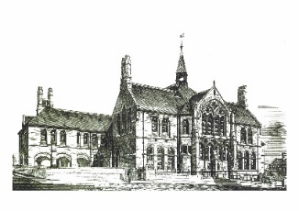
Academy Sheffield encompasses two contrasting facilities that bring together the traditions and history of education in Sheffield and the latest technology and facilities to provide pupils and the community with an outstanding environment for learning. Overlooking Sheffield city centre, the new state of the art building will feature a full complement of highly equipped classrooms providing a bright and colourful learning environment for all pupils with additional open learning spaces for independent and small group study.

New Build – Floor Plans

Astrea Academy Sheffield

First Floor
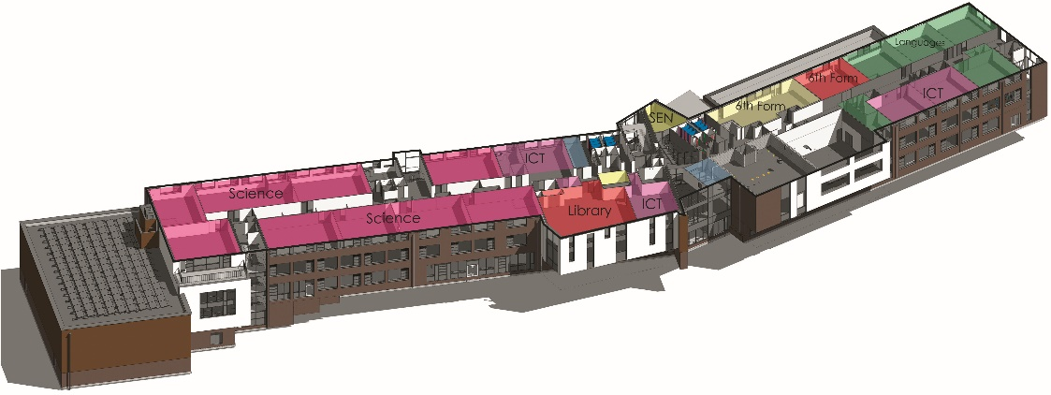
Upper Ground Floor
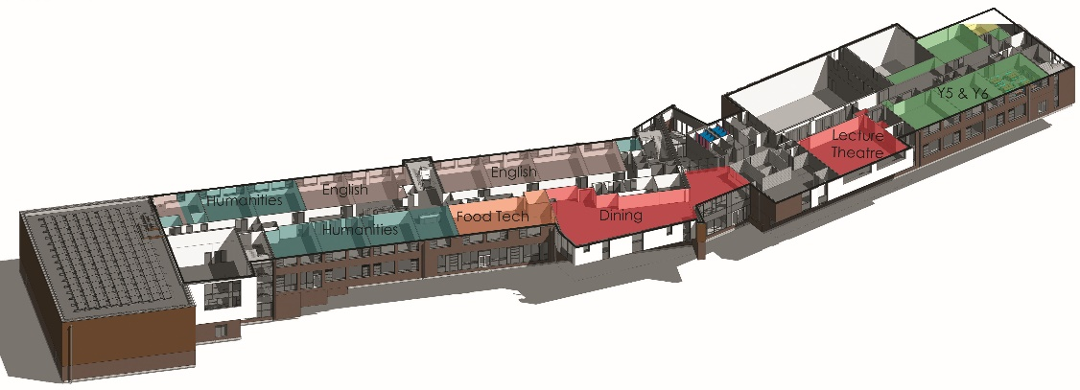
Ground Floor
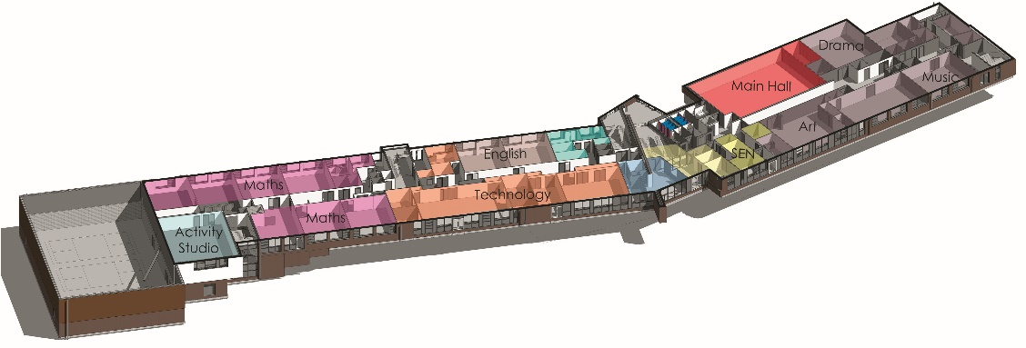
Lower Ground Floor
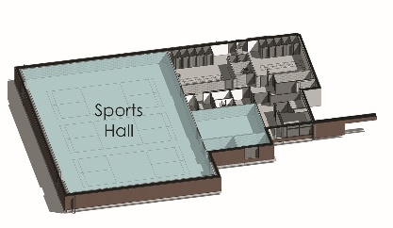

The Department

Astrea Academy Trust

The English Department at Astrea Academy Sheffield
The Department
Astrea Academy Sheffield’s English department is driven by a genuine enthusiasm for English Literature and a deep curiosity for the English language. We believe that all of our pupils deserve to experience the best that has been thought and said and therefore pride ourselves on delivering a knowledge-rich curriculum which spans the classics to contemporary writing.
Our Approach
As English teachers, we aim to impart our expertise to our pupils and to enable them to love the fascinating complexities of our subject, just as we do. Being a brand new all-through school brings with it a multitude of exciting opportunities. The English department is still shaping its curriculum for future years and would welcome teachers who will bring subject specific expertise. As a department, we use an evidence-based approach to pedagogical decision making and are proud that our curriculum is rooted in research. We hold incredibly high expectations for all of our pupils and expect them to engage with challenging texts from the beginning of key stage three.
Our curriculum
We treat the texts that we study with the upmost respect. Therefore, pupils only study three texts across each year in order to give them the time and space to explore them properly. Our curriculum travels chronologically through the history of great literature as we believe pupils should understand how literary movements are informed and influenced by each other. Authors studied at key stage three include Homer, Chaucer, Shakespeare, Brontë and Pullman. We expect all of our pupils to act like scholars of English and we model this way of being to them at all times.
Co-curriculum
The English department is at the forefront of academy life. This means that the right candidate would be involved in our curriculum planning as well as that of our co-curriculum which currently includes: a writing group, reading groups, a debate team, drama clubs and the running of the school library. We are committed to ensuring that the study of English at Astrea Academy Sheffield lives far beyond the walls of our classrooms and that all of our pupils experience a variety of trips, clubs and competitions.
Reading
As a department, we champion the Accelerated Reader program as a way to engage our pupils with reading. We know that reading is the fundamental foundation that must underlie pupils’ success in our subject and all others. There is a strong reading culture in the school and literacy is understood to be integral to all subject areas. We have invested our time in a number of reading initiatives such as the Premier League Reading Stars Project which is delivered by Sheffield Wednesday Football Club and the Love To Read reading mentorship program. All of our pupils are given at least 30 minutes a day in which to read silently and as members of staff we also communicate our passion for reading daily.

About

Astrea Academy Trust
We value all-round development of the individual, through arts, sports, leadership opportunities, enrichment and community. This is encapsulated in the skills, qualities and personalities we foster in our pupils.
The Astrea Academy Trust logo communicates the values collaboration, development and aspiration. The three figures are coming together in the shape of a tree, which represents growth, whilst the tallest figure reaches upwards, towards a star, which is above and beyond the highest branch of the tree.
Academies, staff and children within the Trust benefit from a strong ethos of support and collaboration across the Astrea family. Teachers within Astrea belong to a national community of professionals, and benefit from a wide range of networks and development opportunities across the Trust.
Astrea benefits from the involvement of leading educationalists, including our Professional Adviser Professor John West-Burnham, and strong links to prestigious institutions such as the Institute of Education.
Ethos

Astrea Academy Trust

The work of the Astrea Academy Trust is underpinned by five core Value Partners, which are equally applicable to pupils, staff and the work of the Trust itself.

Each pair of Value Partners is accompanied by a call for action in the form of a hashtag, which is used in verbal, digital and hard copy communications.

The Value Partners can be used as a measure of individual, Academy and Trust progress and as a guide to inform the direction of change.

Responsibility and Leadership
Individuals in the Astrea community are accountable for their own decisions and actions and are supported by strong leaders, while trailblazers are encouraged to develop skills and talents in others. The Trust has a strong commitment to developing and nurturing our own leaders. #4equity

Enjoyment and Innovation
We know that everyone learns best when they enjoy what they do and can follow their innate desire to achieve. Astrea pushes boundaries so that pioneering ideas are tried and tested so that our academies remain leaders in the advancement of teaching and learning methods. #go4it

Aspiration and Development
Every member of the Astrea community, from the youngest pupil to the oldest member of staff, is encouraged to cultivate opportunities to grow. We achieve excellence by being inspired to become the best we can be. The progress and well-being of pupils is our top priority, at the centre of every decision. #Astreastars

Collaboration and Inclusion
Astrea honours and applauds the differences that make us unique whilst actively seeking and celebrating the common ground that binds us together as a strong community. We work together in a productive environment where dynamic ideas are shared in partnership, so that every member of the community may thrive #all4one

Honesty and Integrity
We are honest and open. Astrea decisions and responses are grounded in time-honoured moral principles that remain constant in the face of challenges and change #4good
You can learn more about the Values, and hear from staff and pupils across Astrea Academies, at our website: https://astreaacademytrust.org/

The Family of Academies within

Astrea Academy Trust

Academies currently within Astrea Academy Trust:

Primary | Website
- Atlas Primary Academy, Doncaster | http://www.stirling.doncaster.sch.uk/
- Byron Wood Academy, Sheffield | https://astreabyronwood.org/
- Carrfield Primary Academy, Rotherham | https://www.astreacarrfield.org/
- Castle Academy, Doncaster | https://www.astreacastle.org/
- Denaby Main Primary Academy, Doncaster | https://www.astreadenabymain.org/
- Edenthorpe Hall Academy, Doncaster | https://astreaedenthorpehall.org/
- Gooseacre Primary Academy, Rotherham | https://www.astreagooseacre.org/
- Greengate Lane Academy, Sheffield | https://www.astreagreengatelane.org/
- Hartley Brook Primary Academy, Sheffield | https://www.astreahartleybrook.org/
- Hatfield Primary Academy, Sheffield | https://www.astreahatfield.org/
- Hexthorpe Primary Academy, Doncaster | https://www.astreahexthorpe.org/
- Highgate Primary Academy, Rotherham | https://www.astreahighgate.org/
- Hillside Academy, Doncaster | https://astreahillside.org/
- Intake Primary Academy, Doncaster | https://www.astreaintake.org/
- Kingfisher Primary Academy, Doncaster | https://www.astrea-kingfisher.org/
- Lower Meadow Primary Academy, Sheffield | https://www.astrealowermeadow.org/
- The Hill Primary Academy, Rotherham | https://www.astreathehill.org/
- Waverley Primary Academy, Doncaster | https://www.astreawaverley.org/
Secondary
- Astrea Academy Woodfields, Doncaster | http://astreawoodfields.uk/
- Cottenham Village College, Cambridgeshire | https://www.astreacottenham.org/
- Ernulf Academy, Cambridgeshire | http://www.ernulf.cambs.sch.uk/
- Longsands Academy, Cambridgeshire | http://www.longsands.cambs.sch.uk/
- Netherwood Academy, Barnsley | https://astreanetherwood.org/
Special School
- The Centre School, Cambridgeshire | https://www.astreacentreschool.org/
All-through
- Astrea Academy Sheffield, Sheffield | https://astreasheffield.org/

Job Description

Astrea Academy Trust

Position: Teacher of English (suitable for NQT)
Salary: Competitive
Contract: Permanent
Reporting to: Principal
Purpose of this role
The Teacher of English will ensure the highest standards of learning, development and achievement for their pupils and will take responsibility for the education and welfare of all pupils of Astrea Academy Sheffield. The Teacher of English has particular responsibility for the education of pupils for whom they are timetabled to teach and responsible for including the planning, preparation and assessment of work for pupils who are absent, excluded or in isolation.
Key Responsibilities
- Set high expectations which inspire, motivate and challenge all pupils
  - Establish a safe and stimulating environment for pupils, rooted in mutual respect.
  - Set goals that stretch and challenge pupils of all backgrounds, abilities and dispositions.
  - Demonstrate consistently the positive attitudes, values and behaviour which are expected of all pupils.

- Promote good progress and outcomes by all pupils
- Promote high standards of attainment, progress and outcomes for all pupils.
- Plan differentiated teaching to build on pupils’ capabilities and prior knowledge.
- Guide pupils to reflect on the progress they have made and their emerging needs and adapt classroom practice if necessary.
- Demonstrate knowledge and understanding of how pupils learn and how this impacts on teaching.
- Encourage pupils to take a responsible and conscientious attitude to their own work and study.
- Demonstrate good subject and curriculum knowledge
- Have a secure knowledge of the relevant subject(s) and curriculum areas, foster and maintain pupils’ interests in these subjects and address misunderstandings and misconceptions.
- Demonstrate an understanding of and take responsibility for promoting high standards of literacy, numeracy and oracy including the correct use of standard English, whatever the teacher’s specialist subject.

- Plan lessons (in line with minimum expectations) and teach well-structured lessons
- Impart knowledge and develop understanding through effective use of lesson time.
- Promote a love of learning and children’s intellectual curiosity.
- Set and assess homework and plan other out-of-class activities to consolidate and extend the knowledge and understanding pupils have acquired.
- Reflect systematically on the effectiveness of lessons and approaches to teaching.
- Contribute to the design and provision of an engaging curriculum.

- Adapt teaching to respond to the strengths and needs of all pupils
- Know when and how to differentiate appropriately, using approaches which enable pupils to learn more effectively.
- Have a secure understanding of how a range of factors can inhibit pupils’ ability to learn, and implement strategies to overcome these.
- Demonstrate an awareness of the physical, social and intellectual development of children, and know how to adapt teaching and learning to support pupils’ education at different stages of development.
- Have a clear understanding of the needs of all pupils, including those with special educational needs; those of high ability; those with English as an additional language; those with disabilities; and be able to use and evaluate distinctive teaching approaches to engage and support them.
- To plan for, direct and be responsible for the work of additional support personnel within the classroom to ensure that support impacts on the learning of pupils.

- Make accurate and productive use of assessment
  - Make accurate and productive use of assessment in line with the expectations of the academy.
  - Make effective use of a range of assessment for learning techniques to measure progress in lessons.
  - Know and understand how to assess the relevant subject and curriculum areas, including statutory assessment requirements.
  - Make use of formative and summative assessment to secure pupils’ progress.
  - Use relevant data to monitor progress, set targets and plan subsequent lessons.
  - Give pupils regular feedback, both orally and through accurate marking, and encourage pupils to respond to the feedback.

- Manage behaviour effectively to ensure a good and safe learning environment
  - Have clear rules and routines for behaviour in classrooms, and take responsibility for promoting good and courteous behaviour in both in classrooms and around the academy, in accordance with the academy’s behaviour policy.
  - Have high expectations of behaviour, and establish a framework for discipline with a range of strategies, using praise, sanctions and rewards consistently and fairly.
  - Manage classes effectively, using approaches which are appropriate to pupils needs in order to involve and motivate them.
  - Maintain good relationships with pupils, exercise appropriate authority and act decisively when necessary.

- Fulfil wider professional responsibilities
  - Make a positive contribution to the wider life and ethos of the academy.
  - Develop effective professional relationships with colleagues, knowing how and when to draw on advice and specialist support.
  - Deploy support staff effectively (where available).
  - Take responsibility for improving performance through appropriate professional development, responding to advice and feedback from colleagues.
  - Communicate effectively with parents, carers and external agencies with regard to pupils’ achievements and well-being.

- Personal and Professional Conduct
- Demonstrates a high standard of personal and professional conduct and uphold public trust in the profession by maintaining a high standard of ethics and behaviour in and outside of the academy in line with the academy’s policy.
- Has professional regard for and actively promote the ethos, policies and practices of the academy and maintain high standards in own dress, attendance and punctuality.
- Understands and acts within the statutory frameworks which set out professional duties and responsibilities.

- Values
- Makes the education of pupils within the academy the main purpose of the role of the teacher.
- Accepts accountability for achieving the highest possible standards in their own work and conduct and to be able to be self-critical and reflective.
- Acts with honesty and integrity at all times.
- Is able to forge positive professional relationships.
Teachers Standards
Teachers Professional Responsibilities
A teacher (other than a headteacher) will be required to undertake the following duties:
- Teaching
- Plan and teach lessons and sequences of lessons to the classes they are assigned to teach within the context of the school’s plans, curriculum and schemes of work.
- Assess, monitor, record and report on the learning needs, progress and achievements of assigned pupils.
- Participate in arrangements for preparing pupils for external examinations.
Whole school organisation, strategy and development
- Contribute to the development, implementation and evaluation of the school’s policies, practices and procedures in such a way as to support the school’s values and vision.
- Work with others on curriculum and/or pupil development to secure co-ordinated outcomes
- Subject to paragraph 52.10 supervise and so far as practicable teach any pupils where the person timetabled to take the class is not available to do so
Health, safety and discipline
- Promote the safety and well-being of pupils
- Maintain good order and discipline among pupils
Management of staff and resources
- Direct and supervise support staff assigned to them and, where appropriate, other teachers
- Contribute to the recruitment, selection, appointment and professional development of other teachers and support staff
- Deploy resources delegated to them
Professional development
- Participate in arrangements for the appraisal and review of their own performance and, where appropriate, that of other teachers and support staff
- Participate in arrangements for their own further training and professional development and, where appropriate, that of other teachers and support staff including induction
Communication
- Communicate with pupils, parents and carers
Working with colleagues and other relevant professionals
- Collaborate and work with colleagues and other relevant professionals within and beyond the school
In addition;
- Demonstrate a clear understanding of the form tutor role, and participate fully (if requested / allocated a group) as a tutor, in the related PHSE and assemblies programmes
- Support the Strategic Direction and Development of the Academy as directed by your line manager and SLT
- Participate and contribute towards the Faculty achieving plans that support the Academy Strategic Learning and Development Plan
- Participate fully in all training opportunities offered
Accountability
a) To the Curriculum Leader / designated line manager, Senior Leadership Team and Governing Body for effective fulfilment of the roles and responsibilities outlined above and appended
b) To provide objective information, and support to the Head of Department, SLT and the Local Education Consultative Committtee on Subject matters to enable them to meet responsibilities for securing effective teaching and learning, high standards of achievement, efficiency and good ‘value for money’ and to enable them to present coherent and accurate accounts of the academy’s performance to a range of audiences including the DfE, OFSTED, the local community and others
c) Support the Head of Department / designated line manager in creating and developing an organisation in which staff within the faculty recognise that they are accountable for the success of the academy
d) Assist the Head of Department in ensuring that all parents are well informed about curriculum, attainment and progress and are able to understand realistic and challenging targets for improvement and to make a full informed contribution to achieving them
General
All Astrea Academy Sheffield employees are required to:
  - Abide by the Health & Safety at Work Act
  - Attend training as required
  - Respect confidentiality
  - Work within the Academy and Trust policies and procedures
  - Comply with the Academy and Trust no smoking policy
  - Participate and contribute to team meetings
  - Co-operate and liaise with departmental colleagues
  - Demonstrate a commitment to their own development, to take advantage of education and training opportunities and develop their own competence
  - Support and encourage harmonious internal and external working relationships
  - Make a positive contribution to raising the profile of the academy

The Academy Trust is committed to safeguarding and promoting the welfare of children and young people and expects all staff and volunteers to share in this commitment.

The above duties are not exhaustive and the post-holder may be required to undertake tasks, roles and responsibilities as may be reasonably assigned to them by the Principal.

Person Specification

Astrea Academy Trust

This part will allow you to understand who we are looking for within this role and the skills knowledge or experience that we would expect.
Attributes | Criteria | How Identified
Relevant Experience | Successful English teaching or teaching practice experience. | Application
Education & Training attainments | Qualified teacher status. | Application
 | Degree or equivalent qualification in English or a related subject area. | Application
 | Evidence of recent in-service training in the specialist subject and other related areas. | Application
General & Special Knowledge | Able to demonstrate a thorough knowledge of English teaching. | Application/Interview
 | Able to demonstrate a knowledge of innovative approaches to the teaching of English. | Application/Interview
Skills & Abilities | Must be an effective teacher, skilful in communicating with individuals and have a positive presence in the classroom. | Application/Interview
 | Displays commitment to the protection and safeguarding of children and young people | Application/Interview
Any additional factors | Ability to teach English to GCSE level. A Level experience is desirable. | Application/Interview
 | Must be confident, flexible, enthusiastic, approachable and able to inspire others. | Interview
 | Willingness to undertake professional development in the specialist subject and other related areas. | Application
 | Willingness to assist in the development of extra-curricular activities. | Application
 | Must be able to contribute to the work of departmental teams. | Application
 | Must be determined to raise achievement. | Application
 | Ability to offer another subject would be advantageous. | Application

Child Safeguarding Policy

The Trust is committed to Safeguarding and Promoting the Welfare of all its students. Each student’s welfare is of paramount importance. We recognise that some children may be especially vulnerable to abuse e.g. those with Special Educational Needs, those living in adverse circumstances.

We recognise that children who are abused or neglected may find it difficult to develop a sense of self-worth and to view the world in a positive way. Whilst at the Academies, their behaviour may be challenging. We will always take a considered and sensitive approach in order that we can support all our students.

The Trust’s Child Safeguarding Policy applies to all adults, including volunteers, working in or on behalf of the Trust.

Everyone in the education service shares an objective to help keep children and young people safe by contributing to:
- Providing a safe environment for children and young people to learn in education settings; and
- Identifying children and young people who are suffering or likely to suffer significant harm, and taking appropriate action with the aim of making sure they are kept safe both at home and in the education setting’
Keeping Children Safe in Education 2016

The Trust pays full regard to ‘Keeping Children Safe in Education’ guidance 2016. We ensure that all appropriate measures are applied in relation to everyone who works for the Trust who is likely to be perceived by the children as a safe and trustworthy adult including e.g. volunteers and staff employed by contractors. Safer recruitment practice includes scrutinising applicants, verifying identity and academic or vocational qualifications, obtaining professional and character references, checking previous employment history and ensuring that a candidate has the health and physical capacity for the job. It also includes undertaking interviews and an Enhanced DBS check.
Please visit https://astreaacademytrust.org/about-us/statutory-documents/ for the full policy.

Explanatory Notes

Applications will only be accepted from candidates completing the Trust’s Application Form. Please complete ALL sections of the Application Form which are relevant to you as clearly and fully as possible. CVs will not be accepted in place of a completed Application Form.

Safeguarding Children and Young People
We are committed to safeguarding and promoting the welfare of children and young people. We expect all staff to share this commitment and to undergo appropriate checks, including an enhanced DBS check.

- Candidates should be aware that all posts in Astrea Academy Trust involve some degree of responsibility for safeguarding children and young people, although the extent of that responsibility will vary depending on the nature of the post. Please see the job description enclosed in this Application Pack for further details.
- Accordingly, this post is exempt from the Rehabilitation of Offenders Act 1974 and therefore all convictions, cautions and bind-overs, including those regarded as “spent” must be declared.
- If you are currently working with children, on either a paid or voluntary basis, your current employer will be asked about disciplinary offence, including those related to children or young people (whether disciplinary sanction is current or time-expired), and whether you have been the subject of any child protection allegations or concerns and if so the outcome of any investigation or disciplinary proceedings. If you are not currently working with children, but have done in the past, that previous employer will be asked about these issues.
- Where neither your current or previous employment has involved working with children, your current employer will be asked about your suitability to work with children, although it may be answered not applicable where it is appropriate; if your duties have not brought you into contact with children or young people for instance.

Interview Process
After the closing date, short listing will be conducted by a Panel. You will be selected for interview entirely on the contents of your application form, so please read the Job Description and Person Specification carefully before you complete your form.

All candidates invited to interview must bring the following documents:

- Documentary evidence of right to work in the UK
- Documentary evidence of identity that will satisfy DBS requirements
- Documentary proof of current name and address
- Where appropriate any documentation evidencing change of name
- Documents confirming any educational or professional qualifications that are necessary or relevant for the post

Please note that originals of the above are necessary, photocopies or certified copies are not sufficient.

We will seek references on shortlisted candidates for Trust based positions and may approach previous employers for information to verify experience or qualifications before interview. Any relevant issues arising from references will be taken up at interview.

In addition to candidate’s ability to perform the duties of the post, the interview will also explore issues relating to safeguarding and promoting the welfare of children, including:

- Motivation to work with children and young people
- Ability to form and maintain appropriate relationships and personal boundaries with children and young people
- Emotional resilience in working with challenging behaviours
- Attitudes to use of authority and maintaining discipline

Conditional Offer: Pre-Employment Checks
Any offer to a successful candidate will be conditional upon:

- Verification of right to work in the UK
- Receipt of at least two satisfactory references (if these have not already been received)
- Verification of identity checks and qualifications
- Satisfactory Enhanced DBS Check
- Verification of professional status such as QTS Status, NPQH (where required)
- Satisfactory completion of a Health Assessment
- Satisfactory completion of the probationary period (where relevant)
- Where the successful candidate has worked, or been resident overseas in the previous five years, such checks and confirmations as may be required in accordance with statutory guidance

How can I apply?

Astrea Academy Sheffield

This is an exciting and very rewarding role and we look forward to receiving your application.

Please complete and send the Astrea Application Form and Equal Opportunities Monitoring Form which are available together with this document to the below contact;

Name: Charlotte Reed
Position: Academy Support Manager & PA to Executive Principal
Contact: Charlotte.Reed@astreasheffield.org

The Application Process
The candidates selected for interview will be informed after shortlisting and full details of the interview programme will be provided. If you do not hear from us within 14 days of the closing date of this position, unfortunately you have been unsuccessful on this occasion. The information supplied in your application, as well as any supporting documents provided at the application or interview stage, will be used as part of the Astrea Academy Trusts Recruitment and Selection Process. All information is stored securely and all data submitted by unsuccessful candidates will be destroyed responsibly after 6 months from the date of interview.

Astrea Academy Trust pays full regard to ‘Keeping Children Safe in Education’ guidance 2016. We ensure that all appropriate measures are applied in relation to everyone who works for the Trust. Safer recruitment practice includes scrutinising applicants, verifying identity and academic or vocational qualifications, obtaining professional and character references, checking previous employment history and ensuring that a candidate has the health and physical capacity for the job. It also includes undertaking interviews and an Enhanced DBS check. Please visit https://astreaacademytrust.org/about-us/statutory-documents/ for the full policy.

