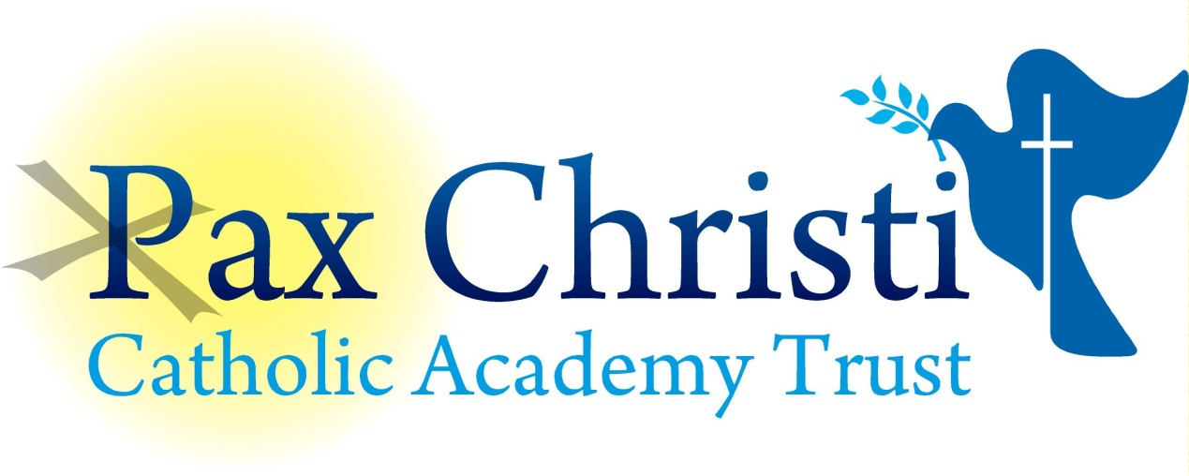

CHRIST THE KING CATHOLIC VOLUNTARY ACADEMY

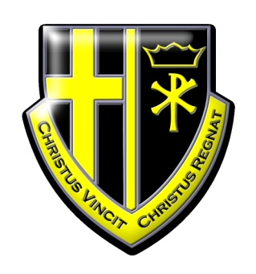

JOB DESCRIPTION

Cover Supervisor
NJE Grade 3
34.5 hours per week term time only

Current Postholder: | Vacancy
Job Description Review Date: | November 2017
Job Purpose
The post holder will provide support to the Academy when Teaching Staff are not available.

Line Management
Responsible to: Principal, Operations Director and Assistant Principal
Responsible for: No staff

Specific Responsibilities
1. Supervising students, ensuring that students can access the work left in accordance with the academy policy
2. Preparing the learning environment and the materials used therein
3. Managing student behaviour to ensure a constructive working environment
4. Responding to students about the work that has been set
5. Collecting any work completed after the lesson and returning it to an agreed person/place
6. Leaving the room in good order at the end of the lesson
7. Supervising entry and departure of the students in accordance with academy policy
8. Recording and reporting on attendance at lessons in accordance with academy policy
9. Exam invigilation under the supervision of the Examinations Officer
10. Undertaking the activities and role of the Form tutor
10. Reporting back as appropriate using the academies’ agreed referral procedures on the behaviour of pupils during the class and any other issue arising
11. At times when not doing the above, doing general administration tasks and display work for specific departments as required

Skills and Abilities
The postholder will be expected to demonstrate the following skills and abilities at all times during the discharge of their duties:

- Work on own initiative and to demonstrate the ability to solve unexpected or new problems in a methodical, efficient manner.
- Learn new skills and expand current skill set and to be able to pass on knowledge and techniques to others.
- Demonstrate good general interpersonal and communication skills.
- Deal with conflicting demands and work flexibly.

Whole Academy Responsibilities
- Be a positive influence on the climate and culture of the Academy and show a positive example at all times.
- Support the catholic ethos of the Academy.
- Be aware of and comply with policies and procedures relating to child protection, health, safety and security, confidentiality and data protection, copyright etc reporting all concerns to line manager.
- Be aware of and support difference and ensure all pupils have equal access to opportunities to learn and develop
- Contribute to the overall aims of the Academy.
- Appreciate and support the role of other professionals.
- Attend and participate in relevant meetings as required.
- Participate in training and other learning activities and performance development as required.
- Recognise own strengths and areas of expertise and use these to advise and support others.
- Be aware of confidential issues linked to home/pupil/teacher/school work and to keep confidences as appropriate
- Any other curriculum duties which may reasonably be regarded as within the nature of the duties and responsibilities/grade of the post as defined.

General

To work in collaboration with other Pax Christi Academies, sharing good practice and supporting during time of absence and/or heavy workload.
- This job description contains the main accountabilities relating to this post and does not describe in detail all the tasks required to carry them out. All staff are expected to be flexible to ensure the most effective organisation and delivery of services.
- The duties and responsibilities of the post will evolve with the natural development of the Academy and/or Trust. Such changes are, therefore, a normal part of the post and the post holder must be prepared to undertake any other duties commensurate with the general level of responsibility of the post which may be determined from time to time subject to the proviso that any permanent, substantial changes shall be incorporated into the job description and evaluated as such.

