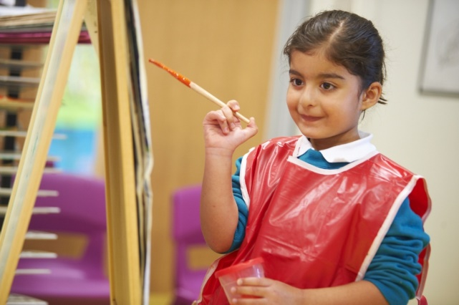

The Views of the Berryfields School Council

(Noah, Yasmin, Logan, Antonina, Mason, Jess, Cameron, Jayden, Sofia, Emily, Noah, Connor, Melina, Prithvi, Hayley, Tyler, Mahika, Diyaa, Riley, Lucy, Jaiden)

What are the things that are most special about our school that you would want the new Headteacher to know about?

- Berryfields CE Primary School is friendly – everyone knows your name. It’s like we are one big family.
- Teachers take care of us and keep us safe. Our school is an anti-bullying school.
- We learn, using our learning powers and have kind, lovely, good teachers. Teachers are funny, not bossy.
- We accept differences and beliefs; we are respectful and have faith.
- Christian faith
- We have a special school prayer and a variety of different assemblies.
- Families are invited for special events, like our school fair; a special artist comes in for Art Week.
- Our school is bright and colourful. The classrooms are nice and big with good resources and equipment. We read exciting books and have fun things – like the pirate ship.
- There are lots of clubs and we enjoy class trips.

What do you want our new Headteacher to be like?

- Someone who enjoys being a Headteacher
- Kind, caring and knowledgeable - thoughtful
- Someone to go to, with a problem - understanding
- Well educated, hardworking and experienced
- Trustworthy
- Ambitious to make the school even better
- Good at assemblies
- Reasonable - firm but fair. Doesn’t have favourites
- Believes in people - prepared to give second chances
- Comes into class to see work and outside at break times
- Friendly, joins in with community events
- Mutually respectful
- Funny and responsible
- Energetic, sporty and creative
- Positive and enthusiastic
- Doesn’t matter if they are male or female

The Views of the Berryfields Parents

What are the things that are most special about our school that you would want the new Headteacher to know about?

- Our school is very community based and nurturing. We want our children to be happy, have fun, learn and feel safe.
- The previous Headteacher created a school, which was about the whole child, not just statistics.
- It is important to me that my child is happy and safe and that she progresses to the best of her ability.
- We have some fantastic children and teachers in this school, who want to learn and to teach.
- Its sense of community, its caring ethos and the fact that the Headteacher knows all of the children by name
- I believe what makes the school special is the community, within which it is set. Berryfields is a new housing development and the school is fairly new too. The majority of pupils who attend the school come from the immediate surrounding local area and the friendships formed between children within the school, and then extend outside of school and also between parents. This creates great community spirit and parents wanting to contribute to the school in the best way they can.
- Before and after school club is very important to many parents and essential to working families.
- Sports days are always a great day for parents and children alike. The usual set up is a lovely occasion, with races and a picnic. Other occasions like mother’s day assemblies / nativity / grandparents’ afternoon are lovely extras, especially for the children.
- Enrichment clubs are valued and offer experiences to children who may not be able to afford to attend clubs outside of school.
- I think the new Headteacher needs to know how much we do care for the school to be brought up to standard and how we want our amazing FoBS (PTA) to continue as it's great for us all.
- The new board of governors seem to want to improve the school.

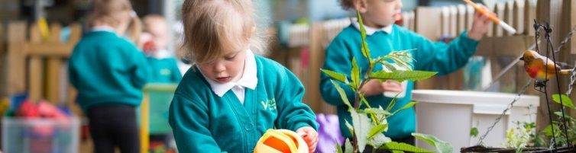
What qualities do you consider the most important, for governors to consider when recruiting the new Headteacher?
They must:
- Be personable and very approachable for both parents and children
- Have experience, good organisational skills and exceptional communication skills
- Be consistent, fair and supportive of staff, making them feel valued
- Be of trustworthy character and able to guide the school in the right direction
- Have a strong presence with the children, including on the playground before and after school
- Have a clear and concise behaviour management strategy with a focus on rewarding positive behaviour and zero tolerance for violence or bullying
They need to:
- Have a clear vision on the aspirations and values that they would like to instil in the children
- Have a clear strategy on how to improve the school and work towards implementing changes in order to improve the school’s Ofsted rating
- Get to know the children and make them feel secure
- Be a strong, caring, approachable, nurturing and proactive Headteacher who is transparent in the tuning of the school
- Have a good working relationship with the staff at both the Primary and Secondary School
- Take time to listen to parents’ views and take them into consideration and work effectively with both staff and parents
- Value parents as working in partnership with the school
- Support FoBs (Berryfields PTA) and make every effort to attend events held at the school
- Effectively communicate with parents, using newsletters, emails and messages regarding information and events
- Not be afraid to tackle some of the problems, arising because our school is a mixed school with many social issues
- Have consideration for people with a different culture and ethnic background and treat people the same
- Be friendly with the children without compromising discipline and punctuality
- Have plans are to make Berryfields Primary a more positive, vibrant place
- Be keen on dressing up on world book day, with full costume!

And finally … the view of a highly committed staff member

‘Berryfields has a strong Early Years team, from our Nursery classes through to Reception. An excellent candidate for the new Headteacher position would both recognise and embrace the crucial formative role of the Early Years, and how the care and education provided in this phase, differs from the classes working at National Curriculum level. This candidate would regard those working in the Early Years phase as highly skilled professionals with a rich knowledge of children's early development.

We would also expect the new Headteacher to be compassionate and approachable from the perspective of staff, children and parents. They should be committed to creating a nurturing environment for all children that encourages aspiration and engagement with the school community, both by children and their families.’

