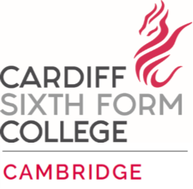
Candidate Information Pack
Full time Houseparent

The college seeking to employ a full-time residential houseparent.

The Houseparent will join the existing boarding team will oversee the well-being and pastoral care of students.

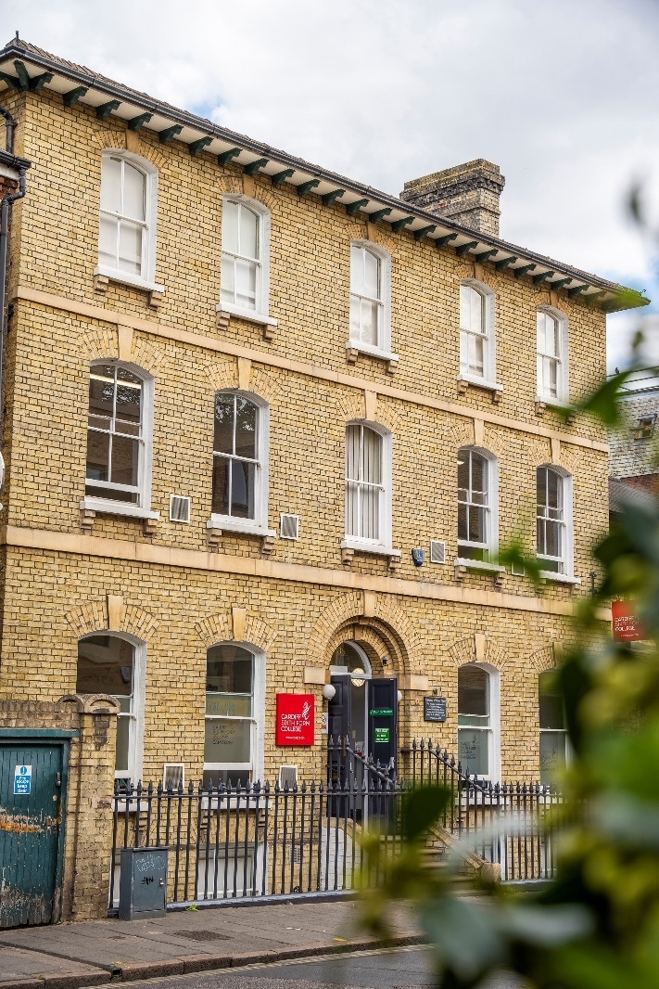

What would you do if you worked in a school with the most able students from across the world?
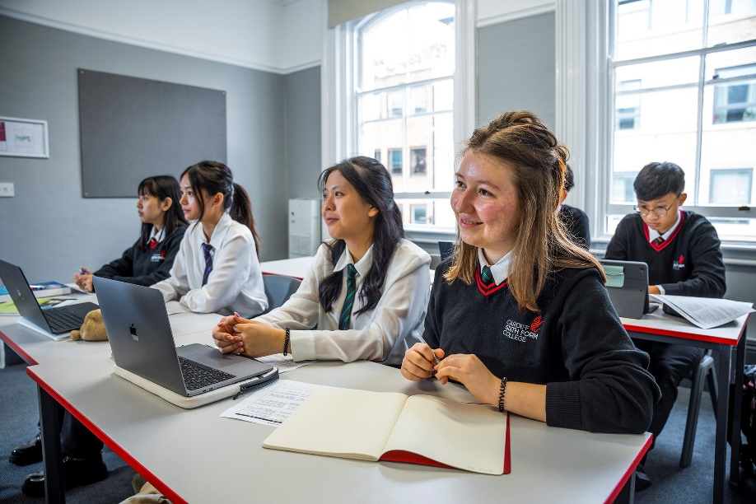
Introduction & Background
Cardiff Sixth Form College was set up in 2004 as a small private tutorial centre in response to a perceived need in the community to cater for those students of high academic ability but relatively modest financial means. Latterly, expansion of the college has allowed for international students to access this same service. The aim of Cardiff Sixth Form College is to prepare students for a well-balanced, modern life with outstanding levels of educational achievement. A combination of small class sizes, individual attention and excellent teaching leads to first-class academic results with the college being recognised consistently as the ‘Number One Independent School in the UK, at A Level’ since 2011.
Cardiff Sixth Form College is an international boarding school which brings together some of the most talented students from different countries, providing a stimulating environment in which to study. Students bring an enthusiasm and focus to their studies and are hungry for knowledge and success. In 2021, 98% of students achieved A*-A grades and 100% A*-B. 17 students went on to Oxbridge and 50% to the G5 universities with 81% going onto QS Top 100 universities worldwide.
The opening of a new site in Cambridge in September 2022 means that both Cardiff and Cambridge colleges now operate as ‘One College, on Two Campuses’.
Location
Cardiff Sixth Form College, Cambridge is set in the heart of the city of Cambridge. Based in three buildings, closely located to the town centre, it is very much an ‘urban college’.
Cambridge is a city on the River Cam in eastern England, home to the prestigious University of Cambridge, dating to 1209. University colleges include King’s, famed for its choir and towering Gothic chapel, as well as Trinity, founded by Henry VIII, and St John’s, with its 16th-century Great Gate. University museums have exhibits on archaeology and anthropology, polar exploration, the history of science and zoology.
The city's skyline is dominated by several college buildings, along with the spire of the Our Lady and the English Martyrs Church, and the chimney of Addenbrooke's Hospital. Anglia Ruskin University, which evolved from the Cambridge School of Art and the Cambridgeshire College of Arts and Technology, also has its main campus in the city.
Cambridge is at the heart of the high-technology Silicon Fen with industries such as software and bioscience and many start-up companies born out of the university. Over 40 per cent of the workforce have a higher education qualification, more than twice the national average. The Cambridge Biomedical Campus, one of the largest biomedical research clusters in the world includes the headquarters of AstraZeneca, a hotel, and the relocated Royal Papworth Hospital.
The first game of association football took place at Parker's Piece, immediately behind the Cardiff Sixth Form College main building. The Strawberry Fair music and arts festival and Midsummer Fair are held on Midsummer Common, and the annual Cambridge Beer Festival takes place on Jesus Green.
The city is well served with excellent road and rail links. It is adjacent to the M11 and A14 roads and Cambridge station is less than an hour from London King's Cross railway station.
School Aims & Ethos
Cardiff Sixth Form College’s vision is to be “The Best Academic School in the World”: lofty aspirations which are backed up by a remarkable history of high academic achievement and successful university placements.
Ralph Waldo Emerson said: “Without ambition one starts nothing. Without work one finishes nothing. The prize will not be sent to you. You have to win it.” This epitomises the attitude of a typical Cardiff Sixth Form College student who is ambitious, whose aspirations are broad and whose academic dreams are significant. It is for the hardworking and diligent student who wants to excel and broaden their academic horizons. It is for students who wish to win a place at the best universities to study courses which will provide fulfilment and challenge. It is not for everyone, but it is the perfect place for many.
The college aims to deliver teaching and learning that challenges, inspires, demands and delivers excellence; careers guidance which is outstanding and is tailored to the individual’s needs and aspirations; pastoral care which is safe, caring, compassionate, understanding and developmental; administration which is efficient and supportive, with compliant systems, both complementing and leading the provision; and sustainability that comes from a profitable organisation that invests for and in the future.

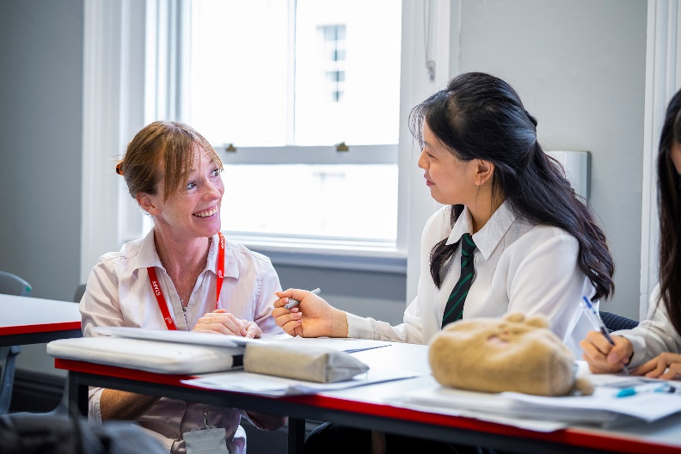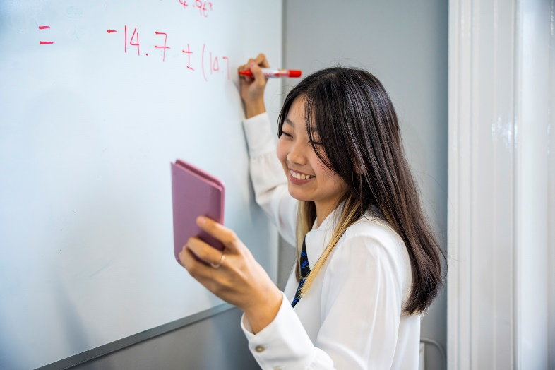

Cardiff Sixth Form College’s new Cambridge campus
As the leading A level provider within the UK, Cardiff Sixth Form College offers an outstanding academic programme for admission to the best universities in the UK and internationally. At the Cambridge campus, students will follow a predominantly STEM programme and may select from the following subjects:
Biology | Further Mathematics | Mathematics | Chemistry | Physics | Economics | Computer Science
In addition, the college helps students build management and project skills, teamwork abilities, confidence and a healthy mindset. Our teaching approach places considerable emphasis on independent learning – to look beyond simple answers and demonstrate a passion for knowledge and discovery. To support this aim, all students have access to courses in critical thinking, effective communication, leadership and entrepreneurship.
Learning begins in the classroom but doesn’t end there. All students take part in an extensive super-curricular programme, ‘The Cambridge Edge’. This including elements from work observation, academic enrichment trips, career-based societies and a wide range of academic competitions.
An extensive university preparation programme complements the curriculum, giving students the best chance to achieve their potential. This includes specific assistance for Oxbridge entry, Medicine and Healthcare degrees and international university preparation. As a part of Dukes Education, we are supported by Dukes Consultancy, including Oxbridge Applications, Medic Applications and A List for US University Applications in providing expert and bespoke assistance to our students.

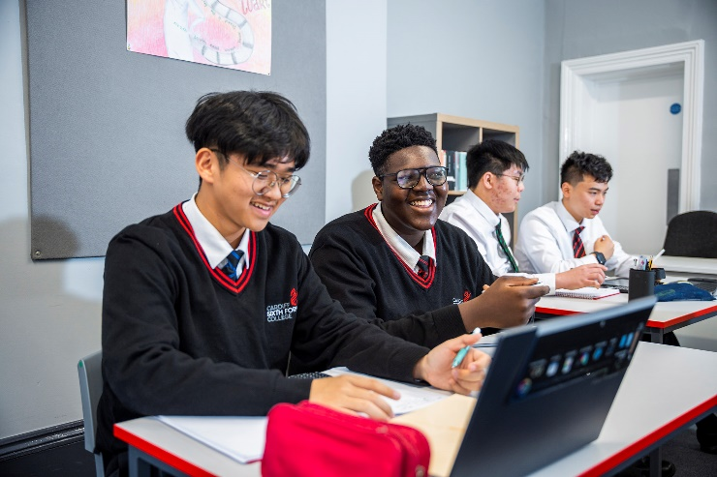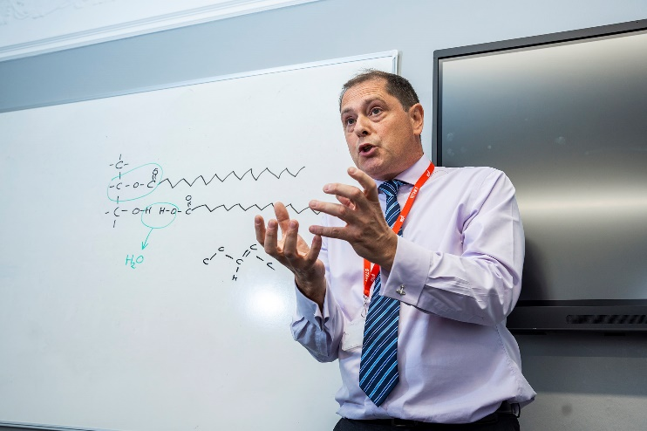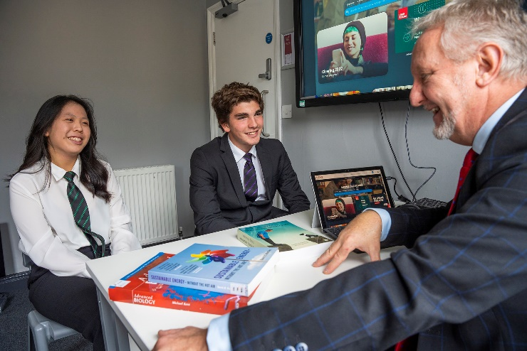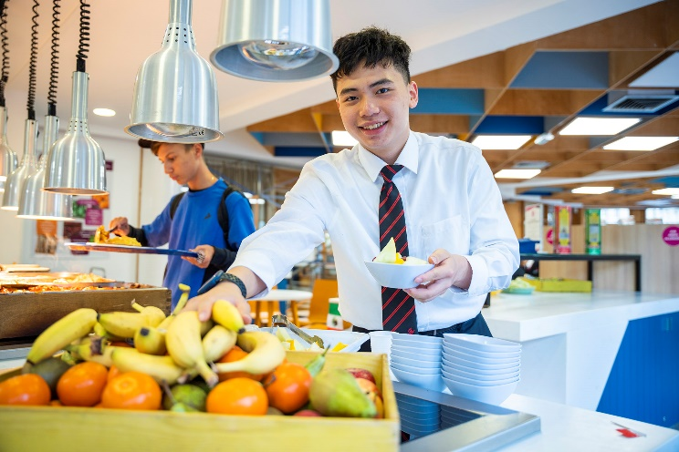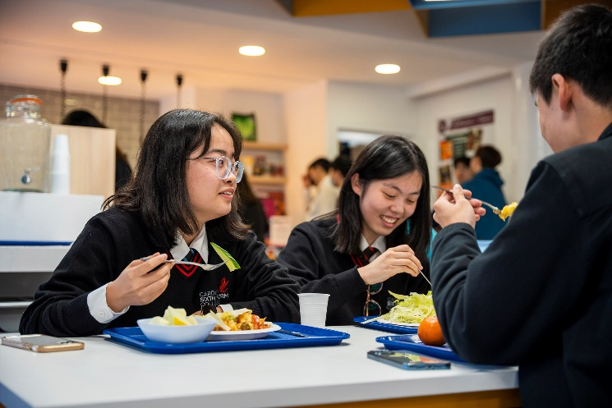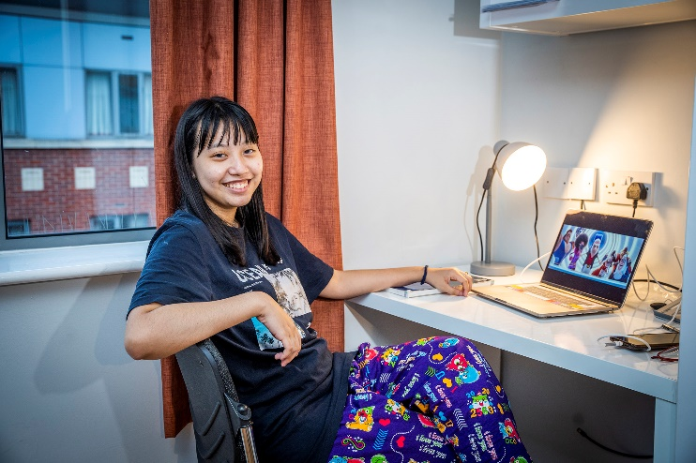

Houseparent at CSFC Cambridge
Cardiff Sixth Form College Cambridge was launched in September 2022 with a small cohort of international students. The college will grow substantially in September 2023 and resulting in a number of additional boarding staff roles becoming available.
The houseparent will join the existing boarding team to provide pastoral care of the highest standard that inspires our able and ambitious students to develop as young people outside of the classroom

JOB DESCRIPTION

Job Title: | House Parent
Department: | Boarding
Responsible to: | Head of Pastoral through the Senior Houseparent
Purpose of the job: | As part of the Pastoral & Boarding team the purpose of the role of the House Parent is to provide a safe, caring boarding environment that enriches the lives of the pupils/students in the care of the college. Under the direction of the Head of Boarding, to act “in loco parentis” for the pupils/students and to provide all boarders with the best possible experience of a boarding education by ensuring a challenging and  supportive environment: a home from home for boarders.

Care, Welfare and Development of Boarders Duties:
- Know each pupil/student personally and be concerned for their development – academic, social and personal welfare by creating a homely boarding experience.
- Develop, in the pupils/students, a sense of collective responsibility and sensitivity to the difficulties and needs, of others, and to encourage such support and help for each other as is appropriate.
- Ensure that pupils/students abide by the school timings and leave in the morning in time for lessons and are in the house at curfew, and any other time required.
- Be part of an effective boarding team, working under the direction of the Senior Houseparent
- /Head of Pastoral, to maintain the highest possible standards of care and support to all pupils/students including correctly following all policies.
- Ensure that policy and procedures are understood and followed regarding the care of ill pupils/students, dealing with emergencies of any kind.
- Liaise with relevant members of staff, including Head of Houses, other college staff and out of hours safeguarding contacts, regarding academic and pastoral welfare.
- Ensure that younger students (CSA’s) are supervised and cared for more closely than sixth formers.

Records, Duties and Tasks:
- Ensure that residence rules are followed, in accordance with the pupil/student and boarding handbook, notices and residential pupil/student induction information and to act appropriately, recording the misdemeanour and action taken.
- Ensuring leave Requests are completed an authorised correctly, including permissions to stay away with guardian or parents.
- Ensuring that the ‘handover’ log, discipline, medication, sanctions and other centralised records are kept up to date.
- Maintaining records of all communications/contacts with parents and guardians.
- Take part in appraisals and probationary meetings as directed.
- Writing pupil/student reports regarding their experience and behaviour in boarding.
- To monitor guests to the residence for both students and staff, making sure all guests comply with boarding house regulations.
- To participate in regular meetings with the pastoral and boarding team.
- Organising, involvement and support of a full, varied programme of extra-curricular activities so that pupils/students are adequately occupied in their free-time.
- To comply with all health and safety procedures and policy as required by the College.
- Sign a service agreement which specifies the College’s expectations of staff conduct within the boarding house.
- Other duties will include registration, room checks, laundry, monitoring evening snacks and assisting with pupil/student arrivals and departures.
- Undertake any other related tasks as may reasonably be requested by the Senior Houseparent, Head of Pastoral or other Senior Staff.
- Comply with all health and safety procedures as required by the college on all sites, particularly to ensure all fire evacuation requirements are met.

Safeguarding Responsibilities
- Cardiff Sixth Form College is committed to its responsibility for safeguarding and promoting the welfare of its pupils/students in line with government recommendations and policies. Due to this, all staff at the college have a responsibility for safeguarding and reporting any concerns regarding pupils/students to the DSL. Your safeguarding responsibilities mean that you will need to:
- Demonstrate a commitment to promoting and safeguarding the welfare of children and young persons in line with College Policy and procedure.
- Respond and deal with incidents in a sensitive, empathetic and supportive manner, reporting any incidents to the accommodation manager and pastoral team.
- Be willing to undertake additional safeguarding training to enhance professional development.

Person Specification:
- To have a working knowledge of the national and local inspectorate requirements including NMS and Independent School Standards.
- Being adaptable and showing good judgement. Demonstrating individual initiative and an ability to complete tasks without supervision whilst also functioning as a part of a team.
- Works effectively with other people by being self-aware; treating people equally and sensitively, whilst ensuring all aspects of confidentiality are maintained.
- Developing good working relationships with colleagues, and sharing knowledge and best practice.
- The ability to manage difficult situations if they should arise.
- Communicates clearly by getting the message across effectively, listening carefully and responding to feedback.
- Represents CSFC professionally and adheres to the highest levels of customer service with all stakeholders including students, parents, agents, guardians and external service providers.

Terms & Conditions
- Remuneration: £18,000 to £22,000 depending on experience
Accommodation is available but not required. If residential then council tax, water rates and utility bills will be paid by the College, except for personal telephone calls. Meals will be available in the College during term time. If non-residential then you will be required to sleep in the boarding house overnight as dictated by the rota.
- Working Hours: As a member of the boarding team the working hours are before and after the school day, and at weekends. You can expect to have one night off during each week (Monday – Thursday) and to have a weekend rota with one weekend off in three. Boarding staff may be asked to work more than 48 hours a week and will be asked to sign a Working Time Agreement accordingly.
- Holiday entitlement: 50 days (excluding bank holidays) to be predominantly taken during
college holidays
- Notice period: 1 term
- Probationary period: 6 months reviewable at discretion of CSFC
- Pension: Inclusion in the Cardiff Sixth Form Pension Plan
- Training: Commitment to ongoing training for safeguarding, health and safety, food hygiene and relevant boarding specific training courses

Cardiff Sixth Form College is an equal opportunities employer and is caring and reasonable in its approach to all staff.

Cardiff Sixth Form College winning the ‘Overall Setting of the Year’ Award at the 2022 Annual Dukes Education Conference.

