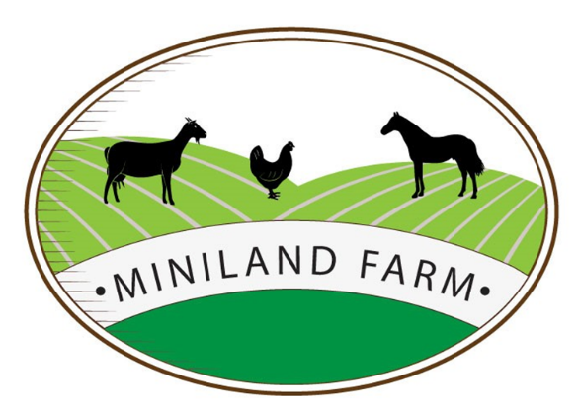
Miniland Farm
Thornhill, Hollywater Road, Passfield,
Hampshire, GU30 7RS
Contact: 07519 326542
Admin: enquiries@minilandfarm.com
Director: debs@minilandfarm.com

LSA Application Form

PERSONAL INFORMATION
Title | Name |  | Date of Birth
Address

Phone Number |  | Email Address
Have you ever been disqualified with working with children or been subject to a safeguarding concern YES / NO
Have you ever been subject to any of the following |  | Capability procedure: YES / NO  Disciplinary procedure: YES / NO

DESIRED EMPLOYMENT
Full Time Part Time | Position applying for
Salary expectation | Date you can start
Current job/title | Hours available to work

Education – most recent first
Date | School/College/University | Qualification & Grade
Employment History – explaining any gaps
Date from/to | Employer | Job role/description

Suitability for the role: provide a personal statement including your interests/experience for the position.

References - required including current employer
Can we contact your current employer prior to interview?
Yes No
If yes, please supply contact details

1st reference | 2nd reference
Name:  Company:  Job role:  Address:  Phone no:  Email: | Name:  Company:  Job role:  Address:  Phone no:  Email:

