
Welcome to

UTD 1878

IPSWICH HIGH SCHOOL

WOOLVERSTONE HALL
SUFFOLK, ENGLAND

Campus

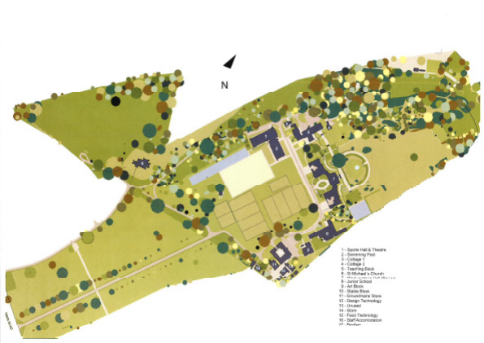
1. Sports Hall & Theatre
2. Swimming Pool
3. Cottage 1
4. Cottage 2
5. Teaching Block
6. St Michael’s Church
7. Woolverstone Hall (Senior)
8. Preparatory
9. Art Block
10. Stable Block
11. Groundsman’s Store
12. Design technology
13. Unused
14. Store
15. Food Technology
16. Staff Accommodation
17. Pavilion

2 01473 780201 | w w w.ihseducation.co.uk | Woolverstone, Suffolk, IP9 1AZ

Welcome


Thank you for your interest in joining the staff of Ipswich High
School.

The role represents a significant opportunity for you to contribute to our story, and to enhance the educational experience of all our students. This is an exceptionally exciting time to be joining our outstanding school, as you will be a cornerstone in our change toward a Diamond Model of education.

As Head, I am enormously proud of the teaching and support staff. Every member of our school has access to support and training to help them develop professionally within their role.

I hope that on reading about this position, you will decide to apply. I am sure you will find a truly rewarding and enjoyable journey ahead of you, it is a vital role at a time of exciting developments within the school.

Yours faithfully,



Ms Oona Carlin

01473 780201 | w w w.ihseducation.co.uk | Woolverstone, Suffolk, IP9 1AZ 3

Ipswich High School is a leading independent day school in Suffolk, proudly educating hundreds of students every year, between the ages of three and 18. The school has long enjoyed a high profile across the region, and is much respected for both its academic success year-on-year, and for its superb pastoral care and enrichment activity. With feeder schools spread across East Anglia, the school typically sees its greatest demand for places from the counties of Suffolk, Essex and Norfolk.

Founded in 1878, the School has been on the Woolverstone site since 1992. The outstanding setting provides us with an impressive 84 acres, on which we have created sporting, academic and technological facilities, which are perfect for the demands of a twenty-first century student. We benefit from: a designated Sixth Form Suite, bespoke outdoor Junior Playground, Drama and Dance Studio, 25m competition swimming pool, Design Studio with cutting edge technology, floodlit astro-pitches and a state of the art Fitness Suite.

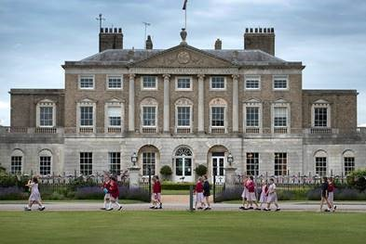
Proud of our superb natural surroundings, we make full use of the site’s own woodland, which offers an outdoor learning area for the Preparatory, as well as a pond and parkland, which are used for scientific research.

At Ipswich High School, pupils follow a broad and balanced curriculum from which they enjoy great academic success. In 2017, our GCSE 96.7% of our grades were A*-C with our A*-A pass rate 70.4%. Equally, our 2017 A Level were impressive, 12.1% of our grades were A*,
38.5% were A*-A.

We deliver a well-co-ordinated careers
programme and all pupils participate in work experience. Our pupils proceed to degree courses in a wide variety of subjects, and often at the most popular universities, 56.6% of our 2017 cohort went to read at a Russell Group University.

The school is fiercely proud of its friendly and caring ethos. We attach great importance to pastoral care and most full-time teachers are also form tutors. The school also has a well-deserved reputation for sport, drama, art, dance and music as well as for its academic rigour.

Full and part-time teachers are expected to contribute to our extensive enrichment programme,
which includes the Duke of Edinburgh scheme and World Challenge.

Our New Era

In September 2017, we announced that Ipswich High School will be moving towards a Diamond
Model of education.

This new era formally begins from the Autumn Term of 2018, when we will commence our enrolment of boys, in the Sixth Form and certain years of the Junior School. The decision to adopt this much respected style of education has the full backing of an incredibly supportive teaching team, and our Board of Governors.

4 01473 780201 | w w w.ihseducation.co.uk | Woolverstone, Suffolk, IP9 1AZ

Development, Health, Pensions & Union

• Attractive pay scales compared with those in the maintained sector.

• The school is committed to staff development with an annual review scheme and regular opportunities for
in-service training. We run an Induction Programme for all new staff including familiarisation with our computer network, Intranet and remote access.

• Teaching staff are provided with a school laptop/iPad.

• All teachers are eligible to belong to the
Teachers’ Pension Scheme.

• All support staff are invited to join the
Standard Life Pension.

• All staff able to join NEU union membership with free on site advice available from the NEU representative.

• Corporate Membership of Ipswich Sports Club, at 30% off advertised Membership Subscription Fees.

Free Provision & Discounted Services

• Mid-morning refreshments and a midday
meal are free of charge during term time.

• There is free onsite parking.

• All staff can swim free of charge on two evenings per week and, at specified times, have free use of the new Fitness Suite.

• Staff undertaking a free eye test will be offered £40 towards the cost of new reading glasses.

• Offer of free Microsoft Office software on devices at home while employed at the School.

• Hire of glasses/crockery and cleaning equipment can be arranged for a nominal fee and 50% staff discount is offered when hiring facilities.
Parent Benefit

• A 50% reduction in school fees from Reception class onwards is available to full-time staff; for part-time staff, the fee reduction is calculated pro rata.

Staff wellbeing is a School priority and we also provide:

• Free electric charge points for electric cars.

• Half price flu vaccination.

• Cooked lunch each day (term time) and sandwiches/fruit during parent evenings.

• Free tea and coffee for all staff all day.

• Newspapers in staffrooms.

• Fruit in staffrooms.

• Meditation Room.

• Subsidised Christmas Party (including partners).

• Continual refurbishment of staff areas.

• Continual review of staff duties.

• Cover supervisors in the Senior and Junior
School.

• End of year staff BBQ and presentations to long serving members.

01473 780201 | w w w.ihseducation.co.uk | Woolverstone, Suffolk, IP9 1AZ 5

Please complete an application form and return to our HR Officer, enclosing a
letter supporting your application.

For further information, please contact the HR Officer at recruitment@ihs.gdst.net

Ipswich High School Woolverstone Ipswich
IP9 1AZ

Tel: +44 (0) 01473 780201

Web: www.ihseducation.co.uk

Safeguarding Checks

All appointments in will be subject to two satisfactory references, Disclosure check by the Disclosure and Barring Service, medical fitness for this role and evidence of identity and qualifications. All the above checks must be completed before beginning work in the school. In the unlikely event of an unsatisfactory report being received following the issuing of a contract, the offer of appointment will be terminated without notice.

We are committed to the safeguarding of children and child protection screening will apply to this post.

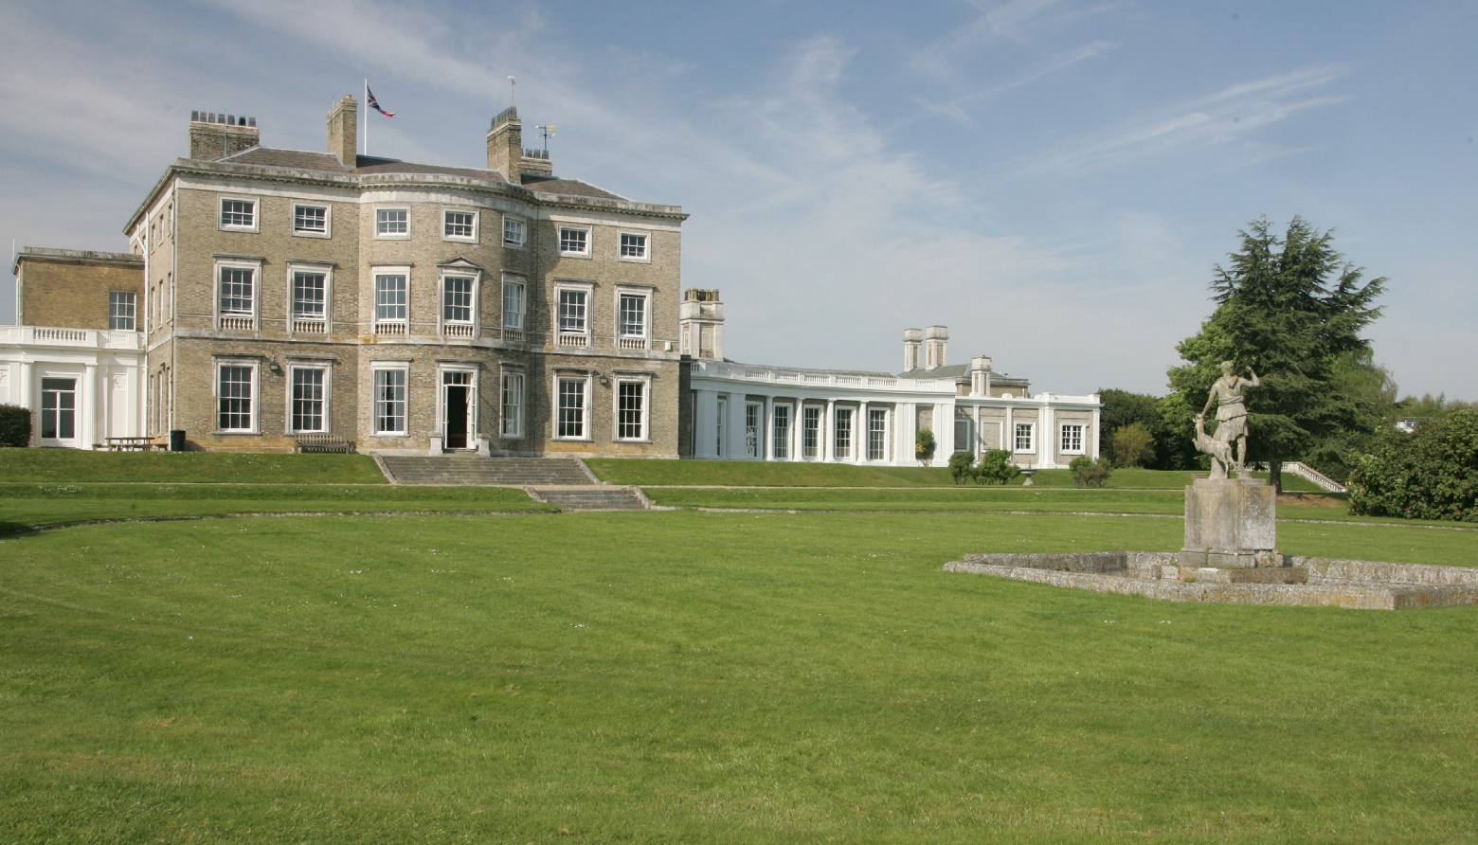

6 01473 780201 | w w w.ihseducation.co.uk | Woolverstone, Suffolk, IP9 1AZ

1171

IPSWICH HIGH SCHOOL

WOOLVERSTONE HALL
SUFFOLK, ENGLAND

www.ihseducation.co.uk
Telephone 01473 780201 I Fax 01473 780985 I Email enquiries@ihs.gdst.net I Woolvers tone, Ipswich, S uffolk IP9 1AZ

