
Job Title: Teaching Assistant Maths

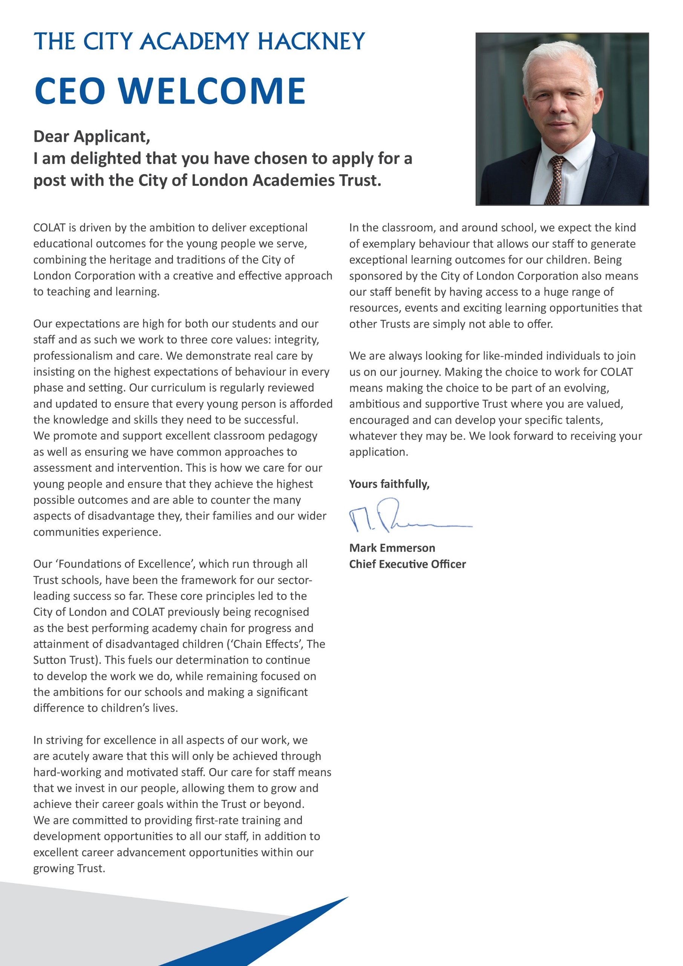

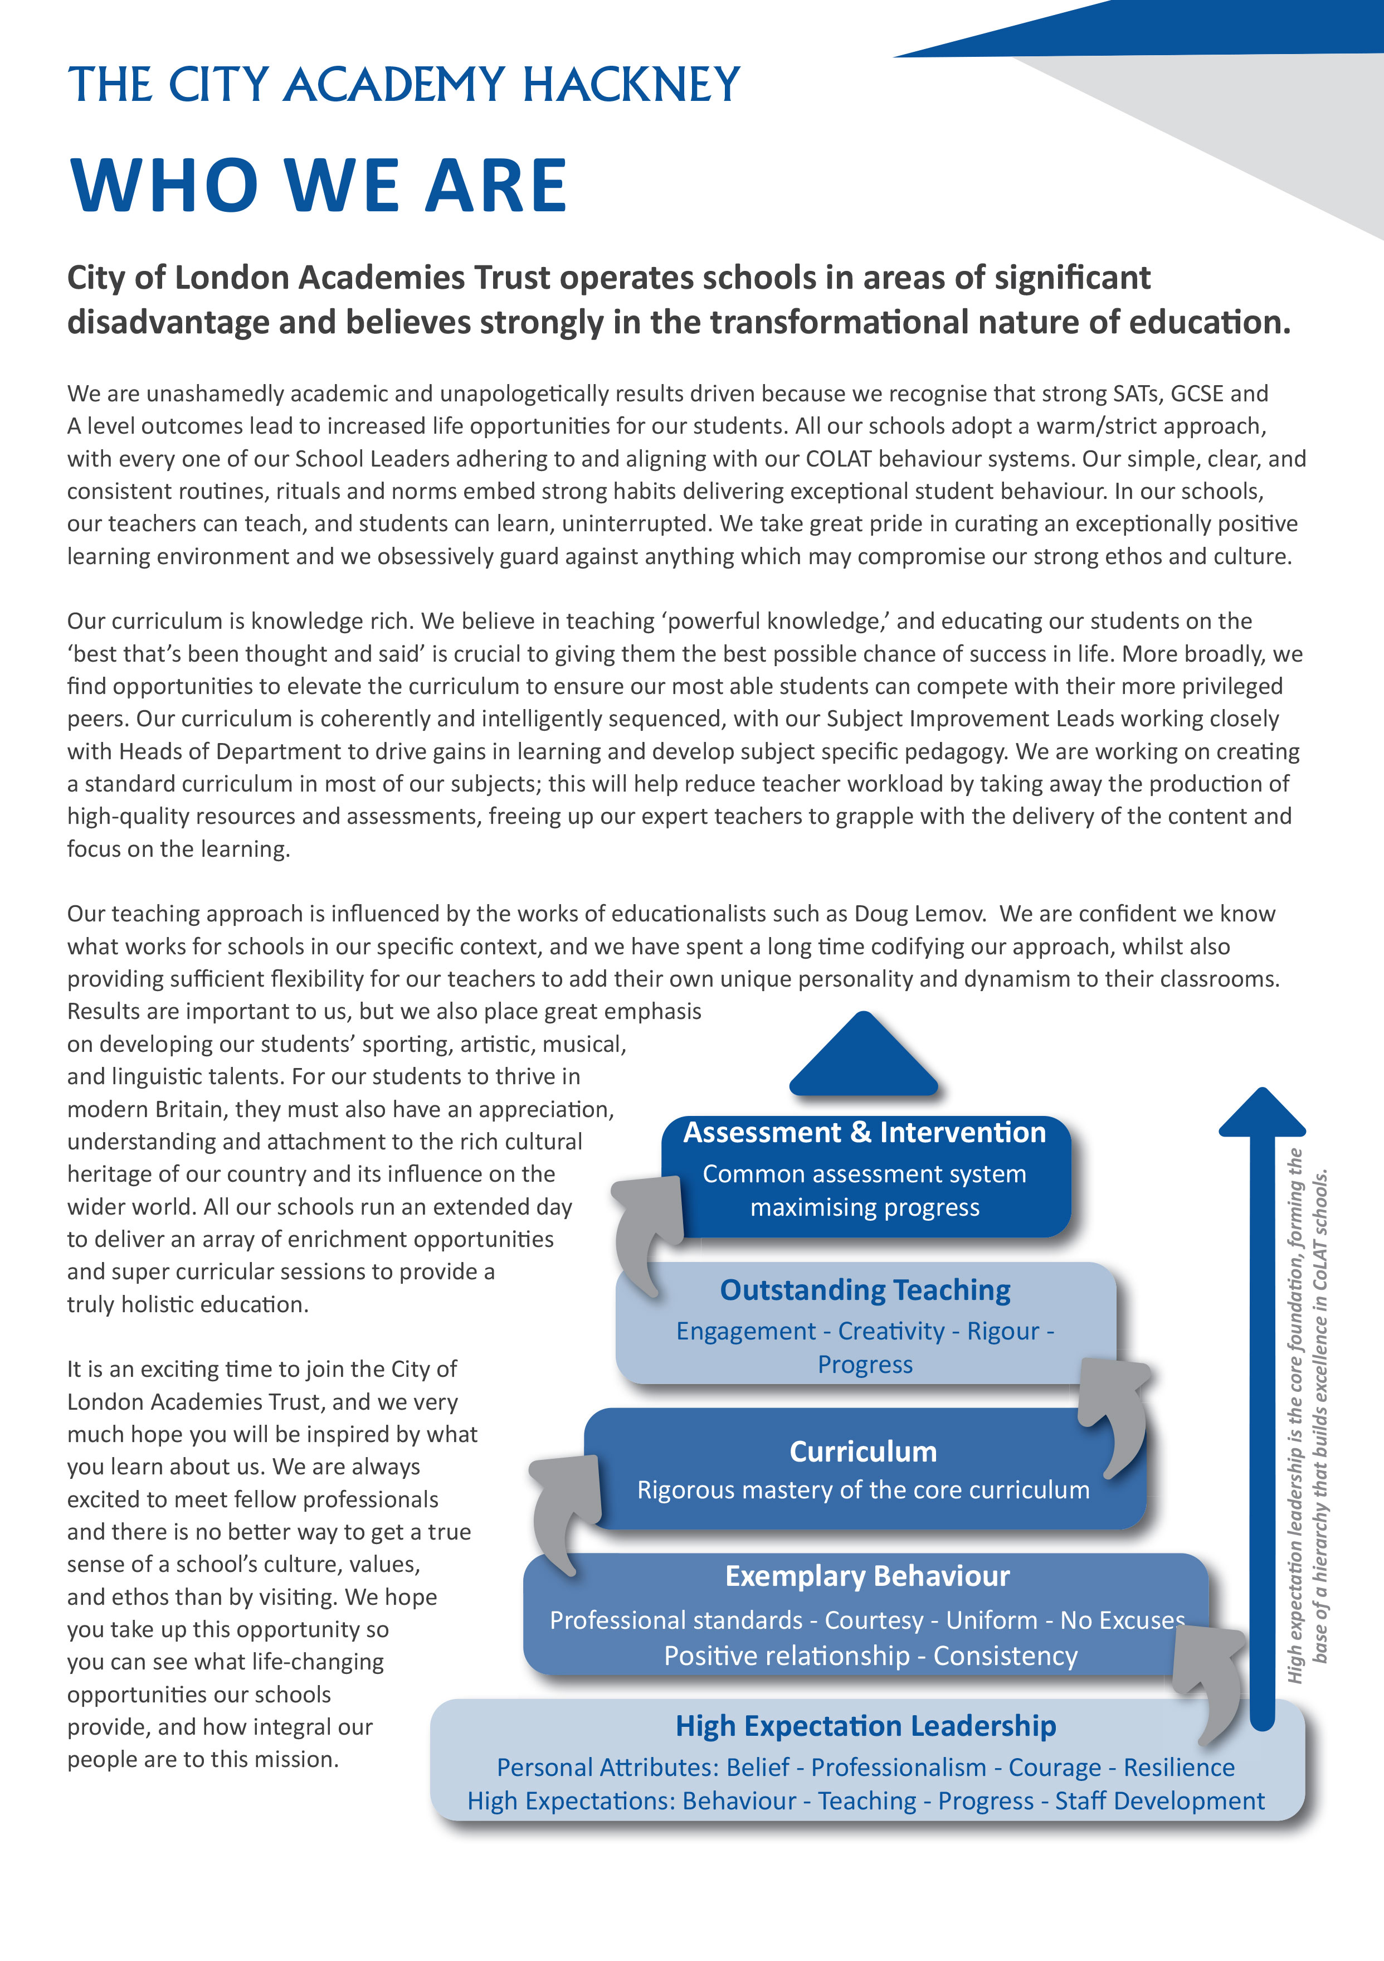

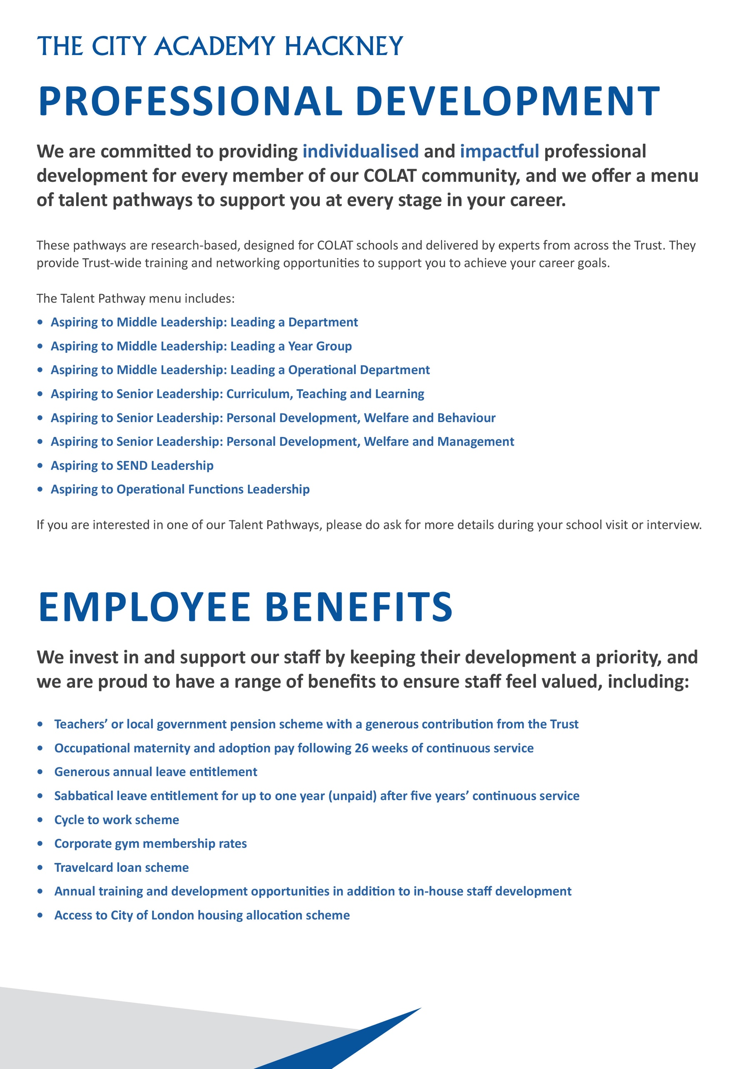
Headteachers Welcome

Dear Candidate,

Thank you for expressing an interest in the post of TEACHING ASSISTANT - MATHS at The City Academy, Hackney.

At The City Academy, Hackney, we are dedicated to providing all the students in our community with the best possible educational opportunities. We believe excellence is achieved through three key ingredients: clear structures, high expectations and strong relationships. Our outstanding curriculum is built around 'The City Experience' which places equal value on academic, creative, sporting, linguistic and personal development.
We pride ourselves on being a school which offers young people a warm and supportive environment, enabling them to meet our very high expectations. Our inspirational staff are skilled and committed and we are generously supported by The City of London Academies Trust. As a result of this, our students make exceptional progress.
We are looking for staff who are committed to working with students of all abilities, who constantly seek to learn and improve and who are ambitious for themselves as well as for their students. We expect hard work, skill and dedication, and in return will provide a supportive, flexible working environment, first class training opportunities and a comprehensive benefits package.

If you have the experience and passion to join our team and inspire the next generation, we look forward to hearing from you. Please apply via our website: https://www.thecityacademyhackney.org/

If you have any questions or would like to arrange a visit to the academy please contact our HR team at hr@thecityacademy.org. I look forward to reading your application.

Yours sincerely,



Anna Sarchet
Principal

Teaching Assistant Maths - Job Description

Post: TEACHING ASSISTANT – MATHS

Accountable to: Higher Level Teaching Assistant, Faculty of Learning Leadership Team, Subject Leaders

Grade/Range: Local Government Pay Scale, Inner London

Salary: Scale 4 Point 7-10 £29,412 - £30,771 per annum, pro-rata
Actual salary: £25,719 to £26,907 per annum (2023/24)

Working pattern: 35 Hours, Term time only (39 weeks)
ocation: Hackney
Disclosure level: Enhanced

Responsible for: Assisting students with educational needs

Main Purpose
- To assist in the support of students with educational needs to enable them to access the curriculum as fully as possible.
- Receive specific instructions from the FOL Leadership Team, HLTA, Subject Leaders and/or subject teachers.

Key Accountabilities

The duties outlines in this job description are in addition to those covered by the Local Government Terms and Conditions Document. It may be modified by the Principal, with your agreement, to reflect or anticipate changes in the job, commensurate with the salary and job title

Supporting Students
- To teach small groups of students
- To develop an understanding of the educational needs of the students
- To assist students to learn as effectively as possible in class, group and individual situations
- To establish a supportive relationship with students
- To encourage the integration of students into classes
- To effectively disseminate up to date information of the educational needs of the students within the Faculty of Learning team and the wider school community
- To seek opportunities for and encourage the inclusion of students in all aspects of school life
- To help promote and reinforce students’ confidence and self-esteem
- To help keep students on task and build motivation
- To undertake break and lunchtime duties where needed to support students who find these unstructured time difficult, such as students with ASC
- In addition to the above, some Teaching Assistants will be required to support students with particular duties relating to their physical needs

Supporting the Head of Learning
- To assist in the development, implementation and review of Student Learning Plans (SLPs) for students, and work materials.
- To monitor and record student progress.
- To be a Personal Adviser, being responsible for monitoring the academic progress and emotional wellbeing of a small group of students.

- To contribute to the evaluation of support programmes by providing regular feedback about students to the teacher.
- To contribute, where appropriate, to statutory reviews of students’ statements.

Supporting the Academy
- To liaise, advise and consult with other members of the team supporting students.
- To be aware of policies and procedures including those relating to confidentiality.
- Any other task as directed by the Principal which are consistent with the aims of the post.
- In addition to the above, some Teaching Assistants will be required to support students with particular duties relating to their physical needs.

Additional Responsibilities
- Adhere at all times to professional business standards of dress, courtesy and efficiency in line with the ethos and specialism of the academy.
- Attend team and staff meetings.
- Attend and participate in open evenings.
- Uphold the academy’s behaviour code and uniform regulations.
- Be responsible for ensuring subject knowledge is developed and participate in staff training and development.

Key Organisational Objectives
The post holder will contribute to the academy’s objectives in service delivery by:
- Following Health and Safety requirements and initiatives as directed.
- The academy is committed to safeguarding and promoting the welfare of children and young people and we expect all staff to share this commitment.
- Ensuring compliance with Data Protection legislation.
- At all times operating within the school’s Equalities policies, demonstrating commitment and contribution to improving standards of attainment.
- Adopting Customer Care and Quality initiatives.
- Fulfilling the role of Student Personal Adviser and/or mentor if required.
- Contributing to the maintenance of a caring and stimulating environment for young people.

Conditions of Service
Governed by the National Agreement on Pay and Conditions of Service, supplemented by local conditions as agreed by the Trust.

Special Conditions of Service
Because of the nature of the post, candidates are not entitled to withhold information regarding convictions by virtue of the Rehabilitation of Offenders Act 1974 (Exemptions) Order 1975 as amended. Candidates are required to give details of any convictions and are expected to disclose such information at the appointment interview.

Because this post allows substantial access to children, candidates are required to comply with departmental procedures in relation to Police checks. If candidates are successful in their application, prior to taking up post they will be required to give written permission to the Department to ascertain details from the Metropolitan Police regarding any convictions against them and, as appropriate the nature of such convictions.

Equal Opportunities
The post holder will be expected to carry out all duties in the context of and in compliance with the academy Equalities policies.

Safeguarding Children
COLAT is committed to safeguarding and promoting the welfare of children and young people. We expect all staff to share this commitment and to undergo appropriate checks, including enhanced DBS checks.
The above responsibilities are subject to the general duties and responsibilities contained in the Statement of Conditions of Employment. The duties of this post may vary from time to time without changing the general character of the post or level of responsibility entailed.
The person undertaking this role is expected to work within the policies, ethos and aims of the Trust and to carry out such other duties as may reasonably be assigned. The post holder will be expected to have an agreed flexible working pattern to ensure that all relevant functions are fulfilled through direct dialogue with employees, contractors and community members.
English Duty
This role is covered under part 7 of the Immigration Act 2016 and therefore the ability to speak fluent spoken English is an essential requirement for this role.

Teaching Assistant Maths – Person Specification

Our Values and Vision
The City of London Academies Trust, sponsored by the City of London Corporation, aims to provide high-quality education for students and pioneer educational innovation. We are driven by the ambition to provide world-class experiences and deliver exceptional educational outcomes for the young people we serve.

All City of London academies draw upon the traditions, institutions, heritage and historical successes of London to furnish each of their diverse communities with life-transforming learning experiences. In doing so, we believe that the young people we serve develop into successful, compassionate young adults, who make a positive contribution to their local, national and global communities.

Our schools are characterised by a common understanding of what makes outstanding schools, based on five key principles which are known as our 'Foundations of Excellence'​.

Our Staff
Our staff have high expectations, are consistent and driven to provide the best teaching and opportunities for our students. Teachers work in a well-disciplined environment where they are able to teach creative and engaging lessons, and all staff are given exciting opportunities to develop and learn from exceptional practitioners.

Equal Opportunities
The postholder will be expected to carry out all duties in the context of and in compliance with the COLAT Equalities policies.

 | Essential | Desirable
Qualifications
Educated to degree level or equivalent
Subject Specialism – Mathematics
Experience, Skills and Knowledge
Experience of using Microsoft Office Suite
Ability to use ICT to raise achievement
Provide high-quality assistance to pupils with educational needs
Collaborative teaching methods and working with colleagues in the preparation, assessment and monitoring work
Ability to provide high-quality outcomes
Demonstrable experience of improving student outcomes
Personal Qualities
Well organised
Well presented
Excellent communication skills and organisational skills
Ability to work hard under pressure while maintaining a positive, professional attitude
Ability to organise and prioritise workload and work on own initiative
Excellent creative teaching ability
Commitment to personal career development
Other
Awareness of Safeguarding and Child protection policies and procedures
Awareness of developments in the National Curriculum
Commitment to safeguarding and promoting the welfare of children and young people
Willingness to undergo appropriate checks, including enhanced DBS Checks
Motivation to work with children and young people
Ability to form and maintain appropriate relationships and personal boundaries with children and young people
An understanding of, and commitment to, Equal Opportunities, and the ability to apply this to strategic work and day-to-day situations
Understanding of different social backgrounds of students
Understanding the needs of students and the appropriate strategies to support them
Understanding the needs of bilingual students

