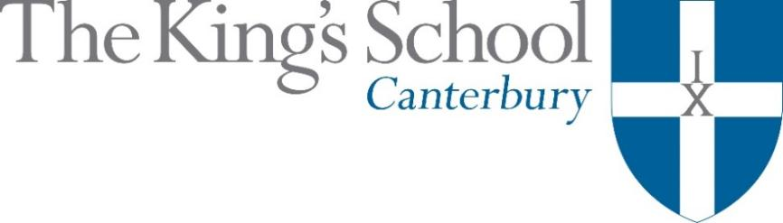

Appointment of a Teacher of Classics
September 2019

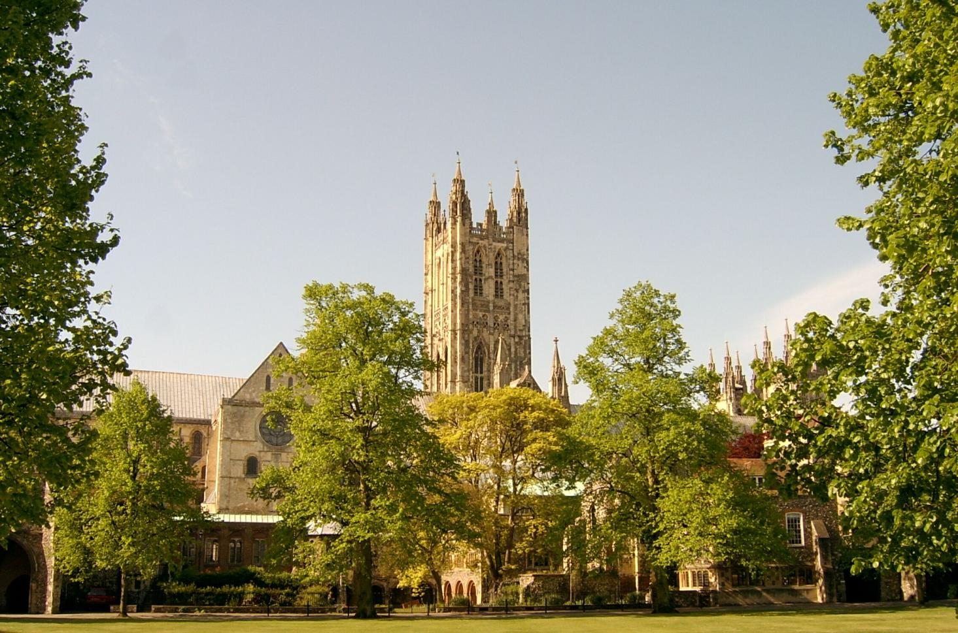

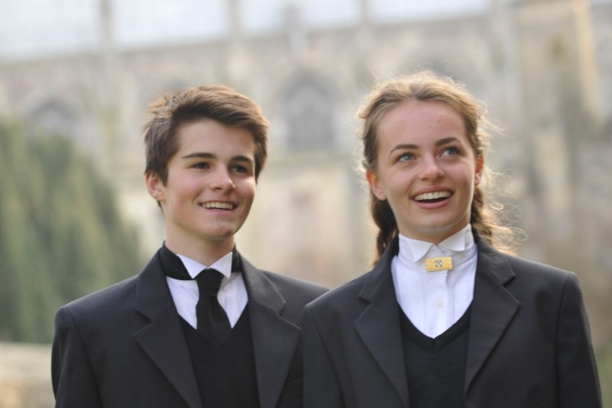
THE KING’S SCHOOL is a leading independent co-educational boarding school, situated in the heart of the historic cathedral city of Canterbury in Kent.

The precincts of Canterbury Cathedral are part of a world heritage site, a centre of pilgrimage and study, and host to over 1 million visitors each year from many different cultures. This international dimension deeply influences the life of the city and the school.

The origins of King’s date back to the arrival of St Augustine in 597 AD and the school’s Christian tradition remains at its heart although pupils and staff subscribe to many different faiths and beliefs and none. Embracing this diversity, there is a desire to foster fairness, tolerance, courage, perseverance, mutual respect and understanding. The Benedictine tradition of developing mind, body and spirit within a community given to hospitality still influences the life of the Cathedral and the school lives out its life in that context. Thus, academic excellence and scholarship take their place alongside the school’s commitment to physical and cultural endeavour. Sport is strong, with a number of boys’ and girls’ teams at national level. Music and drama are outstanding, both having the finest traditions and producing performances of the highest standards. King’s Week, the school’s own Festival of Creative and Performing Arts, attracts thousands of visitors each summer.

The curriculum at King’s is based upon strong academic roots. It emphasises and relies upon what is best in traditional school education: scholarly excellence supported by a caring pastoral and tutorial system, and a wide-ranging co-curricular programme. The curriculum is continually adapting and reacting to the changing demands of modern education: new subjects are added, new teaching techniques adopted, and there is an increasing awareness of the need to provide programmes of study that match individual needs and skills. The school does not gauge its success by exam results alone but by broader measures of educational attainment and personal development, helping pupils to achieve their potential and equipping them to play an active and responsible role in society as young adults.

Our family of schools comprises The King’s School, Canterbury (KSC), The Junior King’s School (JKS) and, from September 2018, the International College. At KSC there are currently 851 pupils, split 50-50 boys-girls, of whom about 80% are boarders. There are six boys’ boarding houses, seven girls’ boarding houses and three mixed day houses. Junior King’s occupies a fine rural site on the banks of the River Stour, in Sturry, two miles from Canterbury. There are over 375 pupils at Junior King’s of whom 20% are boarders.

The King’s School occupies various sites around the Cathedral and its precincts. Many teaching departments and the majority of houses are in the beautiful ancient buildings around Green Court on the north side of the Cathedral. To the east of the Cathedral the St Augustine’s site is home to five boarding houses, a medieval refectory, and the magnificent neo-Gothic school library (shown in the picture below). There are two major sites for sport: Birley’s, and the Recreation Centre, both within walking distance of the school, with rowing at Westbere Lakes in Sturry. The International College opened in September 2018 as the third school in the King’s family, and a fourth school will open in Shenzhen, China, in 2019.

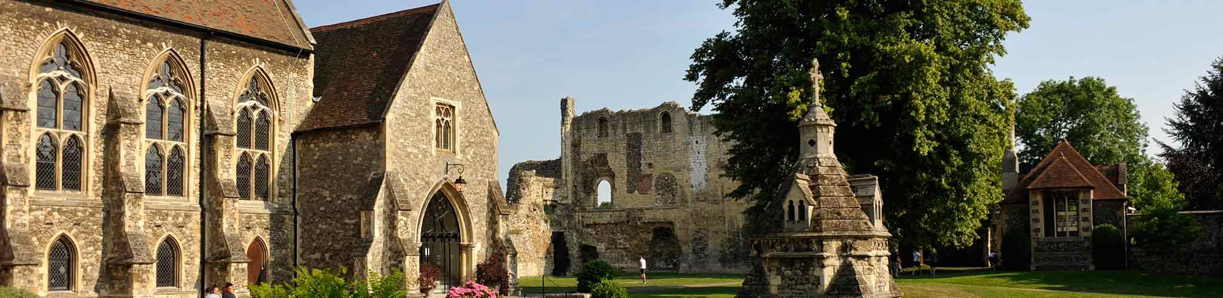

The school library, Undercroft, and ruins of St Augustine’s Abbey on the St Augustine’s campus at King’s

www.kings-school.co.uk

THE ROLE
We seek to appoint a well-qualified and highly-motivated graduate to teach Classics from September 2019.

At King’s there are four full-time Classics teachers. The classrooms are located together at the heart of the school within a medieval building; each room is fitted with an interactive white board and the department is well-resourced. The successful candidate will be joining a busy and lively team of committed teachers who put the progress of the pupils at the heart of all that they do.

All pupils study Classics in their first year according to ability. While some pupils study Greek as well as Latin and Classical Civilisation topics, others study Latin and Classical Civilisation. Classical Civilisation resources are produced in-house and we use the John Taylor books, Latin to GCSE and Greek to GCSE as a basis for language work, pupils beginning at a point suitable to their experience and potential. For those who have not had the chance to study Latin or Greek there are ab initio courses and plenty of pupils who start Classical languages at King’s in Year 9 go on to study them at GCSE.

Pupils are prepared for OCR examinations in Latin and Greek and Classical Civilisation. We currently have two Year 11 sets for GCSE Latin, one set for Latin and Greek GCSEs and two sets for Classical Civilisation. The same pattern pertains in the Year 10 sets. Classical subjects remain popular in the Sixth Form with three A levels offered. On the Classical Civilisation side, we currently teach The World of the Hero, Democracy and the Athenians and Imperial Image. Exam results are excellent at every level and King’s students enjoy considerable success in gaining places at university. Every year we send pupils to study Classical subjects at Oxbridge and other good universities.
The Classics department offers many enrichment opportunities. Activities include: expeditions abroad with a trip proposed to Pompeii and the bay of Naples in 2019-20; visits to local and national museums and theatres, as appropriate; invited speakers and pupil-led presentations under the auspices of the Pater Society; Classics extension classes for those interested in pursuing the subject further and participation in national prize competitions.

The post is suitable for a person with a good Classics or Classics-related degree, capable of teaching Classics from Year 9 to A level and potentially a little beyond. We are looking to appoint someone who is a personable and who is or has the potential to become an excellent classroom practitioner. S/he should offer a strong academic record, energy, and a genuine passion for Classics as well as good humour, administrative skill, and plenty of initiative. Although school teaching experience or a teaching qualification is not essential, the successful applicant will have the ability to interact effectively with classes of teenagers. The opportunity to teach some Greek at various levels is available but a candidate with little or no Greek experience should not be put off applying.

APPLICATIONS
Applications should be submitted online through the King’s School website (www.kings-school.co.uk – Staff Vacancies), and should include a personal statement for the Headmaster and a CV by 9 am on Friday 22nd February 2019. If you have any difficulties accessing the internet please contact the School Office: reception@kings-school.co.uk, 01227 595501.

Those considering applying but requiring more information, can contact the Head of Classics, Miss Janet Taylor, for an informal discussion: jt@kings-school.co.uk.

The King’s School is committed to safeguarding and promoting the welfare of children and applicants must be willing to undergo child protection screening including checks with past employers and the Disclosure and Barring Service.
The King’s School, Canterbury is an educational charity - Registration No: 307942

February 2019

