
St Catherine’s Catholic School

Learning Support Assistant

We are seeking to appoint highly motivated, enthusiastic, and energetic people to work as a Learning Support Assistant for the SEND department. Learning Support Assistants are a vital element in supporting the learning of our most vulnerable peoples on the SEN register.
This is a full time position for 37.5 hours per week (5 days per week) and term time only (39 weeks per year).
St Catherine’s is a Catholic Girls mainstream school with a range of pupils with special educational needs. The majority of pupils have social and communication difficulties including autism, dyslexia and social, emotional mental health.
Staff at St Catherine’s benefit from an excellent team ethos. We encourage all staff to be active in their professional development and a comprehensive package of induction will be provided along with the opportunity to further develop skills and knowledge through training. We are committed to the well being of all our staff and offer a programme of activities in support of this.
At St Catherine’s Catholic School we are committed to safeguarding and promoting the welfare of our young people and expect all staff to share this commitment. Appointments are subject to the completion of an enhanced DBS check and receipt of satisfactory references.
We are an equal opportunities employer.
To be successful at St Catherine’s, you will:
- commit to our supportive but challenging ethos and culture
- thrive on working in teams but be able to work independently
- constantly challenge yourself to become a better practitioner
- be committed to our comprehensive extracurricular programme
- be passionate about diversity and inclusion
- demonstrate an unwavering commitment to Catholic education and the ethos of the school.

In return, we will offer you:
- a school where students are keen to learn
- an incredibly supportive group of colleagues and leaders
- a personalised professional development programme delivered through twilight sessions and dedicated training days
- fast track promotion opportunities
- the chance to perform on a wider stage through our proud membership of the LSU group of schools and the Archdiocese of Southwark.

For an informal conversation about the role, please contact Ms Konadu-Aboagye

Key information
Start date: January 2022 (or before)
Salary: £19,789.42
Visits: By arrangement
Closing date: Noon 13th December 2021

We particularly welcome applications from candidates who will help us to make our staffing body more representative of London’s rich and diverse community.

St Catherine’s Catholic School is committed to safeguarding and expects all applicants, referees and members of the school community to share this commitment





St Catherine’s Catholic School

Person specification Learning Support Assistant
At St Catherine’s, we don’t believe in a single, carbon-copy model of what constitutes an excellent teacher, leader or member of support staff. The best people come in all shapes and sizes. We’re looking for candidates who bring a breadth of experience and fresh eyes, both inside the classroom and beyond.

The following list offers a brief snapshot of the attributes we value. In all cases, we’d be looking for direct examples of how you have embodied these characteristics throughout your career along with your potential to move us on and demonstrate excellence:

Essential
- GCSE in maths and English
- Training in the area of literacy/numeracy and/or in a particular curriculum or learning area e.g. bilingual, sign language, dyslexia, ICT, Maths, English
- Ability to plan and deliver tailored intervention programmes
Desirable
- Degree is desirable
- Ability to relate well to children and adults
- Good use of ICT skills – Microsoft, emails, SharePoint
- First Aid Training is desirable
- NVQ 3 or equivalent in teaching assistance or equivalent experience
Experience
- Working in education
- Working with young people (key stage 3 and 4)
- Working with a range of SEND needs
- Experience of working with pupils with complex SEMH needs
Personal Qualities
- Punctual, good communication skills, collaborative approach and willingness to learn

We particularly welcome applications from candidates who will help us to make our staffing body more representative of London’s rich and diverse community.

Job Description Learning Support Assistant
Key responsibilities and objectives:
Teaching & Learning:
- Lead on interventions to consolidate learning in core subjects and support social emotional mental health.
- Support pupils with transition difficulties.
- Support the education and social development of pupils under the direction and guidance of the SENCO and class Teachers.
- Provide support for named pupils to enable them to be fully included and make expected progress.
- Establish productive working relationships with pupils, act as a role model and set high expectations
- Promote positive values, attitudes and good pupil behaviour, dealing promptly with conflict and incidents in line with established policy and encourage pupils to take responsibility for their own behaviour
- Support pupils consistently whilst recognising and responding to their individual needs and at the same time promote the inclusion of all pupils
- Employ strategies to recognise and reward achievement of self-reliance, providing feedback to pupils in relation to progress and achievement
- Liaise effectively with teachers, other support staff, health and education specialists, parents, visitors and volunteers
- Work effectively with class teachers on lesson planning and differentiation.
- Use detailed knowledge and specialist skills to support pupils learning

Administrative Duties:
- Responsible for keeping and updating records as agreed with the SENCO
- Produce LSA observation records on a termly basis to support with the annual review process.
- Meet deadlines.
- Determine the need for, prepare and maintain general and specialist equipment and resources
- With SENCO and Teachers’ support, create differentiated material and resources for pupils on the SEN register.

Standards & Quality Assurance:
- Be aware of and comply with policies and procedures relating to SEN, child protection, health, safety and security, confidentiality and data protection, reporting all concerns to an appropriate person
- Maintain high professional standards i.e. formal, punctuality and attendance
- Attend SEND meetings and other meetings as required
- Appreciate and support the role of other professionals
- Participate in training and other learning activities and performance development as required Accompany staff and pupils on visits, trips and out of school activities as required
- Work constructively as part of a team, understanding classroom roles and responsibilities and own position within these
- Be prepared to work at both Key Stage 3 and 4 as necessary

General responsibilities and objectives:
- To work within the academy framework with regard to Health and Safety
- To promote equal opportunities in St Catherine’s School
- To actively promote the aims and ethos of the St Catherine’s school

- To support the school’s commitment to the continued professional learning of all staff
- To undertake any additional duties as may reasonably required by the SENCO
- To be aware of and assume the appropriate level of responsibility for safeguarding and promoting the welfare of children and to report any concerns in accordance with the school’s safeguarding policies.

St Catherine’s Catholic School is committed to safeguarding and expects all applicants, referees and members of the school community to share this commitment

St Catherine’s Catholic School

How to Apply

We look forward to receiving your application.

We will only consider complete applications. These will consist of two parts:

- A CES application form, available to download from our school website or the TES.
- A covering letter of no more than three sides of A4, explaining why you would be a suitable candidate for St Catherine’s school, based on your experience to date.

In addition to the application form and covering letter, we are happy to accept CVs, although it is not essential.

Timeline for appointment

Visits: Actively encouraged and can be arranged by emailing info@stccg.co.uk

Application deadline: 13th December 2021

We particularly welcome applications from candidates who will help us to make our staffing body more representative of London’s rich and diverse community.

St Catherine’s Catholic School is committed to safeguarding and expects all applicants, referees and members of the school community to share this commitment

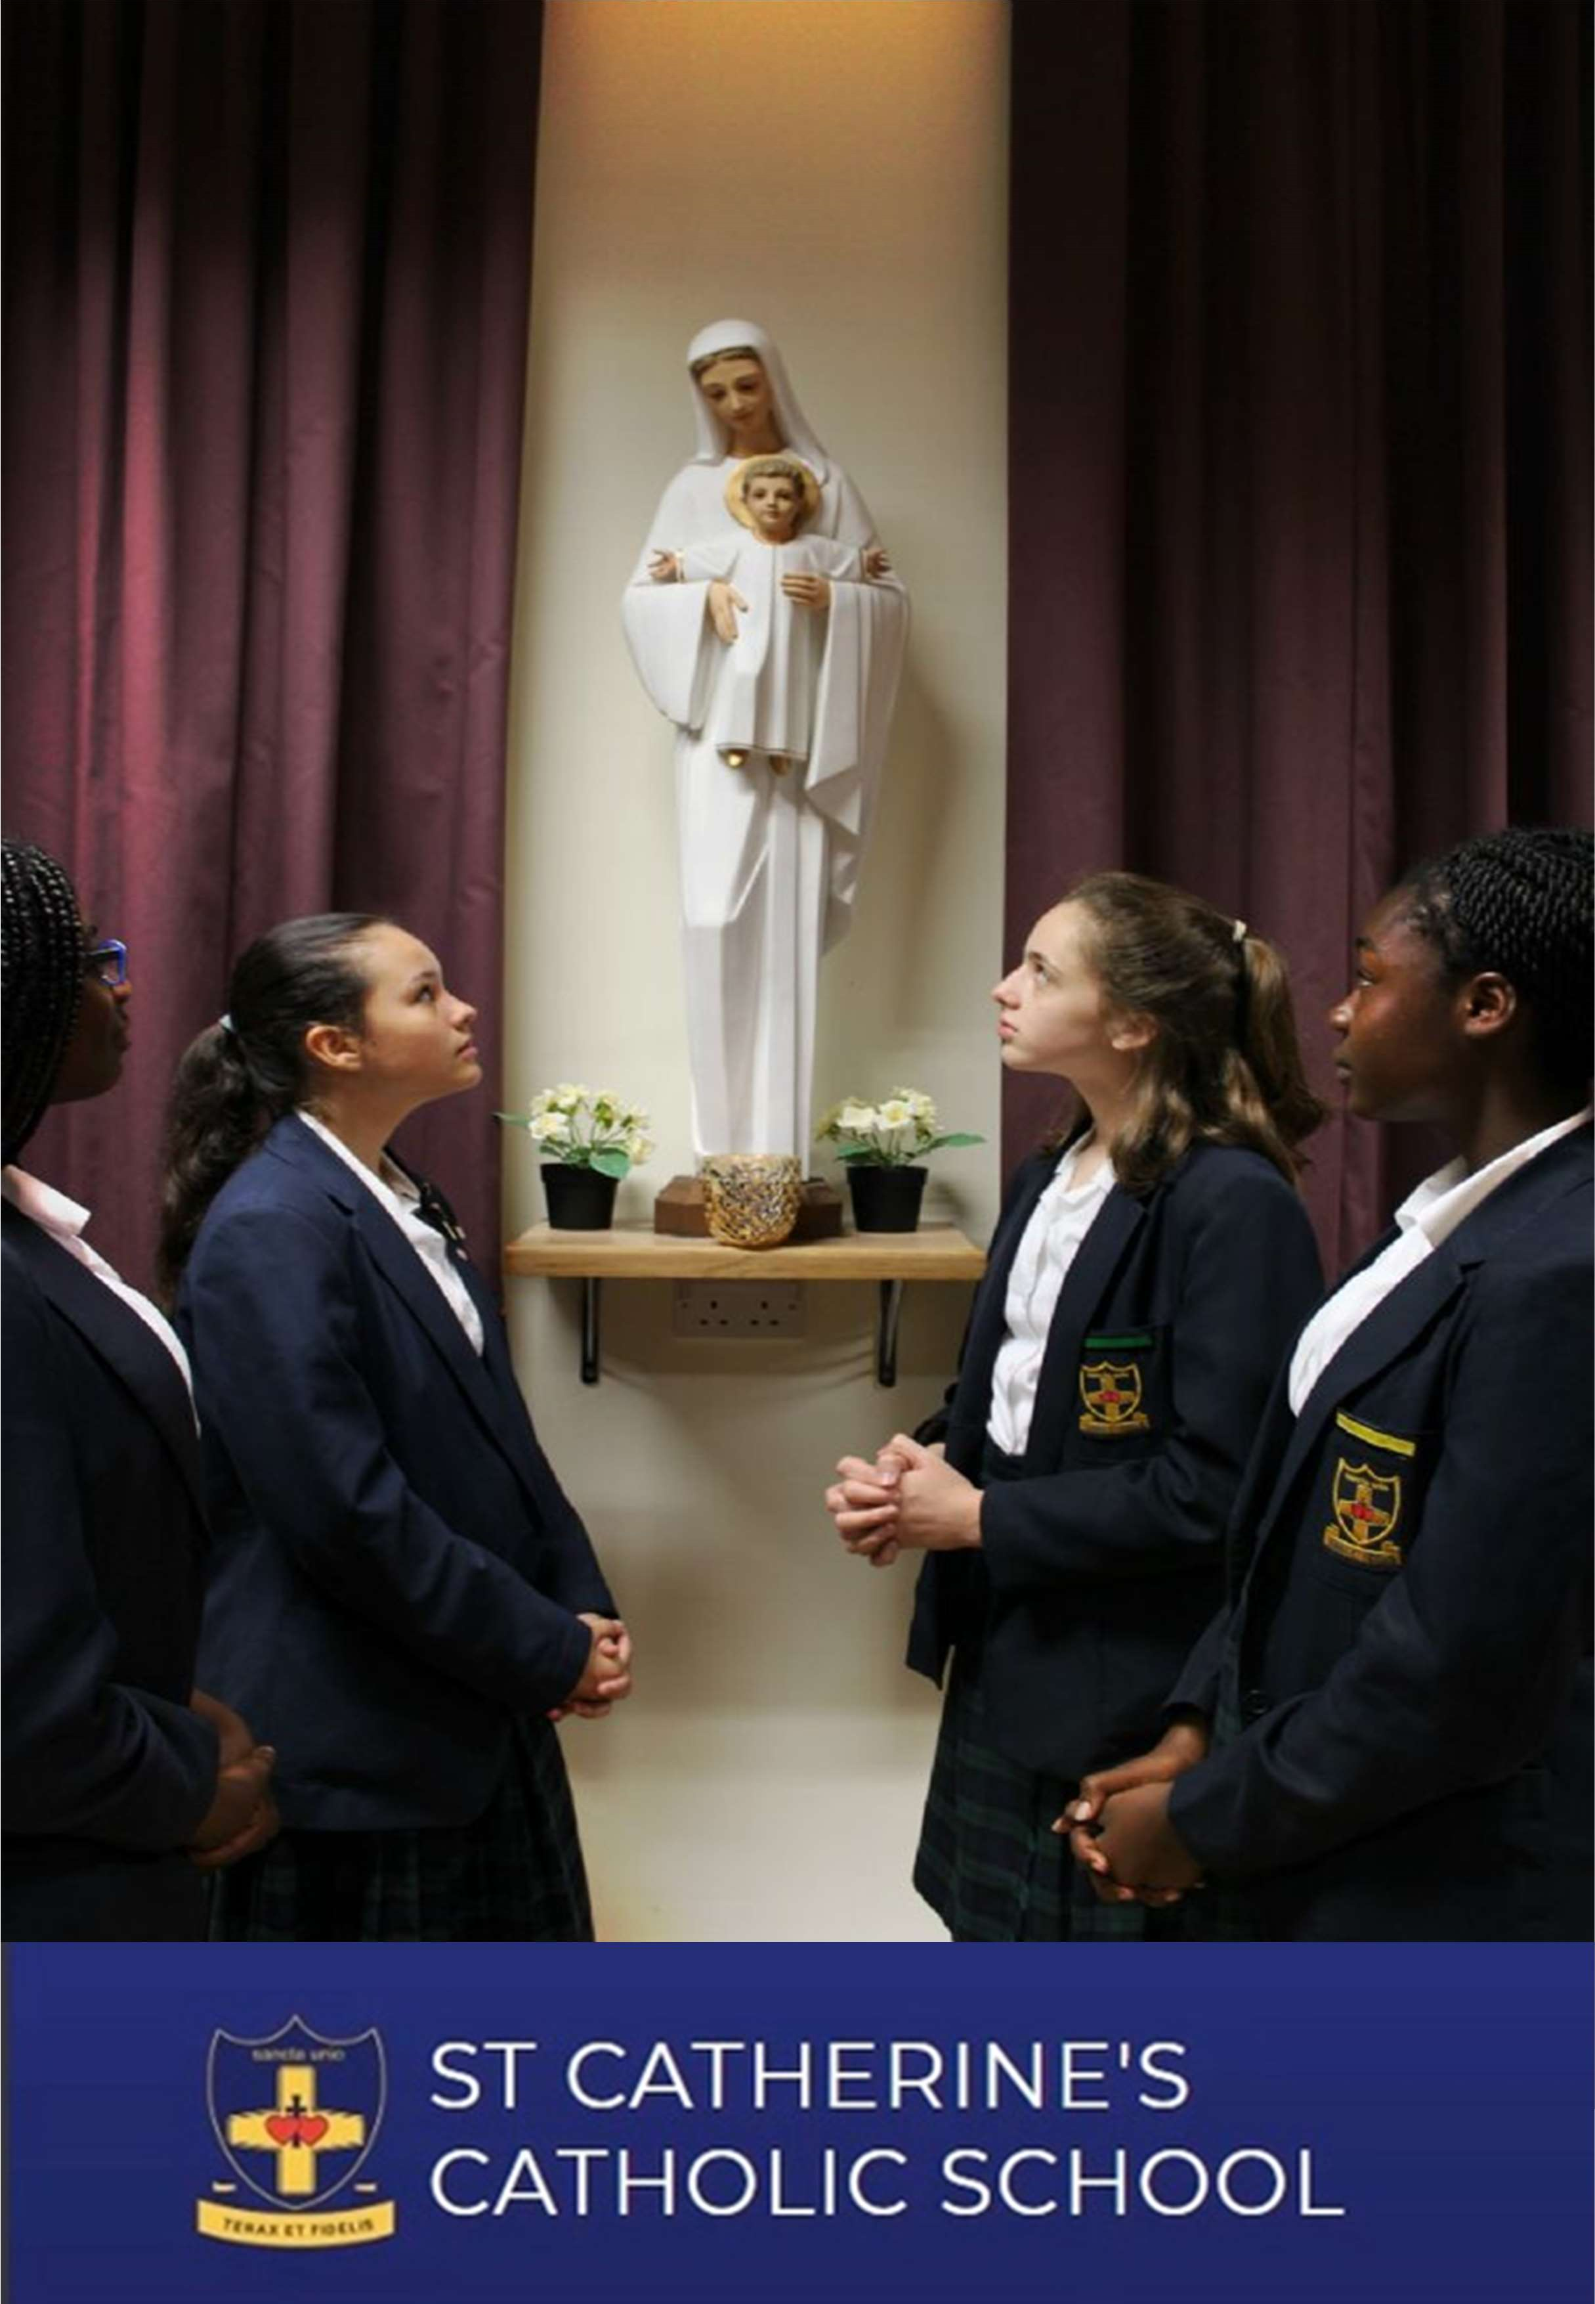


St Catherine’s Catholic School

 Watling Street, Bexleyheath, Kent, DA6 7QJ  01322 556333  info@stccg.co.uk  www.STCCG.co.uk

Headteacher : Mrs Nicola Thompson BSc (Hons) NPQH

