

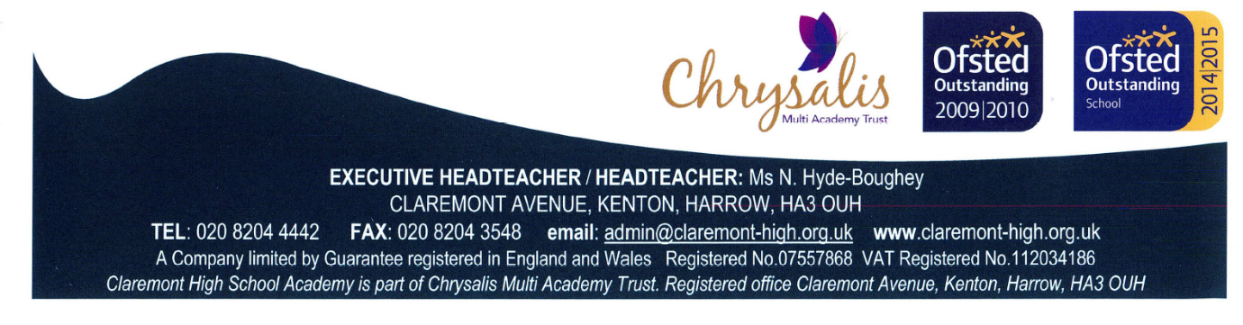

|  |
| --- |
| **Teaching Assistants**  **Full Time: One year contract initially, subject to reviews**  **Salary Scale 3 Point 5 £19,312 p.a. (£16,518.36 p.a. pro rata)**  **35hrs per week Term Time only**  Required from October 2021, the successful candidate will support pupils with special educational needs, encouraging pupils in their learning and the acquisition of skills, and will assist teaching staff with the management of pupils in the classroom.  You will be dealing with a wide variety of people at all levels, so you must be an effective communicator, with strong interpersonal skills, flexible, adaptable and a willingness to work as part of a team. You must have 5 GCSEs (or equivalent) grades A* to C including English, Maths and Science. Some experience of working with children between the ages of 11- 16 is preferable.  **To apply:** All application forms and post details can be found on our website:  [www.claremont-high.org.uk](http://www.claremont-high.org.uk).  **All applicants must:**   1. Complete the school’s application form. 2. Submit a written personal statement (not more than 2 sides of A4) detailing how your experience, qualifications and skills meet the requirements of the role you are applying for.   **Please email your applications FAO Ms Panchal, the Headteacher’s PA to:-**  [**daxa.panchal@claremont-high.org.uk**](mailto:daxa.panchal@claremont-high.org.uk) **/** [**admin@claremont-high.org.uk**](mailto:admin@claremont-high.org.uk)  **Closing date: 12pm on Wednesday 29th September 2021**  Chrysalis Multi Academy Trust is committed to safeguarding and promoting welfare of children, and all applicants must be willing to undergo child protection screening appropriate to the post, including checks with past employers and Disclosures and Barring Service checks. |