

**POST OF**

**TEMPORARY TEACHER OF BIOLOGY**

**Part Time (approximately 0.6 of a timetable)**

**Required from 1 September 2020**

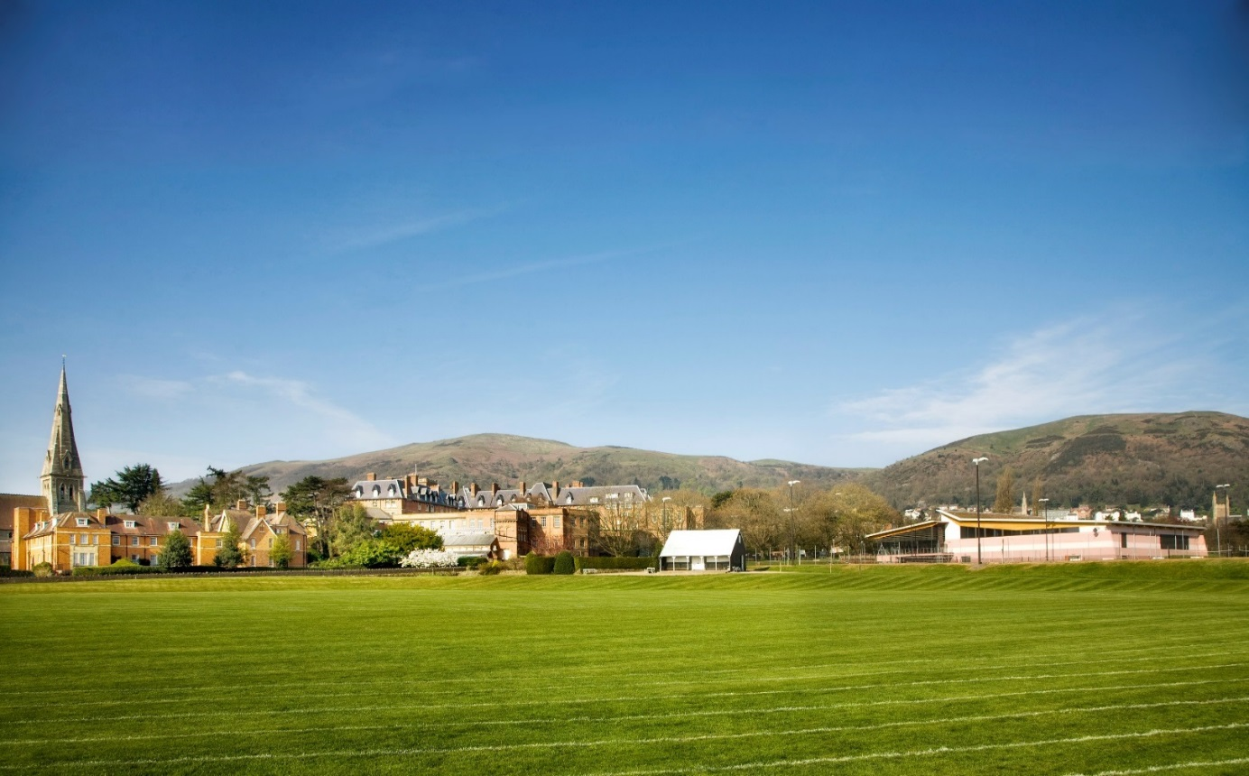



**MALVERN ST JAMES LTD**

Malvern St James is a leading boarding and day School for girls between the ages of 4 and 19. There are approximately 400 pupils split equally between boarders and day girls.

The School is located in the heart of Malvern in Worcestershire. Only two hours from London and one hour from Birmingham, the School has excellent transport links, with Great Malvern station situated just opposite the main School building. The MSJ bus service covers five counties to pick up and return girls each day.

Aspiration, personal development and achievement lie at the heart of the School and each pupil is treated as an individual. Our aim is to promote excellence and innovation in teaching and learning throughout the School. Our commitment is to provide each girl with the challenges and support offered by a bespoke education which will allow her to develop her talents, character and academic abilities to the full. We prepare girls for the most competitive UK and international universities and pathways. In addition, we aim to foster and encourage a wide range of extra-curricular interests. This individual emphasis is complemented with teamwork and a sense of collective responsibility.

We offer pupils full, weekly and flexible boarding and day places, allowing both parents and daughters to choose the option that is right for them. Prep. girls arrive from 7.45am each day and an After-School Club provides free supervision until 6.00pm each day. This enables all the girls in MSJ Prep and the Senior school to participate in the busy activities programme or supervised homework sessions.

Girls benefit from first class facilities which include an award-winning Science and Mathematics Centre which has been expanded to provide greater laboratory space and Mathematics teaching space, a Drama Studio, four ICT suites and a multi-media Language Laboratory. Our Sports Hall continues to expand both its facilities and services offered to the girls and staff for personal training and fitness. The School has a dedicated Sixth Form Centre for Day Girls and Boarders featuring a lively Café Culture recreational area.

MSJ offers a range of boarding options (ages 7 – 18) to fit in with the demands of modern family life and girls can choose from full, weekly, or flexi-boarding. Ofsted recognised the exceptional standard of boarding with an ‘Outstanding’ inspection judgement, which extends to all areas of Malvern St James, Greenslade, the Year 13 Sixth Form Boarding House has recently been transformed with an extensive, highly contemporary, refurbishment programme to provide a transition house for university and there are plans to continue this programme of improvements within boarding. There are also further exciting projects to enhance Teaching and Learning.

Malvern St James also received the highest rating of ‘EXCELLENT’ in the ISI’s Educational Quality Inspection in May 2017.

We offer staff who come to work at the School:

• the opportunity to work with highly motivated staff and talented pupils

• commitment to your professional development

• convenient location in Malvern with excellent transport links

• competitive salary

##### 

**The Biology Department at Malvern St James**

**The Department**

The Biology Department is part of the Science Department, which also encompasses Chemistry and Physics, each of which has its own Head of Subject and dedicated laboratories/workshops, prep rooms and offices. A significant number of girls in the Sixth Form study at least one Science at A Level, such is the popularity of these subjects.

The Science and Mathematics Centre has won an Architectural award and comprises nine laboratories, including three Biology laboratories, six classrooms for mathematics, an ICT suite and three specialist science preparation rooms. Experienced, innovative and committed subject teachers are supported by a team of excellent technical staff. Students from Year 3 upwards enjoy their science lessons in purpose-built and well-equipped laboratories.

**The Curriculum**

Separate sciences are taught at Key Stage 3, whilst at GCSE, Biology, Chemistry and Physics are currently offered as separate science subjects, or as a Double Science award. AQA is the examination board for all KS4 science courses (GCSE Separate Sciences and GCSE Combined Science: Trilogy) For Biology in the Sixth Form, the examination board is OCR.

**Extra-Curricular Activities**

In addition to the formal curriculum lessons, the Science Department runs extra-curricular activities and embraces the aims of British Science Week. MSJ holds an annual science lecture which is open to members of the local community as well as to the School. The School enters students for National Olympiad Competitions in Biology, Chemistry and Physics and prestigious awards have been attained. The Biology Department arranges educational visits to such events as Year 13 Nettlescombe Field Studies Council residential course, Year 7 Malvern Festival of Innovation, Year 9 Cheltenham Science Festival. We have a Science Club for Years 7 – 9 and a MedSoc Society for Years 9 – 11.

**Accountability**

The Teacher of Biology is accountable to the Headmistress via the Head of Biology, the Science and Technology Co-ordinator, the Director of Teaching and Learning on matters relating to Curriculum, Teaching and Learning, and the Director of Pastoral Care and Deputy Head on matters relating to Pupil Wellbeing and Pastoral Care.

**Purpose of the Job**

The role of the teacher is to teach pupils within the school and to carry out such other associated duties as are reasonably assigned by the Head of Biology, Science and Technology Co-ordinator and Director of Teaching and Learning. This requires them to:

* Promote outstanding teaching and inspire a love of learning within the department
* Teach Biology across Key Stages 3/4/5
* Undertake duties as an Assistant Form Tutor/Form Tutor, as outlined in the Staff Handbook
* Adhere to whole-School policies within the department
* Support the visions, aims and objectives of the School
* Be committed to the values and culture of the School, centred around its Boarding ethos
* Be committed to the longer term development and promotion of the Biology Department

**Responsibilities**

The post holder interacts on a professional level with colleagues; the post holder seeks to establish and maintain productive relationships with them and to promote mutual understanding of the school curriculum, with the aim of continuously improving the quality of teaching and learning in the school. The teacher is responsible for:

**Teaching**

* Planning and preparing ongoing courses and lessons to a high standard to promote pupil’s active engagement in learning
* Teaching, according to their educational needs (including those with SEND and the More Able) the pupils assigned to her / him, including the regular setting and marking of work, according to departmental guidelines, to be carried out by the pupils in school and elsewhere
* Assessing, recording and reporting on the development, progress and attainment of pupils
* Organising, leading and participating in extra-curricular activities and educational visits
* Consistently using the Rewards System to promote Growth Mindset.

**Key Tasks**

The Teacher of Biology is required to:

* Deliver engaging, challenging and effective lessons to their classes
* Teach Biology across Key Stages 3/4/5
* Set and mark preparation/homework; set, mark and moderate internal examinations and controlled assessments, under the direction of the Head of Biology
* Set high standards and expectations to maintain a positive and purposeful atmosphere among the pupils and safeguard their health and safety when they are under the care of the department
* Where arranged, to undertake duties as a Form Tutor or Assistant Form Tutor, as outlined in the Staff Handbook
* Prepare reports for all students taught
* Oversee provision of resources and texts for the classes taught
* Contribute to the Subject Development Plan and the Subject Self-Evaluation, alongside other members of the department
* Assist with the planning, review and evaluation of Schemes of Work, as directed by the Head of Biology
* Promote the subject at Open Days and other such events
* Undertake some delegated responsibilities within the department, e.g. to update the noticeboard displays in the Chemistry Department Corridor
* Attend all full Staff Meetings, major School functions (such as Carol Service and Commemoration) and Parents' Consultations for the year groups they teach
* Contribute to organised activities to enrich the subject curriculum, contributing to the extra-curricular activities programme
* Undertake evening, weekend and other duties as required
* Perform duties specific to each department as agreed with the Headmistress from time to time.

**Other activities**

**Assessment and Reports**

* Providing or contributing to oral and written assessments, reports and references relating to individual pupils and groups of pupils.

**Review**

* Participating in arrangements made by the School for the review of her / his performance and that of other teachers.

**Further Training and Development**

* Participating in arrangements for her / his further training and professional development as a teacher
* Reviewing from time to time her / his methods of teaching and programmes of work.

**Educational Methods**

* Advising and co-operating with the Head teacher and other teachers on the preparation and development of courses of study, teaching material, teaching programmes, methods of teaching and assessment and pastoral arrangements.

**Discipline, Health & Safety**

* Maintaining good order and discipline among the pupils and safeguarding their health and safety both when they are authorised to be on the school premises and when they are engaged in authorised school activities elsewhere.

**Staff Meetings**

* Participating in meetings at the school which relate to the curriculum for the school or the administration or organisation of the school, including pastoral arrangements.

**Cover**

* Supervising and, so far as is practicable, teaching any pupils whose teacher is not available to teach them.

**Public Examinations**

* Preparing pupils effectively for public examinations including keeping abreast of all changes to specifications by examination boards to provide relevant and appropriately focused teaching to meet examination requirements.
* Participating in arrangements for preparing pupils for public examinations and in assessing pupils for the purposes of such examinations; recording and reporting such assessments; and participating in arrangements for pupils’ presentation for and supervision during such examinations.

**Management**

* Contributing to the selection for appointment and professional development of other teachers and non-teaching staff, including the induction and assessment of new teachers and initial teacher training
* Supporting the work of other teachers
* Taking such part as may be required of her / him in the review, development and management of activities relating to the curriculum, organisation and pastoral functions of the school.

**Administration**

* Participating in administrative and organisational tasks related to such duties as are described above, including the management or supervision of persons providing support for the teachers in the school and ordering and allocation of equipment and materials.

**All school staff are expected to:**

1. Support the School’s Boarding ethos including support for activities in the evening and weekend on a pro rata rota basis
2. Work towards and support the school vision and the current school objectives outlined in the School Development Plan
3. Contribute to the School’s programme of extra-curricular activities
4. Support and contribute to the School’s responsibility for safeguarding students
5. Regularly review own practice, set personal development targets and take responsibility for own continuous professional development.
6. Work within the School’s health and safety policy to ensure a safe working environment for staff, students and visitors
7. Work within the Equal Opportunities Policy to promote equality of opportunity for all students and staff, both current and prospective.
8. Maintain high professional standards of attendance, punctuality, appearance, conduct and positive, courteous relations with students, parents and colleagues.
9. Engage actively in the performance review process.
10. Adhere to policies as set out in the Staff Handbook/Teacher Standards and Regulations
11. Undertake other reasonable duties related to the job purpose required from time to time
12. Adhere to School Safeguarding and Child Protection Policies.

**PERSON SPECIFICATION**

**Essential:**

* Good Degree / equivalent and relevant qualification in Biology
* Teaching qualification
* Use of IT in the classroom
* Have organised trips and extra-curricular activities
* Experience of teaching at Secondary level and A Level
* Experience of effective marking, recording and assessment
* Evidence of a range of teaching and learning strategies
* Ability to inspire, empower and motivate
* Excellent communication skills
* Good organisational and planning skills
* Ability to prioritise and to work flexibly to tight deadlines
* Pastoral skills
* Team player and adaptable
* Commitment to the safeguarding of children
* A positive attitude to self-development and own learning

**Desirable:**

* Experience of teaching with our examination boards GCSE AQA and A Level OCR.
* An understanding of independent education and the boarding ethos.

**GENERAL REQUIREMENTS**

Malvern St James is committed to safeguarding and promoting the welfare of children.Applicants must be willing to undergo child protection screening appropriate to the post, including checks with past employers and the Disclosure and Barring Service.

This job description is not necessarily a comprehensive definition of the post; it is to be enabling rather than restrictive. It will be reviewed at least once every two years and it may be subject to modification or amendment at any time after consultation with the post holder.

**APPLICATIONS**

The completed application form, which must include all dates of previous employment and give reasons for any gaps in employment, an accompanying CV, together with a covering letter addressed to the Headmistress, should be returned to HR Department, by post to Malvern St James, 15 Avenue Road, Great Malvern, Worcestershire, WR14 3BA, or by email to [recruitment@malvernstjames.co.uk](mailto:recruitment@malvernstjames.co.uk)

A CV will not be accepted instead of a completed application form. The personal statement within the application form should set out why you consider yourself a suitable candidate for the post citing relevant experience, previous achievements and your vision for this role. The statement should not repeat the contents of the covering letter.

References of shortlisted candidates will normally be taken up before interview. Two satisfactory references are required before the appointment is confirmed. The appointment of the successful candidate will also be subject to satisfactory DBS checking.

**BENEFITS OF WORKING AT MALVERN ST JAMES GIRLS’ SCHOOL**

Malvern St James Girls’ School prides itself on its warm, friendly and welcoming environment where all staff are encouraged to play a part in a successful and supportive community.

**Pay**

We offer a competitive salary, taking into account previous experience and relative skills and abilities. Teaching salaries are paid on Malvern St James Teachers’ Pay Scale.

**Pension Scheme**

After completing three months’ employment with Malvern St James, Support Staff will automatically be enrolled into our Pension scheme, to which the School also contributes, this is subject to satisfying certain eligibility criteria and subject to the rules of such scheme as amended from time to time.

Teaching Staff are automatically entered into the Teachers’ Pension Scheme.

Death in Service Cover.

**Sport**

MSJ Sports & Fitness Centre promotes flexibility as a key attribute to create fitter, healthier employees. Discounted membership for staff includes gym and swim and a wide range of classes. Membership contributions are taken by direct debit.

The Sports Club provides many activities for members. These include a wide range of sports, organised tours and regular competitions.

**Other benefits include:**

* **Fee remission**
* **Lunch provided**
* **Onsite Pavilion Café**
* **Access to Massage**
* **Access to Reflexology**

