Amethyst Academies Trust
We are expanding!
Come and join our highly successful team #TeamAmethyst

Due to the success of our Academies we have been asked to increase our student numbers and therefore we have a number of exciting vacancies.
Why choose Amethyst Academies Trust?
Firstly, because our children are amazing! Last year Aldersley achieved a Progress 8 score of 0.82 which is well above average and puts us in the top 2 schools in the Black Country. We passionately believe in our Knowledge-rich curriculum and pre-planned curriculum lessons has reduced teacher planning time. Over many years we have proven that feedback is important to students but through adapting teaching and not arduous marking, hence we do not mark.
All of our staff have a coach that works with them throughout the year which negates formal lesson observations and onerous quality assurance and ensures that they have the CPD that they need for career progression.
Our conduct system is centrally managed and with a team of highly qualified non-teaching pastoral staff that you will lead.
Come and visit our schools to meet our staff and look at the new Amethyst Sixth Form building on the Aldersley Site.
To apply for the post, please complete and return the application form to PA to the Executive Principal Hannah Creamer: hcreamer@aatrust.co.uk.
School: Aldersley High School
Start: April 2021
Role: Teacher of MFL (French and Spanish)
Salary: MPS/UPS
Closing Date: Friday 26th February 2021
Interview Date: w/c 8th March 2021

Staff Testimony
‘I love working in the MFL department at Aldersley. The knowledge rich curriculum and collaborative working ensures our work load is manageable and students make excellent progress. The majority of our students study French or Spanish which means languages are integral to the curriculum. Personally I started as an NQT and have been offered so many opportunities and currently I’m Deputy Headteacher. Come and join our amazing team’.
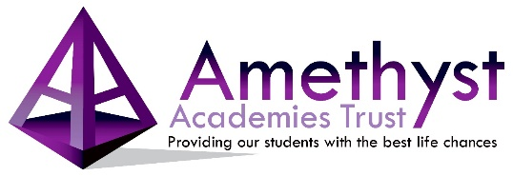
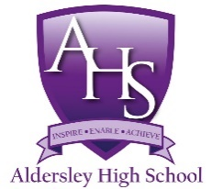

Aldersley High School
Proud to be part of Amethyst Academies Trust

