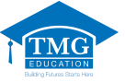
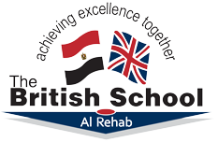

About The British School Al Rehab
The British School Al Rehab is a friendly school where every child is known and valued as an individual and parents are welcome guests and partners. We offer a traditional British education whilst also ensuring we make full use of new ideas, initiatives and technologies. We are a registered centre for Cambridge International and London Edexcel and we offer the full range of IGCSE and A-Level examinations.
The British School follows the English National Curriculum. This means that all subjects: English, Mathematics, Science, Computing, History, Geography, Art & Design and Design & Technology, are taught using the same curriculum and methods as in the UK. We also provide specialist teachers to ensure high quality teaching in PE, Music and French.
All of our class teachers are UK qualified and have taught in schools in England so that we can offer a genuine British education to the children in our care. The language of instruction is English and the teaching style emphasises the application of knowledge to problem solving and the use of imagination and discussion to help understand our world.
We are very aware of our position in Egypt and respond to the wishes of our parents by also offering a full Arabic Language curriculum based on the Egyptian syllabus. This means that all children also receive daily lessons in Arabic and weekly lessons in Islamic Studies, Christian Studies and Social Studies.
British education is renowned for concerning itself with the development of the whole personality. We believe that learning is important, but not enough in itself. We aim to encourage and challenge pupils to develop into well-educated confident people who are ready to lead fulfilled lives in whatever sphere they choose. We value all pupils equally as individuals and provide a safe and civilised environment in which they can develop. Above all we want to inspire in pupils a love for learning which will sustain them throughout their lives.

