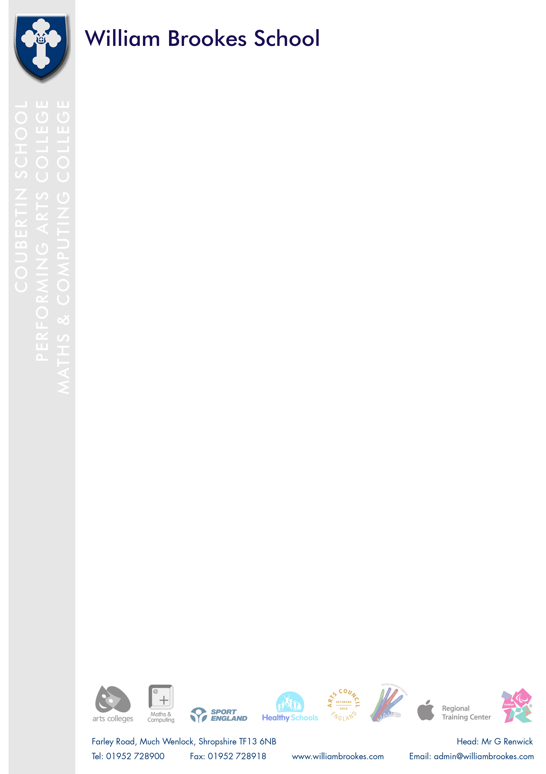

Dear applicant

I am delighted you are considering joining William Brookes School and as Head I am proud to welcome you to our vibrant and successful school. We are the only Coubertin school in Great Britain and value highly our Olympian traditions. This is an exciting opportunity to make a significant difference to the life chances of our students. You will have a important role in building on our rapid improvement in recent years.

William Brookes School achieved 73% 5+ A*-C in English and Maths this summer, the best results in the school’s history. We are one of the top state schools in the county with A8 sitting at 5.4, P8 at +0.16 and EBacc at 35%.

Please explore our website and read through the additional materials included in this pack to find out more about us. The Job Description & Person Specification give you an indication of the scale and ambition we have for this post. If you have the determination to inspire excellence in the young people you teach, I would be delighted to receive your application and you are most welcome to arrange an informal visit to the school and to meet with me.

Your application must be received by the time and date stated in the advert. Please also write a letter to accompany your application form that describes what you consider to be elements of a “good” lesson, paying particular attention to differentiation and challenging the most able students. We would expect to see these elements demonstrated during your observation lessons should you be selected for interview. Your letter must be no longer than 2 sides of A4 or 500 words.

Yours sincerely

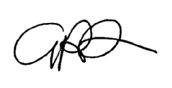

**Geoff Renwick**

**Head**