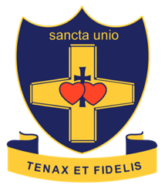
St Catherine’s Catholic School

Teacher of Science

We are seeking to appoint an inspirational Teacher of Science who can deliver high-quality lessons and secure outstanding outcomes for our amazing students. We want you to inspire students and raise their aspirations across all aspects of their schooling, in addition to unlocking their potential in your subject area.

To be successful at St Catherine’s, you will:

- teach to Grade 9 standard
- ensure your students make outstanding progress across all key stages
- commit to our supportive but challenging ethos and culture
- thrive on working in teams but be able to work independently
- constantly challenge yourself to become a better practitioner
- be committed to our comprehensive extra-curricular programme
- be passionate about diversity and inclusion
- demonstrate an unwavering commitment to Catholic education and the ethos of the school.

In return, we will offer you:

- a school where students are keen to learn and progress
- a school where GCSE outcomes are consistently strong. This summer our students achieved outstanding results, bucking national trends, achieving a Progress 8 score of +.71 and an Attainment 8 score of 59.1.
- an incredibly supportive group of colleagues and leaders
- a personalised professional development programme delivered through twilight sessions and dedicated training days
- fast track promotion opportunities
- the chance to perform on a wider stage through our proud membership of the LSU group of schools and the Archdiocese of Southwark.
- the opportunity to join a very high achieving department in our vibrant Catholic school.
- a school where Science enjoys a very high profile and is very well supported by a committed Senior Leadership team.

St Catherine’s is a highly successful, oversubscribed girls’ school with high quality accommodation and resources. It is forward-thinking and enjoys excellent results. In Science our students follow the AQA GCSE course. Last summer our girls made outstanding progress in Science with 38% of pupils achieving a grade 7-9 and 90% of pupils achieving a 4+. The Science department is a highly successful and progressive department and would welcome either an experienced Scientist, or an ECT to this position. The department is accommodated within our Science Building in eight laboratories, each fully networked with Clever Touch boards.

For an informal conversation about the role, please contact Mrs Marie Foucher (Deputy Headteacher)

Key information
Start date: September 2023 (or before)
Salary: Highly competitive and based on experience and potential
Visits: By arrangement
Closing date: Friday 9th June 2023 at 9am
Interviews: week commencing 12th June 2023

We particularly welcome applications from candidates who will help us to make our staffing body more representative of London’s rich and diverse community.

St Catherine’s Catholic School is committed to safeguarding and expects all applicants, referees and members of the school community to share this commitment

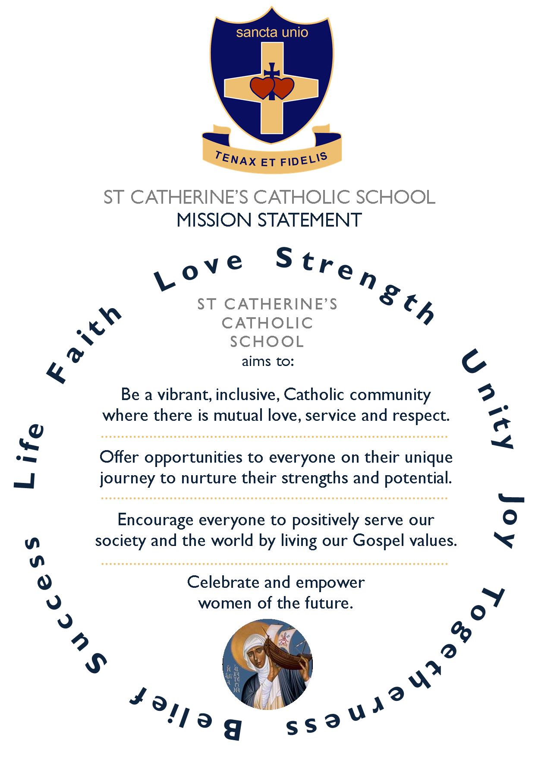

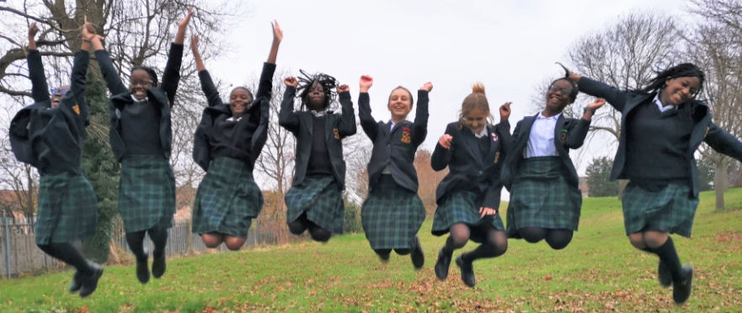

St Catherine’s Catholic School

How to Apply

We look forward to receiving your application.

We will only consider complete applications. These will consist of two parts:

- A CES application form, available to download from our school website or the TES.
- A covering letter of no more than three sides of A4, explaining:
  - Why you would be a suitable candidate for St Catherine’s school, based on your experience to date
  - How you will inspire our students and raise their aspirations
  - What you will bring to the Catholic ethos of the school
  - Why you want the job at this stage of your career
  - How you will contribute to the wider life of the school.

In addition to the application form and covering letter, we are happy to accept CVs, although it is not essential.

Timeline for appointment

Application deadline: Wednesday 24th May 2023 at 9am

Invitation to interview: Wednesday 24th May 2023

Interviews: Friday 26th May 2023

Post begins: September 2023 (or before)

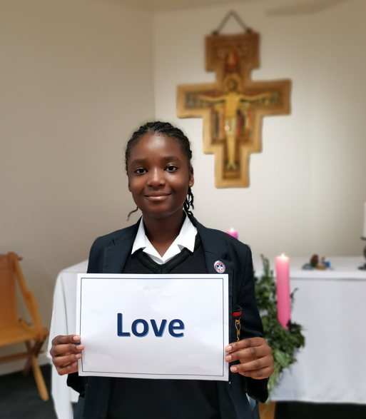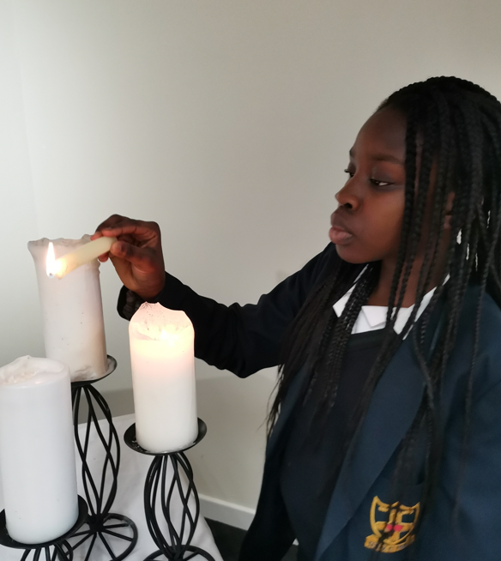

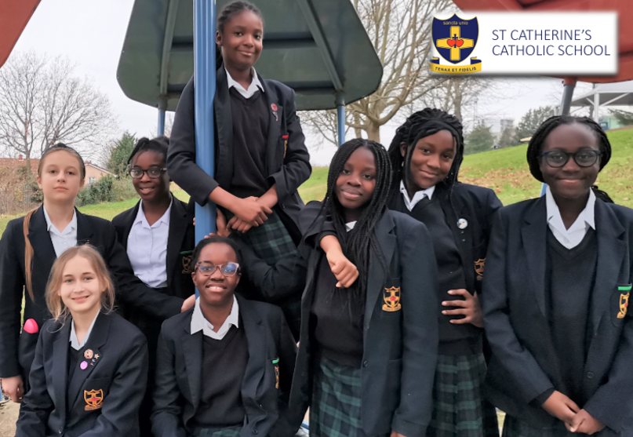

St Catherine’s Catholic School

 Watling Street, Bexleyheath, Kent, DA6 7QJ  01322 556333  info@stccg.co.uk  www.STCCG.co.uk

Headteacher : Nicola Thompson BSc (Hons) NPQH

