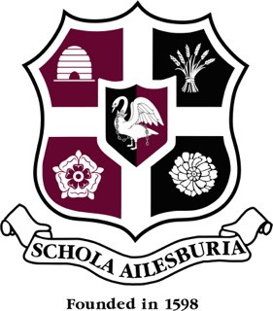
AYLESBURY GRAMMAR SCHOOL

GERMAN DEPARTMENT

At AGS we have a large flourishing German Department where the subject is a popular option at all levels.

At present there is an enthusiastic, well-experienced, mutually supportive staff of 4 teachers who communicate closely with each other on a daily basis, freely sharing ideas and resources.

Pupils begin German in year 7 where half the cohort i.e. 90 pupils, begin their study of German alongside French. At KS3, pupils are taught in their tutor groups and receive 3 hours of teaching per fortnight.

At KS3 pupils use the course books Echo 1, 2 and 3. Pupils’ study is enriched with personal access to thisislanguage.com which pupils use with great competitive enthusiasm.
In year 8 their cultural experience is enhanced with a visit to Cologne and in years 8 and 9 they have the opportunity to take part in Double Club German, a weekly club offering football based German, organised by the Arsenal Football Club and the UK-German Connection. These extra-curricular experiences are heavily subscribed and very popular.

The number of year 9 pupils opting to continue German to GCSE is high ( 65% this year resulting in 3 GCSE classes).

At GCSE we follow the AQA course and every pupil has access to the Kerboodle website and thisislanguage.com and is encouraged to work independently on improving their standard. Year 10 and 12 pupils have the opportunity to participate in our long-standing and highly successful exchange to Stuttgart that we undertake in conjunction with the girls from Aylesbury High School.

In the 6th Form, German is a popular option and we follow the AQA syllabus. We are fortunate to have a young German Foreign Language Assistant with whom all Year 12 and 13 students have a weekly conversation session.

At A-Level currently, for the cultural topics, we are studying “Der Vorleser” by Bernhard Schlink and the film “Das Leben der Anderen”. As it is one of the core topics in the course, we also offer a study visit to Berlin in Year 13.

Our record of exam results is also very good and students have been successful in gaining places to read German at university.

Several students have also been successful in being awarded the prestigious position of Youth Ambassadors with the UK-German Connection.

We are fortunate in having the latest technology at our disposal, including a dedicated MFL computer suite.

