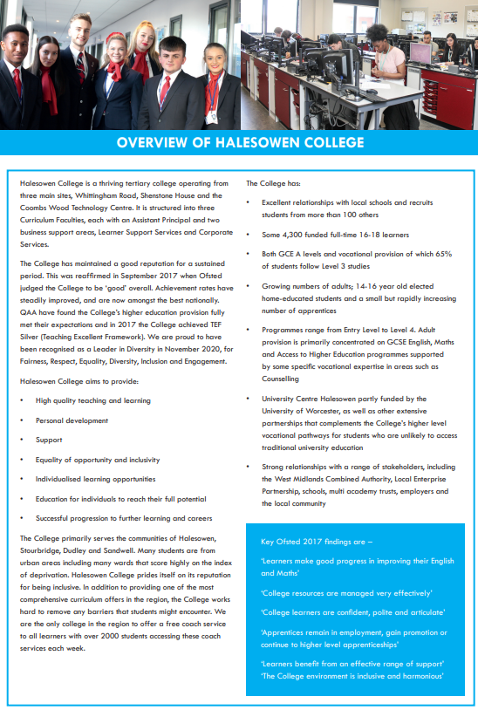

|  |  |  |  |
| --- | --- | --- | --- |
|  | | | JOB DESCRIPTION |
|  | | |  |
| **Job Title** | | | Digital Marketing assistant |
| **Responsible to:** | Marketing Hub Manager | | |
| **Line Manager:** | Marketing Hub Manager | | |
| **Contacts:** | College Staff, Students, also could include Parents, Guardians, General Public, College Stakeholders, Government Agencies | | |
| **Job Purpose:** | Working closely with the Marketing HUB Manager, the post holder will support the production of all Halesowen College promotional material and marketing campaigns. | | |
| **Hours:** | Full Time, 37 hours per week. The actual distribution of working hours will need to be flexible to reflect the varying needs of the College. Time off in lieu is provided for these instances. | | |
| **Salary:** | £20,739.87 - £21,550.17 per annum (Grade D) | | |
| **Annual Leave:** | The leave year runs from 1 September to 31 August  21 days and after 5 years 26 days  8 days Bank Holiday and 5 days for College Closure | | |
| **Pension:** | West Midlands Pension Fund and our employer contribution is 18.9%  Employee contributions depend on your annual salary see:  <https://www.wmpfonline.com/members> | | |
| **Staff Benefits:** | <https://jobs.halesowen.ac.uk/index.cfm?action=content&content=1> | | |

|  |
| --- |
| **Duty and responsibilities:** |
| |  | | --- | | * Work with the Marketing HUB Manager to support the year-round programme of targeted digital, social media and print advertising campaigns throughout the Black Country. | | * Ensure a high level of accuracy is maintained throughout all work, and support proofing and reviewing Team productions. | | * Support the production of the College’s prospectuses. | | * Seek and develop suitable links with students to build a collection of case studies. | | * Undertake content changes on the College’s website [www.halesowen.ac.uk](http://www.halesowen.ac.uk) | | * Support the production of engaging artwork for promotional purposes that is in-keeping with the College’s image and various brands. | | * Support the promotions of Halesowen College events, such as open days, information events, taster days, advice and guidance sessions and InfoFest. | | * Support the Marketing HUB Manager’s PR campaigns for national themes, such as National Apprenticeship Week. | | * Maintain and support the College’s social media presence. | | * Take photos/film to accompany stories for press, trade magazines and website(s) | | * Support the Marketing HUB Manager in liaising with printers and designers for the print and production of marketing literature, when required. | | * Ensure key marketing materials comply with the Competition and Marketing Authority, Equality Act, and Disability Discrimination Act. | | * Participate with the College’s annual appraisal process. | | * Undertake any other duties as may be reasonably required by the Marketing HUB Manager to meet the demand of service provision in the partnerships cluster. | |

Any other duties, which may from time to time, be required and which are commensurate with the skills experience and grade of the post holder.

**Under DBS legislation and guidelines this is a regulated activity.**

**Disclosure and Barring Service Check**

This post, due to its nature, duties and responsibilities, will be subject to a check by the DBS. The level of check which will apply shall be an “Enhanced” level check.  Information about this disclosure can be found at [www.gov.uk](http://www.gov.uk).

To prevent abuse and implement good practice Halesowen College ensures that recruitment practices are robust and rigorous and that all staff employed have up to date and acceptable references, a full and complete employment history, an Enhanced DBS check and a check of the DBS barred lists.

**Safeguarding**   
Halesowen College is committed to safeguarding and promoting the welfare of young people and vulnerable adults and expects all staff and volunteers to share this commitment.  
Successful applicants will be subject to an enhanced Disclosure and Barring check.

**Data Protection**

You are required to meet the specifications of the College’s Data Protection Policy as part of your conditions of employment. This will include information relating to past and prospective employees and students, suppliers and customers.

**Harassment and Discrimination**

You have a duty not to discriminate against or harass colleagues, contractors, students, parents, guardians or potential students or other College visitors, by reason of their age, sex, sexual orientation, gender re-assignment, marriage and civil partnership, pregnancy or maternity, race, disability or religion and belief.

**Safeguarding and Staff Code of Conduct**

You have a duty to abide by the Staff Code of Conduct and Safeguarding Policy.

**Health and Safety**

The College and its employees have legal obligations in respect of the health, safety and welfare of persons at work and the protection of others against risks to health and safety in connection with their activities. Specific health and safety responsibilities are detailed in the College Health and Safety Policy.

Other information for job holders/applicants:

**Equality and Diversity**

Halesowen College is proud of its work in embedding equality and diversity principles in its activities and welcomes applications from all suitably qualified people, irrespective of age, sex, gender reassignment, marital or civil partnership status, disability, race, ethnic or national origin, religion or beliefs, sexual orientation, unrelated criminal convictions or family responsibilities.

We welcome all sections of the community and value the contributions to the achievement of the College’s mission that are made by members of the College from a wide range of backgrounds and experiences. All staff must demonstrate an awareness of equality and diversity principles, as set out in College policies that includes **F**airness, **R**espect, **E**quality, **D**iversity, **I**nclusion and **E**ngagement. It is expected that all members of staff on appointment are committed to and include these principles in their work.

**Information Technology**

The College has approximately 2,600 computers across its sites including PCs, laptops, netbooks and Macs running a range of industry standard software. Equipment is available for long and short term loans, and guest access to our wireless network is provided for personal devices. We also run a PC booking system to ensure you can get access to a computer when you need it. A wide range of classroom technologies are in place such as the Moodle Virtual Learning Environment, cameras, voting devices and interactive whiteboards/data projectors.

All staff and students are given a personal computer account with access to email and storage which is available on and off site.

**Smoking**

Halesowen College is a designated smoke-free environment within the perimeter of all College property by order of the College Governors. This rule applies equally to staff and students, and to all categories of visitor. Acceptance of this rule is a condition of employment for staff, and a condition of being a student for students.

**Campus**

The College has three sites, Whittingham Road, Shenstone House and Coombs Wood. Staff can be asked to be based at and/or work across all campuses.

**Note: This job description is current at the time of issue. It should be recognised that, in keeping with organisational changes and developments, it may be necessary to review the duties listed from time to time and change them to meet organisational objectives.**

