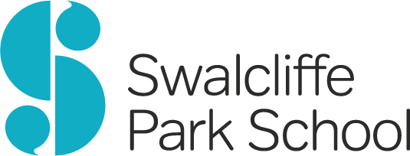

Job Description & Person Specification
Housekeeper/Domestic Assistant

Hours of work: 37. 5 hours full time or part time considered.

Salary: NJC SCP 4 £24,404 per annum (£12.51 per hour) pro rata for part time

Reporting to: Site Manager

Duties

General cleaning duties in Students’ Boarding Houses, Education Block, Offices and communal areas including:

Making beds
- Washing up

- Cleaning bedrooms, toilets and showers
- General tidying of rooms
- Spring cleaning

Mopping and polishing floors
- Occasional laundry duties (washing and ironing)
- Other occasional duties as required e.g. help with whole school events eg Christmas party, Open Day
Six months’ Probationary Period.
Pension scheme: NEST
Sickness entitlement: 2 weeks full pay 2 weeks half pay on completion of probation
Holidays: 25 days per annum plus Bank Holidays, pro rata for part-time staff

Person Specification

Reliable, flexible and adaptable in approach to duties
Thorough, attention to detail
Work to designated timescales
Team player
Able to follow instructions and keep to policies and guidelines
Be compliant with Health & Safety and Safeguarding requirements
Be able to undertake the physical nature of the role with assistance of appropriate equipment and aids.

This school is committed to safeguarding and promoting the welfare of children and expects all staff and volunteers to share this commitment. The successful candidate will be expected to undertake an enhanced disclosure. We are an equal opportunities employer.

